How Melbournians walk during COVID-19

Panagiotis Stylianos

2020-07-28

#### Introduction

In this document we examine the walking frequency of Melburnians during the July lockdown.  
The data are provided in the **rwalkr** package.

#### Plot of Total Steps per Day

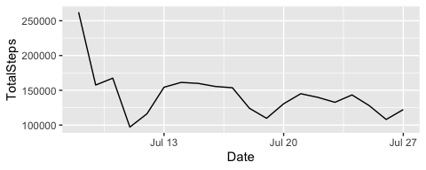

#### Table of five most active sensors

## # A tibble: 5 x 3  
## Sensor TotalSteps Proportion  
## <chr> <int> <dbl>  
## 1 Flinders St-Elizabeth St (East) 228584 7.97  
## 2 380 Elizabeth St 165729 5.78  
## 3 Flinders La-Swanston St (West) 160331 5.59  
## 4 Town Hall (West) 119530 4.17  
## 5 Melbourne Central-Elizabeth St (East) 118594 4.13

#### Formula for proportion

$y_{i}$ = $x_{i}/\sum_{i=1}^{30240}{x_{i}}$

where $x_{i}$ is the total steps monitored by this sensor, $sum_{i=1}^{30240}x_{i}$ is the total steps monitored by all sensors. and $y_{i}$ is the proportion that each sensor contributed to the dataset.

#### Table of Packages and functions used in the report

|  |  |
| --- | --- |
| Library | Functions |
| base | as.Date(), Sys.Date(), sum() |
| dplyr | group_by(), summarise(), mutate(), arrange() |
| ggplot2 | ggplot(), aes(), geom_line() |
| rwalkr | melb_walk() |