Office Ratings

Pete Talbert

4/28/2020

Below I present analysis of The Office television series that ran on NBC from 2005 to 2013. The data is grouped by season and episode, with IMDB ratings, and total IMDB votes.

## How many episodes in each season?

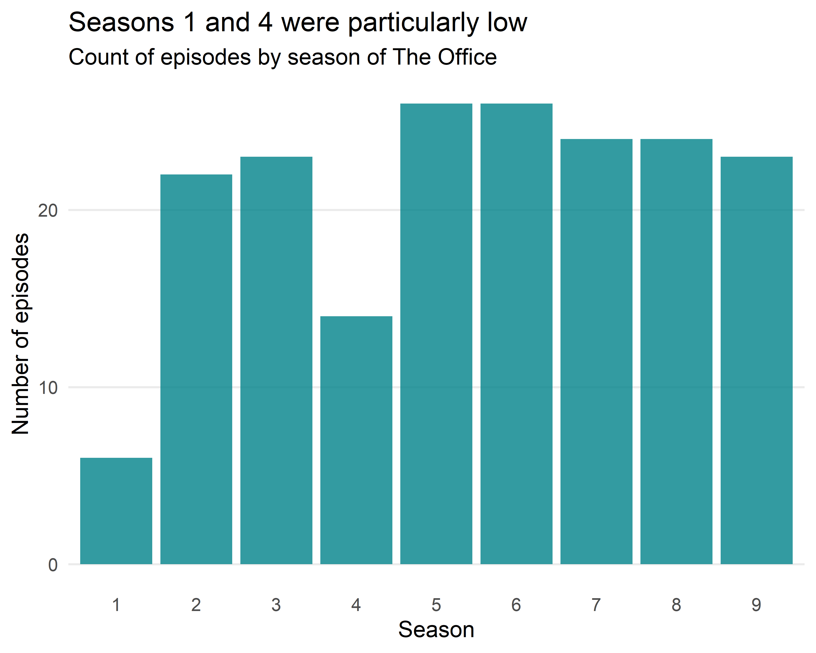

Why are there only 14 episodes in season 4? According to [Wikipedia](https://en.wikipedia.org/wiki/List_of_The_Office_(American_TV_series)_episodes#Episodes), the 2007-2008 Writers Guild of America strike shut down production for nearly five months in the middle of the season.

## What was the average IMDB rating of episodes by season?

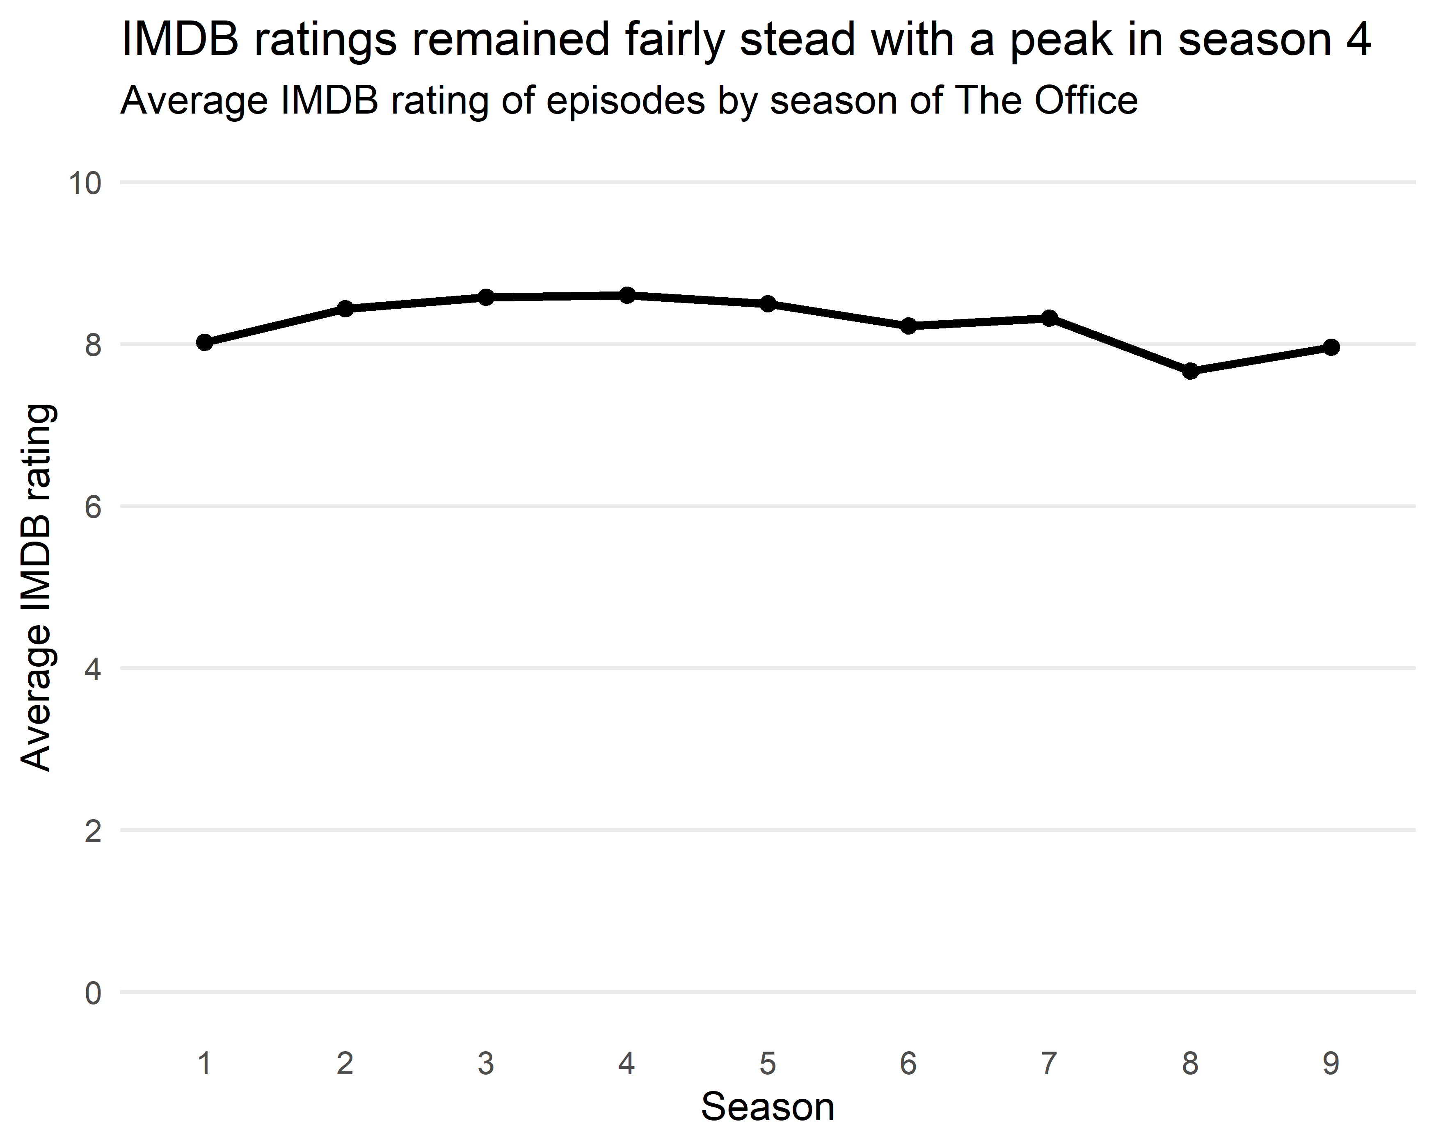

## What was the trend of IMDB ratings within a season?

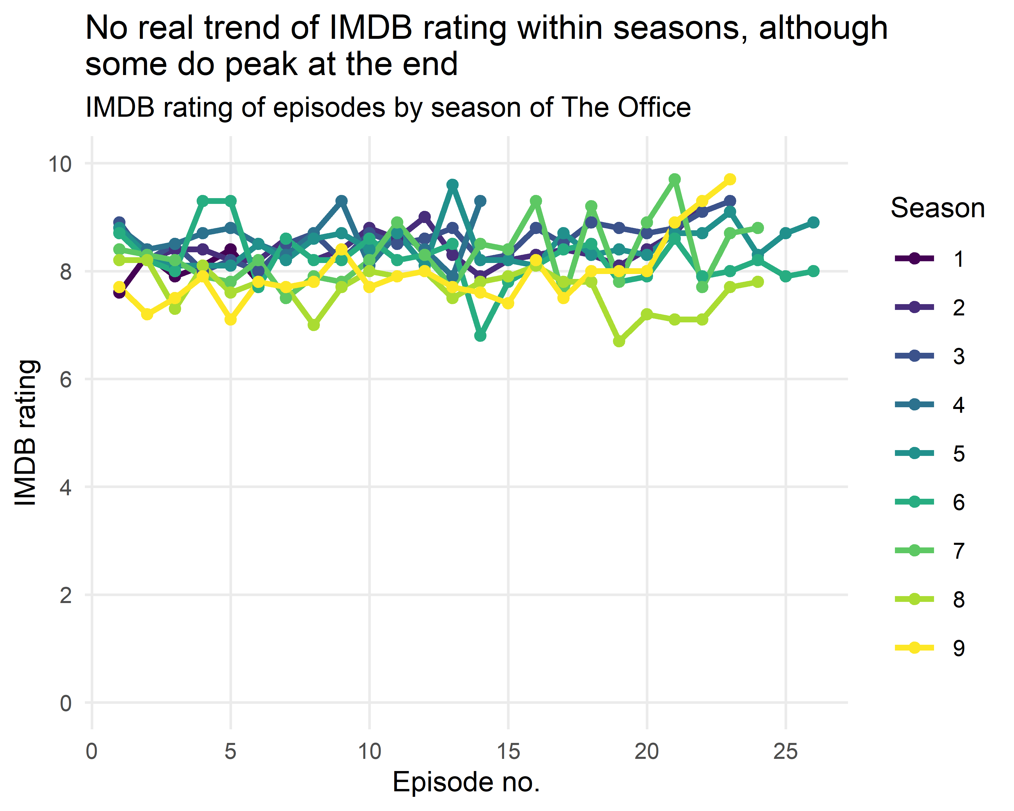

## What were the top ten most popular episodes?

|  |  |  |  |  |
| --- | --- | --- | --- | --- |
| # | Season | Episode | Title | IMDB Rating |
| 1 | 7 | 21 | Goodbye, Michael | 9.7 |
| 2 | 9 | 23 | Finale | 9.7 |
| 3 | 5 | 13 | Stress Relief | 9.6 |
| 4 | 2 | 22 | Casino Night | 9.3 |
| 5 | 3 | 23 | The Job | 9.3 |
| 6 | 4 | 9 | Dinner Party | 9.3 |
| 7 | 4 | 14 | Goodbye, Toby | 9.3 |
| 8 | 6 | 4 | Niagara: Part 1 | 9.3 |
| 9 | 6 | 5 | Niagara: Part 2 | 9.3 |
| 10 | 7 | 16 | Threat Level Midnight | 9.3 |

## Is there a relationship between the IMDB rating and the number of votes?