Marriage

Pete Talbert

9/3/2020

## Let’s try to recreate the plot!

The plot from [here](https://fivethirtyeight.com/features/marriage-isnt-dead-yet/).

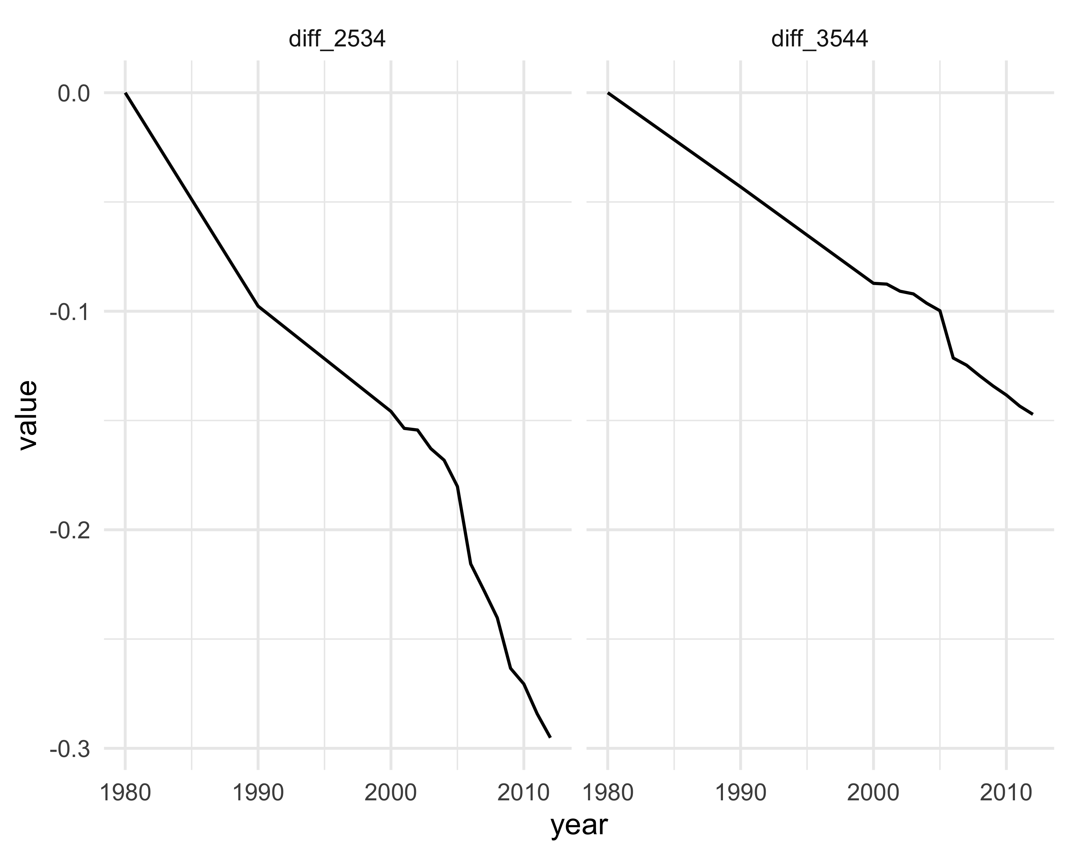

## Okay that’s overall. What about by education?

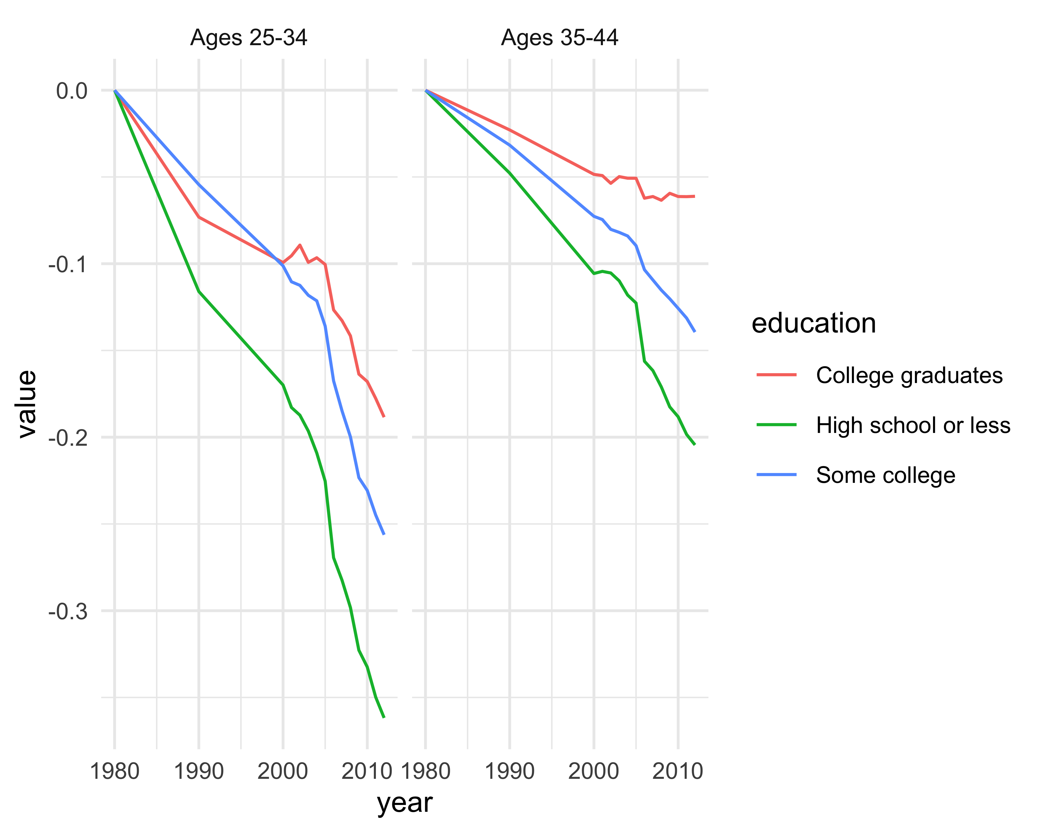

# Awesome! Okay now we need to doctor the ggplot to make it match fivethirtyeight.

