The Office IMDB Ratings

Pete Talbert

8/20/2020

## Do average IMDB ratings for The Office change across seasons?

*The Office* saw higher average IMDB ratings of its episodes the first seven seasons, but in seasons eight and nine it dipped.

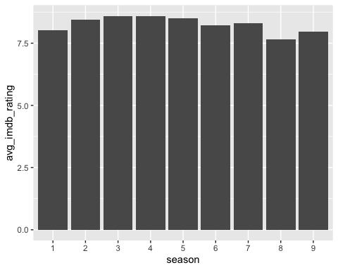

However, in season nine, the finale was one of the highest rated episodes of the entire series.

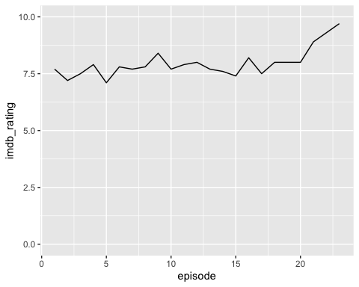

### About the data

The data are IMDB ratings for each episode of *The Office*, the hit NBC show that ran in the mid-2000s. The data comes from the Tidy Tuesday R project, and can be found [here](https://github.com/rfordatascience/tidytuesday/tree/master/data/2020/2020-03-17). Overall, there were 188 rows in the data.