SPONSORSHIP FORM - LINGFIELD MARATHON FUN RUN SUNDAY 3rd MAY 2009
Registered Charity 287788
The money raised as a result of this event will be distributed amongst local charities and other good causes
YOUR SUPPORT IS VERY MUCH APPRECIATED - THANK YOU. Please use block capitals
Name of Fun Run Entrant
Total amount Made from If the sponsorship/donation amount is made of the taxable from taxable income, kindly enter the sponsorship income? sponsor's full address here in order for it to
Sponsor's Name � Yes/No* be treated as Gift Aid. Thank you. *
Please mark your choice of event with a "X" 10 Mile Run 6 Mile Run Contact telephone no. 6 Mile Walk
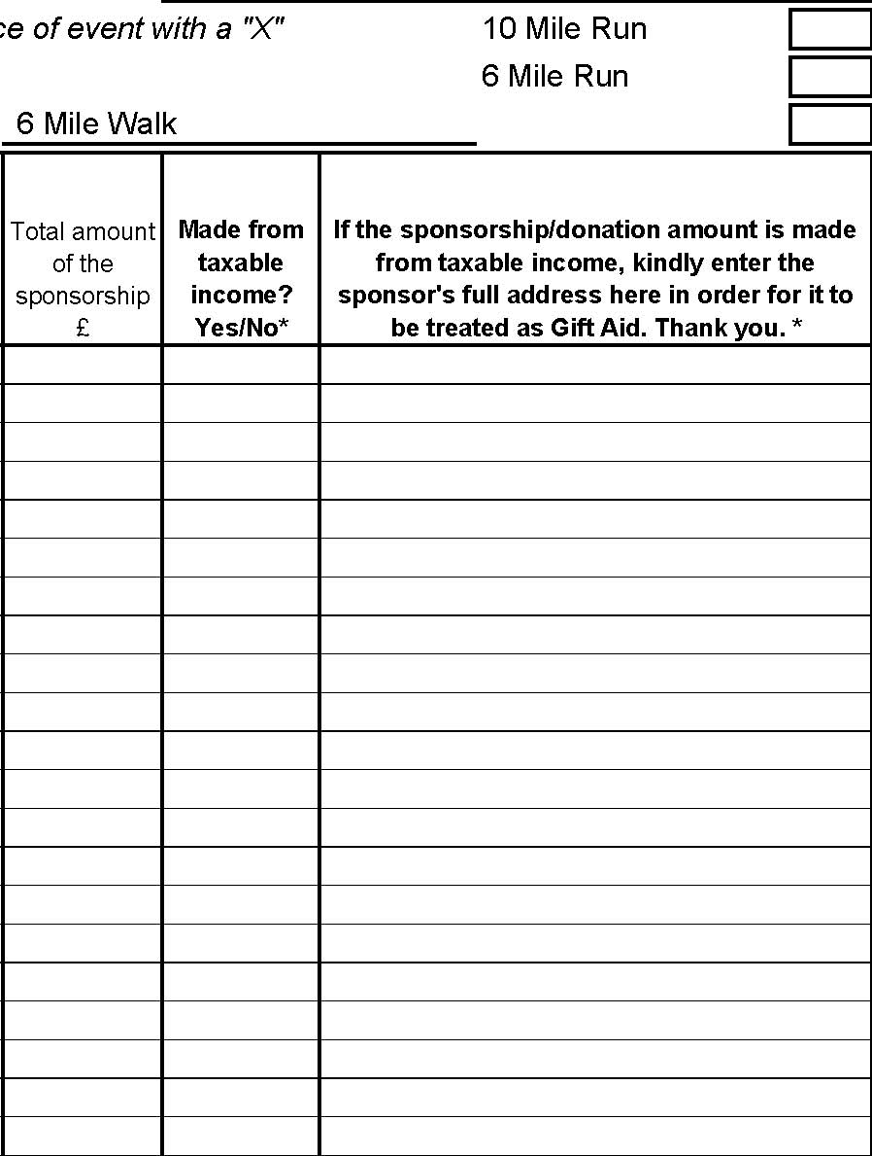
Please use a separate continuation sheet if need be. *Sponsors making sponsorships/donations from taxabl e income declare that all sponsorship/donations made since 6 April 2000, and any payments made hereafter, are made from taxable income and are to be treated as Gift Aid donations.
If ANY of your sponsors are TAXPAYERS, please return this form and your money to:
Mike Ellis, Bidbury House, Hollow Lane, East Grinstead RH19 3PS
Otherwise, please return this form and the money raised, in an envelope, to:
Barclays Bank Plc - Account No: 50369977; Sort Code: 20-23-97 Please make all cheques payable to "The Lingfield Marathon"
Please do not send any cash by mail.
Kindly pay your sponsorship money in as soon as possible. Thank you.
www.lingfield-marathon.org

