Big Data for Journalists

There’s been a revolution in data over the last few years, driven by an astonishing drop in the price of gathering and analyzing massive amounts of information. It only cost me $120 to gather, analyze and visualize 220 million public Facebook profiles. You can use 80legs to download a million web pages for just $2.20.

The technology is not just getting cheaper, it’s also getting easier to use. Companies like Extractiv and Needlebase are creating point-and-click tools for gathering data from almost any site on the web, and every other stage of the analysis process is getting radically simpler too.

What does this mean for journalists? You no longer have to be a technical specialist to find exciting, convincing and surprising data for your stories. I’ve created a short guide to cover my favorite resources, along with a few examples of how they’ve been used to create compelling journalism. Here’s a taster section on websites, and you can download the full, free ebook covering emails, companies, media, topics and gathering, analyzing and visualizing public data sources.

Websites

When you have a page or domain that you want to know more about, there are a few free services that offer interesting information.

Whois - http://whois.domaintools.com

Many of you will already be familiar with whois, but it’s so useful for research it’s still worth pointing out. If you go to this site (or just type whois www.example.com in Terminal.app on a Mac) you can get the basic registration information for any website. In recent years, some owners have chosen ‘private’ registration which hides their details from view, but in many cases you’ll see a name, address, email and phone number for the person who registered the site.

You can also enter numerical IP addresses here and get data on the organization or individual that owns that server. This is especially handy when you’re trying to track down more information on an abusive or malicious user of a service, since most websites record an IP address for everyone who accesses them

Blekko - http://blekko.com

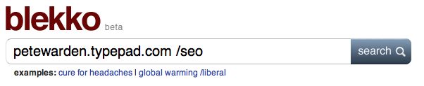
The newest search engine in town, one of Blekko’s selling points is the richness of the data it offers. If you type in a domain name followed by /seo
you’ll receive a page of statistics on that URL

The first tab shows you which other sites are linking to the current domain, in popularity order. This can be extremely useful when you’re trying to understand what coverage a site is receiving, and if you want to understand why it’s ranking highly in Google’s search results, since they’re based on those inbound links. It would have been an interesting addition to the recent DecorMyEyes story for example.
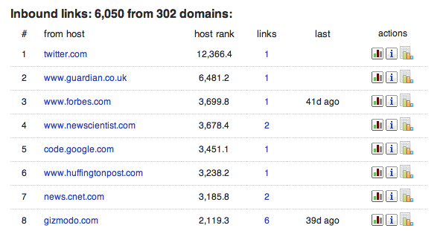

The other handy tab is ‘Crawl stats’, especially the ‘Cohosted with’ section

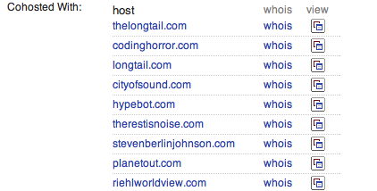

This tells you which other websites are running from the same machine. It’s common for scammers and spammers to astroturf their way towards legitimacy by building multiple sites that review and link to each other. They look like independent domains, and may even have different registration details but often they’ll actually live on the same server because that’s a lot cheaper. These statistics give you an insight into the hidden business structure of shady operators.

bit.ly - http://bit.ly

I always turn to this site when I want to know how people are sharing a particular link with each other. To use it, enter the URL you’re interested in

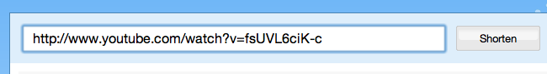

Then click on the ‘Info Page+’ link

That takes you to the full statistics page (though you may need to choose ‘aggregrate bit.ly link’ first if you’re signed in to the service).
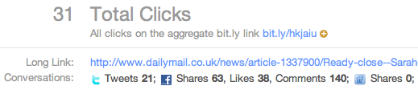

This will give you an idea of how popular the page is, including activity on Facebook and Twitter, and below that you’ll see public conversations about the link provided by backtype.com.



I find this combination of traffic data and conversations very helpful when I’m trying to understand why a site or page is popular, and who exactly its fans are. For example, it provided me with strong evidence that the prevailing narrative about grassroots sharing and Sara Palin was wrong.

Compete - http://www.compete.com

By surveying a cross-section of American consumers, Compete builds up detailed usage statistics for most websites, and they make some basic details freely available.

Choose the ‘Site Profile’ tab and enter a domain
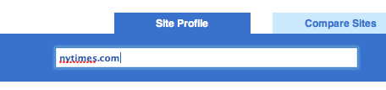

You’ll then see a graph of the site’s traffic over the last year, together with figures for how many people visited, and how often.

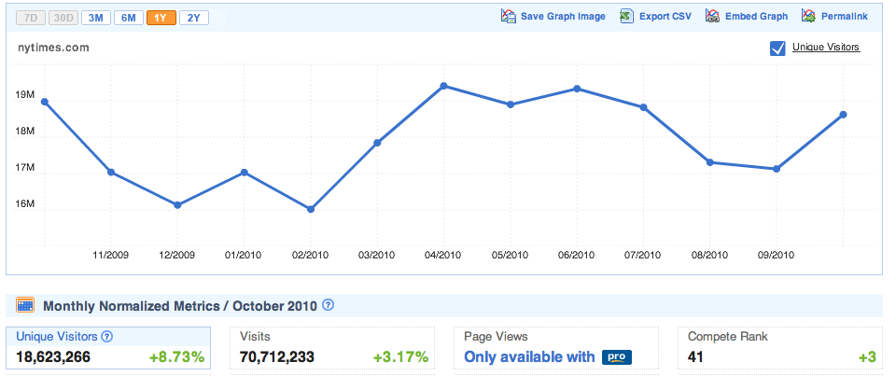
Since they’re based on surveys, the numbers are only approximate, but I’ve found them reasonably accurate when I’ve been able to compare them against internal analytics. In particular, they seem to be a good source when comparing two sites, since while the absolute numbers may be off for both, it’s still a good representation of their relative difference in popularity. They so only survey US consumers though, so the data will be poor for predominantly international sites

Download the full, free ebook

