

Digital Federal Electoral District
Boundary Files

Technical Guide

September 2008

Introduction
The digital federal electoral district boundary files provided on the CD-ROM are made available from Elections Canada. The CD-ROM contains the digital federal electoral districts under the Representation Order of 2003. The files do not include the underlying geographic base map information (National Geographic Database. e.g.: roads, hydrography, etc.).

CD-ROM Content

Directory | Description
Shape | Directory containing digital data in ESRI Shape format.
FED_Shape_data_e.doc | User guide (CD-ROM content and description). (English)
FED_Shape_data_f.doc | User guide (CD-ROM content and description). (French)
feds308.xls | List of federal electoral district codes and names.
licence.txt | Limited data product licence agreement.

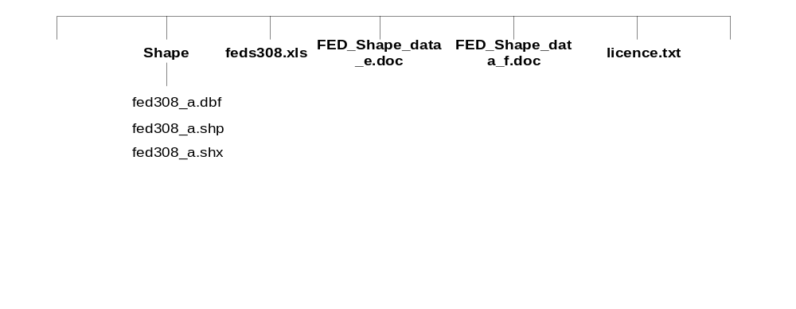CD-ROM Directory Structure

Database Specifications

General
Arc/Info file format: | Version 8 compliant
Precision: | DOUBLE PRECISION
Datum: | NAD83 CNT
Projection: | LAMBERT CONFORMAL
Spheroid: | GRS 1980
Units: | METERS

Projection Parameters
1st standard parallel: | 49 0 0.000
2nd standard parallel: | 77 0 0.000
Central meridian: | -91 52 0.000
Latitude of projection’s origin: | 63 23 26.430
False easting (meters): | 6200000.00000
False northing (meters): | 3000000.00000

Tolerance values
Fuzzy: | 0.001
Dangle: | 0.000

Schema details

Federal Electoral Districts

Layer Name: | FED308_A
Layer Description: | Federal Electoral District boundaries
Layer Feature Type(s): | Polygons

Layer Feature Type(s)
Type | Present | Subclass Name
POINT | N | NA
LINE | N | NA
POLY | Y | NA
NODE | N | NA
ROUTE | N
REGION | N
ANNOTATION | N

Table Descriptions
Table Name: | FED308_A.PAT
Table Description: | Table containing the FED polygon attributes
Table Location: | INFO directory
Related Table(s): | None

Table Definition
COLUMN | ITEM NAME | WIDTH | OUTPUT | TYPE | N.DEC | ALTER NAME | INDEXED
1 | AREA | 8 | 18 | F | 5 |  | -
9 | PERIMETER | 8 | 18 | F | 5 |  | -
17 | FED308_A# | 4 | 5 | B |  |  | -
21 | FED308_A-ID | 4 | 5 | B |  |  | -
25 | FED_NUM | 4 | 10 | B |  |  | -
29 | ED_NAMEE | 100 | 100 | C |  |  | -
79 | ED_NAMEF | 100 | 100 | C |  |  | -

Attribute Definition
ITEM NAME | DESCRIPTION
FED_NUM | Federal electoral district number (e.g. 35061).
ED_NAMEE | Federal electoral district name - English
ED_NAMEF | Federal electoral district name - French

