
KCA UNIVERSITY

SCHOOL OF TECHNOLOGY

FINAL YEAR PROJECT

PLANTWISE CROP ADVISORY AND DISEASE DIAGNOSIS EXPERT SYSTEM

SYSTEM DESIGN SPECIFICATION (SDS)

BY:AUDI PETER OJWANG’ (23/04956)

Table of Contents
1. INTRODUCTION 4
1.1 Purpose 4
1.2 Scope 4
1.3 Objective 4
2. SYSTEM OVERVIEW 5
2.1 Product Perspective 5
2.1.1 Design Method 5
2.1.2 User Interfaces 5
2.1.3 Hardware Interfaces 5
2.1.4 Software Interfaces 5
2.1.5 Operations 6
3. DESIGN CONSIDERATIONS 7
3.1 Operating Environment 7
3.2 Fault Tolerant Design 7
3.3 Architectural Design 7
3.4 User Interface 8
3.4.1 Expected Input 8
3.4.2 Output 8
4. SYSTEM ARCHITECTURE 9
4.1 View of product classes 9
4.2 Individual Classes of System 9
4.2.1 Class: Inference Engine 9
4.2.1.1 Functions 9
4.2.2 Class: Knowledge Base 9
4.2.2.1 Attributes 9
4.2.2.2 Functions 9
4.2.3 Class: Diagnostic Session 10
4.2.3.1 Attributes 10
4.2.3.2 Functions 10
4.2.4 Class: Rule 10
4.2.4.1 Attributes 10
5. FIGURES (DESIGN DIAGRAMS) 11
5.1 Use Case Diagram 11
5.2 Sequence Diagram 12
5.3 Invalid Input Handling Sequence 13
6. GLOSSARY 14
7. REFERENCES 15

- INTRODUCTION

  - Purpose

This document’s purpose is to define the detailed design specifications for the PLANTWISE expert system. It translates the requirements defined in the SRS into a technical blueprint for implementation. It contains specific information about the system architecture, class structures, data inputs/outputs, and the logic flow of the Inference Engine (incorporating Fuzzy Logic and Certainty Factors).

1.2 Scope

This Design Specification is to be used by the development team to implement the Plantwise web-based expert system. It covers the backend logic (Inference Engine), the Knowledge Base structure, the database schema, and the user interface design for both the Crop Advisory and Disease Diagnosis modules.

1.3 Objective

The Plantwise system is established to simulate the reasoning of an agricultural expert. Its objective is to provide accurate, confidence-rated diagnoses of crop diseases and nutrient deficiencies by processing ambiguous user inputs through a Fuzzy Rule-Based logic model .

- SYSTEM OVERVIEW

  - Product Perspective

Plantwise is a web-based decision support system. The system operates on a Client-Server architecture. The client (browser) handles user interaction, while the server hosts the Inference Engine and Knowledge Base. It integrates Rule-Based Reasoning with Fuzzy Logic to handle vague inputs (e.g., "high rainfall") and Certainty Factors to manage diagnostic uncertainty.

    - Design Method

The design of this product utilizes an Object-Oriented Design (OOD) approach to encapsulate the expert knowledge into reusable classes (e.g., Disease, Symptom, Rule).

    - User Interfaces

The user interacts with the front-end via a responsive web application (HTML/CSS/JavaScript).

Farmer View: Wizard-style forms for symptom selection and diagnosis.

Expert View: Dashboard for validating rules and viewing system logs .

    - Hardware Interfaces

Server: Will initially use Local Server for testing and then proceed to a Standard Cloud/Web Server (e.g., AWS)

Client: The client will be any internet-enabled device (Smartphone, Tablet, PC) .

    - Software Interfaces
Platform: Python (Flask) environment.

Database: MySQL as the primary persistent storage of the Knowledge Base (Inference rules).

Inference Logic: Inferences will be made by a custom Python-based inference engine .

2.1.5 Operations

Plantwise operates on a request-response cycle whereby users initiate a diagnostic recommendation session, and the system processes the input against the Knowledge Base to return a result. i.e.(either a diagnosis or a plant suitability recommendation)

- DESIGN CONSIDERATIONS

  - Operating Environment

The Plantwise system is intended to be operated in a distributed web environment to ensure accessibility for remote farmers and extension officers.
Server Side: The application logic and database will execute on a Unix platform running a Python environment (Flask framework). It requires a robust SQL database engine (MySQL).
Client Side: The user interface is designed to run on any standard web browser (Google Chrome, Mozilla Firefox, Safari, Microsoft Edge) across multiple device types (Desktop, Tablet, Mobile Smartphone).

  - Fault Tolerant Design

Application errors and exceptions will be handled by standardized fault detection services to ensure system stability.
Input Validation: All user inputs (e.g., Soil pH values, Certainty Factors) will be validated at the client side (HTML5 constraints) and server side to prevent injection attacks or logic errors.
Database Connectivity: The system implements connection pooling and retry logic. If the Knowledge Base is unreachable, the user will receive a "Service Unavailable" notification rather than a raw application crash.
Rule Logic Exceptions: If the Inference Engine encounters a circular rule reference or missing parameter, it is designed to log the error internally and degrade gracefully by returning the "Next Best" diagnosis or a prompt for more information.

  - Architectural Design

The software is partitioned into a Three-Tier Architecture:
Presentation Tier: Handles User Input (Symptom Checklists) and visual Output (Diagnosis Reports).

Logic Tier (Inference Engine): The core module containing the Fuzzy Logic Processor (for environmental inputs) and the Certainty Factor Calculator (for disease diagnosis).

Data Tier (Knowledge Base): Stores the Rules, Facts, Crops, Diseases, and User Profiles in a relational database .

  - User Interface

The user interfaces via a responsive web screen. The user is prompted for specific values to perform the diagnostic calculations.

    - Expected Input
The user is prompted to enter values for the following variables:
Advisory Module:
Location (County/Sub-County).
Soil pH Level (Numeric, e.g., 5.5).
Rainfall Intensity (Linguistic Variable: Low, Medium, High).
Temperature (Linguistic Variable: Cool, Warm, Hot).

Diagnostic Module:
Crop Name (Selected from list).
Plant Part Affected (Leaf, Stem, Root, Fruit).
Observed Symptoms (Selected from hierarchical list).
User Confidence Level (Numeric: 0.0 to 1.0) for each symptom.

    - Output

The user receives a generated report from the system indicating:

Ranked Diagnosis: The top 3 probable diseases/deficiencies sorted by Certainty Factor (e.g., "Late Blight: 85%").
Recommended Action: Cultural and Chemical remedies for the top diagnosis.
Reasoning Trace: A text summary explaining why the diagnosis was reached (e.g., "Because 'Leaf Spots' AND 'High Humidity' were present...").

- SYSTEM ARCHITECTURE

  - View of Product Classes (Class Diagram Description)
The system is composed of interacting classes that represent the expert system's components.
Diagnostic Session: Manages the state of the current user interaction.
Inference engine: Contains the algorithms for Fuzzy Logic and Certainty Factors.
Knowledge base: Interfaces with the database to retrieve Rules.
Rule: Represents a single "IF-THEN" logical unit.
Symptom: Represents the evidence provided by the user.
Disease: Represents the final conclusion.

  - Individual Classes of System

    - Class: Inference Engine

      - Functions

Fuzzify Input(value, fuzzy Set): Converts crisp inputs (e.g., pH 5.5) into fuzzy membership values. i.e.(slightly acidic)
Forward Chain(symptoms): Iterates through rules to find matches based on provided symptoms.
Calculate CF (rule CF, symptom CF): Computes the final confidence score of the diagnosis based on the rules and the evidence available.

    - Class: Knowledge Base
Stores the agronomic expertise and inference rules in an independent SQL database.

      - Attributes

Rules List: Array of Rule objects.
Facts List: Array of known Diseases and Remedies.

      - Functions

GetRulesByCrop(cropName): Filters rules relevant to the selected crop to optimize performance.

Add Rule(condition, conclusion): Allows admin to update knowledge.

    - Class: Diagnostic Session

Represents a single user's attempt to diagnose a problem.

      - Attributes
Selected Symptoms: List of symptoms chosen by user.
User Certainty: The user's belief in their observation.

      - Functions:

StartSession(): Initializes a new blank form.

SubmitDiagnosis(): Sends data to the Inference Engine.

    - Class: Rule
Represents a single unit of expert knowledge.

      - Attributes:

Antecedents: The "IF" part (Symptoms).
Consequents: The "THEN" part (Disease).
RuleWeight: The expert's confidence in this specific rule (0.0 - 1.0).

- FIGURES (DESIGN DIAGRAMS)

5.1. Use Case Diagram

The following diagram illustrates the interaction between the Farmer, Extension Officer, and the System Components (Diagnosis, Advisory, KB Management).

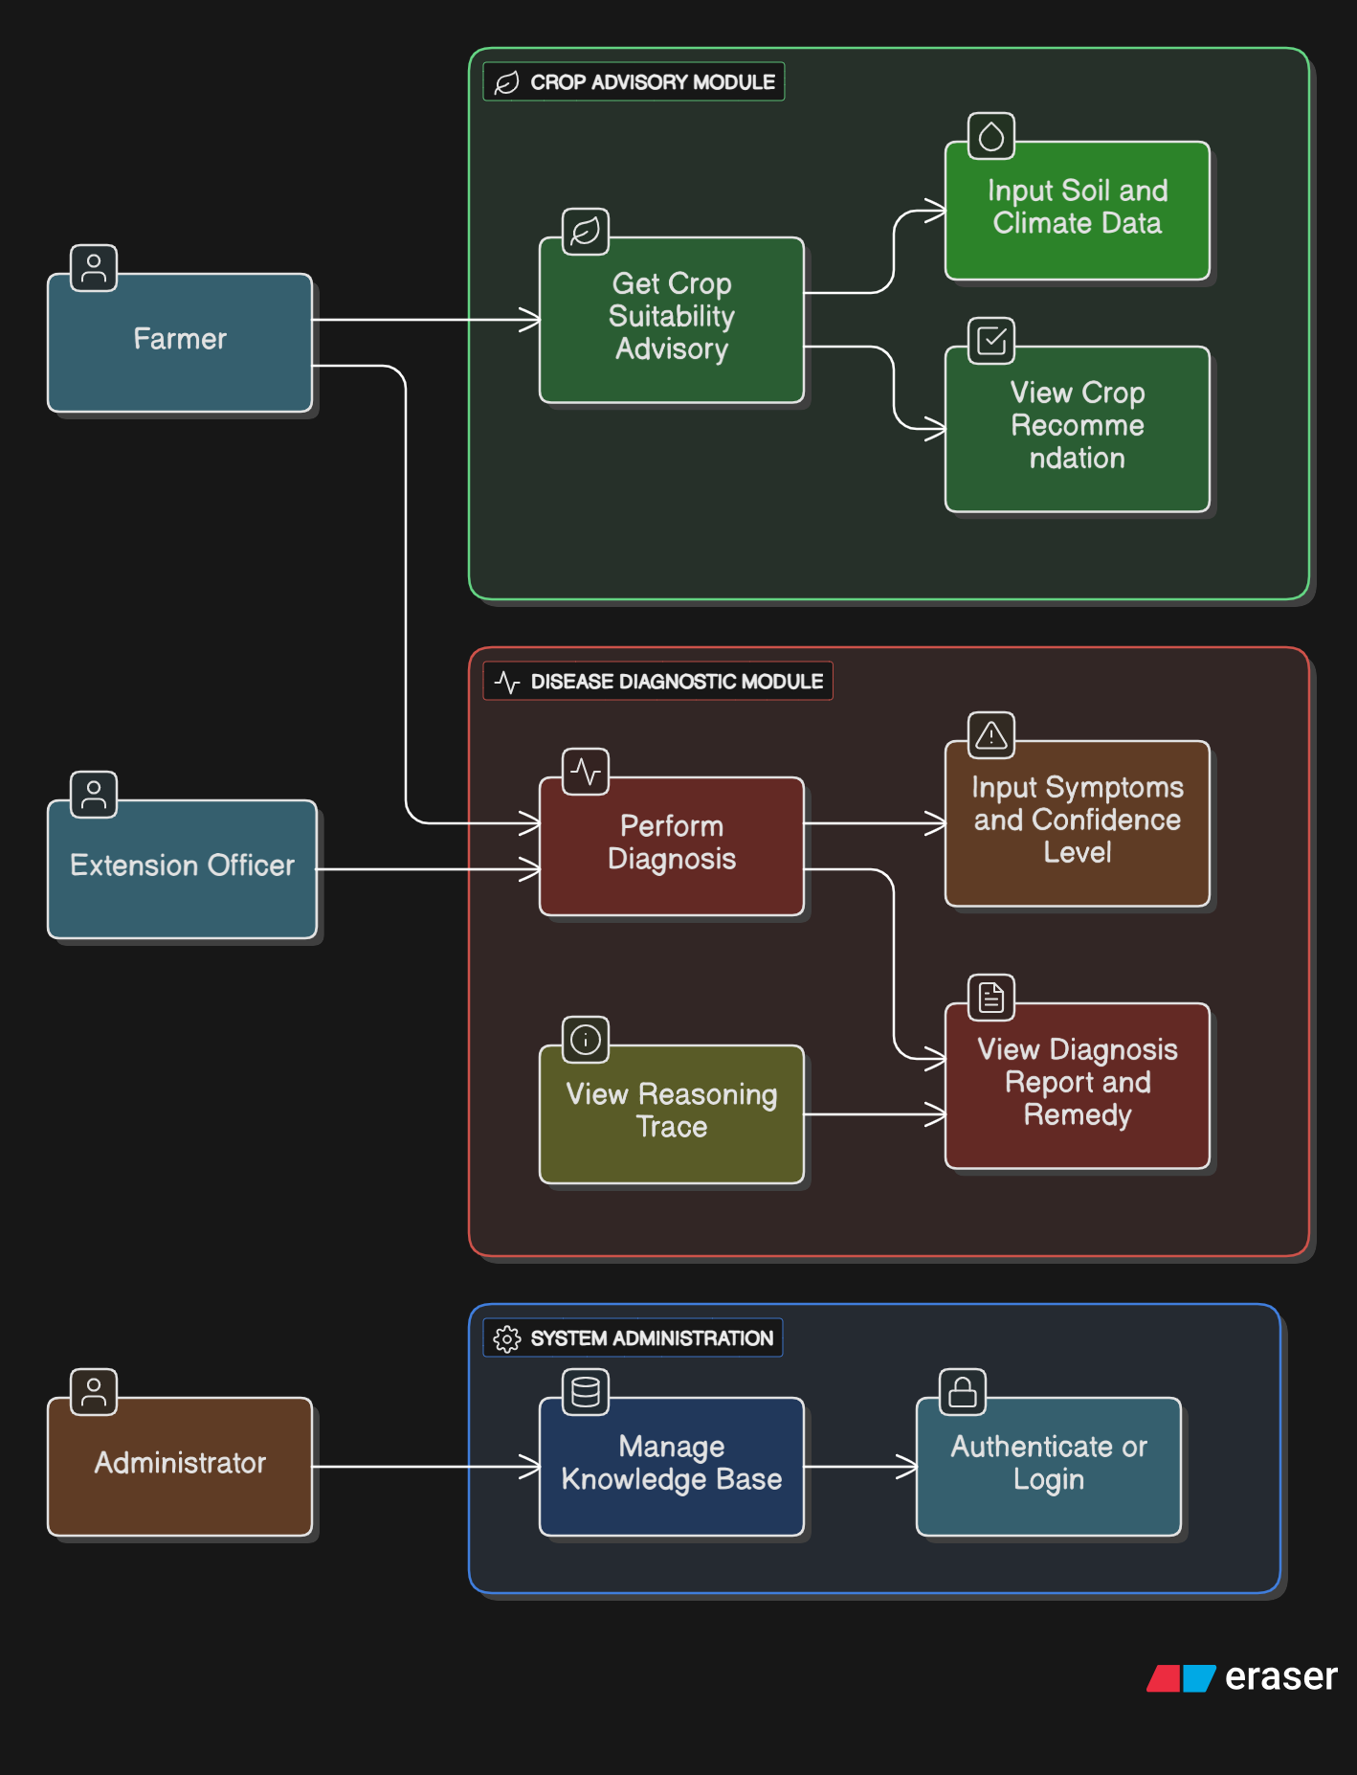
Figure 5.1: Plantwise Use Case Diagram

  - Sequence Diagram

This diagram details the successful flow of a diagnosis request.

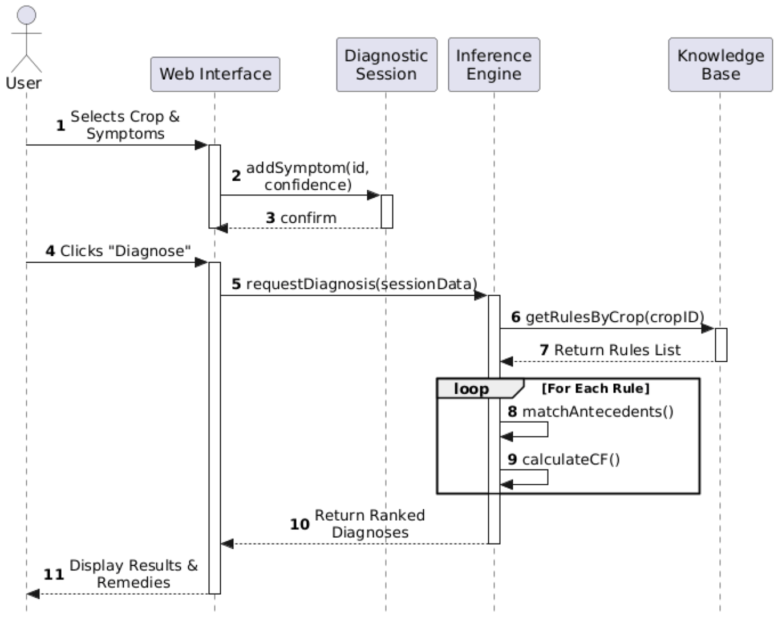
Figure 5.2: Successful Diagnosis Sequence

  - Invalid Input Handling Sequence

This scenario shows how the system handles invalid or out-of-range data (e.g., entering a soil pH of 15) before it reaches the core logic.
NB: (PH ranges from 0-14)

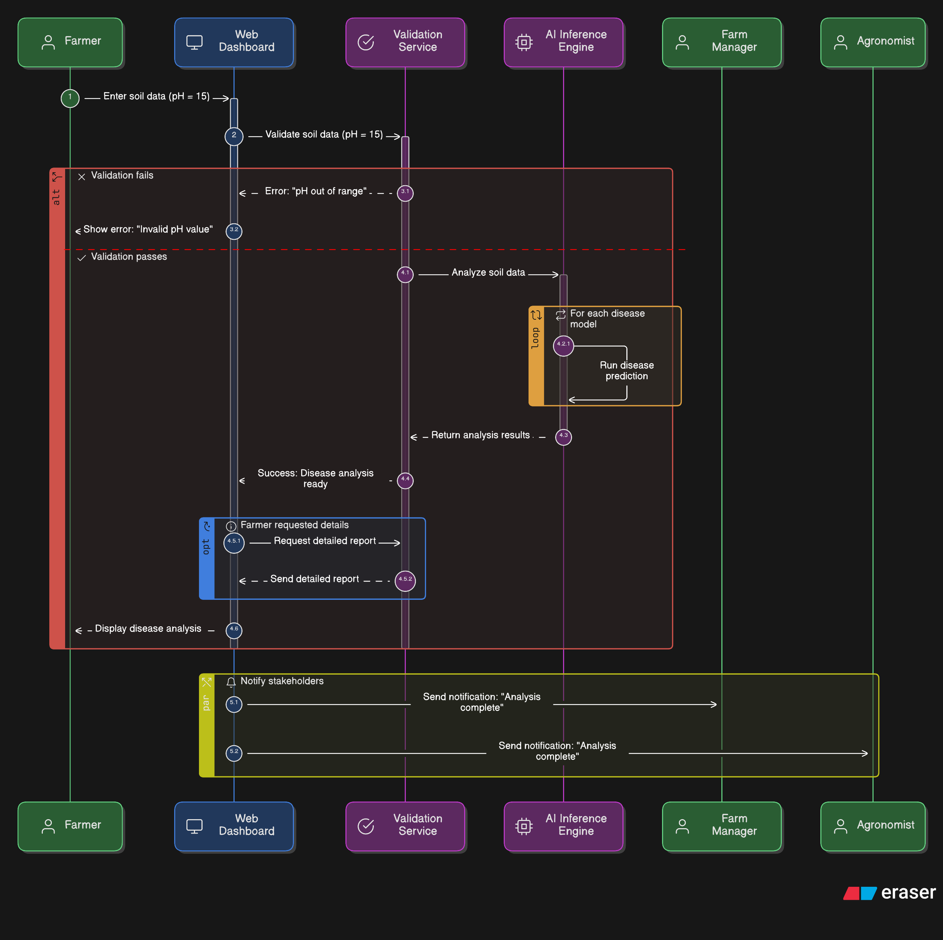
Figure 5.3: Invalid input handling

- GLOSSARY
The following terms and acronyms are used throughout this design specification document to describe Plantwise expert system architecture and logic.
Antecedent: The "IF" portion of a production rule. It describes the condition (e.g., "IF soil is acidic") that must be met for the rule to trigger.
Certainty Factor (CF): A numerical value that represents the degree of confidence or belief in a specific symptom, rule, or diagnosis. It is used to handle uncertainty in the expert system.
Consequent : The "THEN" portion of a production rule. It describes the action or conclusion (e.g., "THEN suggest Lime") that is derived when the antecedent is true.
Defuzzification: The process of converting a fuzzy output (a linguistic result like "High Suitability") back into a crisp numerical value or a concrete ranking for the user.
Forward Chaining: A data-driven inference method where the system starts with the available data (symptoms/soil input) and uses rules to extract more data until a goal (diagnosis) is reached.
Fuzzification: The process of converting a crisp input value (e.g., "Temperature = 28°C") into a fuzzy linguistic value (e.g., "Warm" with 0.8 membership) using membership functions.
Inference Engine: The processing component of the expert system that applies the rules from the Knowledge Base to the facts provided by the user to derive a conclusion.
Knowledge Base (KB): A centralized repository (database) that stores the structured agronomic knowledge (rules, facts, and heuristics) elicited from human domain experts.
Production Rule: A formal logic representation used in expert systems, structured as "IF [Condition] THEN [Action]," used to represent the heuristic knowledge of experts.
Soft Computing: A branch of computer science that deals with approximate models and gives solutions to complex problems (like agricultural diagnosis) where exact mathematical modeling is difficult. (i.e. Fuzzy Logic.)

- References
Jackson, P. (1999). Introduction to Expert Systems (3rd ed.). Addison-Wesley. (Design source for Rule-Based KB structure).
Negnevitsky, M. (2005). Artificial Intelligence: A Guide to Intelligent Systems (2nd ed.). Addison-Wesley. (Primary source for Fuzzy Logic and Certainty Factor algorithms).
Plant, R. E. (1989). An expert system for the diagnosis of peach and nectarine disorders (CALEX/Peaches). Computers and Electronics in Agriculture, 4(3), 221–237. (Source for hierarchical diagnosis design).
Prasad, R., Ranjan, K. R., & Sinha, A. K. (2006). AMRAPALIKA: An expert system for the diagnosis of pests, diseases, and disorders in Indian mango. Knowledge-Based Systems, 19(1), 9–21. (Source for agricultural rule-base structuring).
Sint, P., & Wibowo, A. (2020). Plant Disease Diagnosis Expert System using Certainty Factor. Journal of Physics: Conference Series, 1569. (Recent example of CF implementation in web-based diagnosis).
Tiwari, A., & Singh, A. (2019). Hybrid Expert System for Crop Selection and Disease Management. International Journal of Computer Applications, 178(35). (Supports the Dual-Advisory architecture design).
Rani, P. M. N., Rajesh, T., & Saravanan, R. (2011). Expert Systems in Agriculture: A Review. Journal of Computer Science and Applications, 3(1), 59–71.
Saravanan, R., & Saravanan, R. (2018). Expert Systems in Agriculture: Diagnosis and Crop Management (1st ed.). CRC Press.

