Anna Peterson

GEOG 6180

December 5, 2022

Finding Geologic Hazards by Selecting Lithology

**Description**: This tool has multiple functions where it creates 3 different layers for regions based on geologic units. When first running the tool, the user will be prompted by a hazards warning followed by a selection of which filter to use: Volcano, Earthquake, and Landslide. The first one is a volcanic hazard function where looks for specified volcanic units (e.g. pyroclastic flow, air-fall tephra, etc). The second is a landslide hazard where it has the same function, but searches for other units. The third is exactly the same, but looks for landslide units. Once the geologic units are selected, the polygons are dissolved into an area calculator. This is to determine the amount of error should be added to the buffer. A buffer is then created surrounding the polygons which creates the “hazard zone.”

**Running the script:**

By running the script, you will be greeted by this message



When entering V, E, or L, the python script will run smoothly with no errors and the three carrots should appear in the shell. See below. The raw input will also take volcano, earthquake, and landslide as acceptable answers as well.

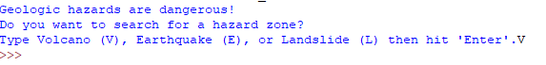

Refresh your geodatabase and the new layers should appear. You can adjust the margin of error or ME to change how much the buffer encapsulates. This is due to the fact that surface geology is limiting and there is likely more that is in the bedrock or eroded away. They will likely look like (depending on where your location is and the ME you determined):

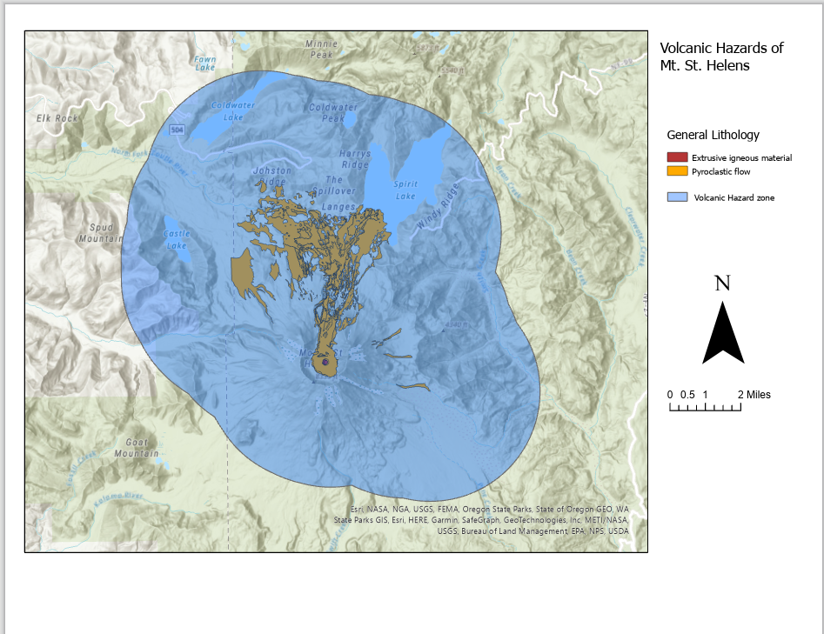

Or

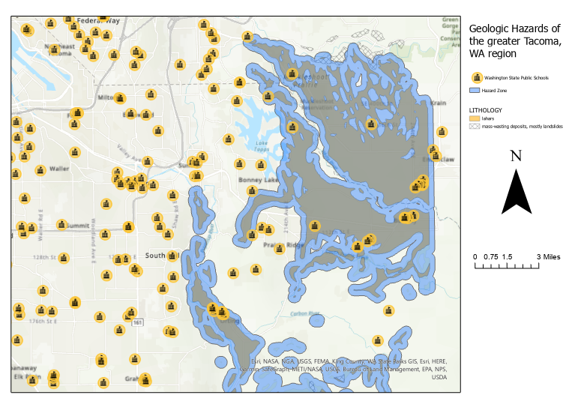

School data was taken from the ArcGIS online database and can be clipped using the following function:

arcpy.analysis.Clip(in_features = Washington_State_Public_Schools,

clip_features = Hazard,

out_feature_class = Danger2Schools)

And will result in:

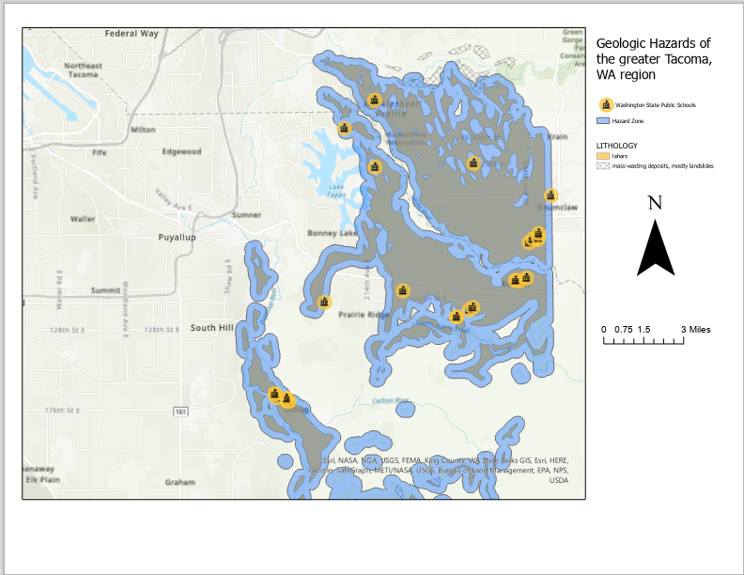

If you input none of the prompted options, you will receive an error:

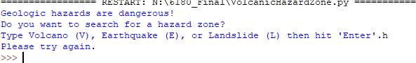

You will need to reload the script and run it again being sure to select the correct prompt.

**Errors**: Geologic units are finicky and will need to be joined with a description file before it can be properly used. Each region describes their lithology differently so look at the file description and change the where clauses accordingly. For example, the Mt. St. Helens volcanics description says pyroclastic flow and extrusive volcanics whereas my Tacoma data looks like basalt flows and flow breccias, Crescent Formation, lahars, volcaniclastic deposits or rocks. It’s something that a user would need to be aware of and change prior to running the script. It also needs to merge for all geologic hazards to create an accurate buffer.

**Citations**

bschneidK12. (2021, October 26). *Washington State Public Schools*. Arcgis.com. Retrieved December 5, 2022, from https://www.arcgis.com/home/item.html?id=23bbd746f9924c149681815cfd2a6300

*Digital Geologic Data for Washington*. Digital geologic data for Washington. (n.d.). Retrieved December 5, 2022, from https://wagda.lib.washington.edu/data/geography/wa_state/wageol/

Finding sum of values in field. Esri Community. (2021, December 11). Retrieved December 5, 2022, from https://community.esri.com/t5/python-questions/finding-sum-of-values-in-field/td-p/327617

Furze, A. J., Bard, J. A., Robinson, J., Ramsey, D. W., Kuntz, M. A., Rowley, P. D., & MacLeod, N. S. (2017, October 31). *Database for geologic maps of pyroclastic-flow and related deposits of the 1980 eruptions of Mount St. Helens, Washington*. Data Series. Retrieved December 5, 2022, from https://pubs.er.usgs.gov/publication/ds1054

Rees, written by E. van, Rees, E. van, & Eric van Rees Eric van Rees is a freelance writer and editor. His specialty is GIS technology. He has more than eight years of proven expertise in editing. (2021, June 3). *Using arcpy's SearchCursor for selecting and returning records*. RSS. Retrieved December 5, 2022, from https://geospatialtraining.com/using-arcpys-searchcursor-for-selecting-and-returning-records/

*USGS mineral resources on-line spatial data*. USGS Mineral Resources On-Line Spatial Data. Retrieved December 5, 2022, from https://mrdata.usgs.gov/