**CHAPTER-1**

**INTRODUCTION**

**INTRODUCTION:-**

**1.1 PROJECT SUMMARY**

The UniDoc System provides a means to the Residents of the country to identify themselves in various Governmental and Non-governmental Departments. The system will create central repository of residents which includes POA and POI with biometrics and it will further form a structure like a profile which includes documents like birth and death certificate, educational details, results, driving license, election card and so on. The system will provide a unique enrollment number to every residents through which every profile will be linked according to their relationships. The UniDoc system will provide E-kyc services to various governmental departments. It provides and an easy and efficient way to update and synchronize their data. It helps to increase consistency and reduce redundancy of data or documents among various governmental departments which results in reduced administrative overhead, time money and paper saving.

Personal Information

**1.2 PURPOSE**

The purpose is to provide a unique identity number to every people and make one profile instead of many and connect those profile based on blood relation. Also we can reduce duplication of data, forging, paper wasting and administrative overhead.

**1.3 Scope**

Project scope of UniDoc system focuses on to reduce paper work and administrative overhead. It will integrate and synchronize all the documents in one central repository and make it easily accessible, sharable and updatable to the residents it reduces complexity in procedure of issuing updating and managing documents and records of the residents with improvement of transparency and security. It will leads to the fully digitized paperless e governance.

**1.4 Objectives**

The project is desired to meet the following objective:

* Design an interactive front end to allow users to have idea about system.
* Make UniDoc System a unique identity and useful for multipurpose.
* User can save data and retrieve it easily in his/her profile.
* Admin can edit and update details as well as provide some constraints.
* Admin can also block users if required.

**1.5 Technology and Literature Review**

**JavaFX:**

**JavaFX** is a software platform for creating and delivering desktop applications, as well as set of rich applications that can run across a wide variety of devices on internet. **JavaFX** is invented to replace Swing which is used as standard GUI library for Java SE, but both will be included for the development of better design or GUI for the user interaction.

**My SQL server:**

**Microsoft SQL Server** is a relational database management system developed by Microsoft. As a database server, it is a software product with the primary function of storing and retrieving data as requested by other software applications which may run either on the same computer or on another computer across a network (including the Internet).

SQL Server includes better compression features, which also helps in improving scalability. It enhanced the indexing algorithms and introduced the notion of filtered indexes. It also includes *Resource Governor* that allows reserving resources for certain users or workflows. It also includes capabilities for transparent encryption of data (TDE) as well as compression of backups.

**SQLite:**

SQLite is a relational database management system. SQLite is not client-server database engine as many other database management system. It is attached in the end of the program.

**JSP:**

Java Server Pages (**JSP**) is a technology that helps software developers create dynamically generated web pages based on HTML, XML, or other document types. Released in 1999 by Sun Microsystems, **JSP** is similar to PHP and ASP, but it uses the Java programming language.

**Servlet:**

A Java **servlet** is a Java program that extends the capabilities of a server. Although **servlets** can respond to any types of requests, they most commonly implement applications hosted on Web servers. Such Web **servlets** are the Java counterpart to other dynamic Web content technologies such as PHP and ASP.NET.

**CHAPTER-2**

**PROJECT**

**MANAGEMENT**

**PROJECT MANAGEMENT**

The primary challenge of project management is to achieve all of the project goals within the given constraints. A systematic and disciplined approach is used by Project management to develop a software.

Project management activities include: initiating, planning, executing, controlling, and closing the [work](https://en.wikipedia.org/wiki/Work_(project_management)) of a [team](https://en.wikipedia.org/wiki/Project_team). This is done to achieve the specific goals and specific criteria.

**2.1 PROJECT PLANNING AND SCHEDULING**

**2.1.1 Model used**:

Based on the user’s objectives, we decided to use the Prototype model for the development of the system. The system to be implemented is a research and development project. Hence, it could not be done in one go. Hence this model has been adopted to meet the requirements accordingly. As far as duration is concerned it was very short and this model was appropriate for the same.

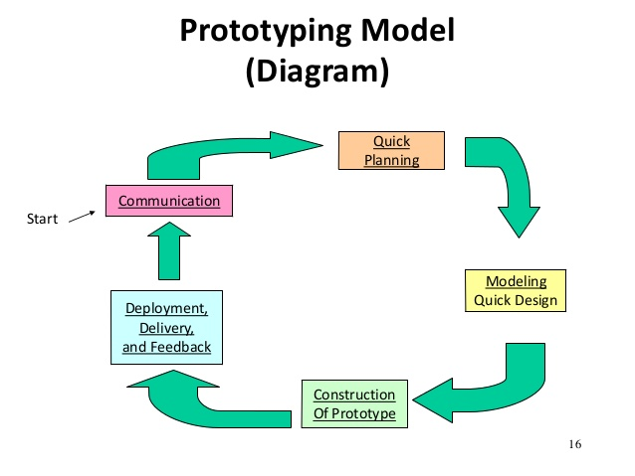

Fig. 2.1 Prototype Model

**2.2 PROJECT PLAN**

The most crucial part of a project is finding an appropriate domain. The observation part helped me in finding the problems and in the initial phase, the time was spent on surfing and identifying the problems deeply. Following is the plan of our project of 4 months:

|  |  |  |  |  |
| --- | --- | --- | --- | --- |
| Milestones Weeks | Week 1 | Week 2 | Week 3 | Week 4 |
| 1st Month | *Observation for finding some problem. | *Brain storming about the problem | *Again going for observation and interact with the people and some government offices. | * deciding with group members about the problem with their some relevant solution. |
| 2nd Month | *prior art search | *Study of the existing solution | *Study of the relevant technology | Making paper prototype |
| 3rd Month | Implementation of the registration module | Database learning and designing  Registration module | Implementation of the website  Patent searching | Database design modifications  registration module implementation |
| 4th Month | Implementation of the registration module | Implementation of the registration module | Connecting registration module to the database  OOAd Designing | OOAd Designing  Report Generation |

**2.3 Risk Management**

The objective of risk management is to ensure uncertainty doesn’t affect the venture. It includes identification, analyzing, prioritizing, and taking necessary actions. This followed by well co-ordination and management of resources. This is done by project manager and one must not neglect it for the endeavor.

**2.3.1. Risk Identification**

The type of risk must be recognized. As there can be requirement risks, estimation risks, people risks, technology risks, organizational risks, project risks, product risks etc.

**2.3.2. Risk Analysis**

In this phase each risk that has been identified earlier is considered one by one and the possibility or seriousness is judged or measured.

**2.3.3. Risk Planning**

Risk planning specifies strategies to manage the risk. The risk that have been analyzed earlier are now planned accordingly to manage them.

Requirement risk: All the requirements were comprehended properly and there will not be much changes in the requirements.

Technical risk: We have selected tools and technology in such a way that these risks are minimized.

**2.4 ESTIMATION**

**2.4.1 Cost Estimation**

Estimation of cost depends on initial implementation of UniDoc system. As there are 33 districts and 249 sub-districts. 25 high capacity servers will be needed for Gujarat only according to me. We can also use cloud storage to store data.

The requirement of servers will depend upon the population of the country and the number of states, districts in those states as well.

After implementation it will not require any further cost.

**2.4.2 Effort estimation**

Effort spent on this project is period of 4 months of this semester as shown in the above table of schedule.

**CHAPTER-3**

**SYSTEM**

**REQUIRMENT STUDY**

**3.0 SYSTEM REQUIREMENT STUDY**

**3.1 USER TRAITS**

Analyzing the traits of a user is one of the important task for any project. By doing so, we can clearly define and target our end users. Without knowing the user of the project one cannot proceed further because they are only the one to use it and project is meaningless if its user is not defined properly. With the help of this we can focus on the main features of the project as well based on user requirements.

We have categorized our customer segment into following:

1. Citizens
2. Rural
3. Urban
4. Lower class
5. Middle class
6. Upper class
7. Government and private bodies
8. Banks
9. Election Commission of India (ECI)
10. Passport Seva Kendra (PSK)
11. RTO
12. Income Tax Department (ITD)
13. Other service providers
14. Telecommunication companies
15. Electricity connection provider
16. Water connection provider
17. Gas connection provider
18. Educational institutes
19. Schools
20. Colleges
21. Training institutes

**Pre-requisite**

1. User should be familiar with operating computer system.
2. User must have registered with UniDoc System in order to access the services.

**The end user of the system are**

1. Admin
2. 2. Citizens

**3.2 HARDWARE AND SOFTWARE REQUIREMENTS**

**3.2.1 Hardware Requirements**

1. Personal Computers
2. Webcam
3. Iris Scanner
4. Fingerprint Scanner

**3.2.2 Software Requirements**

1. Platform: Java
2. Technology: JavaFX, HTML, CSS
3. Tools: NetBeans 8.0.1, Notepad++
4. Database : MySQL

**3.3 Constraints**

The system is designed to work in the environment of Microsoft as well as Linux. It is supported by any browser that we use in day to day life like Firefox, Chrome IE, and Edge.

**3.4 Assumption and Dependencies**

There should be proper connection between servers and the devices in the network.

Database will remain consistent.

There is dependence of database with the status of the person. If the person is dead then changes need to be made accordingly in the database.

Dependency lies between the government and the private bodies that need to access the data.

It is assumed that government will authorize schools and colleges and other bodies for registering and maintaining the data.

It is assumption that biometrics of a person will be regularly updated based on the users request.

**3.5 Safety and Security aspects**

Using Iris scanner and Fingerprint scanner will make the system more secure.

Registration number generator is made by using an algorithm such that registration number can’t be guessed easily and there will be almost no pattern between any two registration numbers.

OTP and DIGITAL SIGNATURE will play a vital role in terms of security.

A helpline number will also be provided so that if a person feels that its information is being accessed by a party then he/she can stop allowing them.

Only selected information will be allowed to access to the third party based on the approval of the citizen.

Time to time notification will be provided to user via SMS for each and every activity like: login, password change, allow/reject request, apply for a particular service, acceptance of the application request, issue solved or not, updates in the details of the person.

**CHAPTER-4 SYSTEM ANALYSIS**

**4.1 Study of current system**

We have studied various civil registry system that are exist right now. In that we have found the CRS of US and India are almost similar and have same functionality that we want. In India currently government of India have launched the Aadhaar card and Digital Locker under the UIDAI and Digital India mission. The Aadhaar repository is the world’s largest biometrics based civil registry system which assigns unique identification number for every residents of India. Currently as of September 5, 2016 there are 105 crore Aadhaar card holders in India. As we have studied the Aadhaar system thoroughly we have not found any problems with this system but we have found that we can further extend its capability by adding some extra features and modifying it without affecting current Aadhaar card system.

**4.2Limitations of the current system**

Current Indian civil registry system does not provide interlinking of the various governmental departments. So the duplicity and inconsistency occurs.

1. System not completely able to identify forged documents.
2. People still have to follow almost complex procedure to getting work done.
3. Sharing of documents is not easy.
4. Update on any detail in all the documents is not easy.

**4.3 Requirement of the system**

System requirement is the most important part of the developing new software system. We focused most of our observation time to gather system requirements by contacting, analyzing and conversation with the actual users of the system. As per our system we can categorize the users in wide range of user groups. All of them have their own needs and personal views. We tried our best to fit the common requirement that we gather from the wide range of customer segments.

We have categorized our system requirement in two parts

1. User requirements
2. Functional requirements

**4.3.1 User Requirements**

User requirements are the key inspirations to developing the new system over the existing system. Because in very first time the user feels the requirement of the system and then functional requirements come in pictures.

The user’s requirement study is carried out by physically going to the on field observation to the various governmental offices and by interacting with the people who come there. We also observed and feels our personal experience at the various governmental offices.

1. **Unified system interface**

Most of all the user recommended that the all the governmental departments should have the standard interface which can be understandable simple as much as possible. All the work should be compete at one cetin place or website.

1. **Easiness in sharing documents**

Current system have complex methods and requirements to share and verify the documents. It should be easy and convenient to all the people and provide some extent of flexibility and easiness to share the documents.

1. **Manage inconsistency and redundancy in documents**

In current system all the departments issue their own documents and verify all in their own manner. Their system store all the documents in its own servers and doesn’t have any mechanism to share the details of the residents to each other to reduce the redundancy in data.

**4.3.2 Functional Requirements**

User requirements are like the abstraction of the requirements that are the nonfunctional requirements of the system. By analyzing the nonfunctional requirements we are able to identify the some requirements that are not actually recommended by the users but for system run successful and satisfy all the user’s nonfunctional requirement it is necessary to be fulfil.

The functional requirements that we have identified are as follows.

* **Authentication**

UniDoc system have large segments of users so the authenticate all them and give authentication and authorization as per their role and responsibility is the most important.

* **Logging**

Very large amount of users will interact to the system daily. To track all the activity and for precaution to the any system failure recovery logging of the system is also necessary.

* **Duplicate registration detection**

It is the duty of the system to detect them any duplicate and redundant registration in the system and handle such type of actions.

* **Authorization levels**

UniDoc system have large segments of the users all the users should not access the all the data so the authorization level must be clearly define for all the users and system should provide impurity that any users can only access the data and perform task as per their authorization level.

* **Transaction corrections, adjustments and cancellations**

UniDoc System perform large amount of transactions every day and it is quite often that traction may be failed due to any resource reason and server or network problem. To handle all this type of transaction are canceled, revoked and failed should be managed in such a way that system can keep its consistent state.

**4.4 Feasibility study**

A feasibility study is carry out to objectively and rationally judge the strengths and weaknesses of the system. The feasibly study evaluates the project’s potential for success and give the major threats and cost estimation of the system. It gives a in detailed view of our systems requirement’s feasibility weather it is feasible or not. There are three study aspects in the feasibility study portion of the investigation.

A feasibility study is a short, focused study, which aims to answer a number of questions.

* Does the system contribute to the overall objectives of the society?
* Can the system be implemented using current technology and within given cost and schedule constrains.
* Can the system be integrated with systems which are already in place?

There are various types of feasibility studies.

1. Operational
2. Technical
3. Scheduling
4. Economical
   * 1. **Operational feasibility**

The factors concerned in it are:

* How well the solution will work in the organization and how the end-users and administrator feel about the system.
* This people oriented test measures the urgency of problem or the acceptability of a solution to find: Is the problem worth solving?
* Resource Monitoring System is very use full for the organizations, which have more employees and less resource. It is often performed with a working prototype of the proposed system. Test of system’s user interfaces and measured in how easy they are to learn and to use and how they support the desired productivity levels of Organization. Easy to learn and use with user satisfaction.
  + 1. **Technical feasibility**

The things we were concerned about were measure of practicability of a specific technical solution and availability of technical resources and expertise.

* Is the proposed technology or solution practical?
* We had to make sure that the chosen technology is known and easy enough to solve the problems.
* Do we currently possess the necessary technology?
* Technology would be infeasible and not practical if the organization cannot afford the technology.
* Do we possess the necessary technical expertise, and is the schedule reasonable?
* If there are not enough systems professionals who are familiar with the applied technology, learning curve for new system can influence the technical feasibility. It also can impact on the schedule.
  + 1. **Schedule Feasibility**

It is the measure of how reasonable the project timetable is. Schedule can be mandatory or desirable. It’s better to deliver a properly functioning information system later than to deliver an error-prone. The time we were given was at the maximum 2-3 months to give a robust application, which must be good on functions even if looks are compromised as the final images and color would be decided later while integrating the modules.

* + 1. **Economic feasibility**

Is the measure of cost-effectiveness of a project or solution?

As soon as specific requirements and solutions have been identified, the analyst can weigh the cost and benefits of each alternative cost-benefit analysis. We don’t have to worry about this aspect of feasibility.

Benefits expected from the system:

Benefits normally the system provide is to increase profits or decrease costs.

With the use of this project the intelligence of the student is can be determined. This is the main benefit. The performance and the preparation of the student can be measured using this system. This system is also improves the efficiency of the faculty members because this system is helping to dissolve the problem paper work.

**4.5 FEATURES OF NEW SYSTEM**

The features of the new system are so well behaved with some extra functionality:

* If person is died all his/ her services in respected governmental departments will be closed/ revoked / transferred.
* If an address of the person changed than if his /her family wants to update their address to than it can be updated via one click new update will be reflected in all the respected governmental departments.
* If the person change his / her name than it will be automatically reflected in all the respected departments and all the documents of his /her parents / son / wife /husband or whole family and where ever his account is linked.
* Older data like old address, name will be achieved for cross checking and record of proof.
* If person move temporarily to a new place than they can also register the temporary address.
* If court declare the person as criminal and wanted to caught them than all the services on his / her name will be blocked immediately and his name will be added in tracking list and whenever he /she use that any services through the UniDoc than he / she will be caught.
* The UniDoc Enrollment number can be used as an OpenID authentication.
* Digital signature will be used to remotely sign the documents.

**4.6 REQUIREMENTS VALIDATION**

This section is concerned with showing that the requirements actually define the system, which the customer wants. It was the most reliable feature as far the system IMS is concerned.

In addition to that, the system also has to provide security to the registered user such as administrator or simple user. And our system has to fulfill both the above-mentioned requirements and it has done it effectively.

Requirement validation examines the specification to ensure that all system requirements have been stated unambiguously; those inconsistencies, errors have been detected and corrected and the system is tested successfully and the work products confirm to the standard. Primary requirements validation mechanism is Formal Technical Review. Most of the questions (conducted in FTR) answers Related to Institute Management System is summarized in following statements:

* Source of the requirements are identified.
* Final statement of requirements has been examined by original source.
* Requirements are testable.
* Requirements related to main requirements are found.
* Requirements are clearly stated and not misinterpreted.
* All sources of requirements are covered to get maximum requirement.
* All methods of finding requirements are applied.
* Requirements are not duplicated and each of them gives distinct idea of processes within project.
* Requirements do not violate any domain constraints.
* Requirements associated with system performance, behavior and operational characteristics are clearly stated and understood.

**4.7 Context Diagram**

The context diagram defines the high level overview of the system. It specifies the boundary of the system. How the system interacts with the environments and its shows the logical interactions of the high level entities of the system.

We have made the context diagram of the UniDoc system with respect to four major entities that are

* Residents
* Enrollment agency
* Government / Administrators
* E-kyc Provider

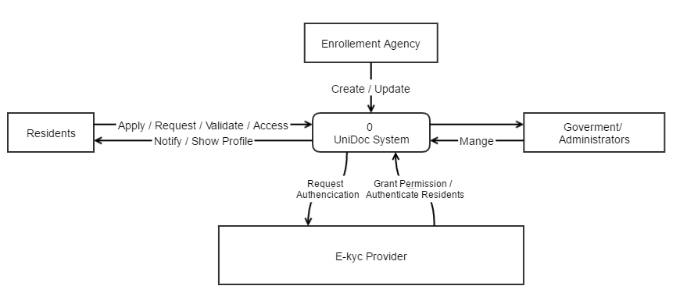

Fig. 4.1 Context Diagram

**4.8 Data Flow Diagram**

**4.8.1 Enrollment process DFD**

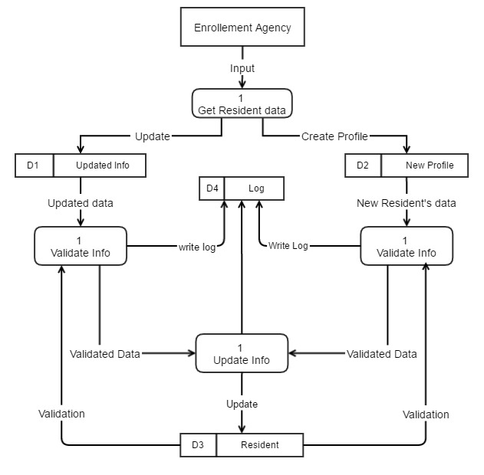

Fig 4.2 Level-1 DFD of Enrollment Process

* + 1. **DFD of e-kyc Provider and Residents**

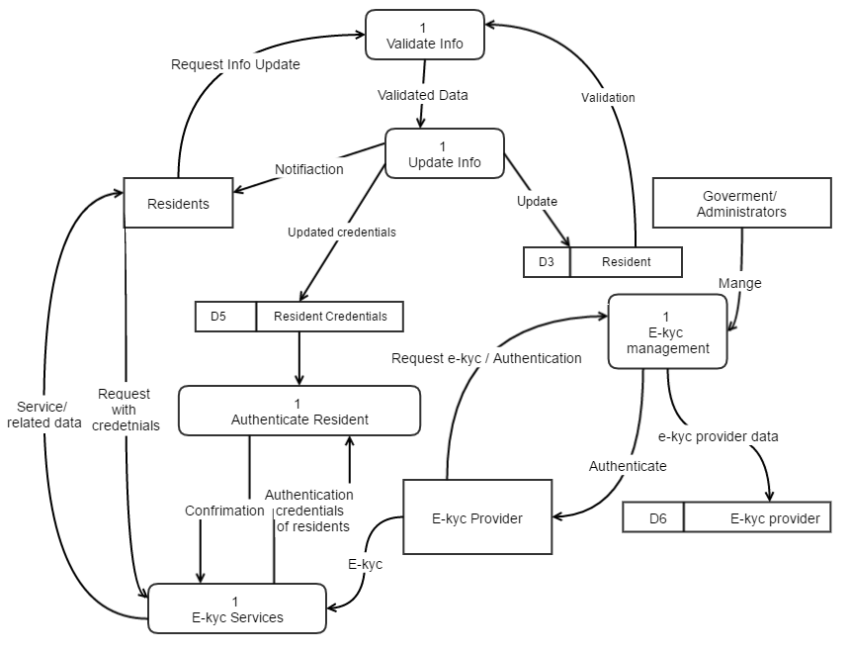

Fig 4.3 Level-1 DFD of E-kyc Providers and Residents

**4.9 Use Case Diagram**

**4.9.1 Use case of Residents**

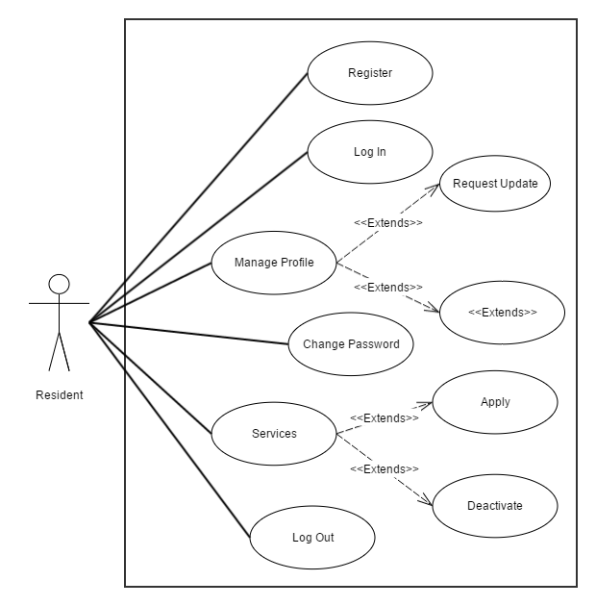

Fig 4.4 Use case of residents

**4.9.2 Use Case for E-kyc providers**

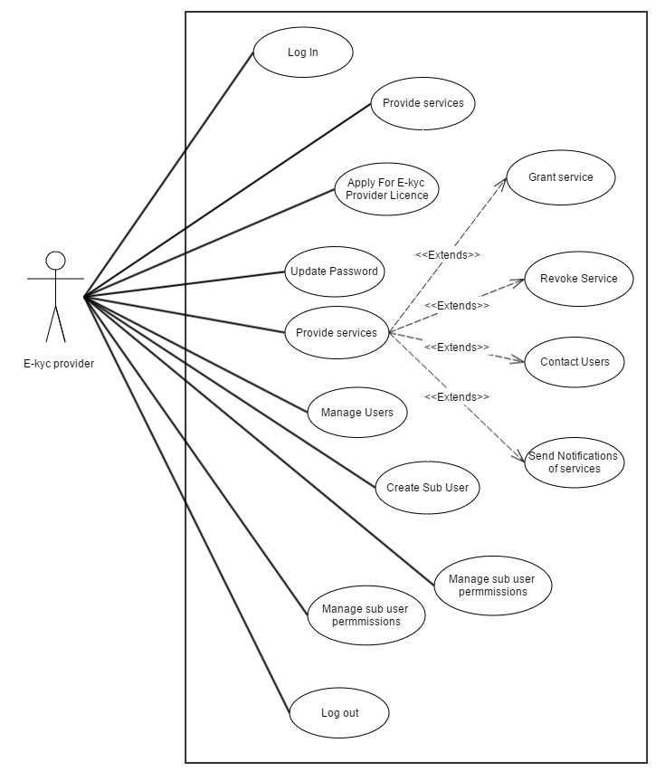

Fig 4.5 Use Case of e-kyc providers

**4.9.3 Use Case for the System**

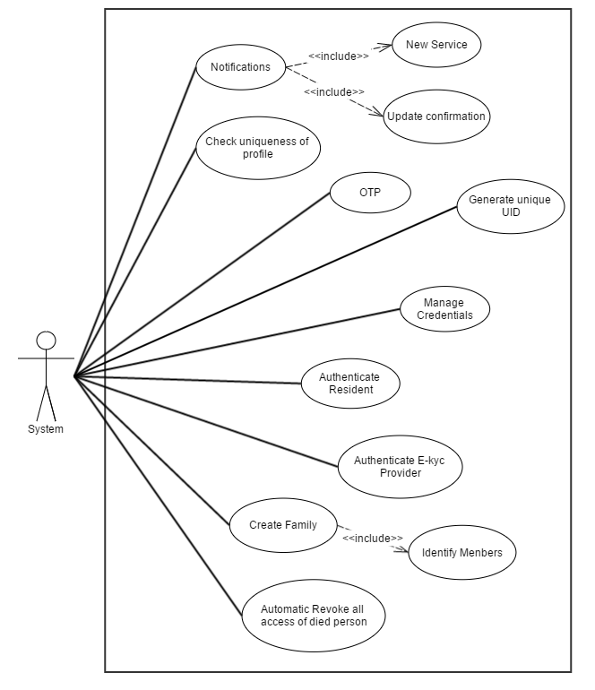

Fig 4.6 Use case for the system

**CHAPTER-5 SYSTEM** **DESIGN**

**5.1 Database Design**

**5.1.1 Table Diagram**

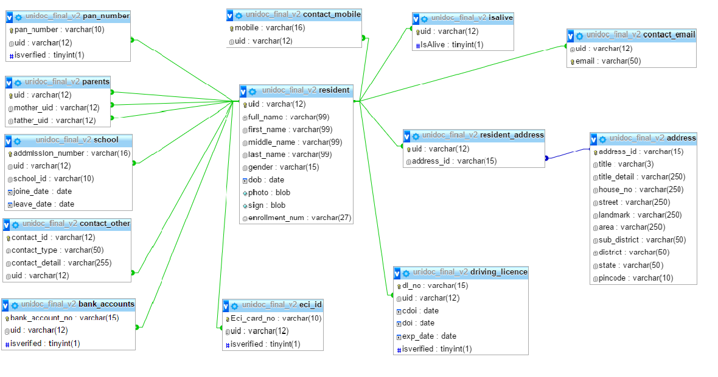

Fig 5.1 Table diagram

**5.1.2 Table Structure**

**1. Resident**

|  |  |  |
| --- | --- | --- |
| **Attribute Name** | **Datatype** | **Constraint** |
| Uid | Varchar(12) | Primary Key |
| full_name | Varchar(50) |  |
| First_name | Varchar(50) | Not Null |
| middle_name | Varchar(50) |  |
| last_name | Varchar(50) | Not null |
| Gender | Varchar(5) |  |
| Dob | date |  |
| photo | blob |  |
| Sign | blob |  |
| Enrollment_number | Varchar(27) | Foreign Key |

**2. Address**

|  |  |  |
| --- | --- | --- |
| **Attribute Name** | **Datatype** | **Constraint** |
| address_id | Varchar(15) | Primary Key |
| Title | Varchar(3) |  |
| title_detail | Varchar(100) |  |
| house_no | Varchar(50) |  |
| street | Varchar(250) |  |
| landmark | Varchar(250) |  |
| Area | Varchar(250) |  |
| sub_district | Varchar(50) |  |
| district | Varchar(50) |  |
| state | Varchar(50) |  |
| pincode | Varchar(8) |  |

**3. Bank Account**

|  |  |  |
| --- | --- | --- |
| **Attribute Name** | **Datatype** | **Constraint** |
| account number | Varchar(15) | Primary Key |
| Uid | Varchar(12) | Foreign key |
| is verified | tinyint(1) | Not null |

**4. Contact_Email**

|  |  |  |
| --- | --- | --- |
| **Attribute Name** | **Datatype** | **Constraint** |
| Email | Varchar(100) | Primary Key |
| Uid | Varchar(12) | Foreign key |

**5. Contact_Mobile**

|  |  |  |
| --- | --- | --- |
| **Attribute Name** | **Datatype** | **Constraint** |
| Mobile | Varchar(17) | Primary key |
| Uid | Varchar(12) | Foreign key |

**6. Contact_Other**

|  |  |  |
| --- | --- | --- |
| **Attribute Name** | **Datatype** | **Constraint** |
| contact_id | Varchar(12) | Primary key |
| Uid | Varchar(12) | Foreign key |
| contact_type | Varchar(12) |  |
| contat_detail | Varchar(250) |  |

**7. Driving License**

|  |  |  |
| --- | --- | --- |
| **Attribute Name** | **Datatype** | **Constraint** |
| Dlno | Varchar(15) | Primary key |
| Uid | Varchar(12) | Foreign key |
| Cdoi | Date | Not Null |
| Doi | Date | Not Null |
| exp_date | Date | Not Null |
| Isverified | Tinyint(1) | Not Null |

**8. Eci Id**

|  |  |  |
| --- | --- | --- |
| **Attribute Name** | **Datatype** | **Constraint** |
| Eci_numer | Varchar(10) | Primary key |
| Uid | Varchar(12) | Foreign key |
| Isverified | Tinyint(1) | Not Null |

**9. is alive**

|  |  |  |
| --- | --- | --- |
| **Attribute Name** | **Datatype** | **Constraint** |
| Uid | Varchar(12) | Foreign key |
| Isalive | Tinyint(1) | Not Null |

**10. Pan number**

|  |  |  |
| --- | --- | --- |
| **Attribute Name** | **Datatype** | **Constraint** |
| pan_numer | Varchar(10) | Primary key |
| Uid | Varchar(12) | Foreign key |
| isverified | Tinyint(1) | Not Null |

**11. Parents**

|  |  |  |
| --- | --- | --- |
| **Attribute Name** | **Datatype** | **Constraint** |
| Uid | Varchar(12) | Primary key |
| uid_mother | Varchar(12) | Foreign key |
| uid_father | Varchar(12) | Foreign key |

**12. Resident_Address**

|  |  |  |
| --- | --- | --- |
| **Attribute Name** | **Datatype** | **Constraint** |
| Uid | Varchar(12) | Foreign key |
| Address_id | Varchar(15) | Foreign key |

**13. School**

|  |  |  |
| --- | --- | --- |
| **Attribute Name** | **Datatype** | **Constraint** |
| admission_number | Varchar(16) | Primary key |
| Uid | Varchar(12) | Foreign key |
| school_id | Varchar(10) |  |
| Join_date | date |  |
| Leave_date | date |  |

**5.2 Project Logo**

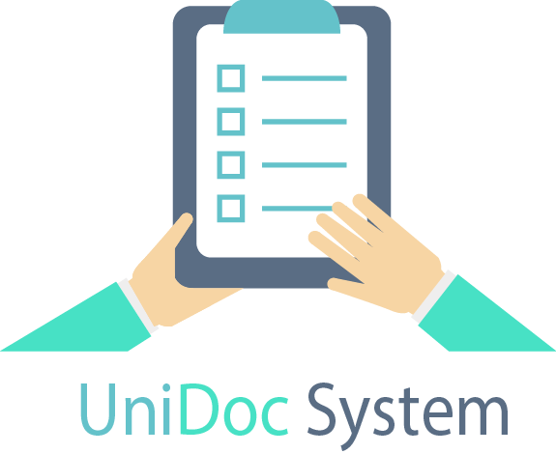

Fig 5.2 UniDoc System logo

**5.3 Interface Design**

**5.3.1 Registration module**

**1. Splash Screen**

While loadingregistration module splash screen including UniDoc system logo will be shown for 5 seconds.

It will automatically redirects to the Login Screen.

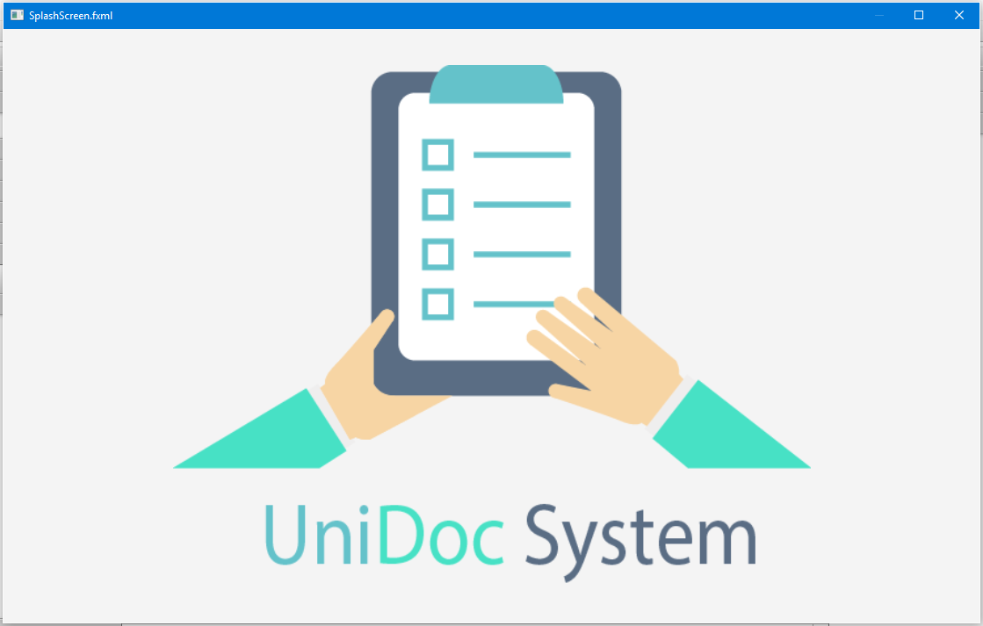

Fig 5.3 Splash screen

**2. Log in Screen**

In this window the user will login by his /her credentials and it will redirects to the operation window.

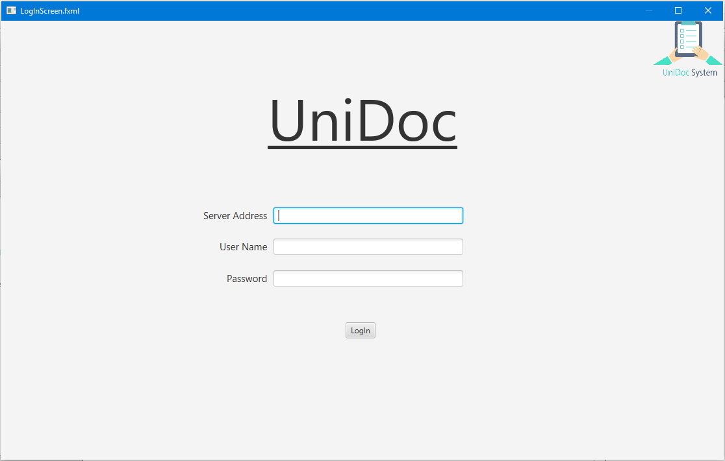

Fig 5.4 Log in screen

1. **Operational window**

From this window user choose which operation he / she want to perform. By selecting new registration it will redirects to the POI entry form.

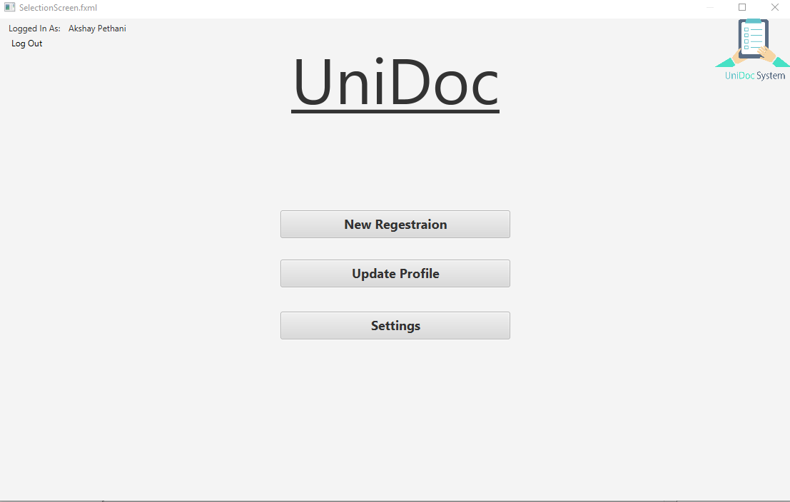

Fig 5.5 Operational window

1. **POI Form**

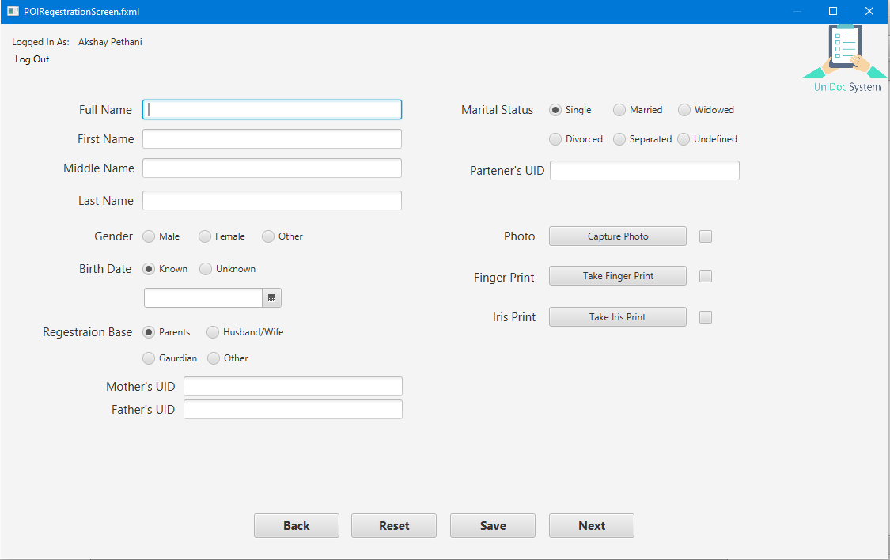

Fig 5.6 POI form

**5. POA Form**

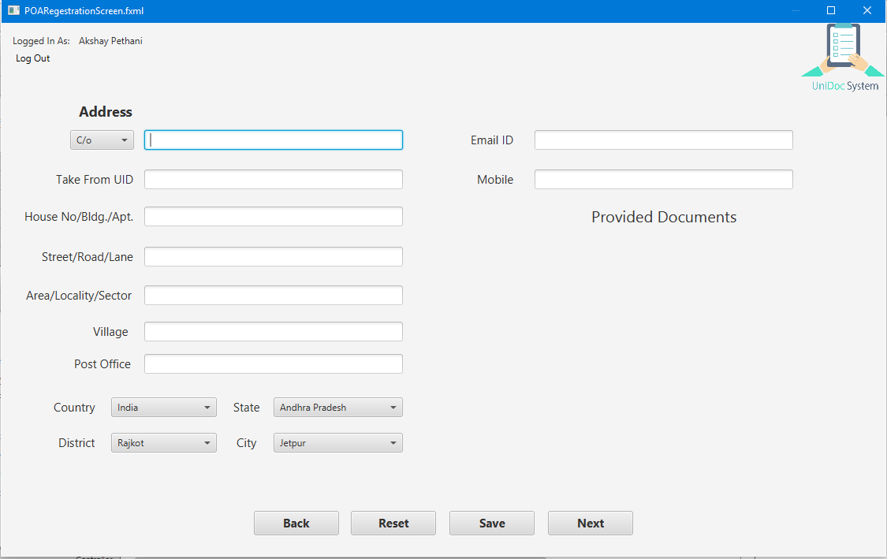

Fig 5.7 POA form