Instructions

On frp_identity, client.lua

Comment the yellow lines on **Destroy** function:

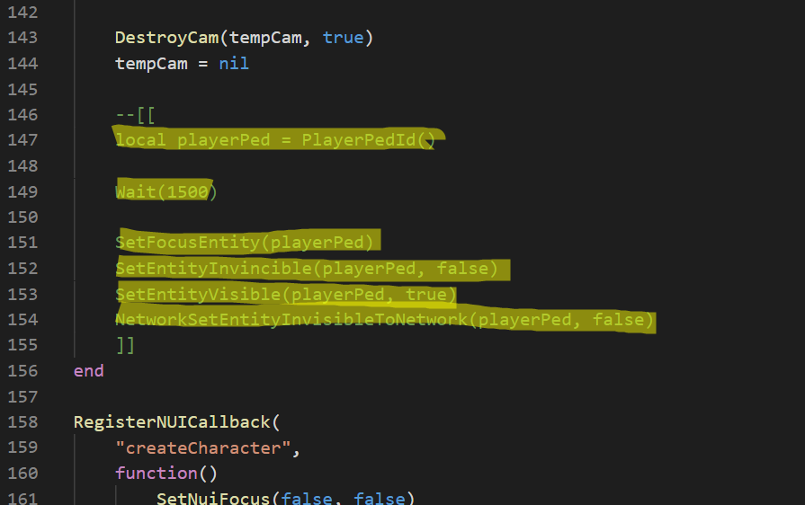

Comment yellow lines on **spawnCharacterSelected** and add the line

*TriggerServerEvent("FRP:LOGIN:LoginMenu", charId)*

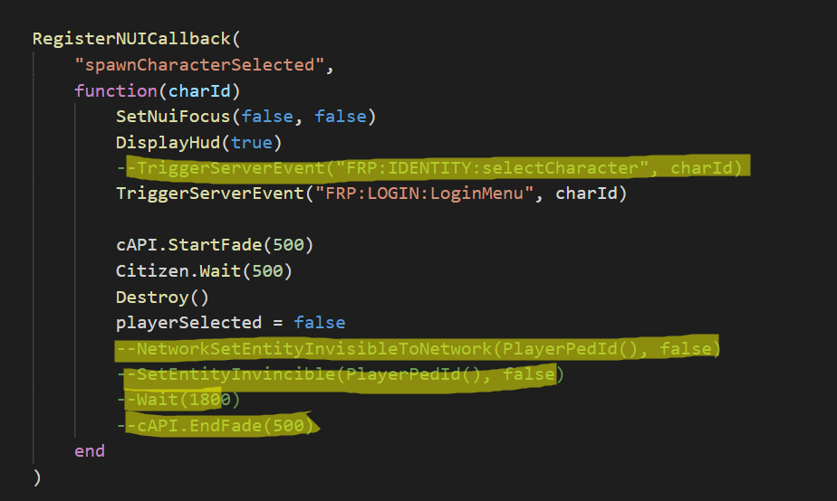

On _core > server > class, User.lua add those lines

*self.setCharacterData = function(this, cid, targetName, key, value)*

*API_Database.query("FCRP/SetCData", {target = targetName, key = key, value = value, charid = cid})*

*end*

*self.getCharacterData = function(this, cid, targetName, key)*

*if key == nil then*

*key = "all"*

*end*

*local rows = API_Database.query("FCRP/GetCData", {target = targetName, charid = cid, key = key})*

*if #rows > 0 then*

*return json.decode(rows[1].Value)*

*else*

*return ""*

*end*

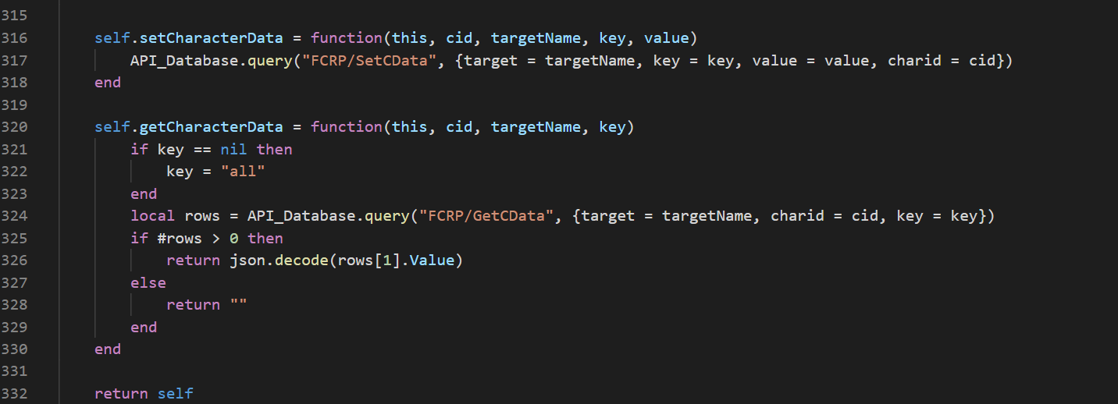

Add frp_login and cal on server.cfg

ensure frp_login