CBA Course Scheduling System v2

Software Development &

Design Document

16 January 2019

|  |  |
| --- | --- |
|  | Team: 2  Peter Nguyen  Joe Cassidy  Rankin Dam  Jordan Lawson |
|  |  |
|  |  |
|  | Chlotia Posey Garrison, PhD  CSCI 475 |
|  |  |
|  | ___________________________________  Date Appendix (Req) Presented to Customer |
|  |  |
|  |  |
|  | ____________________________________  Date UI Presented to Customer |
|  |  |
|  |  |
|  | ___________________________________  Date Feedback Received from Customer |
|  |  |
|  |  |
|  | Notes: |

# Contents

Contents 2

Introduction 3

1.1 Purpose of the system 3

1.2 Design Goals 3

1.3 References 3

2. User Requirements 4

3. System Requirements Specification 8

3.1 User Characteristics 8

3.2 Functional Requirements 8

3.3 Non-Functional Requirements 11

4. Design Decisions 12

4.1 Administration Panel 12

4.2 Reading 13

4.3 Creating and Updating 14

4.3.1 Invalid inputs 15

4.4 Calendar View 15

4.5 Algorithms/Rules 15

5. Access Control and Security Decisions 16

5.1 Access Control Matrix 16

5.2 Security Decisions 17

6. Architectural/Detailed Design 18

6.1 Overview 18

6.2 Subsystem Decomposition 18

6.3 Persistent data management 20

6.4 Site Navigation 21

7. Requirements Traceability Matrix 21

8. Glossary 22

# Introduction

### Purpose of the system

This system shall provide a replacement for the College of Business Administration’s (CBA) current scheduling tool. The current system is a 12-year-old semi-automated course scheduling system with manual processing. A large amount of the current system’s original functionality is broken due to web browser updates. Furthermore, the current system assumes many nonexistent restrictions on course schedules and available rooms.

The replacement system will minimally maintain the current system’s functionality. The manual process of exporting the schedule for the Scheduling Coordinator of Winthrop University to obtain revisions, and the manual conflict resolution process will be maintained.

The system will be used by CBA Department Chairs and the Associate Dean in order to simplify and streamline the course scheduling process for future terms. The system shall maintain a working course schedule and archive previous terms’ schedules. The system shall also maintain a list of available rooms and their associated capacities. The schedules, rooms, and capacities will be used to determine course schedule conflicts and maximum course capacity. The system will also be able to export a term’s schedule as an Excel spreadsheet.

### Design Goals

The system shall be reliable, modifiable, maintainable, and understandable. As stated in Section 1.1, the current system has been in use for at least 12 years. Thus, the replacement system must maintainable for a similar duration.

To aid in maintainability, the system should be easily modifiable. The previous system has been modified by Dr. Stephen Dannelly and it shall be assumed that the replacement system will be modified within its lifespan.

The system shall be reliable and should not suffer from errors due to browser updates over the next 10 years. The system should not crash or display unexpected behavior.

The system shall be understandable, requiring little training.

### References

The requirements in this document are modifications of the requirements stated in the *Requirements Specification*. These requirements have been formed from user interviews and feedback. The existing system is hosted on the Winthrop domain under the CBA section. This system must create a spreadsheet that contains the information needed for Winthrop’s scheduling software, Ellucian Banner. Section 7, Requirements Traceability Matrix, is an external document.

## User Requirements

* Users will be able to log into the system using their Winthrop University credentials.
  + **Inputs:**
    - Username
    - Password
  + Only whitelisted users will be able to login with their Winthrop credentials.
  + There will be three types of users: Department Chairs, Associate Dean, and System Administrator.
* The System Administrator will be able to access all functionalities of the system.
* The System Administrator will be able to add and remove users to the whitelist.
  + **Inputs:**
    - Username
* The System Administrator will be able to create and delete user groups.
  + **Inputs:**
    - Group name
* The System Administrator will be able to add and remove users from groups.
  + **Inputs:**
    - Username
    - Group name
* The System Administrator will be able to assign permissions to groups.
  + **Inputs:**
    - Group
    - Permissions
* Users without a group cannot access any information.
* The Associate Dean will be able to create and delete departments.
  + **Inputs:**
    - Department code (e.g. ACFN)
    - Department name (e.g. Accounting, Finance, and Economics)
  + Departments cannot be deleted if associated to courses.
* The Associate Dean will be able to assign users to departments.
  + **Inputs:**
    - Department
    - Users
* The Associate Dean will be able to create/update/delete buildings.
  + **Inputs:**
    - Building code (e.g. THUR)
    - Building name (e.g. Thurmond Hall)
    - Is enabled
  + Buildings cannot be deleted if associated to any course section.
* The Associate Dean will be able to create and delete room capabilities.
  + **Inputs:**
    - Name
  + Rooms capabilities cannot be deleted if associated to any room.
* The Associate Dean will be able to create/update/delete rooms for buildings.
  + **Inputs:**
    - Building
    - Room number
    - Capacity
    - Room Capabilities
    - Is enabled
  + Rooms cannot be deleted if associated to any course section.
* The Associate Dean will be able to create, delete, and archive terms.
  + **Inputs:**
    - Name
    - Is editable
  + A dialog should appear to confirm deletion of a term.
* The Associate Dean will be able to create/update/delete parts of terms. (e.g. Full Term, First Half, Second Half)
  + **Inputs:**
    - Name
    - Is enabled
  + Parts of terms cannot be deleted if assigned to a term.
* The Associate Dean will be able to assign parts of terms to terms and set a date range.
  + **Inputs:**
    - Term
    - Part of Term
    - Start date
    - End date
* The Associate Dean will be able to to set available time slots according to weekday.
  + **Inputs:**
    - Weekday
    - Start time
    - End time
* The Associate Dean will be able to create or delete instructional methods.
  + **Inputs:**
    - Instructional method name
    - Is room required
  + Instructional methods assigned to course sections cannot be deleted.
* The Associate Dean will be able to restrict courses from being scheduled at the same time.
  + **Input:**
    - Two courses
* The Associate Dean will be able to export and import term schedules as/from Excel spreadsheets.
* The Associate Dean and Department Chairs will be able to create and delete course schedule types.
  + **Input:**
    - Name
  + Schedule types assigned to courses cannot be deleted.
* The Associate Dean and Department Chairs will be able to create and delete course attributes.
  + **Input:**
    - Nname
  + Course attributes assigned to courses cannot be deleted.
* Department Chairs will be able to create/update/delete instructors.
  + **Inputs:**
    - First name
    - Middle name (optional)
    - Last name
    - Is active
  + Instructors associated to any term’s schedule cannot be deleted.
  + Instructors may be marked as inactive.
* Department Chairs will be able to create/update/delete courses.
  + **Inputs:**
    - Department (auto-filled with user’s department)
    - Subject
    - Course level (Graduate or Undergraduate)
    - Course title
    - Credit hours
    - Schedule types
    - Global attributes
  + Courses with course sections cannot be deleted.
* Department Chairs will be able to create/update/delete course sections for terms.
  + **Input:**
    - Term (from previous entry)
    - Course
    - Instructional Method
    - Part of Term
    - Instructors (dropdown, inactive instructors are not shown)
    - Rooms (if applicable)
    - Days of Week (combination of M, T, W, R, F, S, U) (if applicable),
    - Time (if applicable)
    - Additional attributes
    - Course Reference Number (CRN) (optional)
  + Users will be able to search for rooms based on room requirements.
* Department Chairs and Associate Dean will be able to view a term’s schedule.
  + The schedule may be viewed as a calendar or in list form.
  + Course sections may be filtered by fields of a course section.
  + Department Chairs will be able to view only their departments’ courses.
  + Courses may be filtered to show only courses with conflicts or missing information.
  + Scheduling conflicts will be highlighted.
* Users will be able to view all courses an instructor has taught.
* Users will be able to view all instructors that have taught a course.
* The Associate Dean and Department Chairs will be able to view a list of changes made by each user.
* The Associate Dean and Department Chairs will be able to create and delete subjects.
  + **Input:**
    - Name
  + Subjects assigned to courses cannot be deleted.

## System Requirements Specification

### User Characteristics

All users will be Winthrop CBA faculty. Therefore, users will be familiar with general campus knowledge and policies, the campus course registration system, and instructors.

End-product users will be the CBA Associate Dean and Department Chairs. These users will have higher education degrees and will have experience with course requirements and organization.

The maintainers of the system will be future computer science students of Winthrop University and the Department Chair of Computer Science. The Department Chair of Computer Science will have extensive experience with software development and will have experience with scheduling courses. Computer science students will have some software development experience and will have experience with course schedules through course registrations.

### Functional Requirements

* + 1. Users must be able to log into the system using their Winthrop University credentials.
       1. Users must enter their username and password.
       2. Only whitelisted users will be able to login with their Winthrop credentials.
    2. There must be three types of users: Department Chairs, Associate Dean, and System Administrator.
    3. The System Administrator must be able to access all functionalities of the system.
    4. The System Administrator must be able to add and remove users to the system whitelist.
       1. Users require a username.
    5. The System Administrator must be able to create and delete user groups.
       1. Groups require a group name.
    6. The System Administrator must be able to add and remove users from groups.
    7. The System Administrator must be able to assign permissions to groups.
    8. Users without a group cannot access any information.
    9. The Associate Dean must be able to create and delete departments.
       1. Departments require a code (e.g. ACFN) and a name (e.g. Accounting, Finance, and Economics)
       2. Departments cannot be deleted if associated to courses.
    10. The Associate Dean must be able to assign users to departments.
    11. The Associate Dean must be able to create/update/delete buildings.
        1. Buildings require a building code (e.g. THUR) and building name (e.g. Thurmond Hall)
        2. Buildings may be enabled/disabled.
        3. Buildings cannot be deleted if associated to any course section.
    12. The Associate Dean must be able to create and delete room capabilities.
        1. A room capability consists of only a name.
        2. A room capability cannot be deleted if added to a room.
    13. The Associate Dean must be able to create/update/delete rooms for buildings.
        1. A room requires a building, room number, and capacity.
        2. Capabilities may be added and/or removed.
        3. A room may be enabled/disabled.
        4. Rooms cannot be deleted if associated to any course section.
    14. The Associate Dean must be able to create/delete/archive terms.
        1. A term requires only a name.
        2. An archived term may not be modified.
        3. A confirmation dialog requiring the user to type the name of the term must be displayed to delete a term.
    15. The Associate Dean must be able to create/update/delete Parts of Terms.
        1. A Part of Term require a name.
        2. A Part of Term may be enabled/disabled.
        3. Parts of terms cannot be deleted if in use by a course section.
    16. The Associate Dean must be able to add Parts of Terms to Terms.
        1. Disabled Parts of Terms cannot be added to Terms.
        2. A start and end date must be associated to the Part of Term.
    17. The Associate Dean must be able to to set available time slots according to weekday for a term.
        1. A time slot must belong to a term.
        2. A time slot must have a weekday, start time, and end time.
        3. Weekdays must be formated as Monday (M), Tuesday (T), Wednesday (W), Thursday (R), Friday (F), Saturday (S), Sunday (U)
    18. The Associate Dean must be able to create or delete instructional methods.
        1. An instructional method must have a name.
        2. An instructional method may not require a course section to have a room.
    19. The Associate Dean must be able to restrict courses from being scheduled at the same time.
    20. The Associate Dean must be able to export and import term schedules as/from Excel spreadsheets.
        1. The spreadsheet must have the following columns for exporting and importing:
  + Course
  + Section
  + CRN
  + Credit Hours
  + Course Title
  + Instructor
  + Instructional Method
  + Schedule Type
  + College
  + Department
  + Location
  + Time
  + Days
  + Max
  + Enrolled
  + Room
  + Part of Term
  + Session Start
  + Session End
    1. The Associate Dean and Department Chairs will be able to create and delete course schedule types (e.g. Lecture, Thesis, …).
       1. Schedule Types require only a name.
       2. Schedule Types assigned to courses cannot be deleted.
    2. The Associate Dean and Department Chairs will be able to create and delete course attributes.
       1. Course attributes require only a name.
       2. Attributes assigned to courses or course sections cannot be deleted.
    3. Department Chairs must be able to create/update/delete instructors.
       1. An instructor must have a first name and last name
       2. A middle name is optional.
       3. Instructors may be marked as inactive.
       4. Instructors associated to any term’s schedule cannot be deleted.
    4. Department Chairs must be able to create/update/delete courses.
       1. The course requires a department, subject, course level, course title, and credit hours.
       2. The course level must be Graduate or Undergraduate.
       3. Schedule types and course attributes may be added or removed.
       4. The course department must be auto-filled with user’s department.
       5. Courses with course sections cannot be deleted.
    5. Department Chairs must be able to create/update/delete course sections for terms.
       1. A course section requires a term, course, instructional method, part of term, and instructors.
       2. Inactive instructors must be hidden.
       3. If the instructional method requires a location, the section must also have: days of week and time.
       4. Additional course attributes may be added or removed.
       5. A section may optionally have a course reference number.
       6. Rooms may be filtered by room requirements.
    6. Department Chairs and Associate Dean must be able to view a term’s schedule.
       1. The schedule may be viewed as a calendar or in list form.
       2. Course sections may be filtered by fields of a course section.
       3. Department Chairs will be able to view only their departments’ courses.
       4. Courses may be filtered to show only courses with conflicts or missing information.
       5. Scheduling conflicts will be highlighted.
    7. Users will be able to view all courses an instructor has taught.
    8. Users will be able to view all instructors that have taught a course.
    9. The system must keep an audit log of all changes to models.
    10. The Associate Dean and Department Chairs will be able to view a list of changes made by each user.
    11. The Associate Dean and Department Chairs will be able to create and delete subjects.
        1. Subjects require only a name.
        2. Subjects assigned to courses cannot be deleted.

### Non-Functional Requirements

* + 1. The system must be a .NET Core web application.
    2. The system must require little to no user training.
    3. The database shall be automatically backed up daily with a 7-day retention.
    4. The system must be maintainable for at least 10 years.
       1. The system must be easily modifiable.
       2. The system must be flexible.
       3. The system must be well documented.
    5. The system must be completed by the end of April 2019.
    6. The system must use a MSSQL database.
    7. The system must authenticate with Winthrop’s ADFS.

## Design Decisions

The system will provide a web-based interface to meet the requirements layed forth in Sections 2 and 3.

### Administration Panel

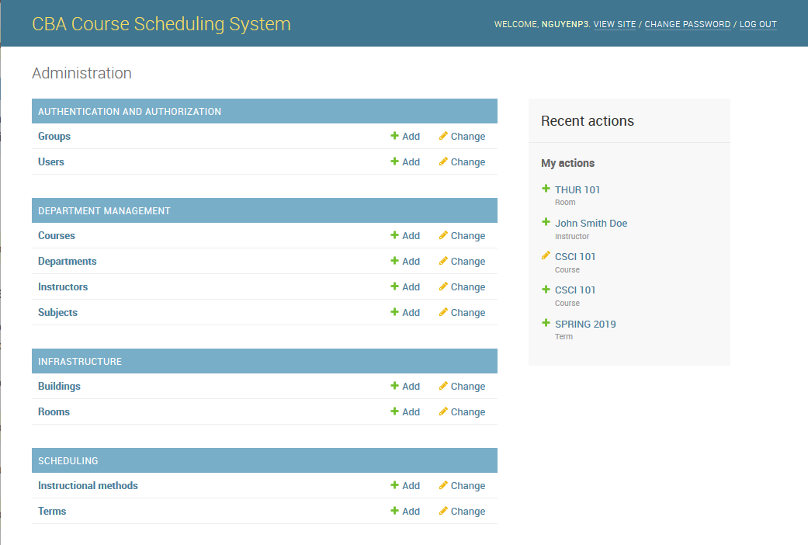

Figure 1

After logging in, the user will be shown the administration panel shown in Figure 1. The administration panel provides an interface to create/read/update/destroy entities listed in the requirements. The index page allows users to view all possible entities that can be edited. A sidebar shows recent actions and acts as a minor audit log.

The administration panel is mostly reflects the entities defined in the ER diagram in Section 6.3.

### Reading

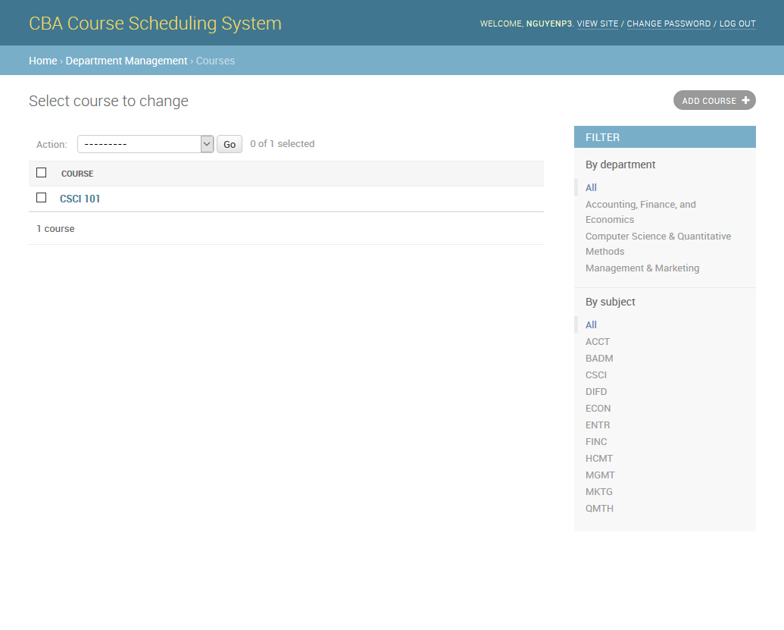

Figure 2

Figure 2 shows an interface used to display a list of courses. The interface provides users the ability to filter items. The administration interface can also provide users with text search/filtering, column sorting, and bulk actions.

### Creating and Updating

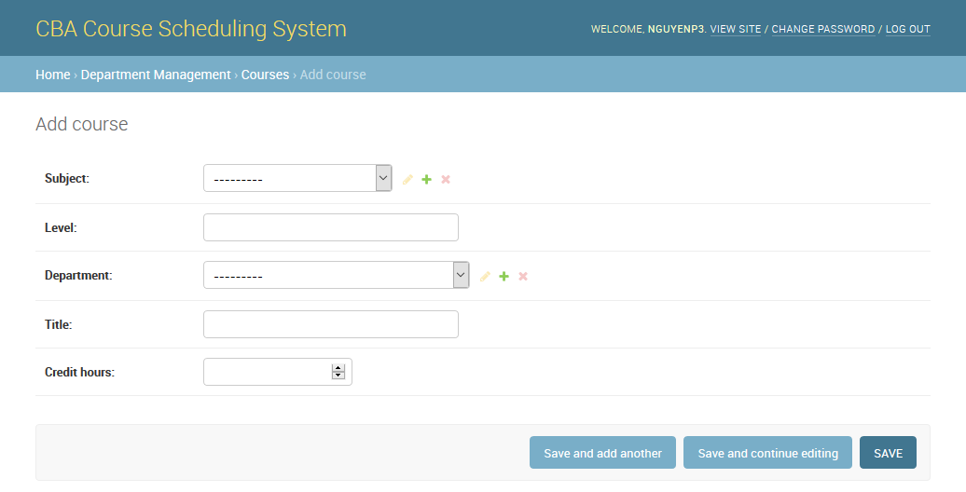

Figure 3

Figure 3 shows the interface used to create a course. The interface for updating a course is identical except for the page title. Fields that relate to other objects have three buttons next to the fields which allow the user to edit, create, or delete the related object. Bold field names notify the user that the field is required. The form allows users to rapidly create multiple courses by providing a “Save and add another” button.

### Invalid inputs

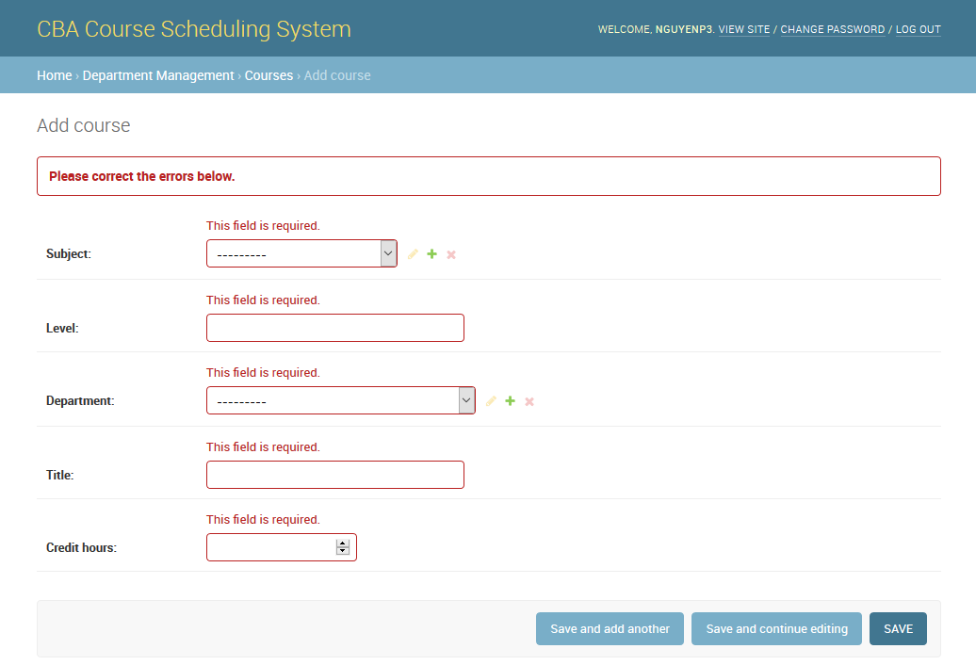

Figure 4

Invalid inputs or conditions result in an overall error notification and individual notifications for each field. The result of attempting to submit the form shown in Figure 3 with invalid input is shown in Figure 4.

### Calendar View

A calendar view will be available to view scheduled course sections for a term. The view will allow users to more easily view and correct time conflicts.

### Algorithms/Rules

#### 4.5.1 Course Scheduling

Scheduled courses conflict if more than one course has the same room, date, and time slot. Scheduled courses will also conflict if the same instructor assigned to multiple courses at the same date and time. Additional constraints based on course identifiers may be added. Course sections will display an error if the instructional method requires a room and the section does not have a room.

#### 4.5.1 Spreadsheet Importing

Course sections will be attempted to be found by CRN first. If no section with the CRN exists, the system will attempt to find a section with the same course and section number. If a course section is found, the differing field values will be noted to the user. If the course section does not exist, the new section and its values will be noted to the user. The user will verify the changes and must confirm the changes.

## Access Control and Security Decisions

### Access Control Matrix

C = Create, R = Read, U = Update, D = Delete

|  |  |  |  |
| --- | --- | --- | --- |
|  | System Administrator | Associate Dean | Department Chair |
| Users | CRUD | R | R |
| Groups | CRUD | R | R |
| Permissions | CRUD | R | R |
| Departments | CRUD | CRUD | R |
| Subjects | CRUD | CRUD | CRUD |
| Schedule Types | CRUD | CRUD | CRUD |
| Course Attributes | CRUD | CRUD | CRUD |
| Courses | CRUD | CRUD | CR  Can only update and delete department courses. |
| Instructors | CRUD | CRUD | CRUD |
| Terms | CRUD | CRUD | R |
| Parts of Terms | CRUD | CRUD | R |
| Time Slots | CRUD | CRUD | R |
| Building | CRUD | CRUD | R |
| Rooms | CRUD | CRUD | R |
| Room Capabilities | CRUD | CRUD | R |
| Instructional Method | CRUD | CRUD | R |
| Course Sections | CRUD | R | CR  Can only update and delete sections of department courses. |
| Export Spreadsheet | Yes | Yes | Yes |
| Import Spreadsheet | Yes | Yes | No |

### Security Decisions

Authentification will be done against Winthrop’s authentication system. The course scheduling system will not store users’ passwords, minimizing the impact of a security breach. The website will be accessed via HTTPS preventing interception of sensitive data.

Access to the system will be minimized by requiring Winthrop users to be whitelisted. Furthermore, only the System Administrator may whitelist users. This may be modified via user permissions.

## Architectural/Detailed Design

### Overview

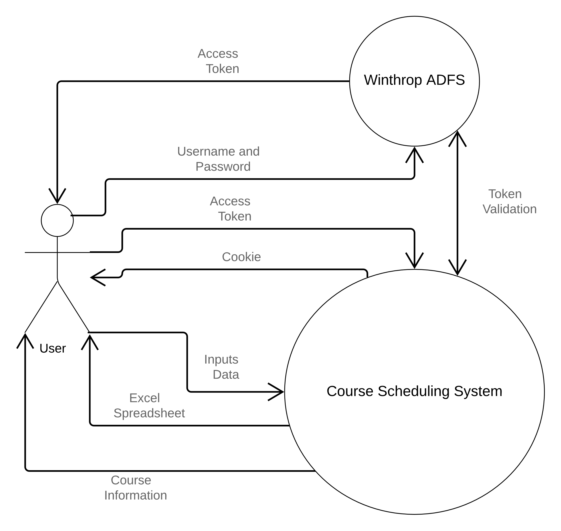

Figure 5

### Users will authenticate using Winthrop’s ADFS server by providing their username and password. The Course Scheduling System will interface with the ADFS server to authenticate the user for the system. The system will provide users with course, infrastructure, and scheduling information. Users will be able to input data to create, update, or delete this information. The system will also be able to provide an excel spreadsheet to the user.

### Subsystem Decomposition

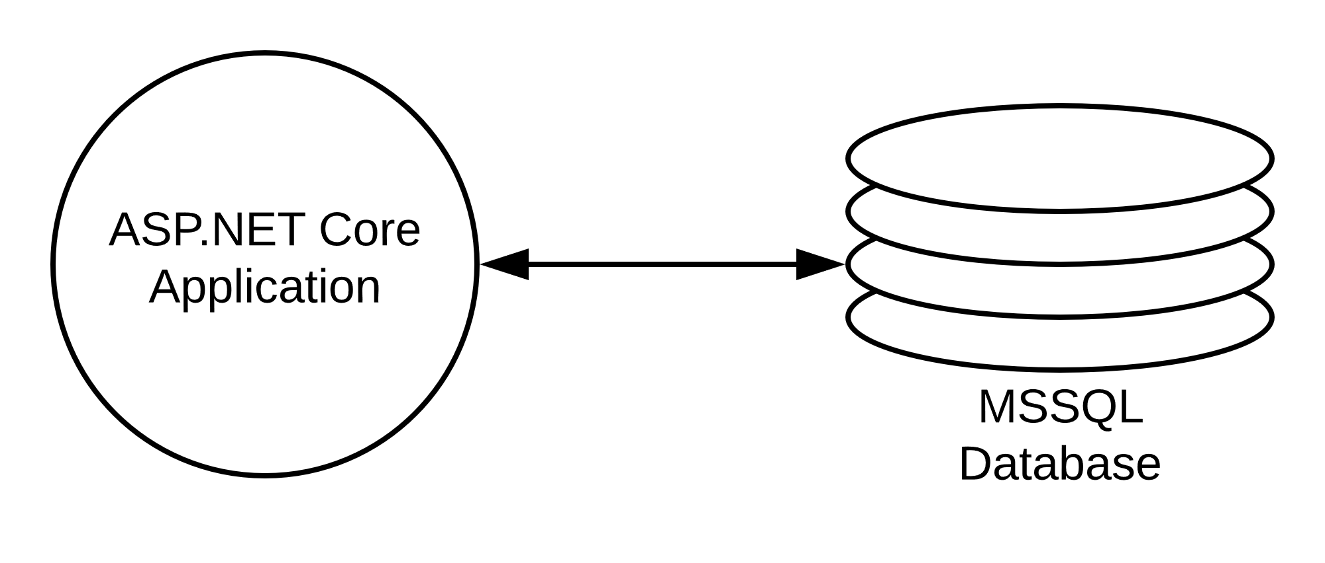

Figure 6

The system will be composed of a ASP.NET Core web application and MSSQL database. The web application will provide all user interactions with the system. The web application will communicate with the SQL database to provide persistent data storage.

The web application is to be written in C# and will use the ASP.NET Core Framework. C# was selected due to its prevalent usage for .NET development. C# was also chosen because its usage in ASP.NET Core documentation.

ASP.NET Core was selected for the web application due to hosting requirements set by Winthrop’s IT department. ASP.NET Core was also chosen for its extensive documentations, speed, and security. Database access will be abstracted using the object-relational mapping (ORM) framework, Entity Framework Core. The code generation capabilities of Entity Framework will greatly reduce development time. The web application will be organized into the following structure with the following models:

* User Context
  + Users
  + Groups
  + Permissions
* Infrastructure Context
  + Buildings
  + Rooms
  + Room Capabilities
* Department Context
  + Departments
  + Instructors
* Course Context
  + Courses
  + Subjects
  + Schedule Types
  + Course Attributes
* Scheduling Context
  + Terms
  + Parts of Terms
  + Time Slots
  + Instructional Methods
  + Course Sections

The SQL database, MSSQL, was chosen due to hosting requirements. Furthermore, Entity Framework integrates well with MSSQL.

### Persistent data management

Data will be stored in the RDBMS, MSSQL. The entities and relations are shown below in Figure 7.

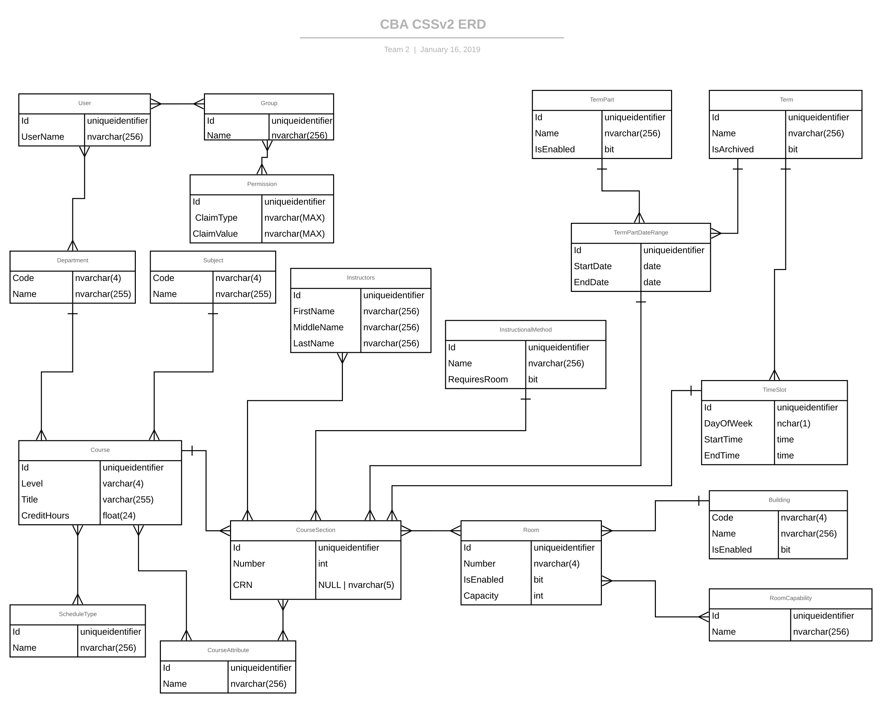

Figure 7

### Site Navigation

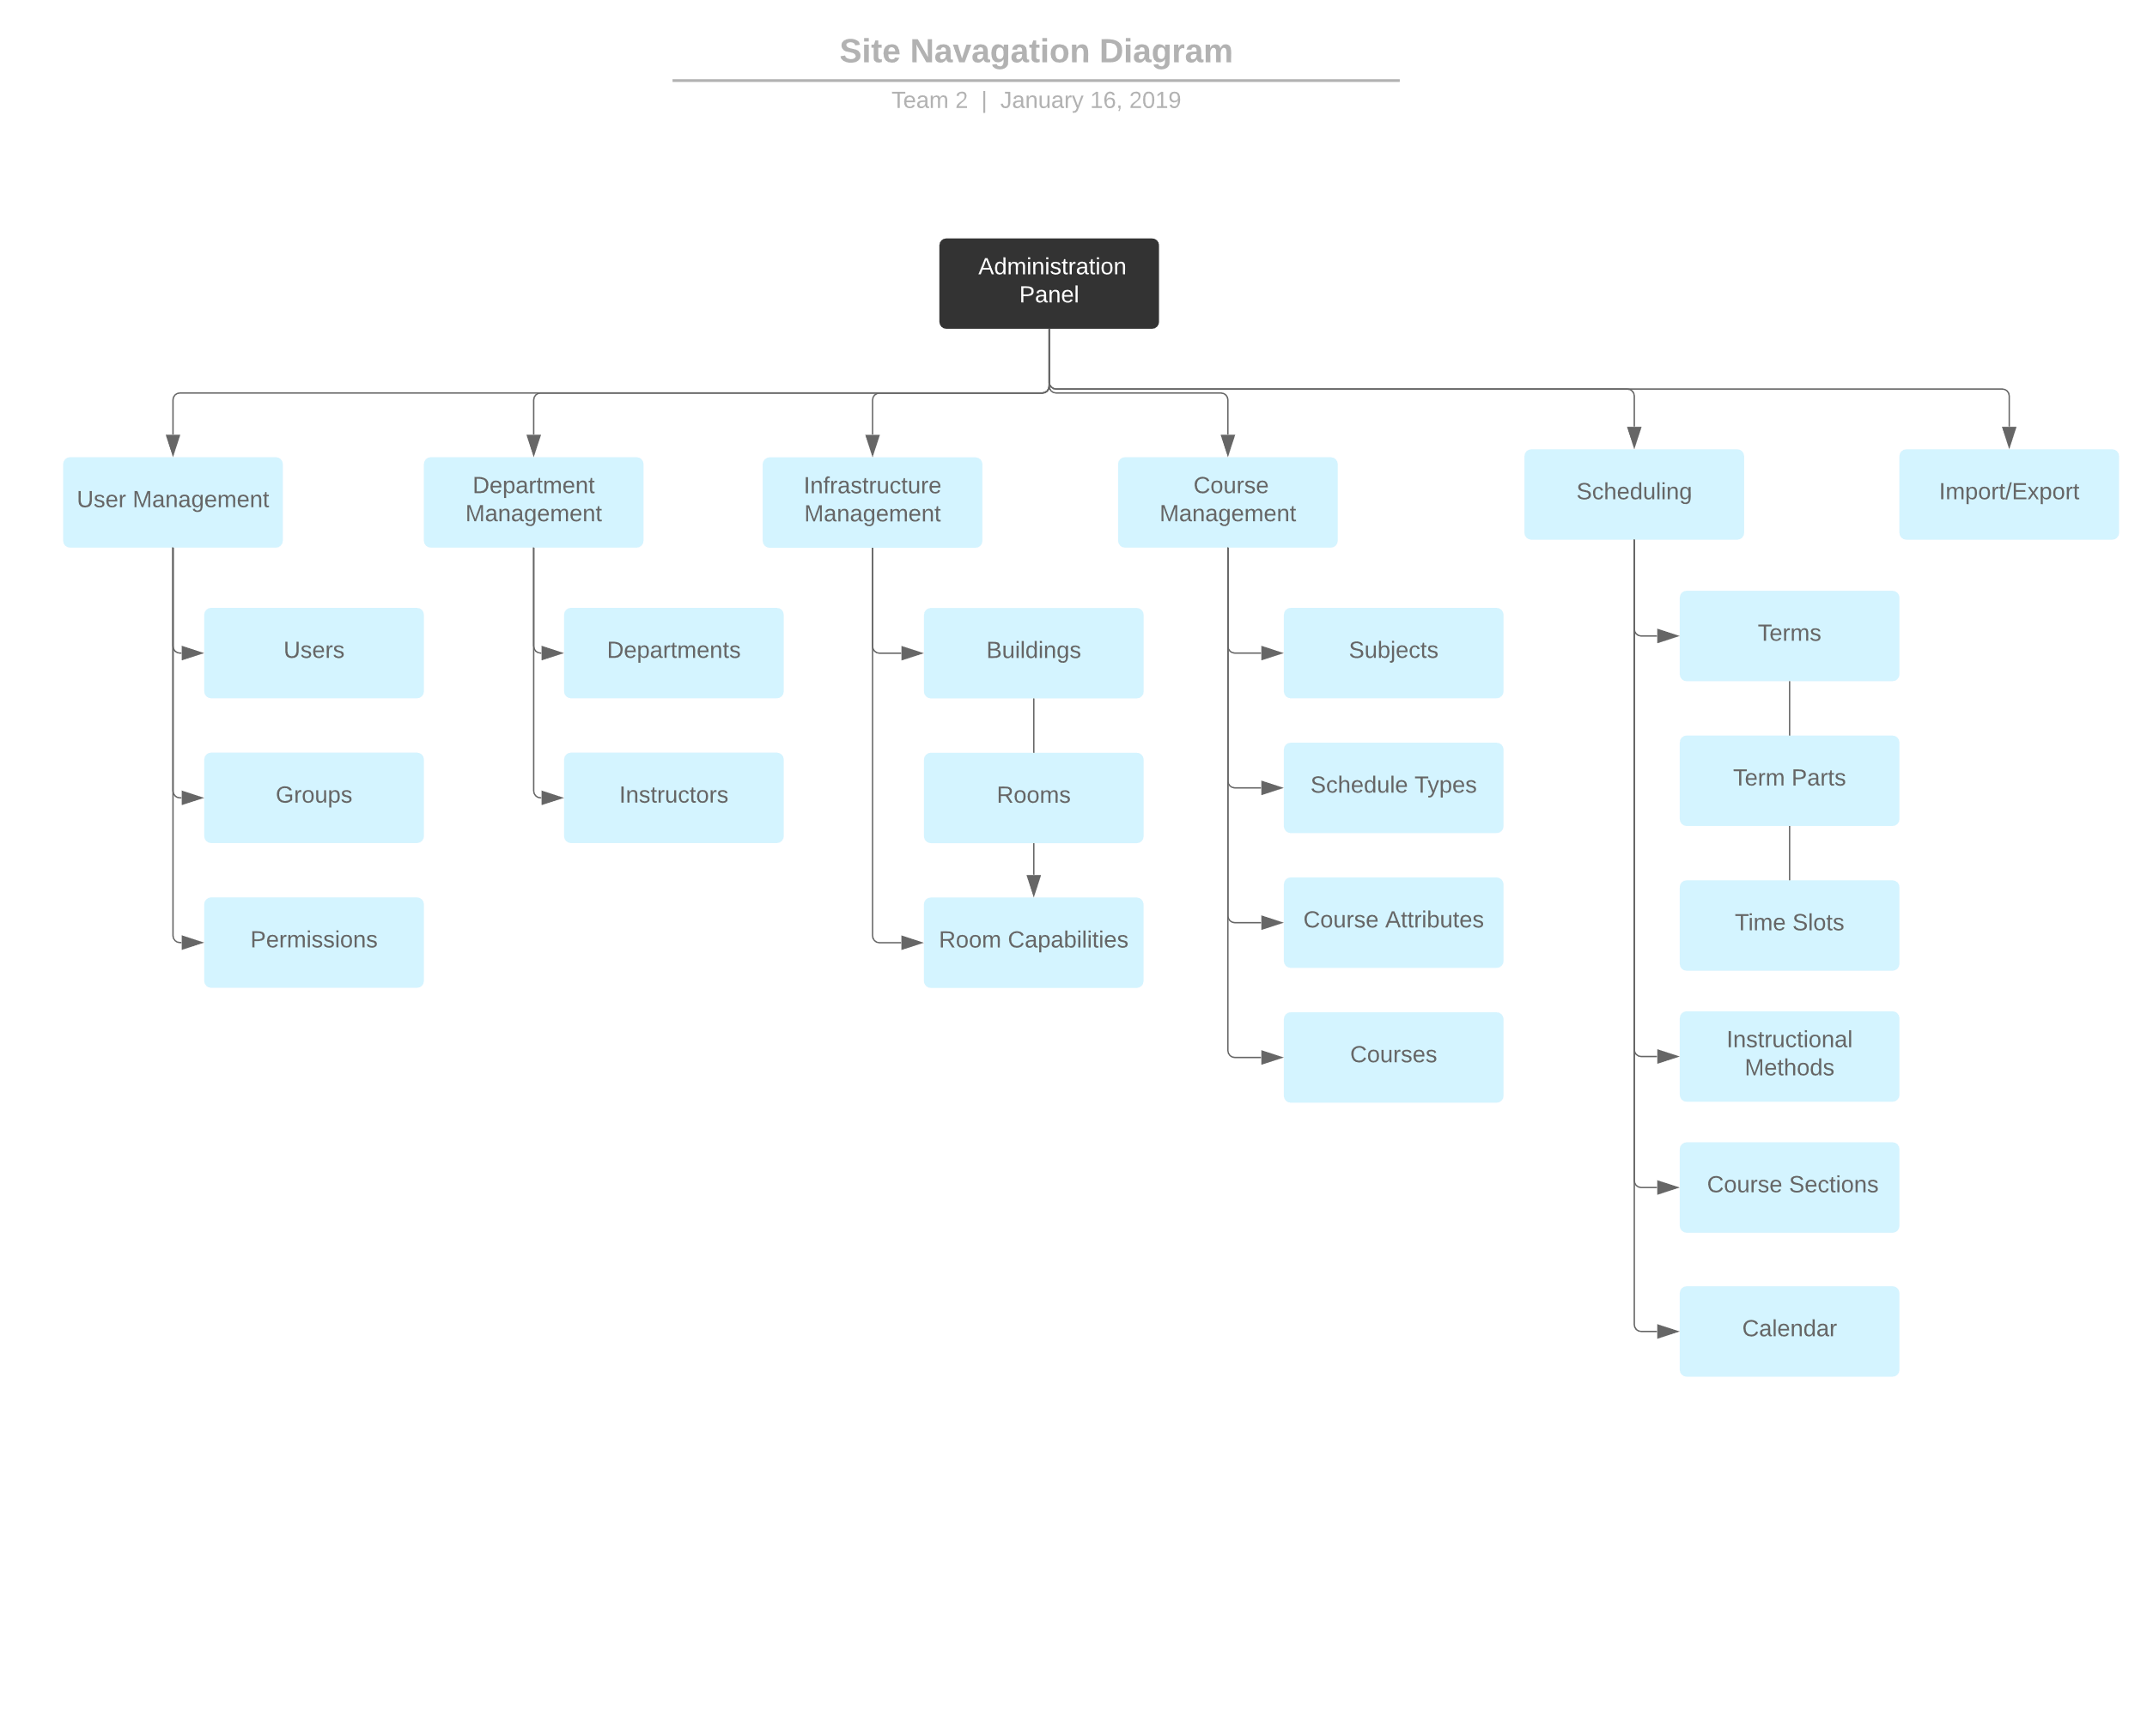

Figure 8

The web application will mainly consist of the administration panel. However, the more complicated and interactive calendar will be separate from the administration panel.

## Requirements Traceability Matrix

The Requirements Traceability Matrix is an external document.

## Glossary

**CBA** – College of Business Administration

**CRN** – Course Reference Number

**CSSv2** – Course Scheduling System v2

**Instructional method** – How a course section is taught. E.g., Classroom, Hybrid, Online

**MSSQL** – Microsoft SQL Server

**Part of Term** – Subdivisions of a term. E.g., Full Term, First Half, Second Half

**Subject** – A course subject. E.g., Accounting, Business Administration

**Term** – A season and year combination. E.g., Spring 2019, Fall 2019

**Time block** – A day of the week and time range. E.g., Monday 9:30-10:45 AM

**Input Validation** – Limiting the types of enterable characters by comparing input to acceptable symbols