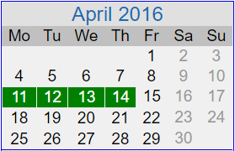
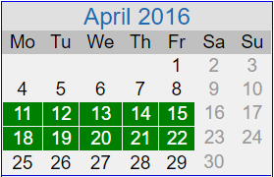
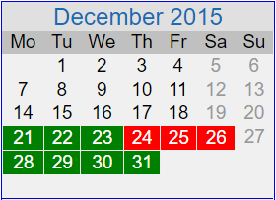
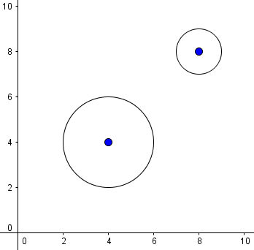
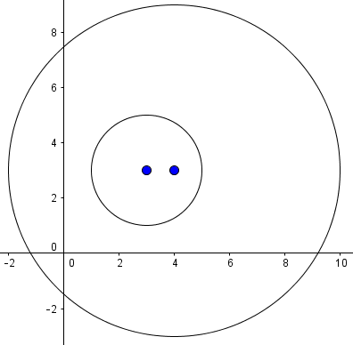
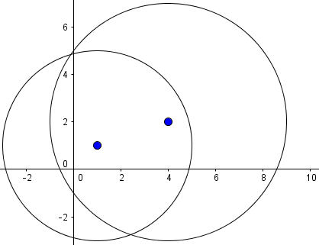
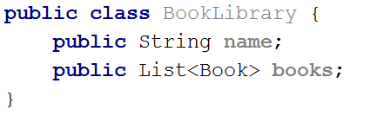
Exercise: Java Basics
Problems for exercises and homework for the “Software Technologies” course @ SoftUni.
You can submit your solutions here: https://judge.softuni.bg/Contests/712/Java-Basics-Exercises.

Part I: Data Types and Methods

Variable in Hexadecimal Format
Write a program that reads a number in hexadecimal format convert it to decimal format and prints it.
Input | Output
FE | 254
37 | 55
10 | 16

Hints
- Use Integer.parseInt(string, base).

Boolean Variable
Write a program that reads a string, converts it to Boolean variable and prints “Yes” if the variable is true and “No” if the variable is false.
Input | Output
True | Yes
False | No

Hints
- Java has a function, which takes a string and converts it to a Boolean.

Reverse Characters
Write a program to ask the user for 3 letters and print them in reversed order.

Examples
Input | Output |  | Input | Output |  | Input | Output
A  B  C | CBA |  | x  Y  z | zYx |  | G  g  n | ngG

Vowel or Digit
Create a program to check if given symbol is digit, vowel or any other symbol.

Examples
Input | Output |  | Input | Output |  | Input | Output
a | vowel |  | 9 | digit |  | g | other

Integer to Hex and Binary
Write a program to convert a decimal number to hexadecimal and binary number and print it.

Examples
Input | Output |  | Input | Output |  | Input | Output
10 | A  1010 |  | 420 | 1A4  110100100 |  | 256 | 100  100000000

Hints
- There are built-in methods, that convert Integer to Hex and Binary.

Part II: Arrays

Compare Char Arrays
Write a program, which compares two char arrays lexicographically (letter by letter).
Print the them in alphabetical order, each on separate line.

Examples
Input | Output
a b c  d e f | abc  def
p e t e r  a n n i e | annie  peter
a n n i e  a n | an  annie
a b  a b | ab  ab

Hints
- Compare the first letter of arr1[] and arr2[], if equal, compare the next letter, etc.
- If all letters are equal, the smaller array is the shorter.
- If all letters are equal and the array lengths are the same, the arrays are equal.

Max Sequence of Equal Elements
Write a program that finds the longest sequence of equal elements in an array of integers. If several longest sequences exist, print the leftmost one.

Examples
Input | Output
2 1 1 2 3 3 2 2 2 1 | 2 2 2
1 1 1 2 3 1 3 3 | 1 1 1
4 4 4 4 | 4 4 4 4
0 1 1 5 2 2 6 3 3 | 1 1

Hints
- Start with the sequence that consists of the first element: start=0, len=1.
- Scan the elements from left to right, starting at the second element: pos=1…n-1.
  - At each step compare the current element with the element on the left:
    - Same value → you have found a sequence longer by one → len++.
    - Different value → start a new sequence from the current element: start=pos, len=1.
  - After each step remember the sequence it is found to be longest at the moment: bestStart=start, bestLen=len.
- Finally, print the longest sequence by using bestStart and bestLen.

Max Sequence of Increasing Elements
Write a program that finds the longest increasing subsequence in an array of integers. The longest increasing subsequence is a portion of the array (subsequence) that is strongly increasing and has the longest possible length. If several such subsequences exist, find the left most of them.

Examples
Input | Output
3 2 3 4 2 2 4 | 2 3 4
4 5 1 2 3 4 5 | 1 2 3 4 5
3 4 5 6 | 3 4 5 6
0 1 1 2 2 3 3 | 0 1

Hints
- Use the same algorithm like in the previous problem (Max Sequence of Equal Elements).

Most Frequent Number
Write a program that finds the most frequent number in a given sequence of numbers.
- Numbers will be in the range [0…65535].
- In case of multiple numbers with the same maximum frequency, print the left-most of them.

Examples
Input | Output | Output
4 1 1 4 2 3 4 4 1 2 4 9 3 | 4 | The number 4 is the most frequent (occurs 5 times)
2 2 2 2 1 2 2 2 | 2 | The number 2 is the most frequent (occurs 7 times)
7 7 7 0 2 2 2 0 10 10 10 | 7 | The numbers 2, 7 and 10 have the same maximal frequence (each occurs 3 times). The leftmost of them is 7.

Index of Letters
Write a program that creates an array containing all letters from the alphabet (a-z). Read a lowercase word from the console and print the index of each of its letters in the letters array.

Examples
Input | Output
abcz | a -> 0  b -> 1  c -> 2  z -> 25
softuni | s -> 18  o -> 14  f -> 5  t -> 19  u -> 20  n -> 13  i -> 8

Equal Sums
Write a program that determines if there exists an element in the array such that the sum of the elements on its left is equal to the sum of the elements on its right. If there are no elements to the left / right, their sum is considered to be 0. Print the index that satisfies the required condition or “no” if there is no such index.

Examples
Input | Output | Comments
1 2 3 3 | 2 | At a[2] -> left sum = 3, right sum = 3  a[0] + a[1] = a[3]
1 2 | no | At a[0] -> left sum = 0, right sum = 2  At a[1] -> left sum = 1, right sum = 0  No such index exists
1 | 0 | At a[0] -> left sum = 0, right sum = 0
1 2 3 | no | No such index exists
10 5 5 99 3 4 2 5 1 1 4 | 3 | At a[3] -> left sum = 20, right sum = 20  a[0] + a[1] + a[2] = a[4] + a[5] + a[6] + a[7] + a[8] + a[9] + a[10]

Bomb Numbers
Write a program that reads sequence of numbers and special bomb number with a certain power. Your task is to detonate every occurrence of the special bomb number and according to its power his neighbors from left and right. Detonations are performed from left to right and all detonated numbers disappear. Finally print the sum of the remaining elements in the sequence.

Examples
Input | Output | Comments
1 2 2 4 2 2 2 9  4 2 | 12 | Special number is 4 with power 2. After detontaion we left with the sequence [1, 2, 9] with sum 12.
1 4 4 2 8 9 1  9 3 | 5 | Special number is 9 with power 3. After detontaion we left with the sequence [1, 4] with sum 5. Since the 9 has only 1 neighbour from the right we remove just it (one number instead of 3).
1 7 7 1 2 3  7 1 | 6 | Detonations are performed from left to right. We could not detonate the second occurance of 7 because its already destroyed by the first occurance. The numbers [1, 2, 3] survive. Their sum is 6.
1 1 2 1 1 1 2 1 1 1  2 1 | 4 | The red and yellow numbers disappear in two sequential detonations. The result is the sequence [1, 1, 1, 1]. Sum = 4.

Part IV: Strings, Maps and Stream API

Reverse String
Write a program that reads a string from the console, reverses its letters and prints the result back at the console.

Examples
Input | Output
sample | elpmas
24tvcoi92 | 29iocvt42

Hints
- Variant I: convert the string to char array, reverse it, then convert it to string again.
- Variant II: print the letters of the string right-to-left in a for-loop.

Fit String in 20 Chars
Write a program that reads from the console a string and fits the string in 20 characters as follows:
- If the string has less than 20 characters, append asterisks ‘*’ to it until it’s exactly 20 characters long.
- If the string length is more than 20 characters, discard all characters after the first 20.
Print the result string at the console.

Examples
Input | Output
Welcome to SoftUni! | Welcome to SoftUni!*
A "regular expression" (abbreviated regex or regexp) is a sequence of characters that forms a search pattern. | A "regular expressio
C# | C#******************

Hints
- If string has a length < 20, write a padRight(20, '*') method.
- If string has a length > 20, use substring(0, 20).

Censor Email Address
You have some text that contains your email address. You are sick of spammers, so you want to hide it. You decide to censor your email: to replace all characters in it with asterisks ('*') except the domain.
Assume your email address will always be in format [username]@[domain]. You need to replace the username with asterisks of equal number of letters and keep the domain unchanged.

Input
- The first line holds your email address.
- The second line holds a text where the email should be censored.

Examples
Input
pesho.peshev@email.bg
My name is Pesho Peshev. I am from Sofia, my email is: pesho.peshev@email.bg (not pesho.peshev@email.com). Test: pesho.meshev@email.bg, pesho.peshev@email.bg
Output
My name is Pesho Peshev. I am from Sofia, my email is: ************@email.bg (not pesho.peshev@email.com). Test: pesho.meshev@email.bg, ************@email.bg

Hints
In order to accomplish the task, you may find these steps useful:
- Split the email into two parts – username and domain.
- Create the replacement string by duplicating the '*' character {username.length} times and appending '@' and the domain.
- Replace all occurrences of your email with the replacement string.

URL Parser
Write a program that parses an URL given in the following format:
[protocol]://[server]/[resource]
The parsing extracts its parts: protocol, server and resource.
- The [server] part is mandatory.
- The [protocol] and [resource] parts are optional.

Examples
Input | Output
http://www.abc.com/video | [protocol] = "http"  [server] = "www.abc.com"  [resource] = "video"
https://www.softuni.bg/Resources/Materials | [protocol] = "https"  [server] = "www.softuni.bg"  [resource] = "Resources/Materials"
ftp://www.su.us/TestResource | [protocol] = "ftp"  [server] = "www.su.us"  [resource] = "TestResource"
https://softuni.bg | [protocol] = "https"  [server] = "softuni.bg"  [resource] = ""
www.nakov.com | [protocol] = ""  [server] = "www.nakov.com"  [resource] = ""

Hints
- Find the leftmost occurrence of “://” in the input URL.
  - If found, the left side holds the protocol, the right side holds the server + resource.
  - If not found, the protocol is missing, the input string holds server + resource only.
- After the “protocol” part is removed from the input URL, find the leftmost occurrence of “/”.
  - If found, the left side holds the server, the right side holds the resource.
  - If not found, the resource is missing, the whole string holds the server.

Change to Uppercase
Write a program that receives a string and modifies the casing of letters to uppercase at all places in the text surrounded by <upcase> and </upcase> tags. Tags will not be nested.

Example
Input
Welcome to the <upcase>Software University</upcase>. Learn <upcase>computer programming</upcase> and start a <upcase>job</upcase> in a software company.
Output
Welcome to the SOFTWARE UNIVERSITY. Learn COMPUTER PROGRAMMING and start a JOB in a software company.

Hints
- You may find the position of the first <upcase> and the first </upcase>, delete the text between and insert the uppercase version of the text without the tags at the position of <upcase>.
- Repeat the above until no more <upcase> and </upcase> tags are found in the text.

Phonebook
Write a program that receives some info from the console about people and their phone numbers. Each entry should have just one name and one number (both strings).
On each line, you will receive some of the following commands:
- A {name} {phone} – adds entry to the phonebook. In case of trying to add a name that is already in the phonebook, you should change the existing phone number to the new one.
- S {name} – searches for a contact by given name and prints it in format "{name} -> {number}".
In case the contact isn't found, print "Contact {name} does not exist.".
- END – stop receiving more commands.

Examples
Input | Output
A Nakov 0888080808  S Mariika  S Nakov  END | Contact Mariika does not exist.  Nakov -> 0888080808
A Nakov +359888001122  A RoYaL(Ivan) 666  A Gero 5559393  A Simo 02/987665544  S Simo  S simo  S RoYaL  S RoYaL(Ivan)  END | Simo -> 02/987665544  Contact simo does not exist.  Contact RoYaL does not exist.  RoYaL(Ivan) -> 666
A Misho +359883123  A Misho 02/3123  S Misho  END | Misho -> 02/3123

Hints
- Parse the commands by splitting by space. Execute the commands until “END” is reached.
- Store the phonebook entries in LinkedHashMap<String, String> with key {name} and value {phone number}.

Phonebook Upgrade
Add functionality to the phonebook from the previous task to print all contacts ordered lexicographically when receive the command “ListAll”.

Examples
Input | Output
A Nakov +359888001122  A RoYaL(Ivan) 666  A Gero 5559393  A Simo 02/987665544  ListAll  END | Gero -> 5559393  Nakov -> +359888001122  RoYaL(Ivan) -> 666  Simo -> 02/987665544

Hints
- Variant I (slower): Sort all entries in the dictionary by key and print them.
- Variant II (faster): Keep the entries in more appropriate data structure that will keep them in sorted order for better performance.

Part V: Classes and Objects

Count Working Days
Write a program that reads two dates in the format dd-MM-yyyy and prints the number of working days between these two dates inclusive. Non-working days are:
- All days that are Saturday or Sunday.
- All days that are official holidays in Bulgaria:
  - New Year Eve (1 Jan)
  - Liberation Day (3 March)
  - Worker’s day (1 May)
  - Saint George’s Day (6 May)
  - Saints Cyril and Methodius Day (24 May)
  - Unification Day (6 Sept)
  - Independence Day (22 Sept)
  - National Awakening Day (1 Nov)
  - Christmas (24, 25 and 26 Dec)
All days not mentioned above are working and should count.

Examples
Input | Output | Calendar
11-04-2016  14-04-2016 | 4
11-04-2016  22-04-2016 | 10
20-12-2015  31-12-2015 | 7

Hints
- Read start date and end date from Console.
- Create two objects of type Date – startDate and endDate.
- Create an array of type Date and add all official holidays in it.
- Loop from startDate to endDate. Add 1 day at each iteration.
- Get the current day in the loop and check whether is Saturday, Sunday or it is contained in the holidays array. If it is not, increment the workingDaysCounter.

Advertisement Message
Write a program that generates a random fake advertisement message to extol some product. The messages must consist of 4 parts: laudatory phrase + event + author + city. Use the following predefined parts:
- Phrases – {"Excellent product.", "Such a great product.", "I always use that product.", "Best product of its category.", "Exceptional product.", "I can't live without this product."}
- Events – {"Now I feel good.", "I have succeeded with this product.", "Makes miracles. I am happy of the results!", "I cannot believe but now I feel awesome.", "Try it yourself, I am very satisfied.", "I feel great!"}
- Author – {"Diana", "Petya", "Stella", "Elena", "Katya", "Iva", "Annie", "Eva"}
- Cities – {"Burgas", "Sofia", "Plovdiv", "Varna", "Ruse"}
The format of the output message is: {phrase} {event} {author} – {city}.
As input, you take the number of messages to be generated. Print each random message at a separate line.

Examples
Input | Output
3 | Such a great product. Now I feel good. Elena – Ruse  Excelent product. Makes miracles. I am happy of the results! Katya – Varna  Best product of its category. That makes miracles. Eva - Sofia

Hints
- Hold the phrases, events, authors and towns in 4 arrays of strings.
- Create Random object and generate 4 random numbers each in its range:
  - phraseIndex → [0, phrases.Length]
  - eventIndex → [0, events.Length]
  - authorIndex → [0, authors.Length]
  - townIndex → [0, towns.Length]
- Get one random element from each of the four arrays and compose a message in the required format.

Intersection of Circles
Create a Circle class with Center and Radius properties. The center is a point with coordinates X and Y (make a class Point). Write a method bool Intersect(Circle c1, Circle c2) that tells whether the two given circles intersect or not. Write a program that tells if two circles intersect.

Input
The input lines will be in format: {X} {Y} {Radius}. Print as output “Yes” or “No”.

Examples
Input | Output | Visualization
4 4 2  8 8 1 | No
3 3 2  4 3 6 | Yes
1 1 4  4 2 5 | Yes

Hints
- Calculate d = distance between the circle centers.
- If the d ≤ r1 + r2 (the sum of radiuses) → the circles intersect (or one of the circles is inside the other or the circles have one common point when d = r1 + r2).
- If the d > r1 + r2 → the circles do not intersect (they have not common shared point).

Average Grades
Define a class Student, which holds the following information about students: name, list of grades and average grade (calculated property, read-only). A single grade will be in range [2…6], e.g. 3.25 or 5.50.
Read a list of students and print the students that have average grade ≥ 5.00 ordered by name (ascending), then by average grade (descending). Print the student name and the calculated average grade.

Examples
Input | Output
3  Ivan 3  Todor 5 5 6  Diana 6 5.50 | Diana -> 5.75  Todor -> 5.33
6  Petar 3 5 4 3 2 5 6 2 6  Mitko 6 6 5 6 5 6  Gosho 6 6 6 6 6 6  Ani 6 5 6 5 6 5 6 5  Iva 4 5 4 3 4 5 2 2 4  Ani 5.50 5.25 6.00 | Ani -> 5.58  Ani -> 5.50  Gosho -> 6.00  Mitko -> 5.67

Hints
- Create class Student with properties Name (string), Grades (double[]), and property AverageGrade (calculated by LINQ as Grades.Average(), read-only).
- Make a list of students and filter all students that has average grade >= 5.00 using Java’s stream API.
- Print the filtered students ordered by name in ascending order, then by average grade in descending order.

Book Library
To model a book library, define classes to hold a book and a library. The library must have a name and a list of books. The books must contain the title, author, publisher, release date, ISBN-number and price.
Read a list of books, add them to the library and print the total sum of prices by author, ordered descending by price and then by author’s name lexicographically.
Books in the input will be in format {title} {author} {publisher} {release date} {ISBN} {price}.

Examples
Input | Output
5  LOTR Tolkien GeorgeAllen 29.07.1954 0395082999 30.00  Hobbit Tolkien GeorgeAll 21.09.1937 0395082888 10.25  HP1 JKRowling Bloomsbury 26.06.1997 0395082777 15.50  HP7 JKRowling Bloomsbury 21.07.2007 0395082666 20.00  AC OBowden PenguinBooks 20.11.2009 0395082555 14.00 | Tolkien -> 40.25  JKRowling -> 35.50  OBowden -> 14.00

Hints
- Create classes Book and Library with all the mentioned above properties:
- Create an object of type Library.
- Read the input and create a Book object for each book in the input.
- Create a STREAM query that will sum the prices by author, order the results as requested.
- Print the results.

Book Library Modification
Use the classes from the previous problem and make a program that read a list of books and print all titles released after given date ordered by date and then by title lexicographically. The date is given if format “day-month-year” at the last line in the input.

Examples
Input | Output
5  LOTR Tolkien GeorgeAllen 29.07.1954 0395082999 30.00  Hobbit Tolkien GeorgeAll 21.09.1937 0395082888 10.25  HP1 JKRowling Bloomsbury 26.06.1997 0395082777 15.50  HP7 JKRowling Bloomsbury 21.07.2007 0395082666 20.00  AC OBowden PenguinBooks 20.11.2009 0395082555 14.00  30.07.1954 | HP1 -> 26.06.1997  HP7 -> 21.07.2007  AC -> 20.11.2009

