EXPERCISE: Write 5 ideas of how you will test the items below:
- EKO Pen made with recycled paper and with blue inc.
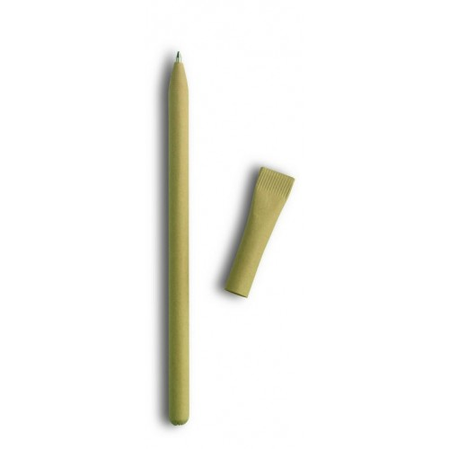
Tests:
- Does the paper has certificate for being eco.
- Are there any dangerous chemicals for the human's health used in the production technology of the paper because the pen will have direct contact with the skin.
- Is the pen well encapsulated, so you do not get dirty with the blue ink when using it?
- Is the pen form comfortable for using?
- For what hand size is the pen designed - child, lady, male?
- Is the paper pleasant as a sensation for the skin?
- Can someone smash the paper easy or it's hard enough?
- Is the ink blue?
- Can you write with this pen?
- Does the pen cap fit well on the pen itself? Is it easy to place? Will it fall easily?
- Does the pen has too sharp writing top? Will it harm someone easily?
- Can you tear the paper easily?
- In what forms is the paper tear? Are there some sharp edges after tearing so it can hurt someone?
- Is the paper suitable for eating? Are the paper's ingredients suitable for eating?
- Is the ink suitable for eating?
- Does the pen has some additional functionality like for example planting?

- Waterproof playing cards with 3 jokers.
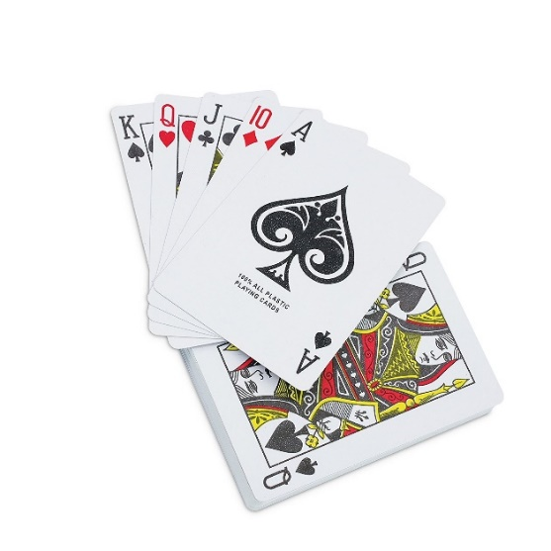
Tests:
- We name the set 2, 3, 4, 5, 6, 7, 8, 9, 10, Jack, Queen, King, Ace as Ranks. Does the set has exactly 1 Ranks from spades, 1 Ranks from hearts, 1 Ranks from diamonds, 1 Ranks from clubs and 3 jokers?
- Is the cards surface waterproof? The playing cards set is printed on a paper and covered with lacquer or laminate usually.
- Is the cards edge waterproof?
- Are all cards without obvious defects from the printing?
- Are all cards without obvious defects from the cutting?
- Are all cards with the proper size?
- Can you tear the cards easily?
- Do you have a nice feeling while touching the cards?
- Do you find any dangerous ingredients in the materials from which are the cards produced? - check the ink, the paper, the coverage.

- Sunglasses made by recycled skate desks.
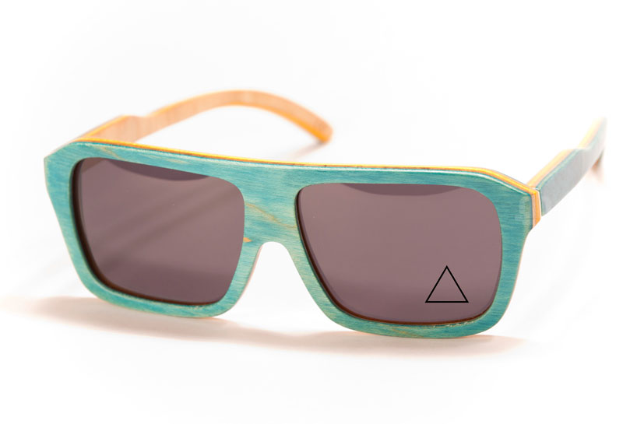
Tests:
- Do glasses fit well with a human head?
Is the size aligned with the proportions of human anatomy?
Is the width of the glasses aligned with the length of the handles to fit the same human head size?
- For what size head is the sunglasses? Kids or adults?
- Does the curve of the handles fit well into the ears so that it can hold the glasses to the head?
- Are the edges sufficiently polished to not irritate or injure the facial skin or the curve between the ears and the head?
- Is the thickness of the frames too big?
- Are glasses too heavy? Is it possible to fall quickly when the head is moving? Do you feel a limitation in your movements or some other discomfort while wearing them?
- Is the nose curve of the sunglasses suitably shaped and sized to make them comfortable for wearing?
- Is the eyeglass assembly stable?
- If there are bolts on the assembly - is there any bolt to irritate the skin?
- In case of used glue on the assembly - is there any dangerous ingredient in it?
- Is the material for the glass transparent enough? Does the eye have any tension when looking through it?
- Does glass material cause any allergies?
- Тhe material from which are prepared the glasses what degrees of UV protection has?
- Can you easily warm the material from which are made the glasses? Then it's unsuitable for sunglasses because it can burn the skin or eye.
- Whether skate desks have some harmful coating that causes allergies or illnesses?
- Can you easily fracture the sunglasses? Then it can harm the owner when falling down or in some extreme cases.

