MVDK

Macro Virus Development Kit v1.0 beta

Created by Wild W0rker

ATTENTION ATTENTION ATTENTION ATTENTION ATTENTION ATTENTION ATTENTION

This program for education purpose only!
The author does not carries any responsibility for destructions of data, made by this program or by programs made with the help of MVDK

ATTENTION ATTENTION ATTENTION ATTENTION ATTENTION ATTENTION ATTENTION

WHAT IS MVDK?

Macro Virus Development Kit is a tool which generates macro viruses for Microsoft Winword, according to user specifications. All output macros that’s text files, which are placed in C:\

HOW TO INSTALL?

To install MVDK on your computer press twice here

INSTALL

(Menu MVDK will be created by setup program)

If you wanna remove MVDK press twice here

UNINSTALL

HOW DOES IT WORK?

MVDK is easy to use, you just need select payload and infection type. After you need select item MVDK in MVDK then main menu will appear

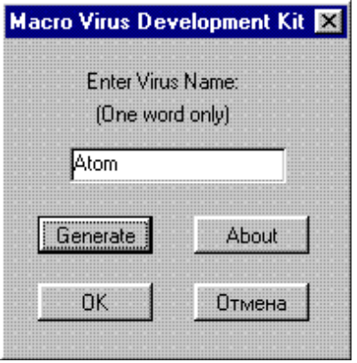

(Pic. 1)

Here you must enter name of your virus (i like Atom;), and press generate button. You can also push Cancel button to abort program.

When you push generate button the Payload dialog will appear

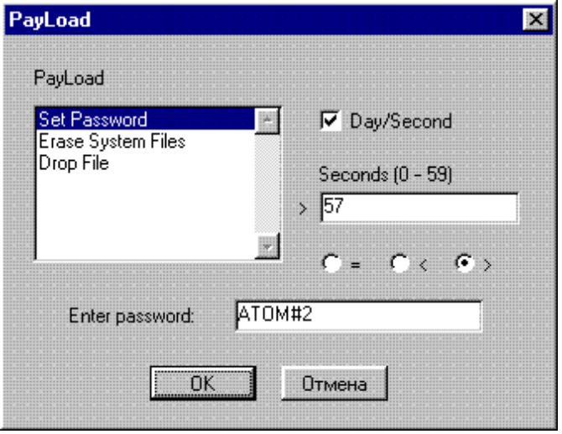

(Pic. 2)

- PAYLOAD SECTION

This version of MVDK can generate only 3 payloads:

- Set Password.
- Erase System Files.
- Drop File.

1. SETTING PASSWORD.

Your virus can set password to document for certain conditions when it saved. If you wanna this payload, you just need select Set Password in payload dialog and type password, then you must set conditions when your virus will set password. Look at the picture 2. Here we set password ATOM#2 on document when it will be saved and current second > 57.

- ERASE SYSEM FILES.

Your virus can erase system files (IO.SYS, MSDOS.SYS, COMMAND.COM) for certain conditions. If you like this payload you need select Erase system files and set payload conditions.

- DROP FILE.

Your macro virus can run other virus (not macro, that’s can be usual COM/EXE/... virus ) through AUTOEXEC.BAT for certain conditions. You can do it if you select Drop File in payload dialog and type file name of the virus which you wanna run.

ATTENTION! If you wanna drop other virus, you must make debug script of this virus (use DBGSCRPT.COM) and type script name in the field «Enter file name:» .

- SET PAYLOAD CONDITIONS

When you select payload you must enter conditions. Your payload run only if current day or seconds =,<,> entered day or seconds.

Example №1: You select «Day» in Day/Second (Check box must be clear), in field «Day» you type 13 and set «<», that’s will be look as:
If current day < 13 then your payload will be executed.
Example №2: You select «Second» in Day/Second, in field «Seconds» you type 34 and set «=», that’s will be look as:
If current second = 34 then your pauload will be execurted.

When you select your payload and type conditions, you can press OK, after menu infect will be appear
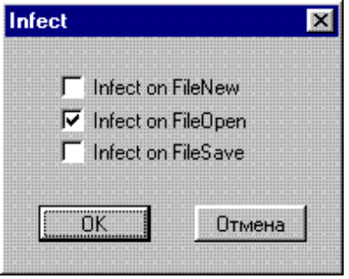

(Pic. 3)

- INFECT

Here you must select event when your virus will infect documents.
Look at the picture 3, here our virus will infect documents when they will be opened. Your virus can also infect documents when they saved and created.

WHAT WILL BE IN RELEASE?

In release you can find more payload’s (something like set random password, messages, etc), all generated sources will be commented, and some more features.

P.S. Check all errors in this text, coz my english very bad;(

DON’T DISTRIBUTE THIS FILE! IT’S FOR BETA TESTERS ONLY!

Dark Conspiracy, 1996

