Multi execution of functions in VBS.

Author:
Falckon/DCA [Dark C0derZ Alliance]

A) Introduction
B) Multi-Execution
C) Example
D) End

A) - Introduction

It has been seen much of vbs Worm, their capacity of reproduction (masive) (which as for me I have not seen),
its facility of codification, with which script kidies learn to create their stupid worms, yes,
but we fence to the grain.

I will try to explain in this article a small re-discovery.

Whenever we wrote a worm in this language, which we do is to order
the instructions that will be interpreted first,thus the worm will begin looking
for archives to infect, when this routine finishes was dedicated to send mails, until there
perfect; unfortunately we will know a clearly slowness since if first begins to look for
archives to infect, we imagine that we have hd of 80 gb with more than 20000 archives
which I do not believe that we infect in 2 minutes; And soon to try to us to send by mail
when the previous routine this finishes.

Ufff... and if the pc is not connected to internet? (shit!)

here is the problem... and i continue thinking about like is that "loveletter"
who caused an epidemic in those times.... but good....

I thinked in this problem a year back ago, when i writted a vbs worm, and decided to investigate,
really i was searching the automatization of a worm! and this is what I found when studying VBS scripts from IIS 5.1
I observed that these could extract the VBS Command Line, uhm yeah!!

Then I had an idea, and this idea responded to my question clearly,
can automate the functions of my worm, with which it would obtain the execution of all the functions of the worm,
working in real time with the consequence of a greater rapidity to execute itself, but with the disadvantage of a clear excessive use of resources.

B) - Multi execution.

The key of, is the procedure including in the Windows Script Host 5.6 "Wscript.Arguments"
which allows us to extract the Script Command Line that would be equivalent to "GetCommandLineA"
API ;), now already they will imagine what it has been happened to me:

if we extract the command line, f. e.: "/mail" then the code execute the mail function,
up to here all is good, but if also we execute the script again and we send the option
"/infect_files" then our viral code will execute the infect file function, that infect files (obiously)
reason why we will have executing two process (WScript.exe)
which will be making actions different, acting at the same time, which guarantees greater fast of spreading.

C ) - Example

A clearly example is this:

'-start code
Dim arg
Set arg = WScript.Arguments 'the command line arg.
if arg.count <> 0 then 'if ARG <> 0 then
if arg.item(0) = "/msg1" then 'If The first arg equal to “/msg1” then
msg1() 'call the sub msg1
elseif arg.item(0) = "/msg2" then 'else if equal to “/msg2” then
msg2() 'call the sub msg2 :D
end if
end if
Sub msg1() 'Sub MSG1 “with the code to execute”
Msgbox "Trin u are my love :D"
end sub
Sub msg2() 'Sub MSG2 “”
Msgbox "The Matrix has u"
end sub
'/end of code

Now good...
we save this script in a vbs file, go to ur command line (Cmd.exe = NT / Command.com = Win9X)
and then execute of this way the script file: xxx.vbs /msg1 and later xxx.vbs /msg2 or if u want
execute all: xxx.vbs /msg1 && xxx.vbs /msg2
and you will already see what shows, but no, not yet I've finished,
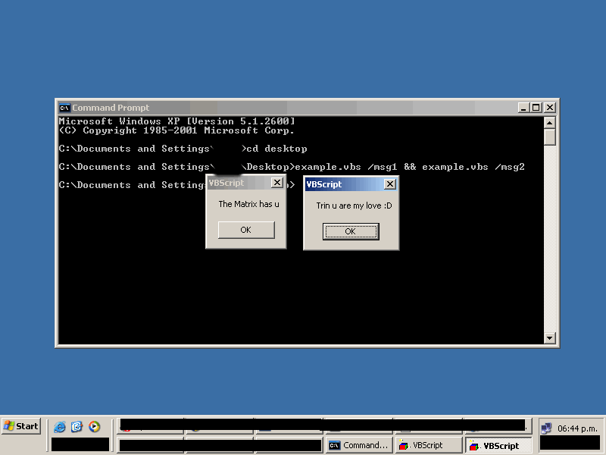

if we hooked the VBS to the registry in the tipical key "Run" but in this form:

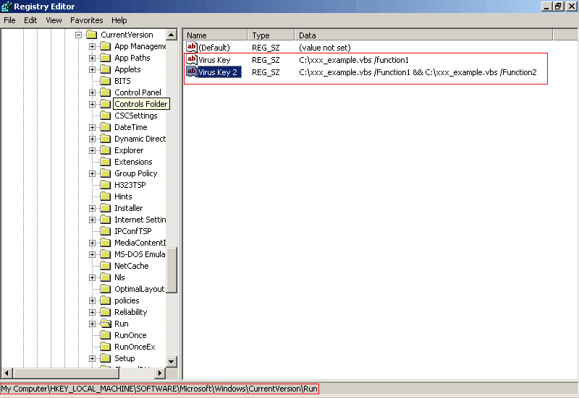

create the keys and put the viral value with its corresponding command line,
which will do to the reboot of the system is to execute the VBS twice,
but each one will make an action different, as before I come commented
the consequence is that is more fast the process of infection,
without the necessity to hope to that other functions finish to
continue with others or using DO-Loops where here stop the code execution
cnd continues executing other functions until that Do-Loop is broken

D) - Good Bye
This is a stupid idea, but u can automatize ur VBS Viruses/Worms hehe ;)
[EOF]

