**Prepare Win32 app content for upload - Java 8**

**Download offline version of the application.**

<https://java.com/en/download/manual.jsp>

**You need scripts that you will put in intune. For Java they look like this:**

32-bit:

Install command

jre-8u351-windows-i586.exe INSTALL_SILENT=1 AUTO_UPDATE=0 REBOOT=0

Uninstall command

MsiExec.exe /X{26A24AE4-039D-4CA4-87B4-2F32180351F0} /qn

HKEY_LOCAL_MACHINE\SOFTWARE\WOW6432Node\Microsoft\Windows\CurrentVersion\Uninstall\{26A24AE4-039D-4CA4-87B4-2F32180351F0}

64-bit:

Install command

jre-8u351-windows-x64.exe INSTALL_SILENT=1 AUTO_UPDATE=0 REBOOT=0

Uninstall command

MsiExec.exe /X "{26A24AE4-039D-4CA4-87B4-2F64180351F0}" /qn

HKEY_LOCAL_MACHINE\SOFTWARE\Microsoft\Windows\CurrentVersion\Uninstall\{26A24AE4-039D-4CA4-87B4-2F64180351F0}

**You need registry key as well. If you don’t have one. You can install the app on your local computer and search for it. They are usually under:**

HKEY_LOCAL_MACHINE\SOFTWARE\Microsoft\Windows\CurrentVersion\Uninstall

**Download IntuneWinAppUtil.exe**

[**https://github.com/Microsoft/Microsoft-Win32-Content-Prep-Tool**](https://github.com/Microsoft/Microsoft-Win32-Content-Prep-Tool)

**Prepare two folders “in” and “out”. Copy your application to “in” folder**

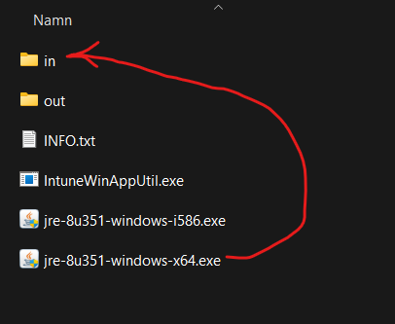

**Now you can run IntuneWinAppUtil.exe as administrator**

**It will run for a few seconds and the window will close.**

**In “out” folder you should see a .intunewin file**

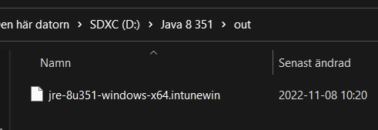

**Now you can go to** [**https://endpoint.microsoft.com/**](https://endpoint.microsoft.com/) **> Apps > Windows**

**Click Add**

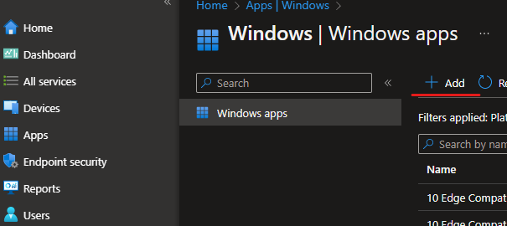

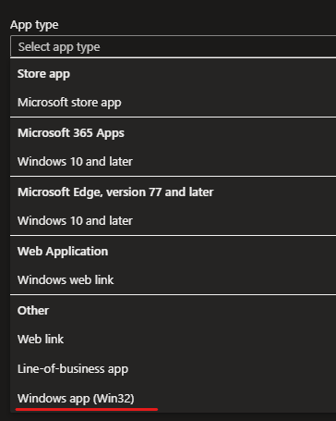**Choose Windows app (win32)**

**Choose your .intunewin file**

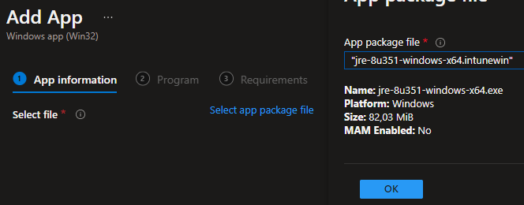

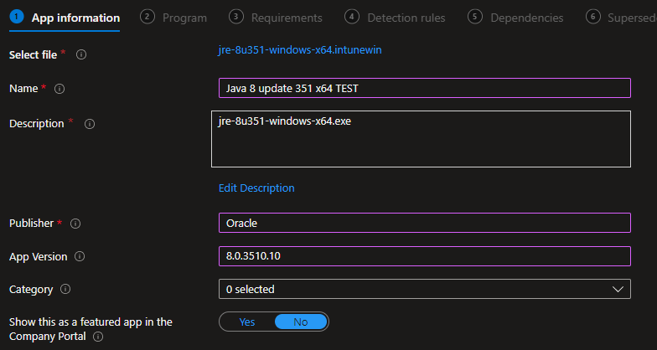

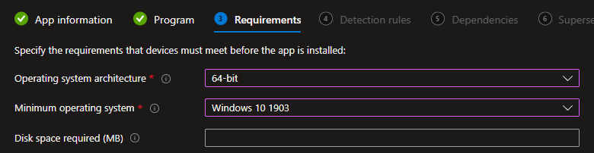

**As detection rule you can use registry**

**Or file path and version.**

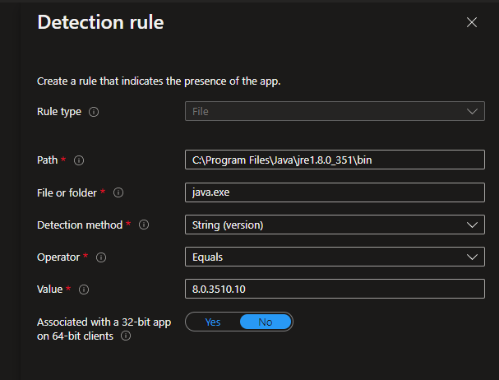

**Choose a group for your workstations.**

