**Prepare Win32 app content for upload – 7 zip**

**Download offline version of the application.**

<https://www.7-zip.org/>

**You need PS scripts that you will package with the application. For 7 zip it looks like this:**

Param(

[Parameter(Mandatory=$true)]

[ValidateSet("Install", "Uninstall")]

[String[]]

$Mode

)

If ($Mode -eq "Install")

{

# Installing...

Start-Process msiexec.exe -Wait -ArgumentList '/i 7z-x64.msi /qn /norestart ACCEPT_EULA=YES'

}

If ($Mode -eq "Uninstall")

{

# Uninstalling...

Start-Process msiexec.exe -Wait -ArgumentList '/x 7z-x64.msi /qn /norestart'

}

**In intune you will put these:**

Install command:

powershell.exe -ExecutionPolicy Bypass -file Install.ps1 -Mode Install

Uninstall command:

powershell.exe -ExecutionPolicy Bypass -file Install.ps1 -Mode Uninstall

**Most often you will need registry key for detection. If you don’t have one. You can install the app on your local computer and search for it. They are usually under:**

HKEY_LOCAL_MACHINE\SOFTWARE\Microsoft\Windows\CurrentVersion\Uninstall

**Download IntuneWinAppUtil.exe**

[**https://github.com/Microsoft/Microsoft-Win32-Content-Prep-Tool**](https://github.com/Microsoft/Microsoft-Win32-Content-Prep-Tool)

**Prepare two folders “in” and “out”. Copy your application and PS script to “in” folder**

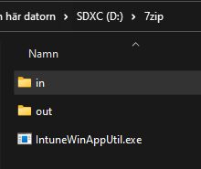

**Now you can run IntuneWinAppUtil.exe as administrator. It will run for a few seconds and the window will close.**

**In “out” folder you should see a .intunewin file. It contains your application and PS script**

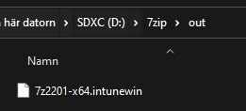

**Now you can go to** [**https://endpoint.microsoft.com/**](https://endpoint.microsoft.com/) **> Apps > Windows**

**Click Add**

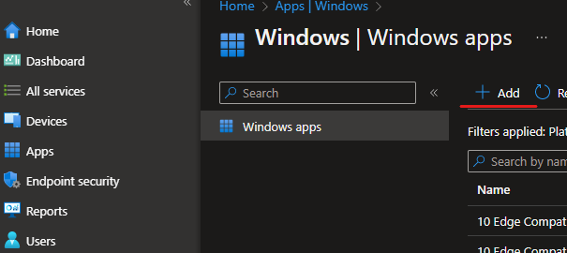

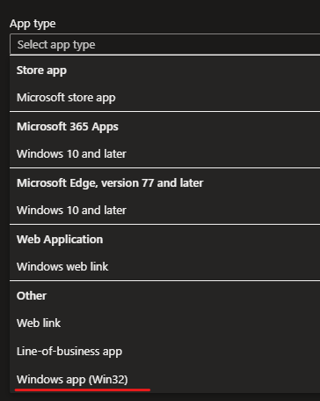**Choose Windows app (win32)**

**Choose your .intunewin file**

**As detection rule I use file and version. You can use registry as well.**

**Choose a group for your workstations.**

