Information Technology Solutions



The Fiontar system can continually gather data from a large number of sources and produce analysis on specific citations such as companies, industry production or geographical locations. Specialist dictionaries comprising of company names, industry specific terms or language can be used to accurately measure and capture nuances of industry relevant news. For example the user can follow various citations to a specific oil company, its operations in a country, its exploration and production habits and its influence in the industry.

Market Turbulence

Markets where assets are traded involve participants with different time horizons and different perspectives. Often news is obtained from different sources and used to asses an asset or market performance. The task of reading, aggregating, analysing and assimilating this information is time consuming and often not consistent. Our system provides a balanced approach to collecting and delivering insights into news analysis.

Special Languages

The Fiontar system can deal with specialisms (financial assets, political campaigns, M&A news) by using specially constructed dictionaries of domain specific terms organised as a hierarchy.

**The Impact of Information**

The Fiontar Affect Analysis System is a tool that is built upon a method of computing the impact of information. The system automates the process of aggregating and analysing large volumes of structured and unstructured news and text and outputs meaningful and informative data. The quantified information can then be used to support financial analysis, trading, risk management and any study or analysis where the impact of news is important.

Fiontar News Impact Analysis

**The Business Challenge**

The task of collecting, analysing and organising useful data is essential for any company or market participant in today’s business world. Extracting meaningful information from structured and unstructured data can give participants an edge over market rivals.

The behaviour of market participants and the sentiment driving their actions has become a major focus of interest. News about the markets is obtained from many sources and used to give an overall impression of the financial market. Firms, investors and speculators attempt to aggregate as much information as they believe relevant to gain an advantage on price determination. This has led to the advent of modeling investor behaviour. Such models are now being used to underpin economic policies, explain irrational market movements and even account for financial booms or busts.

This has been the motivation for why many firms to try and account for the markets sentiment and behaviour through the analysis of unstructured news and media.

Generating Opinion from News and Media

magna aliquam erat volutpat. Ut wisi enim ad minim

veniam, quis nostrud exerci tation ullamcorper. Et iusto odio dignissim qui blandit praesent luptatum zzril delenit augue duis dolore te feugait nisl ut aliquip ex ea commodo.Et iusto odio dignissim qui blandit praesent luptatum zzril delenit augue duis dolore te feugait nulla facilisi. Lorem ipsum dolor sit amet, conse ctetuer adipiscing. Feugait nulla facilisi. Lorem ipsum dolor sit amet, conse ctetuer laoreet dolore magna aliquam erat volutpat. Ut wisi enim ad minim veniam, quis exerci tation ullamcorper suscipit lobortis nisl ut aliquip dolore te feugait nulla facilisi ex ea.

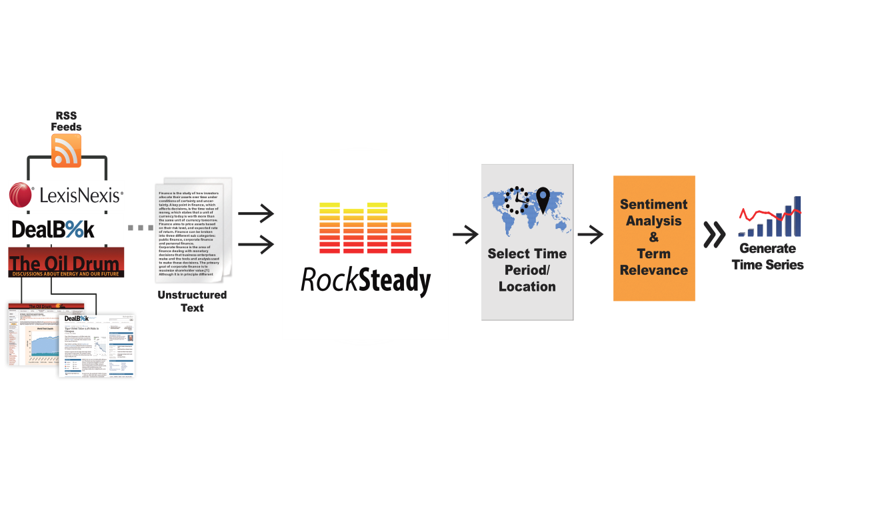

Fiontar

Named Entity Analysis

The identification of names, places and events can assist specific case studies. News related to particular entities such as a financial institution or political event can be collected, analysed and assessed.

Quantitative Analysis

After fusing the quantified news and user specified data (such as asset prices, financial indices) the system can begin by conducting an exploratory analysis of the dataset to reveal patterns or trends. A statistical prediction model can be produced to isolate and indicate the effect of news. Model robustness can be checked and help in interpreting results.

Customised Solutions

The system can run on historical data, back test and produce independent analyses. A cloud version of Fiontar produces real time analysis and

delivery of data in a range of usable formats and visualisations.

**Benefits**

The Fiontar system can aggregate information generate data that would be difficult if not impossible by non-computational methods.

Characterisation and quantification of news and qualitative information facilitates a more in depth analysis of the effect of news.

By capturing the impact of news the system captures valuable information not easily accounted for. The data output can be representative of a market’s mood and contribute to managing risk, improve market timing or trade execution.

System Highlights

Real-Time News Collection and Storage

Collect, format, store and display text data, continuous news streams or historical collections of news.

Data Fusion

New is aggregated, scaled to various time frequencies and merged with financial data.

News Impact Analysis

Fiontar can be applied across many disciplines and assess the impact of news on price movement of financial instruments, political campaigns or a firm’s fundamental value.

*

Trinity College Dublin

Ireland

www.tcd.ie

System Overview