Lab: Lists
Submit your solutions here: https://alpha.judge.softuni.org/contests/lists-lab/5313

Strange Zoo
You are at the zoo, and the meerkats look strange.
You will receive 3 strings on separate lines, representing the tail, the body, and the head of an animal in that order. Your task is to re-arrange the elements in a list so that the animal looks normal again:
- On the first position is the head;
- On the second position is the body;
- On the last one is the tail.

Example
Input | Output
my tail  my body seems on place  my head is on the wrong end! | ['my head is on the wrong end!', 'my body seems on place', 'my tail']
tail  body  head | ['head', 'body', 'tail']
T  B  H | ['H', 'B', 'T']

Hints
We start by reading the three parts of the body:
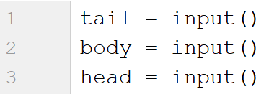
Then, we create a list containing those three elements:
We swap the elements and print the list:

Courses
On the first line, you will receive a single number n. On the following n lines, you will receive names of courses. You should create a list of courses and print it.

Example
Input | Output
2  PB Python  PF Python | ['PB Python', 'PF Python']
4  Front-End  C# Web  JS Core  Programming Fundamentals | ['Front-End', 'C# Web', 'JS Core', 'Programming Fundamentals']

Hints
We read the number n from the console, and we create an empty list:
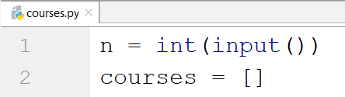
Then, we create a loop that reads each course and adds it to the list:
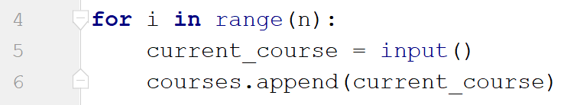
Finally, we print the list:
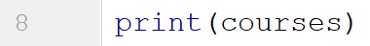

List Statistics
On the first line, you will receive a number n. On the following n lines, you will receive integers. You should create and print two lists:
- One with all the positive (including 0) numbers
- One with all the negative numbers
Finally, print the following message:
"Count of positives: {count_positives}
Sum of negatives: {sum_of_negatives}"

Example
Input | Output
5  10  3  2  -15  -4 | [10, 3, 2]  [-15, -4]  Count of positives: 3  Sum of negatives: -19
6  11  2  35  599  31  20 | [11, 2, 35, 599, 31, 20]  []  Count of positives: 6  Sum of negatives: 0

Hints
We start by reading the number n:
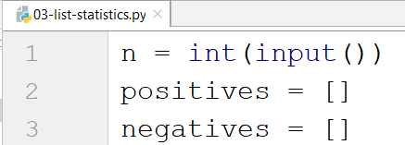
Then, we create a loop that reads the current number and checks if it is positive or not:
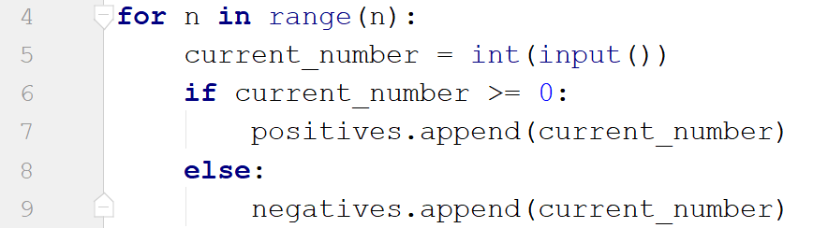
- If it is, we add it to the list of positive numbers.
- If it is not, we add it to the list of negative numbers.
Then we print the three lines:
- To get the count of the positives, we can use the len function.
- To get the sum of the negatives, we can use the sum function.

Search
On the first line, you will receive a number n. On the second line, you will receive a word. On the following n lines, you will be given some strings. You should add them to a list and print them. After that, you should filter out only the strings that include the given word and print that list too.

Example
Input | Output
3  SoftUni  I study at SoftUni  I walk to work  I learn Python at SoftUni | ["I study at SoftUni", "I walk to work", "I learn Python at SoftUni"]  ["I study at SoftUni", "I learn Python at SoftUni"]
4  tomatoes  I love tomatoes  I can eat tomatoes forever  I don't like apples  Yesterday I ate two tomatoes | ["I love tomatoes", "I can eat tomatoes forever", "I don't like apples", "Yesterday I ate two tomatoes"]  ["I love tomatoes", "I can eat tomatoes forever", "Yesterday I ate two tomatoes"]

Hints
We start by reading the number n and the word we would search for. Then, we create our empty list:
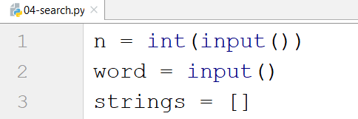
We create a loop that adds all the strings to our list. After that, we print it:
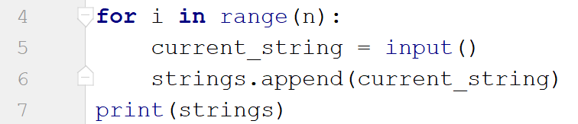
Finally, we create another loop to remove the strings we do not need by iterating through the strings reversed (so we don't skip elements when removing) and print the list again:
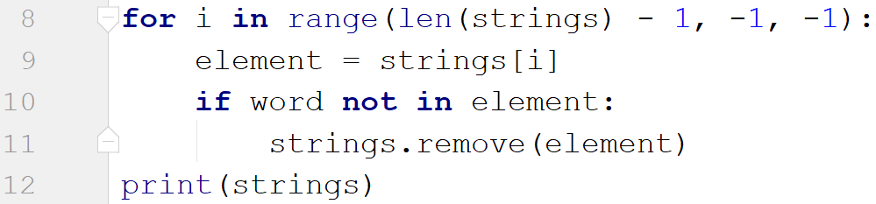

Numbers Filter
On the first line, you will receive a single number n. On the following n lines, you will receive integers. After that, you will be given one of the following commands:
- even
- odd
- negative
- positive
Filter all the numbers that fit in the category (0 counts as a positive and even). Finally, print the result.

Example
Input | Output
5  33  19  -2  18  998  even | [-2, 18, 998]
3  111  -4  0  negative | [-4]

Hints
First, we read the number n. Then, we create the numbers list and the filtered list:
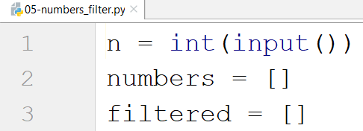
We create a loop that reads all the numbers and adds them to the list:
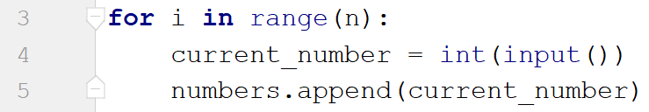
Then, we read the command and check for all the cases:
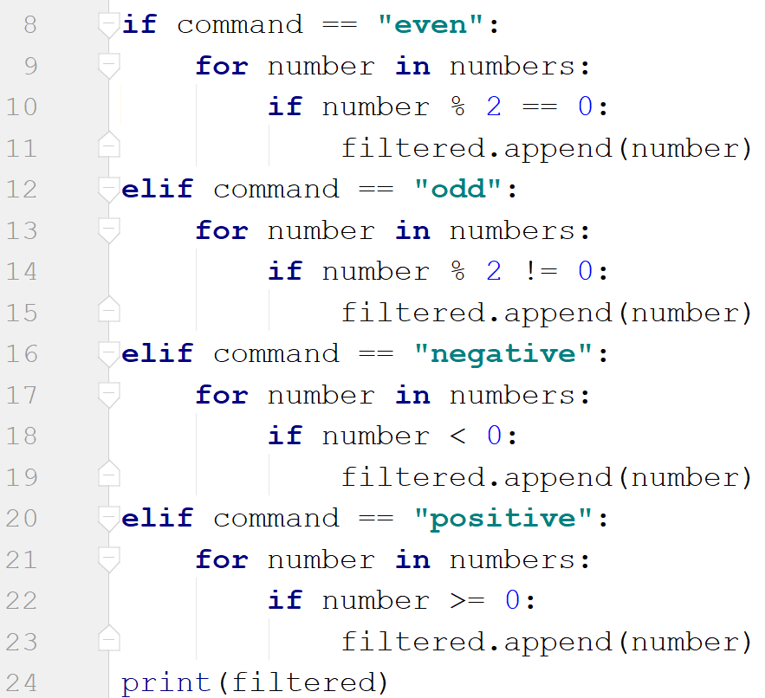
Finally, we print the filtered list.

