Lab: Dictionaries
Submit your solutions here: https://alpha.judge.softuni.org/contests/dictionaries-lab/5307

Bakery
Your first task at your new job is to create a table of the stock in a bakery, and you really don't want to fail on your first day at work.
You will receive a single line containing some food (keys) and quantities (values). They will be separated by a single space (the first element is the key, the second – is the value, and so on). Create a dictionary with all the keys and values and print it on the console.

Example
Input | Output
bread 10 butter 4 sugar 9 jam 12 | {'bread': 10, 'butter': 4, 'sugar': 9, 'jam': 12}
eggs 3 sugar 7 salt 1 butter 3 | {'eggs': 3, 'sugar': 7, 'salt': 1, 'butter': 3}

Hint
Let us start with reading the input and creating an empty dictionary:
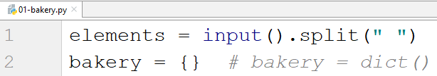
- Note that there are 2 ways of creating a dictionary (with the curly braces or using the dict() method).
Since we know that we will get key-value pairs, we can use a for-loop with step 2. We take the key and the value and add them to the dictionary, and after the loop is over, we print it:
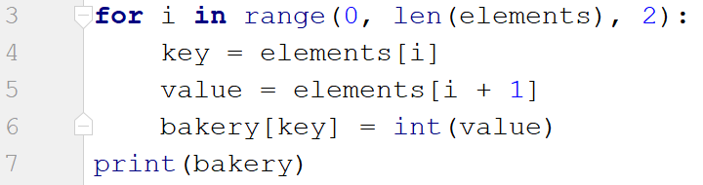
- Note that the value must be an integer (since it is a quantity).

Stock
After you have completed your first task, your boss decides to give you another one right away. Now, not only do you have to keep track of the stock, but you also need to answer customers about product availability.
You will be given key-value pairs of products and quantities (on a single line separated by space). On the following line, you will be given products to search for. Check for each product. You have 2 possibilities:
- If you have the product, print "We have {quantity} of {product} left".
- Otherwise, print "Sorry, we don't have {product}".

Example
Input | Output
cheese 10 bread 5 ham 10 chocolate 3  jam cheese ham tomatoes | Sorry, we don't have jam  We have 10 of cheese left  We have 10 of ham left  Sorry, we don't have tomatoes
eggs 5 bread 10  bread eggs | We have 10 of bread left  We have 5 of eggs left

Hint
We repeat the steps from the previous task for reading the products and adding them to the dictionary.
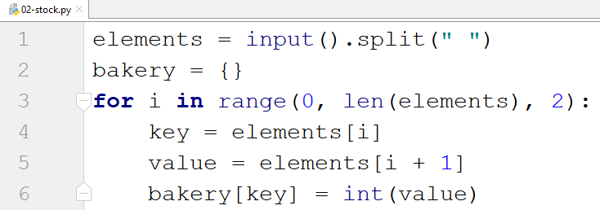
Next, we read the products we have to search for and check for each of them.
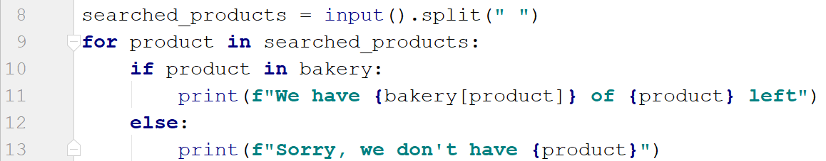

Odd Occurrences
Write a program that prints all elements from a given sequence of words that occur an odd number of times (case-insensitive) in it.
- Words are given on a single line, space-separated.
- Print the result elements in lowercase, in their order of appearance.

Examples
Input | Output
Java C# PHP PHP JAVA C java | java c# c
3 5 5 hi pi HO Hi 5 ho 3 hi pi | 5 hi
a a A SQL xx a xx a A a XX c | a sql xx c

Hints
Read a line from the console split it by a space, and create a dictionary:
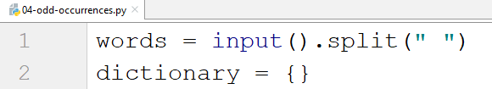
Create a loop and check for each word (lower case) if it is in the dictionary, and if it is not, add it:
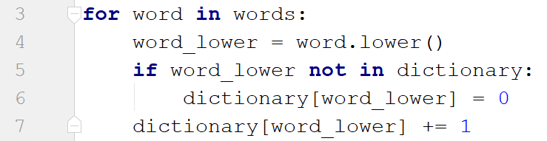
Then create another loop using the items() method and check if the number of occurrences of the current word is odd. If it is, print it:
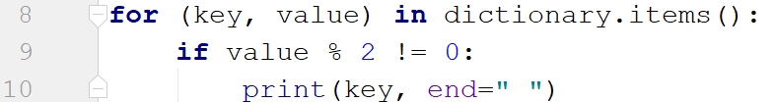

Word Synonyms
Write a program, which keeps a dictionary with synonyms. The key of the dictionary will be the word. The value will be a list of all the synonyms of that word. You will be given a number n – the count of the words. After each term, you will be given a synonym, so the count of lines you should read from the console is 2 * n. You will be receiving a word and a synonym each on a separate line like this:
- {word}
- {synonym}
If you get the same word twice, just add the new synonym to the list.
Print the words in the following format:
{word} - {synonym1, synonym2 … synonymN}

Examples
Input | Output
3  cute  adorable  cute  charming  smart  clever | cute - adorable, charming  smart - clever
2  task  problem  task  assignment | task – problem, assignment

Hint
We start by reading the number n and creating the dictionary with synonyms:
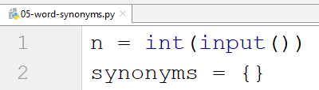
Then we create a for loop to read the word-synonym pairs:
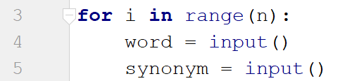
We check if the word is not in the dictionary, and in that case, we set its value to an empty list (since one word can have multiple synonyms), and we append the new synonym to that list:
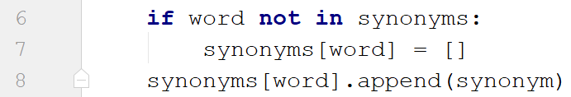
Finally, we print the result:

