Virtual Desktop Infrastructure (VDI)

http://www.techopedia.com/definition/26809/virtual-desktop-infrastructure-vdi

Definition - What does Virtual Desktop Infrastructure (VDI) mean?
- Virtual desktop infrastructure (VDI) is a virtualization technique enabling access to a virtualized desktop, which is hosted on a remote service over the Internet. It refers to the software, hardware and other resources required for the virtualization of a standard desktop system.
- VDI is also known as a virtual desktop interface.

Techopedia explains Virtual Desktop Infrastructure (VDI)
- VDI is a shadow copy of the desktop including its OS, installed applications and documents, which are stored and executed entirely from the server hosting it. VDI provides users the ability to access their desktop remotely, often even from a handheld device because the entire process of executing the interface is done at the central server.
- VDI operates by storing OS preferences, software applications, document and other customized data on a server in the cloud. In theory, or ideally, the user experience is the same as on a physical desktop.
- Virtual desktop interfaces were primarily design to provide global access to desktop systems. They are also used in designing disaster recovery and backup solutions. This is done by routinely updating the desktop’s data on a remote server and enabling the interface for users in case of a system disruption.

Desktop virtualization
From Wikipedia, http://en.wikipedia.org/wiki/Desktop_virtualization#Virtual_desktop_infrastructure
Desktop virtualization is software technology that separates the desktop environment and associated application software from the physical client device that is used to access it.
Desktop virtualization can be used in conjunction with application virtualization and (Windows) user profile management systems, now termed "user virtualization," to provide a comprehensive desktop environment management system. In this mode, all the components of the desktop are virtualized, which allows for a highly flexible and much more secure desktop delivery model. In addition, this approach supports a more complete desktop disaster recovery strategy as all components are essentially saved in the data center and backed up through traditional redundant maintenance systems. If a user's device or hardware is lost, the restore is much more straightforward and simple, because basically all the components will be present at login from another device. In addition, because no data is saved to the user's device, if that device is lost, there is much less chance that any critical data can be retrieved and compromised. Below are more detailed descriptions of the types of desktop virtualization technologies that will be used in a typical deployment.
More: http://www.slideshare.net/datacenters/vdi-how-it-works
--------------------------------------------------------------------------------------------------------------------------

Virtual Desktop Infrastructure (VDI) Overview
by Patrick Rouse [Published on 20 Dec. 2006 / Last Updated on 20 Dec. 2006]

http://www.virtualizationadmin.com/articles-tutorials/vdi-articles/general/virtual-desktop-infrastructure-overview.html

Introduction
In the past few years there has been and continues to be a lot industry buzz around virtualization. At this point most are familiar with the concept of server virtualization and consolidation using VMware ESX or Microsoft Virtual Server. Additionally, many have been successful using application virtualization and streaming technologies like Microsoft Softricity Softgrid to address application compatibility, version control and deployment issues.
VDI is VMware’s designation for the hosting and virtualization of a individual Client OS like Windows XP Professional, Windows Vista or Linux on VMware ESX. The intent is to be able to deploy, secure and manage enterprise desktops in the data center.
For those used to managing server based computing environments, consisting of Windows Terminal Servers and Citrix, managing VDI is definitely similar task. The difference is that instead of managing numerous centralized, multi-user server operating systems, one would be managing potentially hundreds, or thousands of centralized, virtualized single user operating systems.

Architectural Overview
VDI is not one product, but rather a technology consisting of five separate components:
- Thin Client Computer
  - Most leading thin client manufacturers are coming out with new devices geared toward VDI. The only differences between these devices and their standard thin client device offerings is one or more built-in 3rd Party Connection Brokers. Some are also offering local graphics acceleration where MPEG1 & MPEG2 are rendered locally using the thin client’s display adapter, while others are offering VOIP Soft Phone Support. Although any computer could act as a thin client device, true thin client terminal are more often the choice for VDI and companies don’t want to continue to manage the client OS. Some examples of thin client devices geared towards VDI are:
… (deleted)
- 3rd Party Connection Broker
  - The Connection Broker is the brains of the architecture that determines which Remote Desktop Host (XP Pro or Vista) a user is assigned or connected to. The broker is often a full-blown management product allowing for the automatic deployment and provisioning of Remote Desktop Hosts. There are several vendors offering connection brokers, including the following:
… (deleted)
- VMware VirtualCenter
  - Software component for managing ESX Server and libraries of Virtual Machines
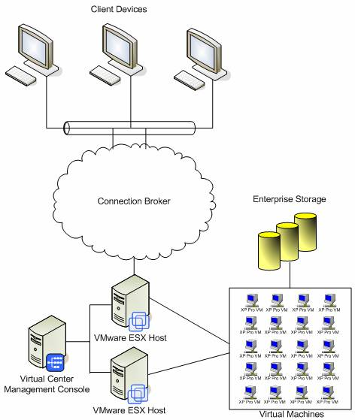

Usage Scenarios
There are many advantages and some disadvantages to any VDI Solution, but some common usage scenarios are:
  - Enterprise Desktop Consolidation – many organizations struggle with management of their client computers. Tasks like procurement of desktop computer hardware, deploying or patching desktop operating systems, updating antivirus signature, securing data, and desktop support become more and more challenging as the size of an organization grows, and the disbursement of employees across multiple locations increases. Replacing all or a bulk of an organization’s computer workstations with expendable thin client terminals and managing the client OS and applications in a centralized location is something most CIOs would love to be able to do.
  - Remote Developer Support – as companies have outsourced all or some of their development efforts, some problems have arisen. How does one provide a remote application developer with a powerful, secure working environment, while protecting the parent organization’s source code and intellectual property. VDI addresses these issues by providing a remote developer with one or a group of virtual machines that can be used, rebooted, destroyed and easily rebuilt. Since the working environment is contained in the corporate data center, source code remains in the hands of the owners.
Advantages of VDI
  - Reduced cost in purchasing desktop computers, as thin clients often last two to three times longer than a desktop computer
  - Centralized Client OS Management
  - Rapid Client Deployment
  - Reduction in desktop support costs
  - Reduction in electricity costs, as thin client computers use only a fraction of amount of energy that is used by a desktop computer.
  - Improved Data Security
  - Secure Remote Access, as most connection brokers offer an SSL VPN Component and Web Portal
  - Compliance with HIPAA and Sarbanes Oxley (SOX)
  - Fewer Application Compatibility Problems than with Terminal Server and Citrix, as users have their own, single user OS.
Disadvantages of VDI
  - Many items that are problematic in Terminal Server and Citrix environments exist in VDI, i.e.:
    - Printing often requires a 3rd party add-on
    - PDA Sync not supported
    - Scanning is not natively supported
    - Bi-Directional Audio is not natively supported
    - Display protocols not suitable for Graphics Design
    - Requires low-latency connection between the client and virtual infrastructure
  - Requires Enterprise Class Server Hardware and Storage Area Network
  - For VMs permanently assigned to specific users, these machines need to be patched just like a physical client computer.
  - Requires IT Staff skilled with VMware and terminal server. These are usually different staff, as the people using VMware are historically using it for consolidating servers, whereas those skilled with terminal server or Citrix are used to dealing with end user applications and devices. Although talk of VDI does not typically mention terminal server, every XP Pro or Vista Remote Desktop Host is a single user terminal server.
  - Does not scale as well as terminal server, which often can host 25 to 100 users per dual CPU server. VDI will likely scale from 10 to 20 VMs per dual CPU server, depending on how each VM is configured.

Conclusion
Virtual Desktop Infrastructure acceptance is becoming more widespread every day. This was evident by the number of VDI sessions at the 2006 VMWORLD Conference, and the percentage of the 7000 attendees that flooded them. There is also no lacking in the number of vendors offering VDI solutions that work with VMware. The question will be which solution to choose, and which solutions still exist a few years from now. As usually happens, new technology causes a lot of companies to jump on the bandwagon. It usually takes a few years to weed out those with solid product and strategy that will continue to grow with the needs of their customers.

