**Hive Class 3 Assignment**

Downloaded Vehicle Sales Data and stored it in Hadoop file system

Create Table sales_order_csv using SerDe with attributes present in spreadsheet

Describe the structure of sales_order_csv

Load data from Hive Warehouse into table.



Query the data present in the table

Create sales_order_orc table

Describe the format of the orc table.

Copy data from sales_order_csv to sales_order_orc.

***Solutions:***

1. Calculate total sales per year

**Query:** select year_id,sum(sales) `Total Sales` from sales_order_orc group by year_id

order by `Total Sales` desc;

**Output:**

Year Total Sales

2004 4724162.599999997

2003 3516979.540000001

2005 1791486.71

**Screen Shot:**

1. Find a product for which maximum orders were placed

**Query**: select productcode,count(ordernumber) as `TotalOrders`

from sales_order_orc

group by productcode

order by `TotalOrders` desc limit 1;

**Output:**

S18_3232 52

**ScreenShot**:

1. Calculate the total sales for each quarter

**Query:** select qtr_id,sum(sales) from sales_order_orc

group by qtr_id;

**Output:** Quarter 1: 2350817.73

Quarter 2: 2048120.29

Quarter 3: 1758910.80

Quarter 4: 3874780.01

1. In which quarter sales was minimum

**Query:**

select qtr_id,sum(sales) `TotalSales` from sales_order_orc

group by qtr_id

order by `TotalSales` asc limit 1

;

**Output: 3**

1. In which country sales was maximum and in which country sales was minimum

Query(Max):

select country,SUM(sales) `TotalSales`

from sales_order_orc

group by country

order by `TotalSales` desc limit 1

Output: **USA**



(Min):

select country,SUM(sales) `TotalSales`

from sales_order_orc

group by country

order by `TotalSales` asc limit 1

Output:**Ireland**

1. Calculate quartelry sales for each city

Query:

select country,

sum(case when qtr_id = '1' then sales else 0 end) as `Q1 Sales`,

sum(case when qtr_id = '2' then sales else 0 end) as `Q2 Sales`,

sum(case when qtr_id = '3' then sales else 0 end) as `Q3 Sales`,

sum(case when qtr_id = '4' then sales else 0 end) as `Q4 Sales`

from sales_order_orc

group by country;

Output:

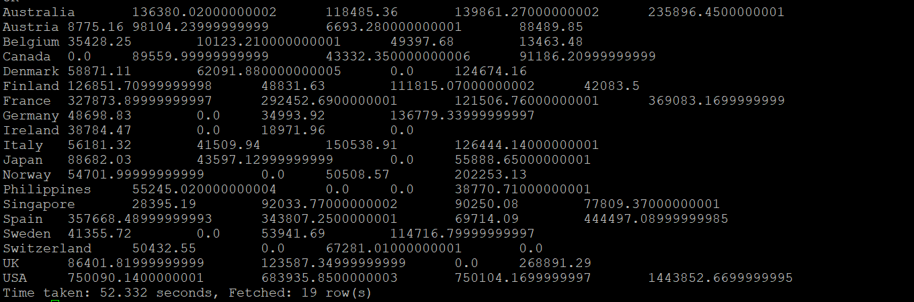

1. Find a month for each year in which maximum number of quantities were sold