**A cooler of feces.**

**The cost of reagents.**

**All these body parts.**

**An IACUC meeting.**

**An incubator full of bees.**

**The federal shutdown.**

**The odds of getting a grant.**

**Frog trampolines.**

**The Promotion and Tenure Committee.**

**Annual Reports.**

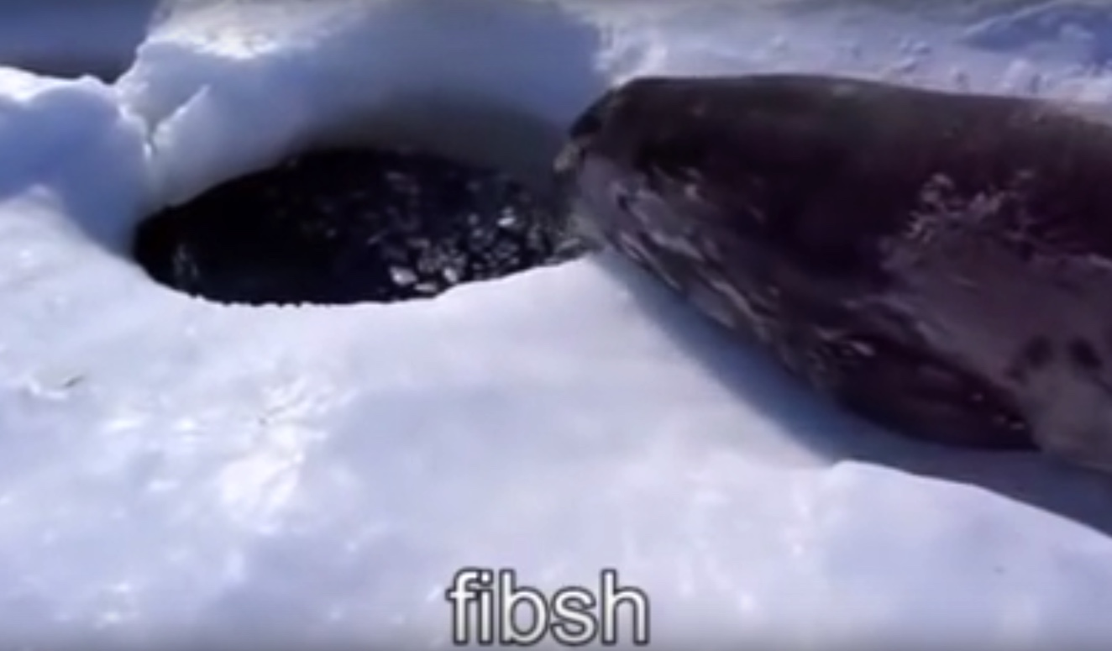**A -80 freezer failure.**

**Anoxic sediment.**

**Manure-induced asphyxia.**

**Publishing.**

**Water Quality Parameters.**

**The Department of Natural Resources.**

**The department van.**

**Friggin’ trees.**

**I should be writing.**

**Citizen Science.**

**Pipetting until your fingers are numb.**

**Applied math.**

**Models.**

**Raw sewage.**

**Internal organs.**

**Academic Twitter.**

**#SciComm**

**Bees?**

**Global Weirding.**

**Impostor syndrome.**

**Pornithology.**

**Bird fembots.**

**Rapid Unscheduled Disassembly.**

**Chlorine Trifluoride (ClF3).**

**E. coli.**

**Renovation-induced asbestosis.**

**Facilities Management.**

**That stain on the lab couch.**

**Continental climate.**

**Field season.**

**Another lake.**

**Friggin’ varmints.**

**Untrustworthy cows.**

**A broken solar panel.**

**ISCOs.**

**Bioremediation.**

**Nitrogen.**

**STEM.**

**STEAM.**

**Unidentified remains.**

**An owl pellet.**

**Forgetting the tape measure.**

**Survey flags!**

**GIS.**

**R.**

**Matlab.**

**Two flat tires in the field.**

**Running out of gas.**

**What-about-ism.**

**Climate deniers.**

**Biogeochemistry.**

**Sustainability.**

**Industry partners.**

**Geo-engineering.**

**Beer.**

**Fungus.**

**Negative results.**

**P≥0.051**

**R2=1**

**That one undergrad.**

**A P-card.**

**Construction.**

**Earlier today it ate itself.**

**Failure.**

**Snails?**

**A clever octopus.**

**Frogs.**

**Bioindicators.**

**A shmoo.**

**Compressed gases.**

**99.999% Ethanol.**

**The Least Publishable Unit.**

**Administrative paperwork.**

**A hiring committee.**

**Research.**

**Teaching.**

**A horse.**

**The random parts bin.**

**Organization.**

**Media attention.**

**Machine Learning.**

**Recursion.**

**Computer Scientists.**

**Supercomputers.**

**My collaborators.**

**My students.**

**My lab.**

**My department head.**

**My mentoring committee.**

**My college.**

**My dean.**

**My subject librarian.**

**My department accountant.**

**My department administrator.**

**My DGS.**

**My thesis.**

**My dissertation.**

**My last paper.**

**My favorite café to work in.**

**Mim’s.**

**Lori’s.**

**A mysterious discoloration.**

**Coffee.**

**More coffee.**

**My caffeine level.**

**My h-index.**

**Botflies.**

**International courses in areas prone to volcanism.**

**Lyme disease.**

**Mosquitoes the size of sparrows.**

**Ticks!**

**Malaria.**

**Phrenology.**

**A test tube of Nitrogen Triiodide.**

**Hot dish.**

**Safety glasses.**

**Laser cutting PVC.**

**Decaf.**

**A cat lying on my keyboard.**

**Plot fees.**

**Prefamulated amulite.**

**Falling off a cliff.**

**A 55 gallon drum of HCl (conc.).**

**A faulty outlet.**

**Alpha centauri.**

**Exoplanets.**

**Super-earths.**

**A parsec.**

**The passive voice.**

**Passive-aggressive post-it notes on lab equipment.**

**Reviewers.**

**Nicknames on conference nametags.**

**My Twitter presence.**

**My personal vehicle.**

**Liability waivers.**

**Informed consent.**

**Low Earth Orbit.**

**Cubesats.**

**A ball of flame on the ISS.**

**3D Printers.**

**A fried circuit board.**

**A car battery.**

**Golf ball sized hail.**

**Snow.**

**An autoclave with a leaky seal.**

**An autoclave.**

**A pressure washer.**

**All the leaf blowers.**

**Suction.**

**Gametes.**

**Thorns.**

**A friendly goat.**

**A hawk attacking your field apparatus.**

**Territorial birds.**

**A skunk.**

**An overly friendly porcupine.**

**Sutures.**

**A tetanus shot.**

**Rabies.**

**Marauding raccoons.**

**A ping-pong ball.**

**Tracking collars.**

**A GPS with a dead battery.**

**No signal.**

**Podcasts.**

**Noise-cancelling headphones.**

**More time.**

**Orbital debris.**

**A busted seismograph.**

**Ground-penetrating radar.**

**A Native American burial mound.**

**A Secchi disk.**

**Too many drones.**

**Fishing for science.**

**Canoes.**

**Heat stroke.**

**Frostbite.**

**A personal floatation device.**

**Hypothermia.**

**Urine as clear as a mountain stream.**

**Dehydration.**

**A water bottle used to store a sample.**

**A very long stick.**

**An endoscope.**

**Expensive equipment on a flimsy old rope.**

**A storm drain.**

**Poisonous herps.**

**Venomous snakes.**

**A cute turtle.**

**Wildlife.**

**A Fermi approximation.**

**Microsoft products.**

**Spreadsheets.**

**My lab notebook.**

**The mating habits of *Anas platyrhynchos*.**

**Phospholipid bilayers.**

***Metasequoia glyptostroboides.***

**My building’s cockroach colony.**

**Surplus.**

**That one dumpster with the good lab equipment.**

**Whiteboard hands.**

**A plethora of display adapters, none of which is the right one.**

**A belt buckle with the NSF logo on it.**

**Panic!**

**Remote Sensing.**

**A hamster running in its wheel.**

**Soil, not dirt.**

**Rocks.**

**Robots!**

**Mountain Dew.**

**Red Bull.**

**My office booze stash.**

**My office chocolate stash.**

**April fools day pranks.**

**Zenodo.**

**GitHub.**

**Open access.Crowdfunding.**

**The lab fridge.**

**A flock of angry geese!**

**Rednecks with shotguns.**

**An American flag draped over instrumentation.**

**Fire.**