In-Stream Monitoring During an Ice-Melt Event

Pete Marchetto, Soil and Water Lab, B&EE

# Introduction

In order to test the efficacy of different methods of depth gauging in streams, a multi-parameter stream gauge and logger was deployed off the bank of Cascadilla Creek near the intersection of Synchrotron Dr., Pine Tree Rd., and Dryden Rd. in Ithaca, NY. The logger had capabilities to acquire parametric data for temperature, turbidity, and conductivity, along with the output from the depth gauge. The deployment site can be seen in Fig. 1.

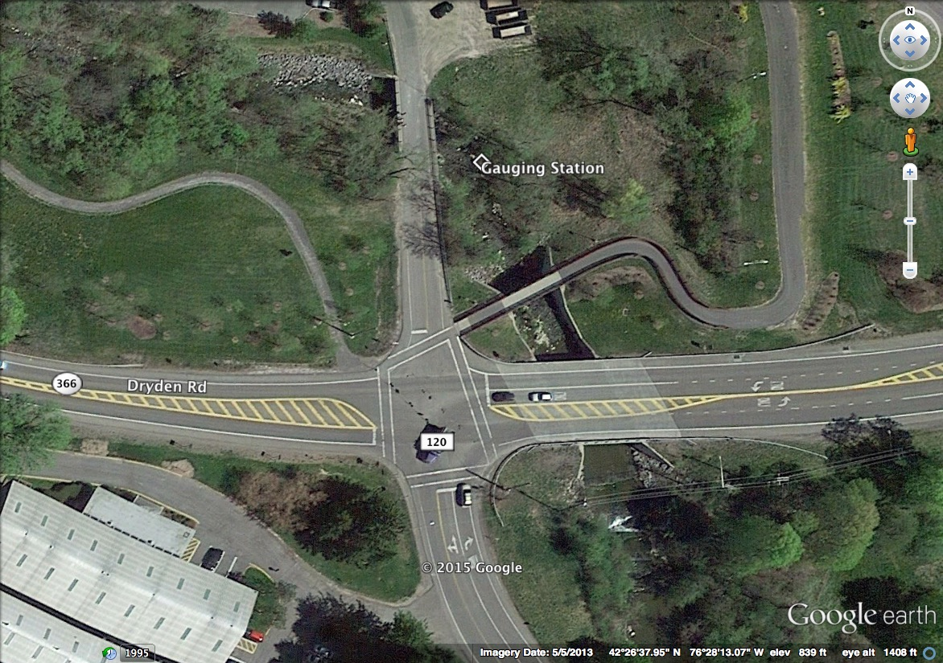

Fig. 1: Location of gauging station.

# Materials and Methods

## Construction

The gauging station was constructed of four major parts: a depth sensor, a sensor cluster for temperature, conductivity, and turbidity, a solar panel, and the logger box itself, as seen in Fig. 2. The logger itself is constructed from an Arduino Pro Mini Microcontroller, OpenLog µSD card logger, Boost Converter, SunnyBuddy solar charger, and 6 Ah Li-Po battery stack (all from SparkFun Electronics, Niwot, CO, USA), as well as a GP-635T GPS receiver (ADH Technology, Taipei, Taiwan). The depth gauge, as seen in Fig. 3, is constructed from a 1 m piece of 2” PVC pipe which has been slit down one side and spray painted flat black inside, a blind endcap, and a GP2Y0A02YK0F proximity sensor (Sharp, Camas, WA, USA), with a standard 40 mm diameter white ping pong ball as a float. Finally, the sensor cluster, as seen in Fig. 4, consists of a turbidity sensor made from a full-spectrum white LED and a CdS photoresistor waterproofed and placed 1 cm apart, a conductivity sensor made from two pieces of 0.5 mm graphite pencil lead placed 5 mm apart, and an LM50 full-range temperature sensor (Texas Instruments, Dallas, TX, USA).



Fig. 2: Block diagram of logger system (left), and logger internals (right). Circles represent ports, with numbers of conductors inside. The 2-port is connected to the solar panel, while the 4-port is connected to the depth gauge, and the 8-port is connected to the sensor cluster.

**

Fig. 3: Depth gauge consisting of pipe, cap, float, and optical proximity sensor.

**

Fig. 4: Sensor cluster schematic with light gate turbidity sensor, LM50 temperature sensor, and graphite conductivity contacts.

## Emplacement

The logger was emplaced on top of a retaining wall above Cascadilla Creek, while the two sensors were run down into the stream along the ice-water division, as seen in Fig. 5.

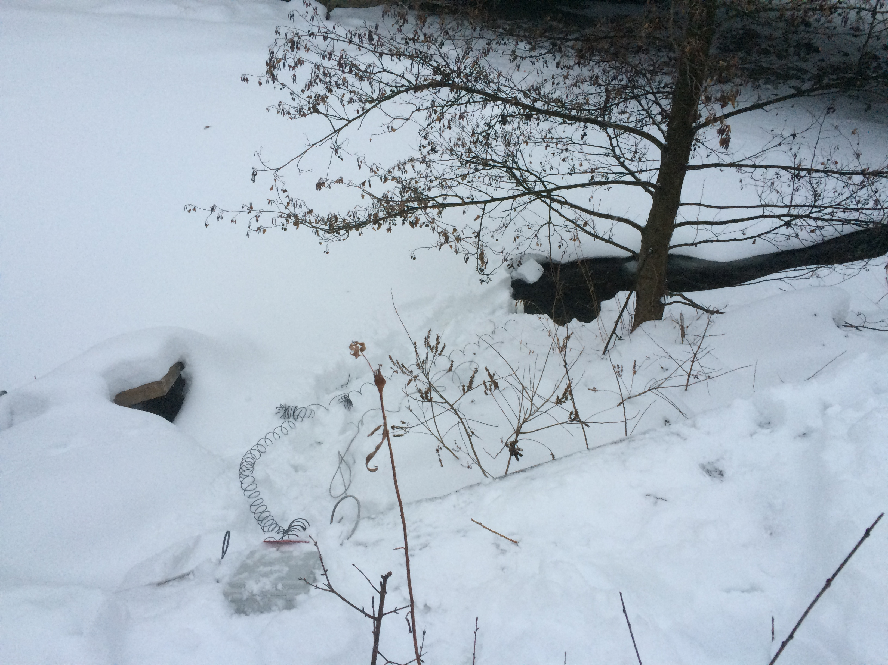

Fig. 5: Logger and sensor emplacement. The logger is at the lower left of the picture, while the sensors are at the ice-water interface at the end of the coiled wire near the center of the picture, under the tree.

# Results and Analysis

A considerable amount of data was retrieved later. The time series of interest, during an ice melt event, can be seen in Fig. 6 below. The actual values have not been calibrated with real units, but the trends stand out. During this event, the temperature came up from the freezing point to allow ice to melt. The depth then increased due to additional liquid water in the flow channel. Finally, the conductivity and turbidity both began to decrease, presumably because of dilution of silt and salt in the creek due to additional freshwater from the melting ice.

Fig. 6: Time series of turbidity, conductivity, temperature, and depth during an ice melt event. Values are in Least Significant Bits, with a sensitivity of 4.88 mV/LSB.

A further correlation analysis was done on the three dependent variables, as seen in Fig. 7 below. Temperature was given priority as an independent variable, as it is intrinsic to the environment. The graph in Fig. 7 clearly shows that temperature then correlated very well (R2≥97.5%) with the other three measured variables, giving even more evidence to the hypothesis of this being an ice melt event.

Fig. 7: Temperature correlation of turbidity, conductivity, and depth. As above, the sensitivity is 4.88 mV/LSB.

# Conclusion

The logger still needs work, especially in creating GPS timestamps for the measurements that it takes. It also still needs to be calibrated so that useful units might be attached to its outputs, rather than just arbitrary dependences on LSBs. However, it has recorded a natural process with high precision, and did all of this while its users were safe and warm over the course of hours. This certainly is an encouraging result that would motivate future work.