Wentworth Institute of Technology

COMP4960 – Software Engineering

Instructors: Kenechukwu Kingsley Okeke, Joshua Gyllinsky

Software Design Document

for

Guessify, Spotify Guessing Game

Version 3.0

Prepared By

Team: Guessify, Group 3

James Guiden, guidenj@wit.edu  
Alec Montesano, montesanoa@wit.edu  
Owen Conlon, conlono@wit.edu

GitHub Link

https://github.com/jag-dev/guessify

April 12th, 2023

Contents

Revision History 3

1. Introduction 4

1.1. Document purpose 4

1.2. Product overview 4

1.3. Product functionality 5

1.4. Definitions 5

1.5. Acronyms and abbreviations 5

2. System requirements 5

2.1. Functional requirements 5

2.2. Non-functional requirements 8

2.3. Other requirements 8

3. System architecture 9

3.1. Overall architecture 9

3.2. Components mapping 11

3.3. Technology stack selection 18

4. System Design 19

4.1. UI 20

4.2. Sequence/activity diagrams 25

5. Others 29

6. Test plan 29

6.1. Connection with Spotify 29

6.2. Selecting a Playlist 29

6.3. Game Options 29

6.4. Playing Rounds 30

6.5. Leaving a Game 30

7. References 31

# Revision History

| **Date** | **Version** | **Description** | **Author(s)** |
| --- | --- | --- | --- |
| *03/20/2023* | *1.1* | *Wrote document purpose, defined problem statements, did problem statement and proposed solution write up* | *James Guiden* |
| 03/20/2023 | 1.2 | Created the overall architecture diagram | Alec Montesano |
| 3/21/2023 | 1.3 | Did novelty writeup, defined product functions, revised non-functional and other requirements | James Guiden |
| 3/21/2023 | 1.4 | Revised functional requirements, added definitions and acronyms | Owen Conlon |
| 3/22/2023 | 1.5 | Did front-end technology stack write up, did UI sketch diagrams | Owen Conlon |
| 3/22/2023 | 1.6 | Did back-end technology stack writeup, worked on class diagram, worked on UI sketches | James Guiden |
| 3/23/2023 | 1.7 | Completed sections 3.1 and 3.2 |  |
| 3/23/2023 | 1.8 | Built entity relationship diagram, did section 5 write up, added references | Owen Conlon |
| 3/24/2023 | 1.9 | Finished class diagram, did section 6.1 and 6.2 test plans | James Guiden |
| 3/25/2023 | 2.0 | Completed section 4.3 sub function diagrams | Alec Montesano |
| 3/25/2023 | 2.1 | Finished test plan sections, finished UI sketches | James Guiden |
| 4/06/2023 | 2.2 | Revised UI sketches | Owen Conlon |
| 4/08/2023 | 2.3 | Revised introduction section and references | Alec Montesano |
| 4/09/2023 | 2.4 | Revised system architecture section | James Guiden |
| 4/10/2023 | 2.5 | Revised functional and non-functional requirements | James Guiden |
| 4/11/2023 | 2.6 | Removed irrelevant sections & diagrams | Owen Conlon |
| 4/11/2023 | 2.7 | Revised non-functional and other requirements | Alec Montesano |
| 4/11/2023 | 2.8 | Revised component mapping diagrams, system architecture, and technology stack | James Guiden |
| 4/12/2023 | 3.0 | Revised sequence diagrams, test plans, UI sketches, and document formatting | James Guiden |

# Introduction

## Document Purpose

In today’s digital gaming world, technology is constantly evolving and new games are pushing the boundaries in terms of graphics and playability. However, that brings interesting challenges to certain groups of players as it becomes harder to understand and adapt to these new systems. This, along with the growing disconnect between peers has led to it being more difficult to find virtual forms of entertainment to enjoy with family and friends of all ages.

* Newer game systems are increasingly difficult to use
* The world has become increasingly virtual and disconnected
* Families lack a variety of virtual entertainment playable by everyone

## Product overview

* + 1. **Problem statements**

Since the start of the COVID-19 pandemic, the need for virtual connection has increased significantly. While there are numerous games available that enable users to connect virtually, many of these games are becoming increasingly difficult to use for people outside a certain age demographic. Additionally, many games lack features that allow users to get to know each other better, limiting the potential for meaningful interactions. As a result, there is a need for new software that is easy to use and accessible to users of all ages, while also providing a platform for virtual connection and fostering opportunities for users to get to know each other better.

* Increased need for virtual interaction
* Lack of personal connection in newly released games
* Certain age demographics have a hard time using newer software
  + 1. **Proposed solution**

Our proposed solution to the problem statements is a music guessing game called Guessify. This game software will utilize the Spotify API to connect a user's Spotify account and select songs from the player's playlists/library. They will then be able to join or create a game where users will get played an audio clip of another player’s song and they will guess who it belongs to. Points will be added to the user’s score who guesses the associated song correctly. Endgame states will be triggered based on preconfigured settings such as maximum rounds and winning scores. The software will be designed as easy to understand and use for players of all ages. Its web-based implementation will allow people around the world to play and provides compatibility between various devices.

* + 1. **Novelty**

There are many family-friendly games out there that can be played virtually with others. However, many of these solutions lack a sense of personal connection between players and do not allow for the opportunity to get to know more about them. Examples of this are Jackbox and Kahoot which provide more “minigame” type functionality that doesn’t rely on the personalities of the players. The musical aspect of this system also provides an interesting benefit in that music is the universal language, allowing players from all over to easily enjoy this game with relative ease. This game will strengthen bonds between family and friends while providing an easy-to-use experience for all.

## Product functionality

* Connect to user’s Spotify account
* Select playlists for game use
* Join a game
* Create a game
* Play through various game rounds
* Update game player list
* Initiate endgame state

## Definitions

**1.4.1 Conditional Rendering →** A method of displaying elements and components   
 based on specified conditions

**1.4.2 Functional Component →** A JavaScript function that accepts properties and returns a  
 React element

**1.4.3 Nested Component →** A child React component that is linked inside a parent   
 component.

**1.4.4 Spotify →** Digital music streaming platform

## Acronyms and abbreviations

**1.5.1 API →** Application Programming Interface

**1.5.2 CSS →** Cascading Style Sheets

**1.5.3 DB →** Database

**1.5.4 HTTP →** Hypertext Transfer Protocol

**1.5.5 JS →** JavaScript

**1.5.6 REST →** Representational State Transfer

**1.5.7 UI →** User Interface

# 2. System requirements

## Functional requirements

2.1.1 Connect to user’s Spotify account

**[REQ-1]** The UI shall provide user input for redirecting to Spotify for account authorization

**[REQ-2]** The system shall integrate with the Spotify API to pull user account information

**[REQ-3]** The system shall assign a unique ID to the user once connection is established

**[REQ-4]** The UI shall not allow a user to connect if Spotify’s service is down

2.1.2 Select playlists for game use

**[REQ-5]** The system shall allow the user to input a display name to use during the game

**[REQ-6]** The system shall pull a list of playlists created by the user’s Spotify account

**[REQ-7]** The system shall allow a user to select one playlists to use

**[REQ-8]** The system shall prevent the user from joining or creating a game without any playlists selected

**[REQ-9]** The UI shall display selectable playlists in a responsive manner adapting to mobile devices

**[REQ-10]** The system shall direct the user to the options menu once a playlist has been selected

2.1.3 Join a game

**[REQ-11]** The UI shall provide a selectable option to join a game in the main menu

**[REQ-12]**The system shall redirect the user to the join game menu when selecting to join a game

**[REQ-13]** The UI shall provide user input for entering a unique code to join a game

**[REQ-14]**The UI shall provide a selectable option to confirm they have entered the code

**[REQ-15]** The system shall connect the user to the game instance associated with the entered join code

**[REQ-16]** The system shall redirect the user to the connected game view

**[REQ-17]** The system shall display an error message if an invalid join code in entered

2.1.4 Create a game

**[REQ-18]** The UI shall provide a selectable option to create a game in the main menu

**[REQ-19]**The system shall redirect the user to the create game menu when selecting to create a game

**[REQ-20]** The UI shall provide user input to confirm game settings and create the game instance

**[REQ-21]** The system shall prevent the user from creating a new game if invalid user input is provided

**[REQ-22]** The UI shall display error messages if invalid user input is provided when creating a new game

**[REQ-23]** The system shall allow the player to select a maximum amount of rounds

**[REQ-24]** The system shall allow the player to select a maximum amount of players

**[REQ-25]** The system shall allow the player to select the winning score amount

2.1.6 Play through various game rounds

**[REQ-26]** The system shall select a random player at the start of the round to pick a song from

**[REQ-27]** The system shall evenly distribute it’s player selections for the rounds

**[REQ-28]** The system shall allow players to play the entirety of the selected song

**[REQ-29]** The UI shall provide the option to vote for who the player believes the song belongs to

**[REQ-30]** The system shall keep track of how many users have voted while ending the round when the final player submits their decision

**[REQ-31]** The system shall add points to the score of players who guess correctly when the round ends

**[REQ-32]** The system shall add points to the score of the selected player if nobody guessed their song or they selected someone who guessed incorrectly.

2.1.7 Update game player list

**[REQ-33]** The system shall update the player list each round with the most recent player scores

**[REQ-34]** The system shall sort the player list in descending order with the highest score at the top

**[REQ-35]** The system shall add and remove players from the player list as they join and leave the game

2.1.8 Initiate endgame state

**[REQ-36]** The system shall redirect the user to an endgame menu

**[REQ-37]** The UI shall display the player list in the endgame menu

**[REQ-38]** The system shall select the player with the highest score as the winner

**[REQ-39]** The UI shall display a selectable option to return to the main menu

## Non-functional requirements

2.2.1 Usability

**[REQ-40]** The UI shall be easy to navigate and learnable by various age demographics

**[REQ-41]** The UI shall have large text and clearly define interaction points for the visually impaired

**[REQ-42]** The UI shall include thoughtful color and design patterns for disabilities such as color blindness

**[REQ-43]** The UI shall be responsive and adaptable to devices of various sizes

2.2.2 Performance

**[REQ-44]** The system shall have a response time of fewer than 2 seconds when joining or creating a game instance

**[REQ-45]** The system shall have an overall response time of fewer than 5 seconds on initial browser connection

**[REQ-46]** The system shall have an overall uptime of more than 95%

2.2.3 Scalability

**[REQ-47]** The system shall be able to handle over 1000 concurrent users

**[REQ-48]** The system shall be able to maintain a minimum of 500 game instances

**[REQ-49]** The system shall support utilizing Spotify’s Extended Quota Mode

2.2.4 Security

**[REQ-50]** The system shall utilize secure HTTP requests to the Spotify API

## Other requirements

2.3.1 Legislative

**[REQ-53]** The system shall have terms and conditions regarding the privacy of user data

**[REQ-54]** The system shall conform to copyright laws and requirements

2.3.2 Development

**[REQ-55]** The system shall run on the latest version of Chrome, Firefox, Edge, and Safari web browsers

**[REQ-56]** The system repository shall have simple yet descriptive commit messages

# 3. System architecture

## 3.1 Overall architecture

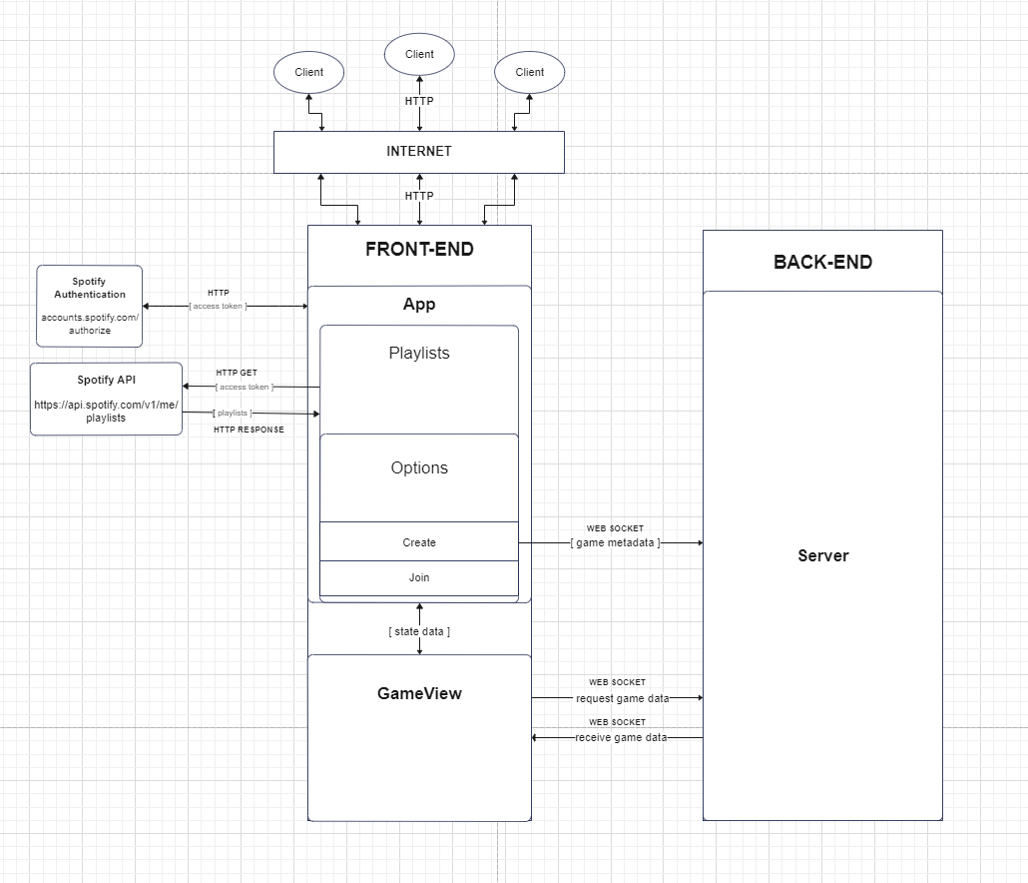

Figure 1. Overall Architecture Structure

3.1.1 Architectures

**3.1.1.1** **Client-Server Model**

In a client-server model, the client or user typically initiates communication with the server by sending a request for a resource or service. The server then processes the request and sends the requested resource back to the client-side. This model provides a number of benefits, including improved scalability, easier maintenance/management, and enhanced security/performance.

**3.1.1.2 Architecture Selection Reasoning**

* **Performance**: A client-server architecture allows for delegating heavy processing tasks to the server which in turn leads to a more responsive experience on the client-side.
* **Scalability**: This model allows for separation of concerns between the client and server, which paves the way for each component to scale independently.
* **Security**: By utilizing a server to handle game logic and data storage, it is possible to more easily control game resources to prevent exploits or inconsistencies.
* **Development Flexibility**: The client-server model allows for the use of different technologies on the server and client sides, giving more flexibility in terms of development and deployment.

**3.1.2** **Component Responsibilities**

**3.1.2.1** **Client**: The client is an end user that interfaces with the front-end through the network in order to communicate with the server.

**3.1.2.2 Server**: The server is a program running on the backend performing game logic and sending/receiving updated information between the connected clients.

**3.1.2.3 Back-End**: A NodeJS runtime environment housing the server program to handle computational tasks and data storage.

**3.1.2.4 Front-End**: A runtime environment with NodeJS utilized by the client to serve the user interface based on conditional rendering of nested React components such as App, Playlists, GameView, etc.

**Front-End Functional React Components**

* **App**: Interfaces with Spotify authentication directly passing the account access token to the children
* **Playlists**: Calls Spotify API to pull user playlist data given an access token and passes a playlist ID to the children
* **Options**: Handles logic for conditionally rendering Create or Join components
* **Create**: Houses the game settings menu and communicates with the back-end to send game creation data before redirecting to the game view passing appropriate state data
* **Join**: Allows user input for a join code and redirects to game view passing appropriate state data
* **GameView**: Displays updated game UI based on data acquired through communication to the back-end as well as sending data acquired through user input

**3.1.2.5 Spotify Authentication**: Spotify’s account authentication service interacted with for the purpose of acquiring the client’s account access token.

**3.1.2.6 Spotify AP**I: Spotify’s API libraries used for pulling data such as the user’s playlists, song metadata, etc.

## 3.2 Components mapping

Functional Requirements

**3.2.1 Connect to a user’s Spotify account**

* Authorize Spotify account and return access token
* App.js redirects to the Spotify authentication page to gather an access token, waiting for token before rendering Playlists.js
* Client **↔** Front-End **↔** Spotify Authentication
* Diagram demonstrates **[REQ-1]** to **[REQ-4]**

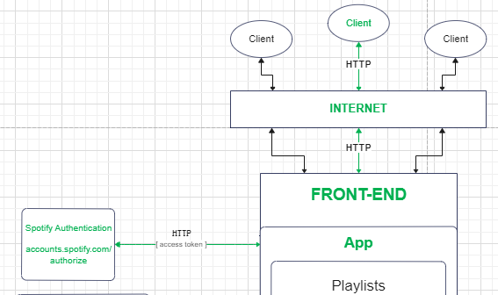

Figure 2. Components Mapping for Functional Requirements  
(Connect Spotify Account)

**3.2.2 Select playlists for game use**

* Make a call to Spotify API given acquired access token to return playlist data to the Playlists component in the front-end
* Playlists.js communicates with the Spotify API to pull and display playlists in the user interface
* Client **→** Front-End **→** Spotify API **→** Front-End **→** Client
* Diagram demonstrates **[REQ-5]** to **[REQ-10]**

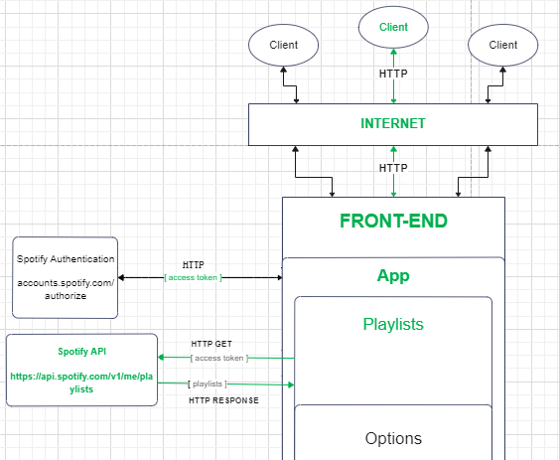

Figure 3. Components Mapping for Functional Requirements  
(Select Playlists)

**3.2.3 Join a game**

* Use a game code to redirect to the corresponding game view and provide appropriate state variables.
* Join.js redirects the user to GameView.js passing the game code in the state data
* Client **→** Front-End **→** Back-End **→** Server **→** Back-End **→** Front-End **→** Client
* Diagram demonstrates **[REQ-11]** to **[REQ-17]**

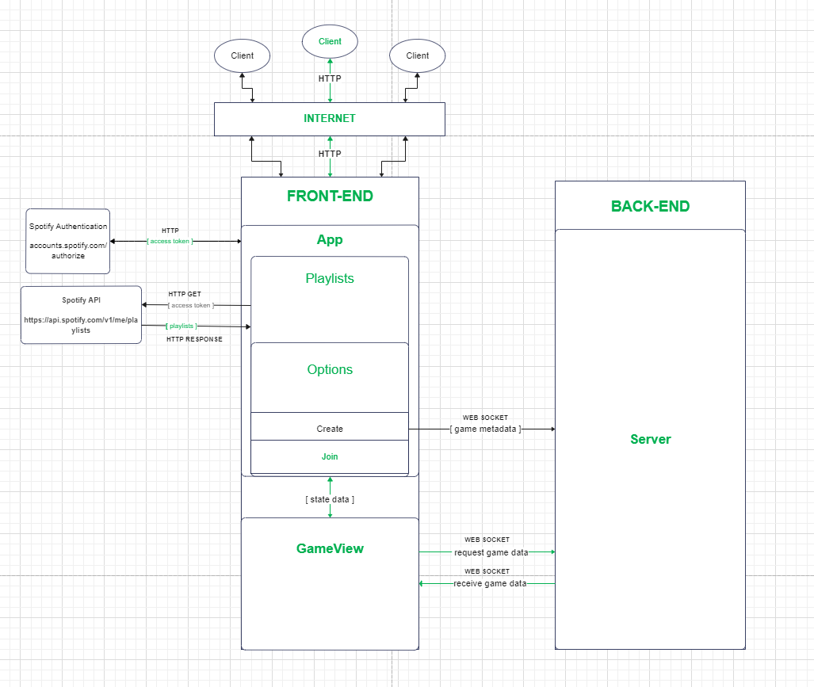

Figure 4. Components Mapping for Functional Requirements  
(Join a Game)

**3.2.4 Create a Game**

* Enter user input into the front-end to send data to the server and be redirected to a game view associated with the newly created game instance with appropriate settings
* Create.js sends game data to the server and redirects to the game view of the newly created instance.
* Client **→** Front-End **→** Back-End **→** Server **→** Back-End**→** Front-End **→** Client
* Diagram demonstrates **[REQ-18]** to **[REQ-25]**

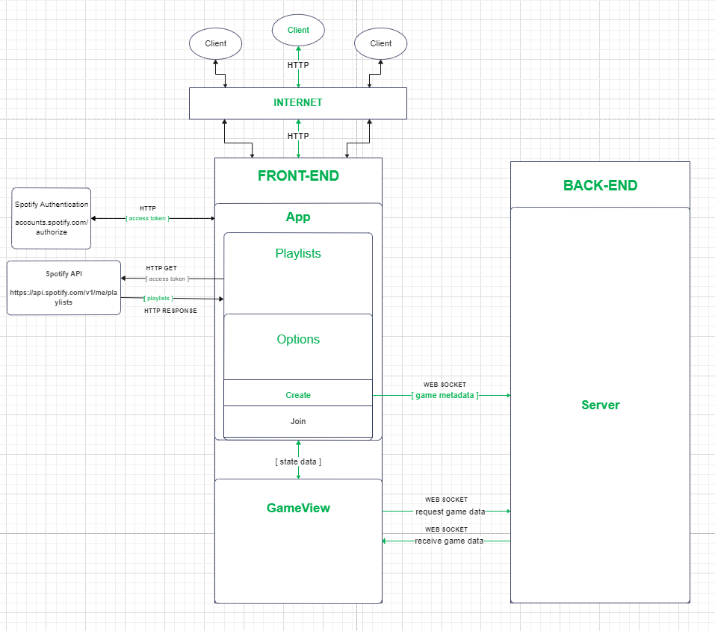

Figure 5. Components Mapping for Functional Requirements  
(Create a Game)

**3.2.5 Play Through Rounds, Update Leaderboard, & Initiate Endgame State**

* Perform game logic, accept user input, and progress through basic system flow based on defined data and interaction.
* GameView.js handles updating the UI and communicating with the server, also redirecting the user given invalid state data or game connection.
* Client **→** Front-End **→** Back-End **→** Server **→** Back-End**→** Front-End **→** Client
* Diagram demonstrates **[REQ-26]** to **[REQ-39]**

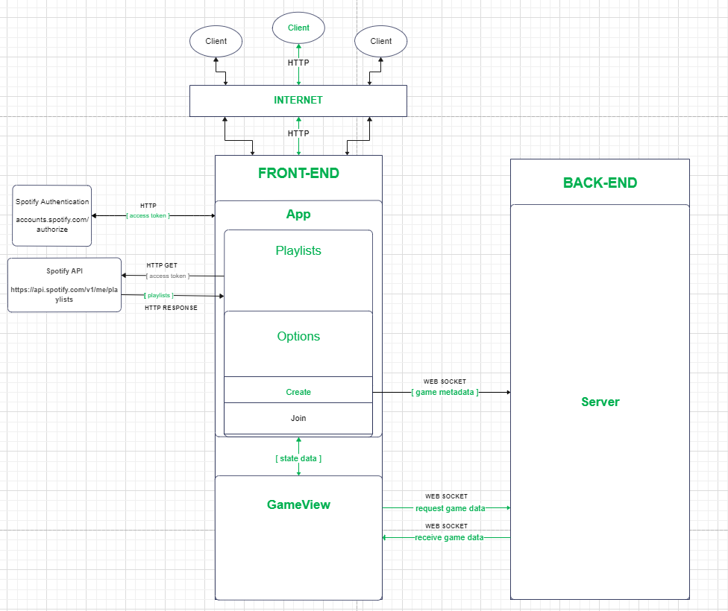

Figure 6. Components Mapping for Functional Requirements  
(Game Functionality)

Non-Functional Requirements

**3.2.6 Usability**

* Nested component structure utilizing conditional rendering to display UI
* App.js is the ancestor of various nested components passing props and rendering data in relation to updated state variables, eventually redirecting to GameView.js
* Client **↔** Front-End **↔** Back-End
* Diagram demonstrates **[REQ-40]** to **[REQ-43]**

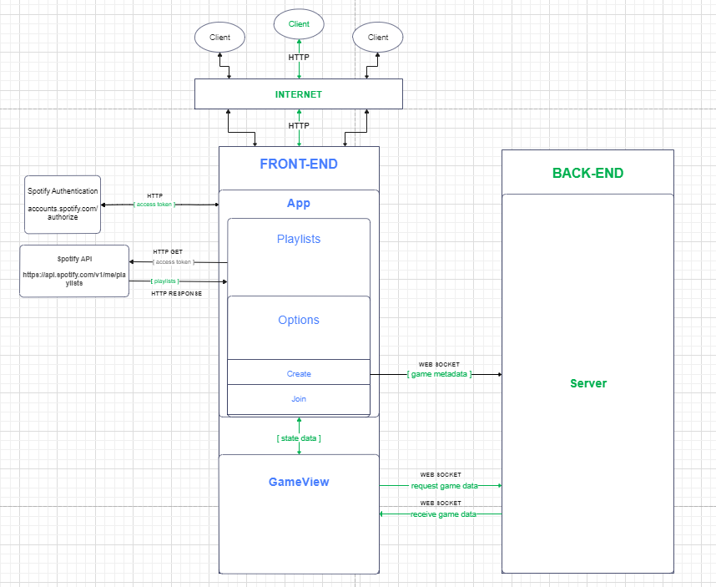

Figure 7. Components Mapping for Non-Functional Requirements  
(Usability Flow)

**3.2.7 Performance, Scalability, Security**

* HTTP requests and encrypted web sockets are employed in component communication
* Game data is stored and processed in the back-end to allow better performance on the client-side
* Client **↔** Front-End **↔** Back-End
* Client **↔** Front**-**End **↔** Spotify API / Authorization
* Diagram demonstrates **[REQ-44]** to **[REQ-50]**

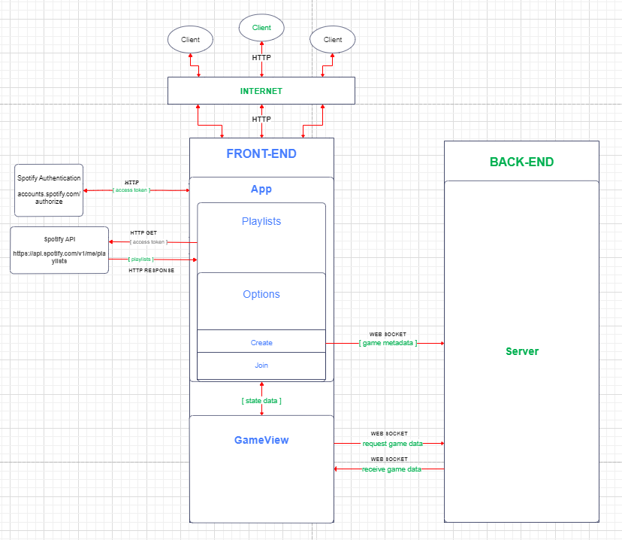

Figure 8. Components Mapping for Non-Functional Requirements  
(Communication)

## 3.3 Technology stack selection

3.3.1 Front-end Technologies

**3.3.1.1 React**: Popular component-based JavaScript library selected due to its nature of being well suited for dynamic and powerful web applications.

**3.3.1.2 Bootstrap**: Open-source CSS framework used for responsive web design. This will help with viewing on devices of various sizes and aspect ratios.

**3.3.1.3 OAuth:** Industry standard authorization protocol. OAuth 2.0 will allow account connection and authorization with Spotify’s services.

**3.3.1.4 Axios:** Promise-based HTTP client for JavaScript allowing for HTTP requests from the browser.

**3.3.1.5 Font-Awesome:** Front-end icon and font toolkit built with CSS for unique styling and customization.

3.3.2 Back-end Technologies

**3.3.2.1 Node.js**: Cross-platform server runtime environment for JavaScript. This will handle server-sided logic and database interactions.

**3.3.2.2 Express**: Highly flexible framework running in Node.js allowing for the creation of robust and secure server programs.

**3.3.2.3 Socket.io**: Event library for real-time communication in web apps between client and server. This will handle game events for multiplayer functionality and updating data for all clients based on user input from one.

**3.3.2.4 Nodemon**: Node.js based application tool allowing for automatic server restarts on detected file changes during the development process.

**3.3.2.5 Cross-Origin-Resource-Sharing (CORS)**: An HTTP header based mechanism used for error handling from 3rd party resources.

# 4. System Design

## 4.1 UI

**4.1.1** **Connecting with Spotify**

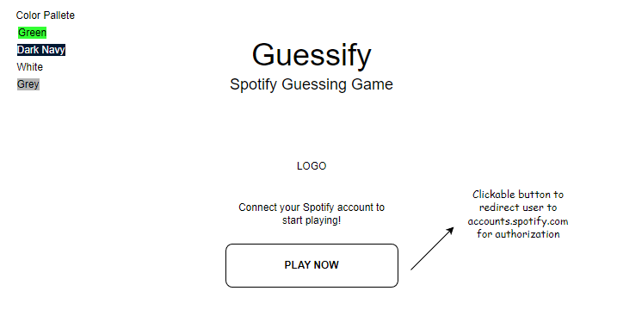

Figure 9. Main Menu Page

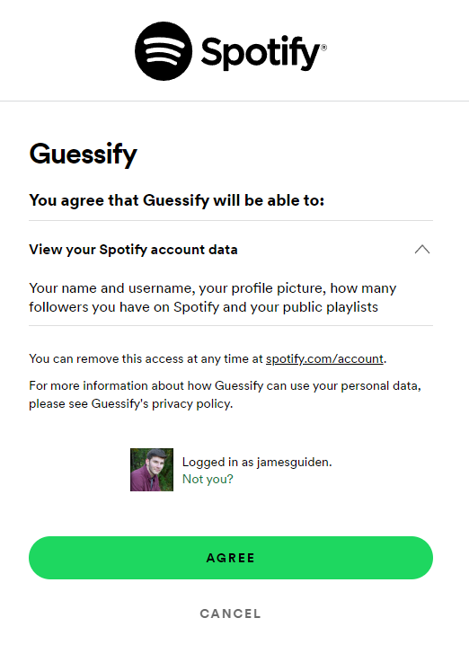

Figure 10. Spotify Authorization Page

**4.1.2 Selecting a Playlist**

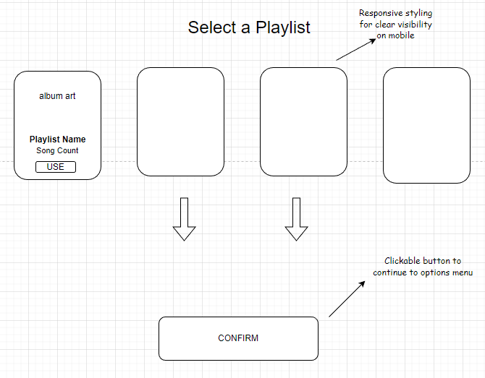

Figure 11. Select Playlists Page

**4.1.3 Selecting an Option**

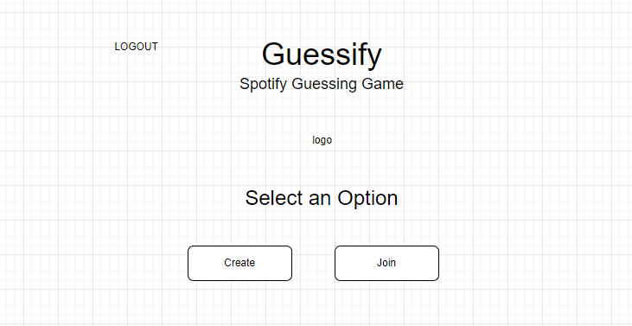

Figure 12. Options Menu Page

**4.1.4** **Creating a Game**

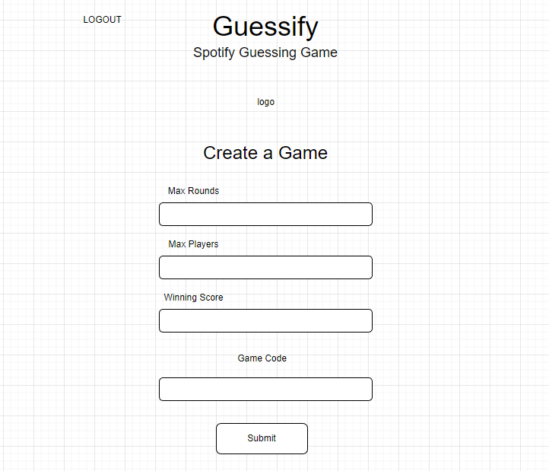

Figure 13. Create Game Page

**4.1.5** **Joining a Game**

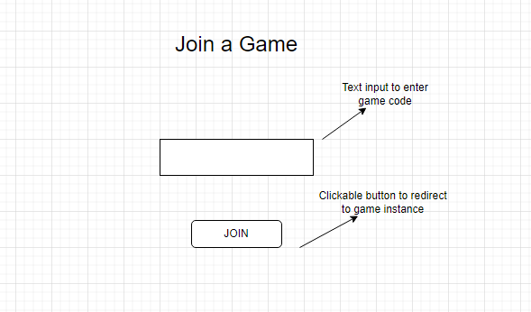

Figure 14. Join Game Page

**4.1.6 Playing Rounds**

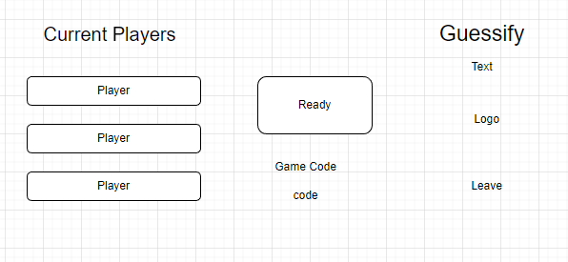

Figure 15. Game Lobby Page

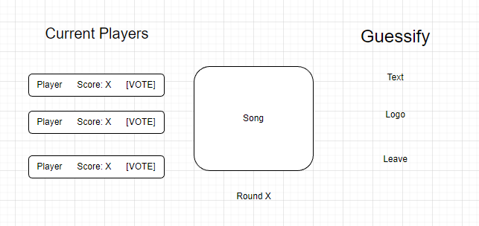

Figure 16. Game View Page

**4.1.8** **Leaving a Game**

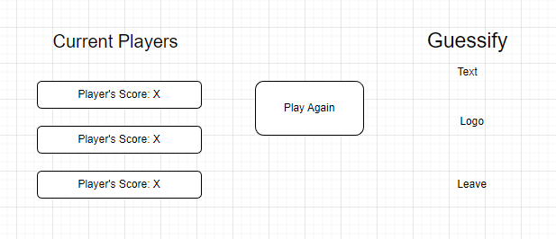

Figure 17. Game Over Page

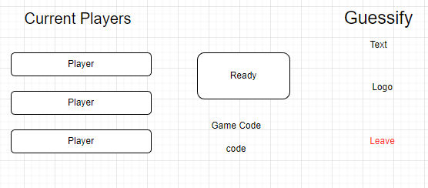

Figure 18. Leave Button

## 4.2 Sequence/activity diagram

**4.2.1 Connecting with Spotify**

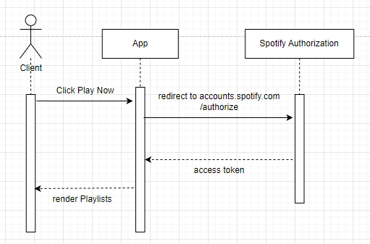

Figure 19. Component Mapping for Spotify Connection

**4.2.2 Selecting a Playlist**

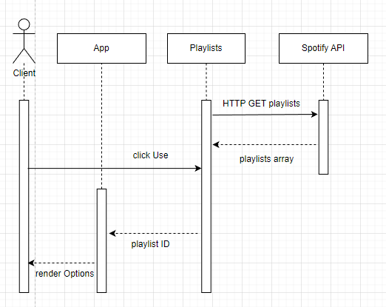

Figure 20. Component Mapping for Playlist Selection

**4.2.3 Selecting an Option**

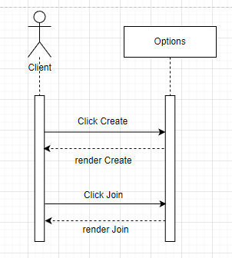

Figure 21. Component Mapping for Option Selection

**4.2.4 Creating a Game**

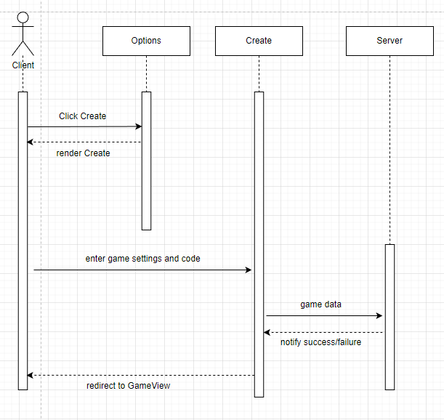

Figure 22. Component Mapping for Game Creation

**4.2.5 Joining a Game**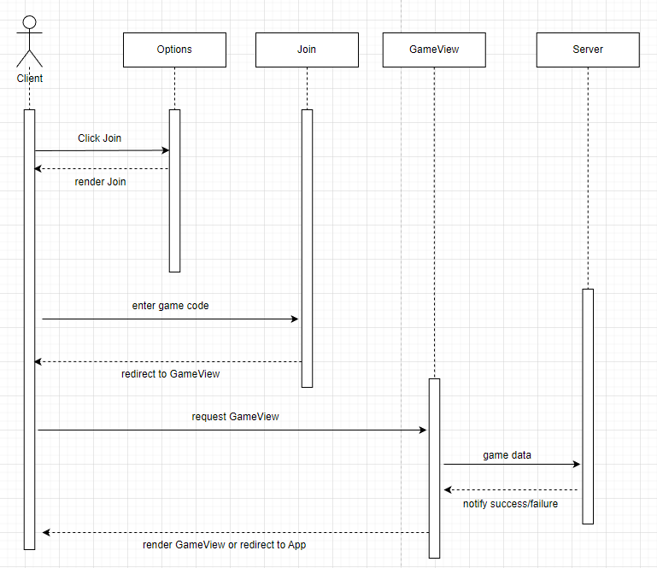

Figure 23. Component Mapping for Game Joining

**4.2.6 Starting a Game**

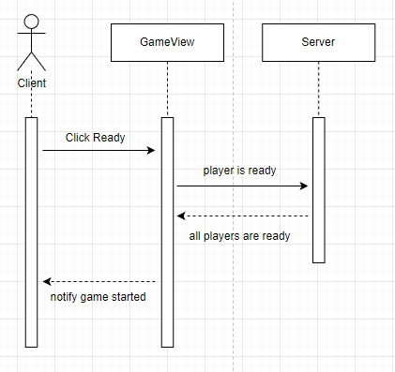

Figure 24. Component Mapping for Game Starting

**4.2.7 Playing Rounds**

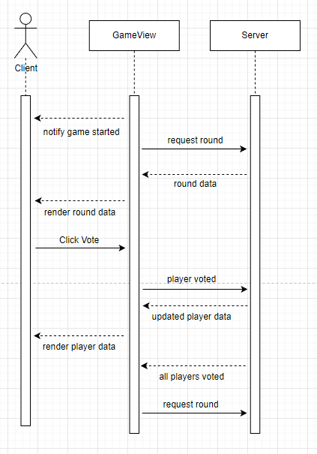

Figure 25. Component Mapping for Round Playing

**4.2.8 Leaving a Game**

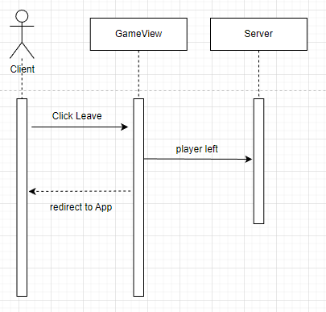

Figure 26. Component Mapping for Leaving Game

# 5. Others

**5.1 Spotify API**

This API is used to interact with Spotify’s services. It allows for connecting to user Spotify accounts to pull playlists and songs to use for gameplay.

# 6. Test plan

Table layout is as follows:

| ***No.*** | ***Test case*** | ***User input*** | ***Pass criteria*** |
| --- | --- | --- | --- |

## 6.1 Connection with Spotify

**6.1.1** **Connecting an Account**

| *1* | *Redirect to Spotify for account connection* | *Button selection* | *Browser redirects to spotify.com’s account authorization page* |
| --- | --- | --- | --- |
| *2* | *Sign in with Spotify* | *Spotify account username and password* | *Valid account credentials are accepted and user is redirected to Guessify with an access token* |

**6.1.2** **Failed Account Connection**

| *1* | *Inputting wrong credentials* | *Spotify account username and password* | *UI does not allow user to progress to playlist selection* |
| --- | --- | --- | --- |
| *2* | *Attempt to play without authenticating account* | *Button selection* | *System redirects user to the main screen* |

## 6.2 Selecting a Playlist

**6.2.1** **Selecting Playlists**

| *1* | *Indicate which playlists to use for gameplay* | *Button selection* | *System renders options component and sides playlist selection* |
| --- | --- | --- | --- |
| *2* | *Access options menu without selection playlist* | *URL* | *Unable to access options menu* |

## 6.3 Game Options

**6.3.1** **Creating a Game**

| *1* | *Select option to create a new game from the options menu* | *Button selection* | *System renders create component and displays menu to the user* |
| --- | --- | --- | --- |
| *2* | *Fill out game settings options* | *Text input, Dropdowns* | *System accepts user input for criteria and settings to build the game with* |
| *3* | *Confirm game settings options* | *Button selection* | *System redirects user to newly created game instance view with appropriate settings* |
| *4* | *Invalid game settings options* | *Button selection* | *UI displays an error message relating to invalid user input for the settings options* |

**6.3.2** **Joining a Game**

| *1* | *Select option to join a game from the options menu* | *Button selection* | *System renders join component* |
| --- | --- | --- | --- |
| *2* | *Enter game join code* | *Text input* | *System accepts user input for a join code* |
| *3* | *Confirm game code* | *Button selection* | *System redirects the users to the game instance view associated with the entered join code* |
| *4* | *Invalid game code* | *Button selection* | *UI displays an error message relating to an invalid game code* |

## 6.4 Playing Rounds

**6.4.3** **View the Leaderboard**

| *1* | *View full leaderboard dropdown at endgame screen* | *Button selection* | *UI is updated to display scores of all players in the game* |
| --- | --- | --- | --- |

**6.4.1** **Voting for Players**

| *1* | *Indicate a player the user is voting for* | *Button selection* | *System accepts user input to indicate which player they desire to vote for and reflects that to the user* |
| --- | --- | --- | --- |
| *2* | *Confirm user vote* | *Button selection* | *System flags the desired player as voted for and adds user score* |

**6.4.3** **View the Leaderboard**

| *1* | *View full leaderboard dropdown at endgame screen* | *Button selection* | *UI is updated to display scores of all players in the game* |
| --- | --- | --- | --- |

## 6.5 Leaving a Game

**6.5.1** **Return to Main Menu**

| *1* | *Select option to leave the game* | *Button selection* | *User is removed from the game instance and redirected to the playlist selection menu* |
| --- | --- | --- | --- |
| *2* | *Selection option to play again* | *Button selection* | *System redirects user to the playlist selection menu* |

# 7. References

<https://developer.spotify.com/documentation/web-api/>

<https://legacy.reactjs.org/docs/getting-started.html>

<https://nodejs.org/en/docs>

<https://getbootstrap.com/docs/5.3/getting-started/introduction/>

<https://socket.io/docs/v4/>

<https://oauth.net/2/>

<https://axios-http.com/docs/intro>