Zerostation

apt-get install vim

root@zerostation:~/bin# vim /etc/ssh/sshd_config

root@zerostation:~/bin# echo "PermitRootLogin yes" >> /etc/ssh/sshd_config

root@zerostation:~/bin# tail -2 /etc/ssh/sshd_config

# ForceCommand cvs server

PermitRootLogin yes

root@zerostation:~/bin# /etc/init.d/ssh restart

[ ok ] Restarting ssh (via systemctl): ssh.service.

root@zerostation:~# ssh-keygen

Generating public/private rsa key pair.

Enter file in which to save the key (/root/.ssh/id_rsa):

Created directory '/root/.ssh'.

Enter passphrase (empty for no passphrase):

Enter same passphrase again:

Your identification has been saved in /root/.ssh/id_rsa.

Your public key has been saved in /root/.ssh/id_rsa.pub.

root@zerostation:~/.ssh# echo "ssh-rsa ….w== rsa-key-20170220" >>authorized_keys

apt-get install iotop

vim ~/.bashrc

zmeniť

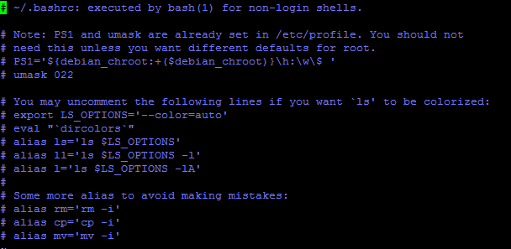

Na...

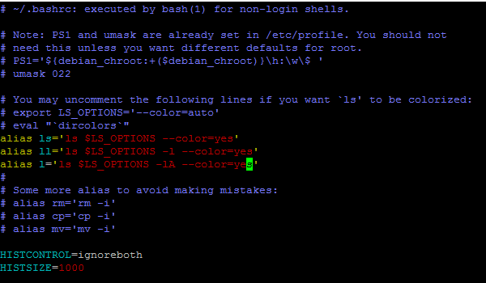

root@zerostation:~/bin# raspi-config

enable SPI;I2C;1-Wire

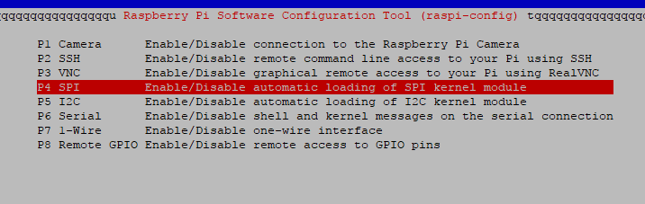

root@zerostation:/usr/lib# ln -s /root/bin/librf24.so.1.2.0 /usr/lib/librf24.so.1

root@zerostation:/usr/lib# ln -s /root/bin/libwiringPi.so.2.44 /usr/lib/libwiringPi.so

root@zerostation:~# apt-get update

apt-get install build-essential python-dev

### Install Adafruit_DHT

<https://learn.adafruit.com/dht-humidity-sensing-on-raspberry-pi-with-gdocs-logging/software-install-updated>

root@zerostation:~/bin# apt-get install git

git clone <https://github.com/adafruit/Adafruit_Python_DHT.git>

root@zerostation:~/bin# cd Adafruit_Python_DHT/

root@zerostation:~/bin/Adafruit_Python_DHT# python setup.py install

Install smbus for python

zle

root@zerostation:~# apt-get install libi2c-dev i2c-tools libffi-dev

zle alebo

root@zerostation:~# apt-get install python3-smbus

takto:

<https://www.abelectronics.co.uk/kb/article/1/i2c--smbus-and-raspbian-linux>

root@zerostation:~# apt-get install python-smbus

add testrf24 to startup

change this:

root@zerostation:~# vim /etc/rc.local

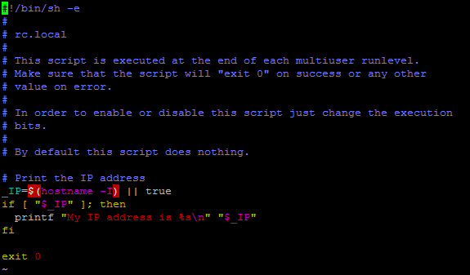

To:

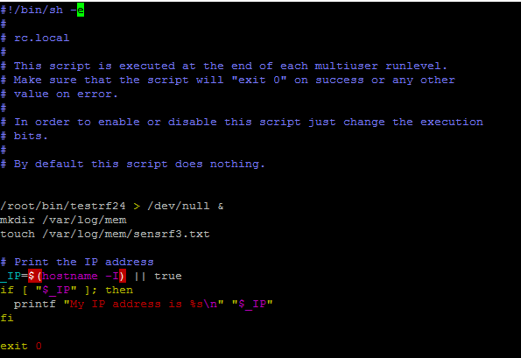

root@zerostation:~# echo "/root/bin/testrf24 > /dev/null &" >> /etc/rc.local

root@zerostation:~/bin# apt-get install git

**Minimize SD Cad Usage on Raspberry Pi**

Edit /etc/fstab, add line:

none /var/log tmpfs size=10M,noatime 0 0

<https://leszekjaskierny.wordpress.com/2017/01/26/minimize-sd-cad-usage-on-raspberry-pi/>

# Pre kompilaciu rf24 na raspberry

root@zerostation:~# cd /usr/src/

root@zerostation:/usr/src# git clone https://github.com/nRF24/RF24

Cloning into 'RF24'...

remote: Counting objects: 3089, done.

remote: Total 3089 (delta 0), reused 0 (delta 0), pack-reused 3089

Receiving objects: 100% (3089/3089), 1.32 MiB | 437.00 KiB/s, done.

Resolving deltas: 100% (1828/1828), done.

root@zerostation:/usr/src# cd RF24/

root@zerostation:/usr/src/RF24# make

root@zerostation:/usr/src/RF24# make install

g++ testrf24.v1.19.cpp -lrf24 -o testrf24.v1.19 –lwiringPi

26.12.2017 20:38 - update

test:

root@zerostation:~/bin# mkdir /var/log/mem

root@zerostation:~/bin# ./testrf24

root@zerostation:~/bin# ls -l /var/log/mem

total 8

-rw-r--r-- 1 root root 30 Dec 26 20:55 sensrf2.txt

-rw-r--r-- 1 root root 28 Dec 26 20:55 sensrf.txt

tocuch /etc/cron.d/sensorapipy

root@zerostation:~/bin# cat /etc/cron.d/sensorapipy

* * * * * root python /root/bin/sensor.api.py

15.02.2018 14:44:53

Disable journaling on ext4 – reduce writes to sd

mount –o remount,ro /dev/mmcblk0p2

tune2fs -O ^has_journal /dev/mmcblk0p2