Relational schema

Create table statements

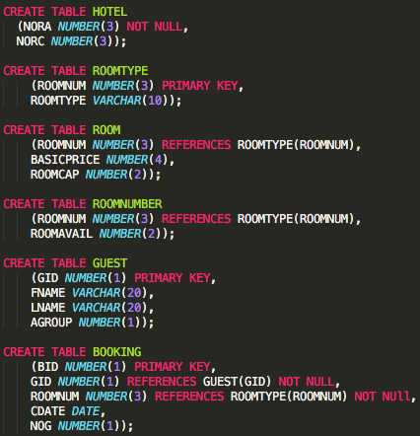

Sample test data

View definitions

1. Creating a view of all the available rooms.

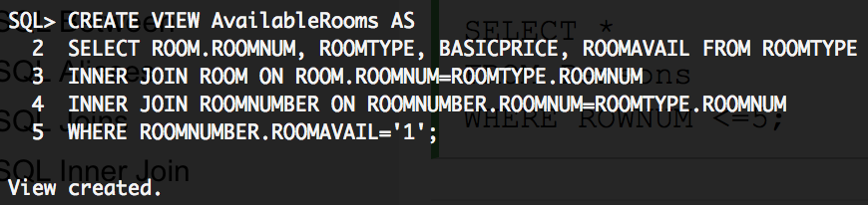

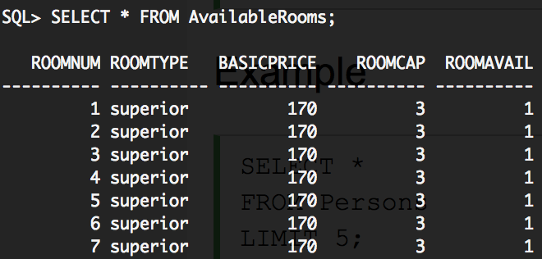

2. Creating a view of all the guests that have booked a specific room (in this case room 1)

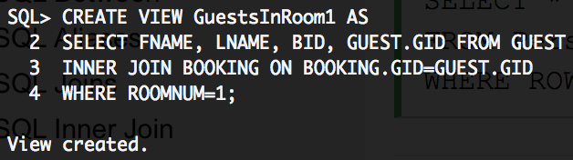

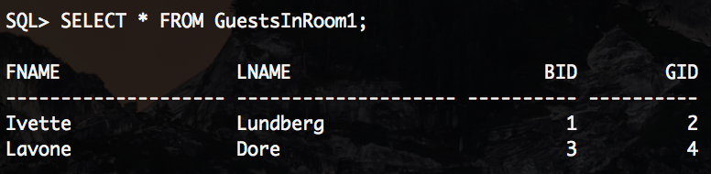

3. Creating a view of all the bookings for a certain room (in this case room 1).

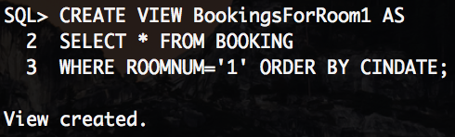

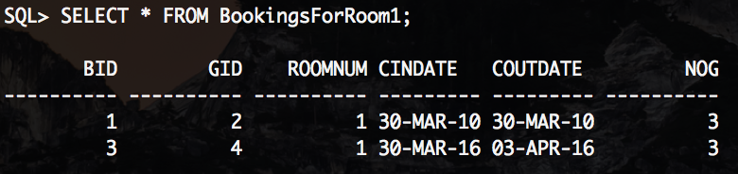

Queries

1. Check if a given person is has a booking at the hotel by his/her first name

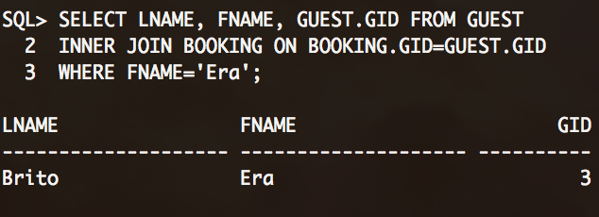

1. Check if a specific room is available.

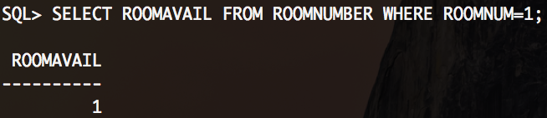

1. Check how many of each room type is currently booked.

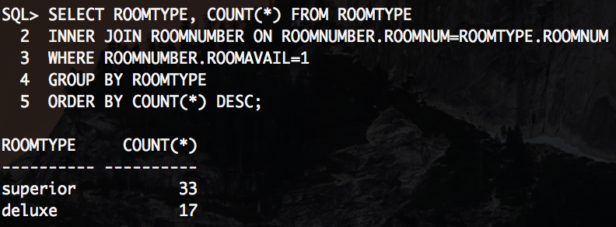

1. Check how much money the hotel earns with the current bookings one night (combining occupied rooms with the price of the rooms).

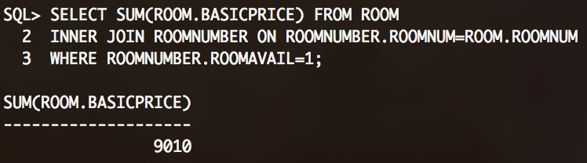

1. Find out what a guests booking ID is from the guest’s last name.

