Coursework 2: Implementation

Topic 3: Hotel

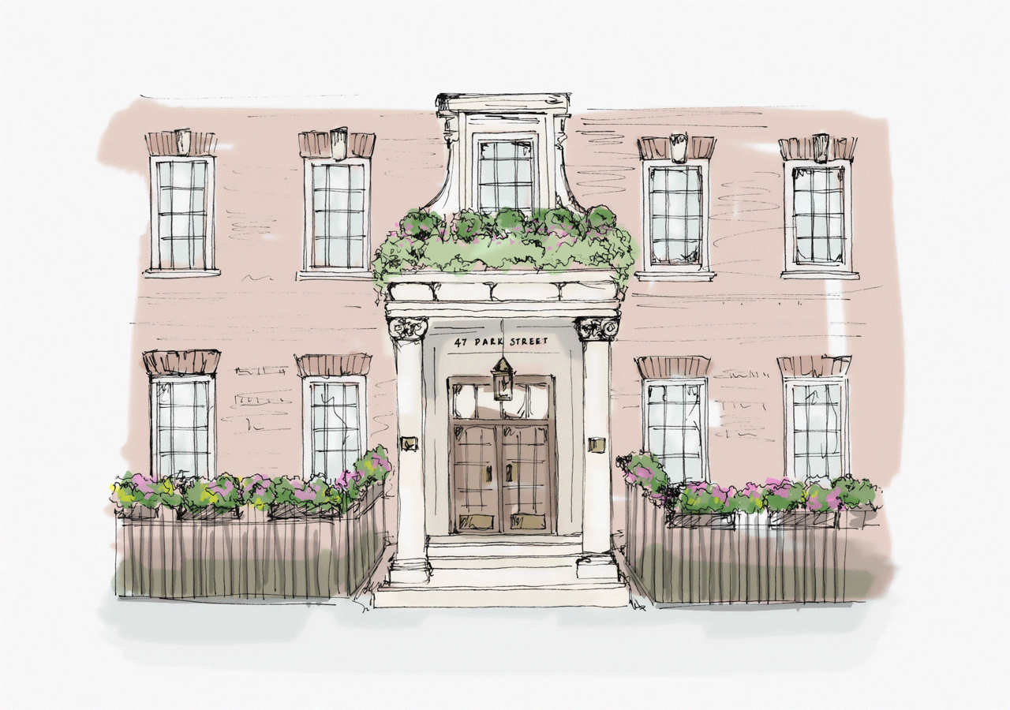

Group name: Huggable Hackers

Group number: 20

Group members:

Name: Cintia Pinto email: c.pinto@se14.qmul.ac.uk

Name: Seán Joyce email: s.joyce@se14.qmul.ac.uk

Name: Kristian Aspevik email: k.a.aspevik@se14.qmul.ac.uk

Name: Petter Stene Pettersen email: p.s.pettersen@se14.qmul.ac.uk

## Relational schema

**BOLD:** Foreign key

UNDERLINED: Primary key

* Room(RoomNumber, RoomType, RoomCapacity, RoomAvailability, BasicPrice)
* BookedRooms(**BookingID, RoomNumber**)
* Booking(BookingID, **CustomerID**, CheckInDate, NumberOfRooms, **RoomNumbe**r, DurationOfStay)
* TotalRoomsAvailable(NumberOfAvailableRooms, Availability)
* Customer(CustomerID**,** BookingId)
* Bookings(**BookingID**)
* Guests(FirstName, SecondName, AgeGroup, BookingID)
* BookingRealationship(**CustomerID**, **BookingID**)

## Create table statements

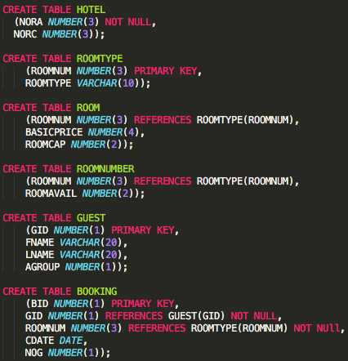

## Sample test data

The initial data in the database is as follows:

* 100 rooms
  + 33 superior 🡪 Price:170, Capability:3, Room numbers: 1-33
  + 33 deluxe 🡪 Price:200, Capability: 2, Room numbers: 34-66
  + 34 basic 🡪 Price: 100, Capability: 2, Roomnumbers:67-100
* The rooms with room number from 1 to and including 50 are available, the rest are occupied.
* 20 guests with a names, age group and a unique identifier (GID- Guest ID).
* 17 bookings spread out in these 5 ”classes”
  + Check-in date before today
  + 3 guests, superior room
  + 2 guests, superior room
  + 1 guest, superior room
  + 2 guests, deluxe room
  + 1 guest, deluxe room
  + 2 guests, basic room
  + 1 guest, basic room

This data allows us to test all the necessary queries to check that the database works, and runs smoothly.

## View definitions

1. Creating a view of all the available rooms.

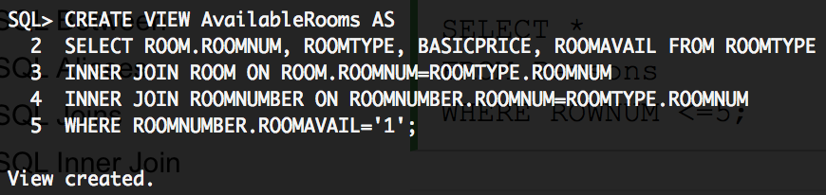

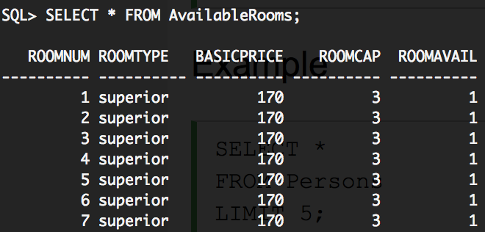

2. Creating a view of all the guests that have booked a specific room (in this case room 1)

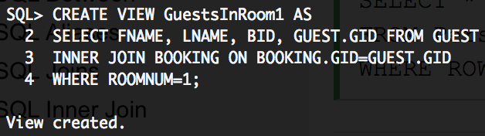

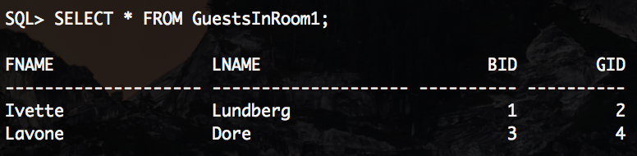

3. Creating a view of all the bookings for a certain room (in this case room 1).

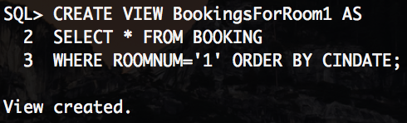

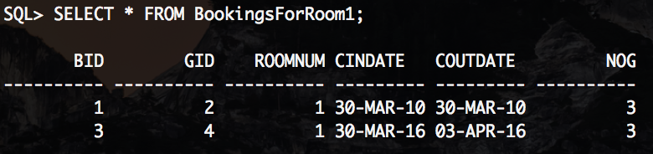

## Queries

1. Check if a given person is has a booking at the hotel by his/her first name

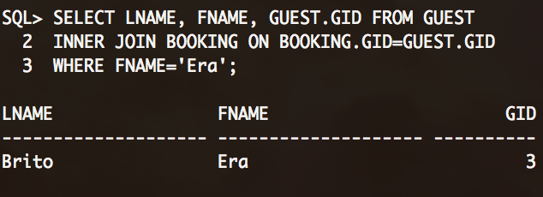

1. Check if a specific room is available.

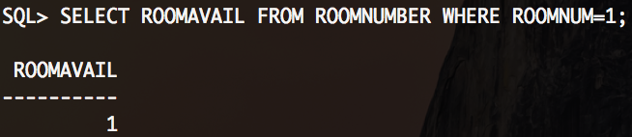

1. Check how many of each room type is currently booked.

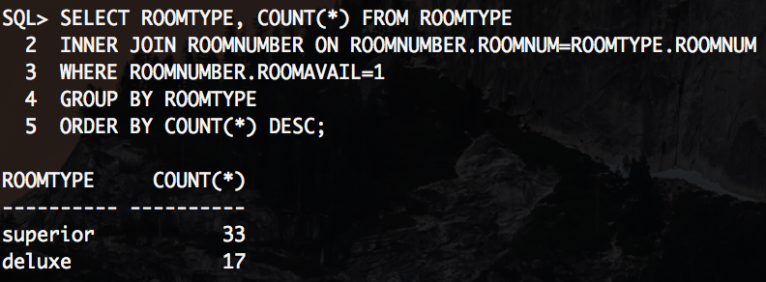

1. Check how much money the hotel earns with the current bookings one night (combining occupied rooms with the price of the rooms).

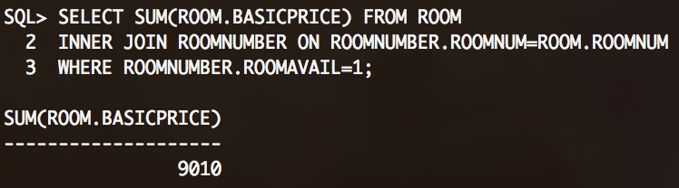

1. Find out what a guests booking ID is from the guest’s last name.

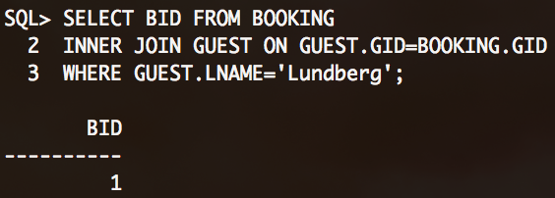

1. The number of nights a specific guest will be staying.

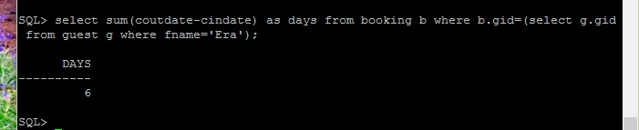

1. The number of bookings with one person after today's date.

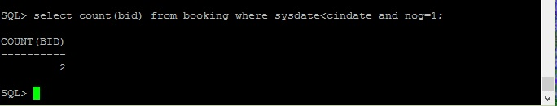

1. Average price paid by all guests with bookings.

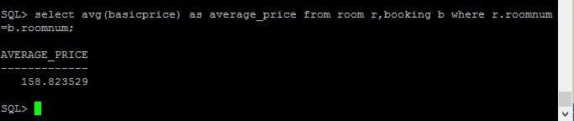

1. 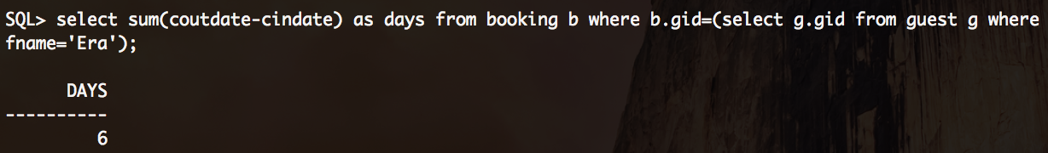The number of days a guest will be staying
2. The number of bookings with one person after today's date

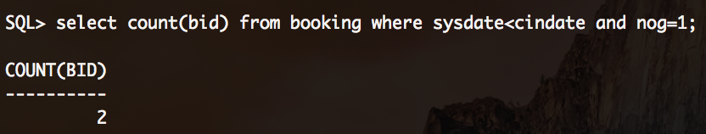

1. The average price paid by all guests with bookings

