Requirements Document
for
TicketSeller
Written by John Kelly
11/24/2013
Table of Contents
Table of Contents ii
Introduction 1
1.1 Assignment #9 : Problem Statement 1
1.2 Document Conventions 1
Requirements Specifications 1
2.1 Use Case Analysis #1 1
2.2 Use Case Analysis #2 2
2.3 Use Case Analysis #3 2
2.4 Use Case Analysis #4 2
2.5 Use Case Analysis #5 3
2.6 Domains 3
2.7 Relations 3
2.8 Constraints 4
2.9 Functional & Non-functional Requirements 4
2.10 Potential Alternatives 5
Module Dependency Diagram 5
UML Diagram 6

Introduction

Assignment #9 : Problem Statement
For this assignment, we were given the task to prepare a series of documents that will serve as the foundation of our own implementations of the cinema complex proposition. To expand more on the problem, we were faced with designing software for a multi-theater cinema complex – one that could handle multiple movies/showtimes across a series of theaters – in the interests of monitoring and collecting sales data for ticket varieties, movies, and matinee counts.

Document Conventions
This Requirements Document is broken up into the following sections:

- The Requirements Specifications
  - Use Case Analysis
  - Domains, Relations, and Constraints
  - Functional & Non-functional Requirements
- Module Dependency Diagram
- UML Diagram

Each division of this document is specified by a RED header, with subsections labeled in Bold. Refer to the previous table of contents for document navigation.

Requirements Specifications

Use Case Analysis #1
Case Description: making a ticket sale for a showtime.
- User inputs “c” into the console when prompted.
- User inputs into the console the order in the appropriate format.
- The price is returned; if 0 is returned then the order is not made as the party request is too large.

Use Case Analysis #2
Case Description: initializing through console.
- User inputs c.
- User selects the appropriate number to the type of data he/she wishes to initialize.
- The user inputs as much data as required.
- User inputs 5 to terminate, continues with order processing.

Use Case Analysis #3
Case Description: initializing with a file
- User inputs “c” into the console when prompted.
- User is prompted to enter the file path to the file.
- Presses enter, the cinema is then properly initialized.

Use Case Analysis #4
Case Description: accessing complex sales information.
- User inputs “c” into the console when prompted.
- The user requests “report” to the console.
- Output contains a report to the user of all sales information.

Domains
Theater: module that represents a theater at the cinema complex. It has a name and a number for identification purposes. Furthermore, the theater module is able to check if a two equal theaters of the same type are being initialized.

Movie: manages the representation of a movie, holding data such as the movie title, length (in terms of hours & minutes).

Showtime: module that holds a Movie, with its start and end times. Based on the start time, the showtime could be a matinee. This module also keeps track of sales for each type of viewer attending the show (adult, child, or senior), as well as keeping track of the total number of viewers attending that show.

Complex: module that organizes the entire cinema complex information & management. Here is where the list of movies available for viewing are held, as well as the list of theaters. Moreover, all of the sales information in regards to ticket sales – i.e. the number of senior ticket sales – are recorded in this module.

Price: the Price module is used to keep track of all of the available prices at the cinema complex. Prices have a name and an amount. This additional class is made in the interest of keeping large price ranges in a tangible structure.

User Interface: the entire system will be interacted with through the command line, as running the program immediately prompts the user. The program is interacted with through the console, though in terms of both data initialization and order processing, the user has the option to pass in a file or continue to use the console for said operations.

Relations
Theater: related to the Complex class, whereas its numeric identification is stored and can be accessed through the complex fields (“nowPlaying”).

Movie: a movie is where all information regarding that specific film instance are located, or in other words, the movie’s title and length, in both minutes and hours.

Showtime: here, we have a Movie stored, along with relevant information such as its start/end time, price, available seat count, and so on. Based on the start time of that Showtime, it is determined to be a matinee or not. Also, here is where all sales information, as well as attendee counting is located, making it relevant to sales and managerial reports.

Complex: the Complex holds an <code>ArrayList<Movie></code> that serves as the storage of all movies available at that complex. This information is all to be static, as since a Showtime can have the same movie instance and have different start/end times, it is imperative that the same Movie instance be used across the system to prevent side effects (i.e. multiple instances of the same movie on the complex movie list). The Complex also holds an <code>ArrayList<Theater></code> which holds all of the Theater-s available at that complex.

Price: all of the prices offered at the cinema complex are stored in the complex class, whereas they are accessible and mutable from there.

User Interface: how the user is to interact with the system; uses the console to convey and read information to/from the user.

Constraints
The first, clear constrain of the system is the lack of wide flexibility offered by the system in terms of navigation. The user is always going to be able to loop back through the program if, for instance, an incorrect file path is inputted by the user (when initializing the cinema by file). However, the user will always, after initialization, be prompted to process orders. There is no way to initialize the system and keep the data, as upon stopping the program, re-initialization is needed.

Another constraint to the program is in regards to the order of deletion when handling data. For instance, there is no U.I. or file to pass into the program that will “clean” up unwanted data. There are safety measures, say for instance, to keep the user from inputting movies that would overlap (by file or by console) or theaters with the same name/number. However, there is no way to manually access the data for deletion, but rather only for initialization. The user, in order to delete unwanted data, must restart the program and thus re-initialize the data in the manner that is now desired.

Functional & Non-functional Requirements
As shown above with the Use Case Analysis, the system is able to handle generic interaction with the system, or in other words, it works properly when the user interacts with the console properly (i.e. appropriate syntax use). However, the specificity of the console gives rise to a constraint to the system, as stated before. The entire system, therefore, will be interacted with via the console, with no exceptions.

The system will generate/modify data according to the user’s input.

Large-scale system management (i.e. the addition of multiple theaters, as thus, much more showtimes) is recommended to be done outside of the system UI and done via the complex initialization. In other words, passing in a file with the cinema complex data is HIGHLY recommended for ease-of-use.

If the system faces hardware or software malfunction of ANY kind whatsoever, the user will be forced to troubleshoot their external errors without the system running, and upon correcting these errors, the system is to be restarted completely. There are NO exceptions thrown to signal that a hardware error has occurred. There are ones, however, that will notify the user for attempting improper data initialization or order processing.

In terms of speed, there is a generally little amount of information that the system will be handling, so processing speeds are irrelevant. There are no speed constraints to this assignment, and any issues in regards to memory allocation or speed are deemed outside the scope of this assignment.

Potential Alternatives
To briefly touch on potential design alternative in this system’s implementation, the only area that was considered with an alternative design was the User Interface. Here was provided the opportunity to implement a GUI that would most likely improve the experience of the user with the system. However, due to timing constraints, it was deemed that using the console for user interface would be appropriate and acceptable.

Module Dependency Diagram
The following is a breakdown of the system as a Module Dependency Diagram. In summation, this is an organization of the relationships between modules and their dependencies.
COMPLEX
THEATER
MOVIE
SHOWTIME

UML Diagram
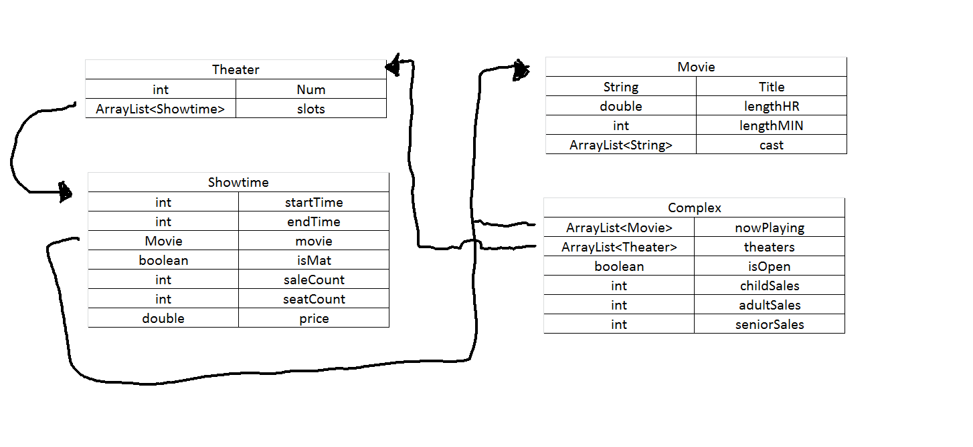
This diagram is used to show the relationship between the class structure of the system and their interactions. This is done through the illustration of relationships with two types of arrows – a “using arrow” with an open head and an “extension arrow” with a closed head – to show how different modules, shown as nodes, are related and interact.

