This code is designed to perform face recognition using a Siamese neural network and MTCNN for face detection.

It takes an input image, detects faces, compares them to a set of known faces, and produces an output image with recognized faces highlighted. The Siamese network is used to calculate the similarity (or dissimilarity) between the faces based on their feature vectors.

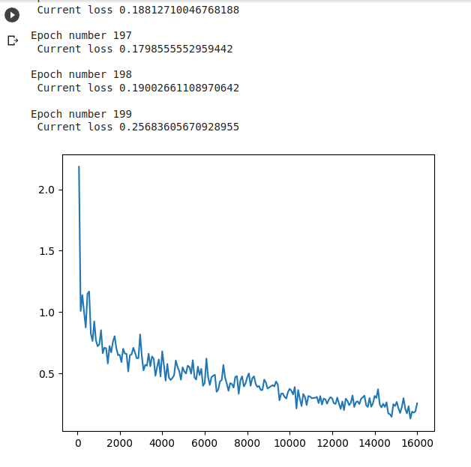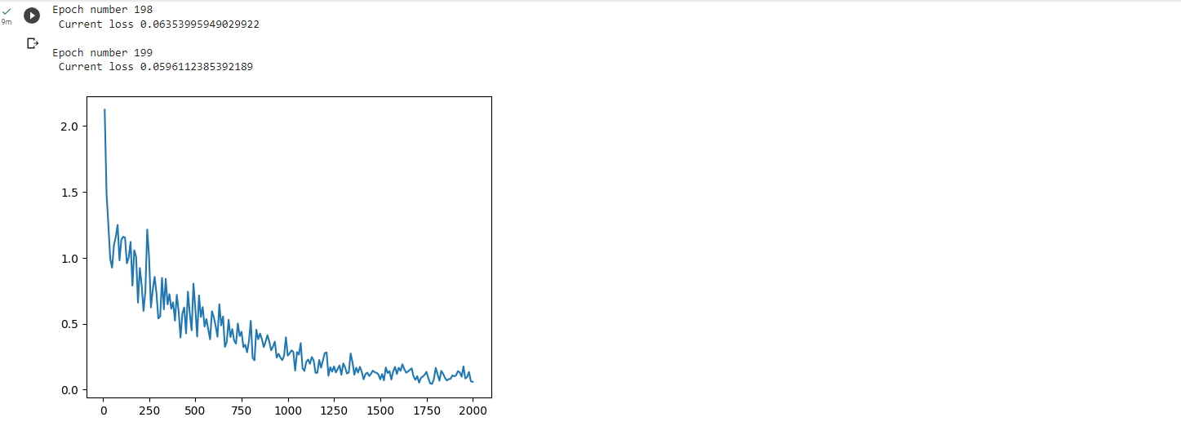

Even though it was possible to achieve low loss and the model showed correct test results below, it has performed poorly at the demo picture person recognition, so need to work on it further.

