1. **Install WAMP on Windows**

## Step 2: Initiate WAMP Server Install Process

Soon after you click on the downloaded file, you will be asked to choose your preferred language and click the “Ok” button. As I’m choosing English here. See below.

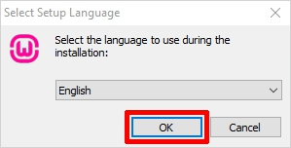

The next screen you will see is about the license agreement. Click on the “I accept the agreement” radio button and then the “Next” button to continue with the installation shown below.

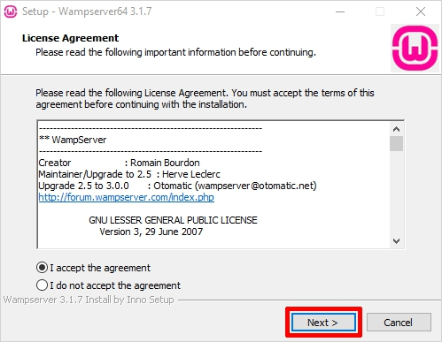

The next screen will inform you about the required components that have to be present in your computer system for the proper functioning of the WampServer. The main purpose of this step is to check for the suitable version of Microsoft VC++ re-distributable package. Click on the ‘Next’ to continue.

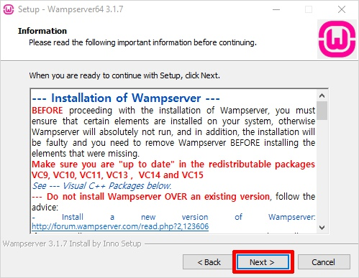

## Step 3: Select Location/Destination to Install WAMP

Here, you need to select the location to install the WAMP on your computer. However, you can accept the default location and move ahead. To continue with the installation hit the ‘Next’ button.

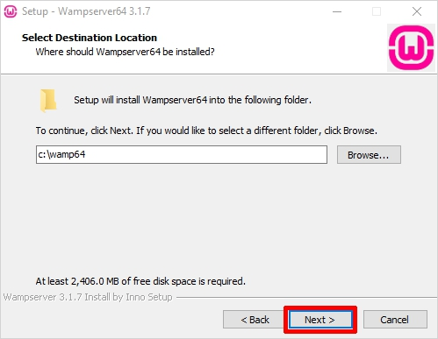

## Step 4: Select Start Menu Folder to Install WAMP

Now, you need to select the folder where you wish to create the program’s shortcut. You can select any folder of your choice or you can continue with the default option. You can easily access this folder from the Windows start button. Choose the folder and click ‘Next’ to continue.

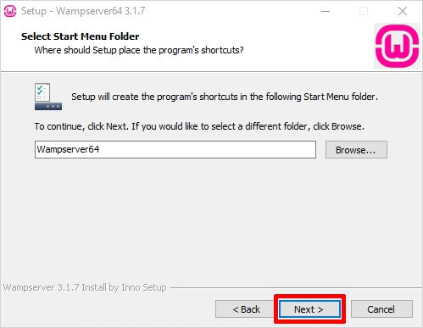

## Step 5: Ready to Install WAMP

Finally, you would see a ready to install wizard with a ready setup to begin the installation. Just hit the ‘Install’ button to begin the installation procedure.

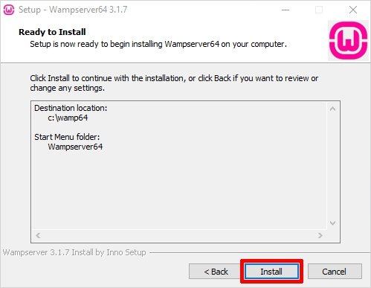

Now, just be patient as the WampServer is extracting files to your selected location. Let the process complete.

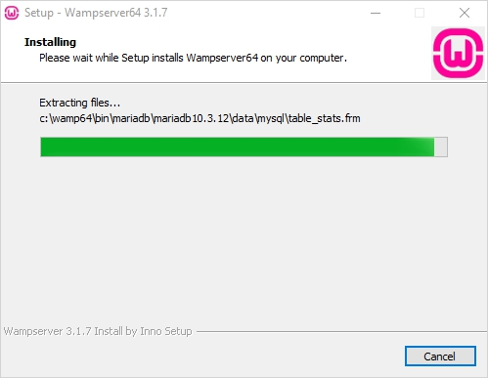

Once the status bar is turned fully green, an information screen will appear like the one shown below. Click ‘Next’ to continue.

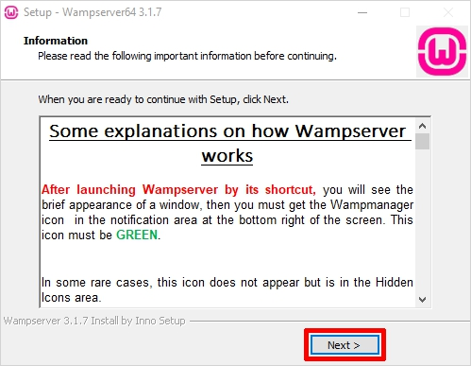

## Step 6: WAMPInstallation Complete

The installation is almost done now simply click ‘Finish’ to exit the setup.

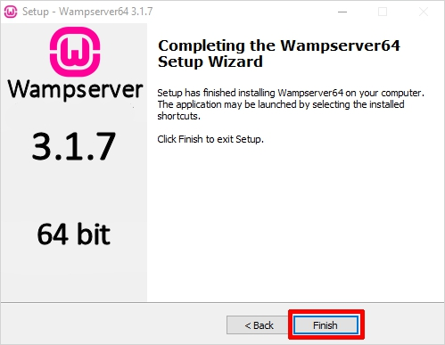

1. **Install Composer on Windows**

### **Step 1: Download Composer .exe File**

In first step 1, you need to open your browser and type getcomposer. Then visit on [www.getcomposer.org](https://getcomposer.org/download/). And download composer. If you already composer download / installed Composer.  So, you need to move on next step.

Click  Download Composer from [www.getcomposer.org](https://getcomposer.org/download/).

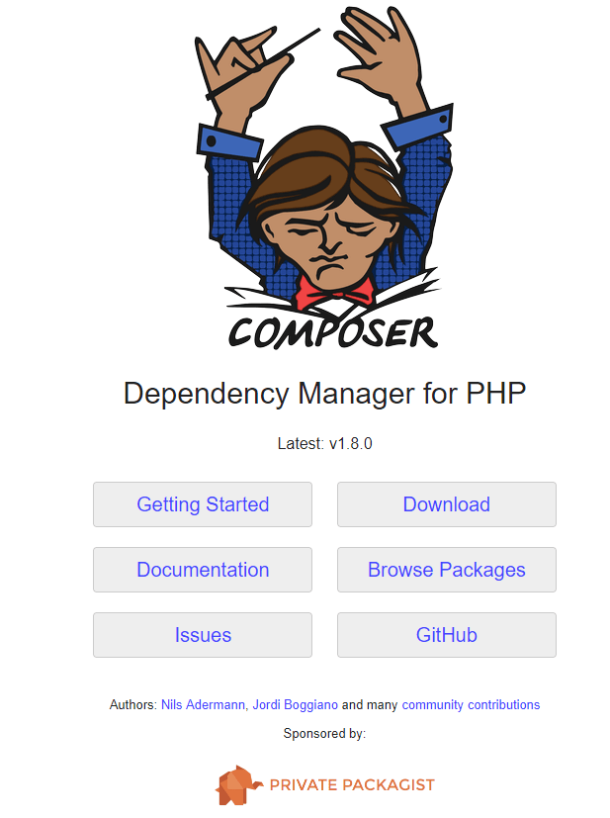

### **Step 2 – Run the setup and Install Composer**

In step 2, click on download composer.exe file. Then open one prompt box :

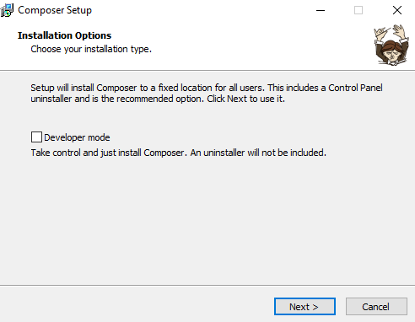

Now Set PHP path and click on next:

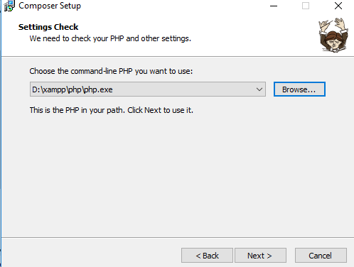

If you have any proxy URL enter here, don’t know to leave it to click next:

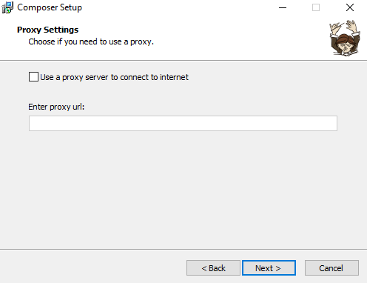

Now, review the composer setup wizard. And click on install.

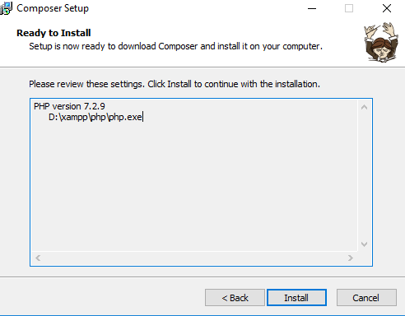

Composer has been installed successfully. Click to finish button.

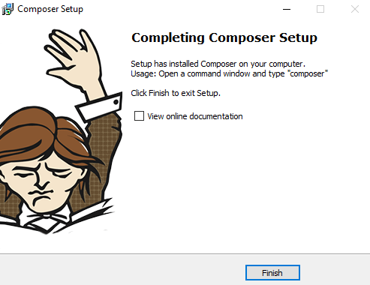

### **Step 3 – How to check composer is installed or not in windows**

Now, open your terminal and type the following command on command prompt:

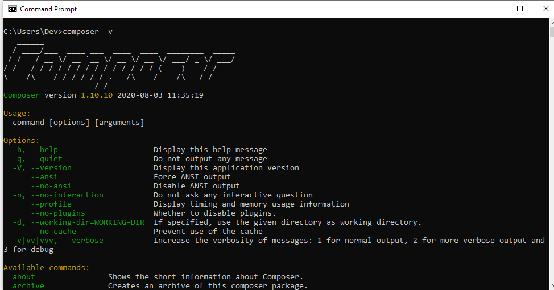

After run the above command on cmd. If You will look like the image given below. So composer successfully installed on your windows 10 xampp.

1. **Installing Laravel**

Type the following command in your command prompt window:

* composer global require “laravel/installer”.
* composer create-project –prefer-dist laravel/laravel Project_name: this command will install Laravel and other dependencies with it also generate the ANSI key.

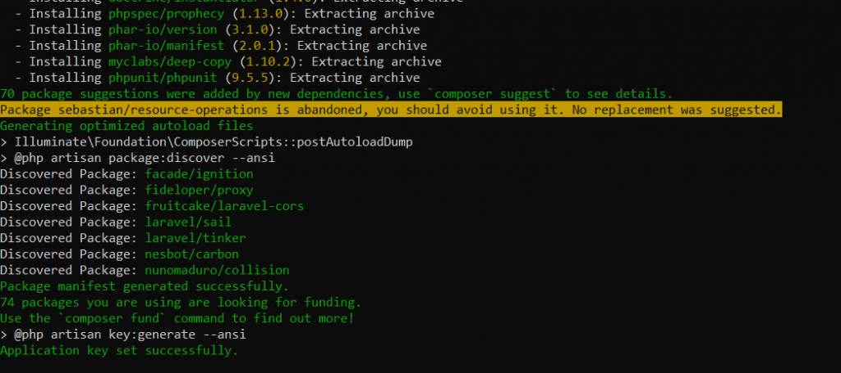

Open CMD run

cd C:\wamp64\bin\mysql\mysql5.7.31\bin

mysql -uroot -p < /Users/{YOUR WINDOWS USERNAME}/Downloads/baseelement-app/installation/baseelemnt.sql

cd C:\Users/{YOUR WINDOWS USERNAME}/Downloads\baseelement-app

php artisan serve

Go to the IP URL that you see on your CMD screen