The project is a multi-page responsive website for a furniture store named FurnitureShop. It demonstrates the integration of HTML, CSS, Bootstrap, JavaScript, and jQuery to create a visually consistent and interactive user experience. The website contains an implementation of jQuery AJAX and local JSON storage. The website includes five main pages: Home, Products, Cart, Checkout, and Contact. Each page follows the same structure with a unified header, navigation bar, and footer to maintain a consistent design and easy navigation.
The homepage presents the most popular furniture categories in a clean grid layout. It uses the Bootstrap grid system to ensure responsiveness on desktop, tablet, and mobile devices.
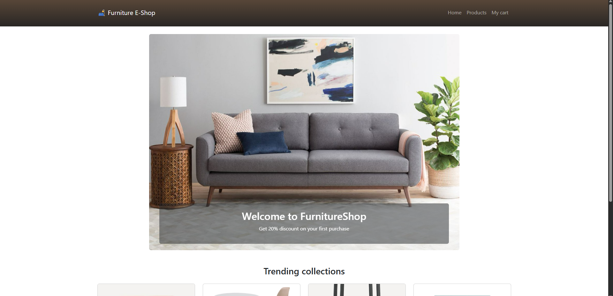
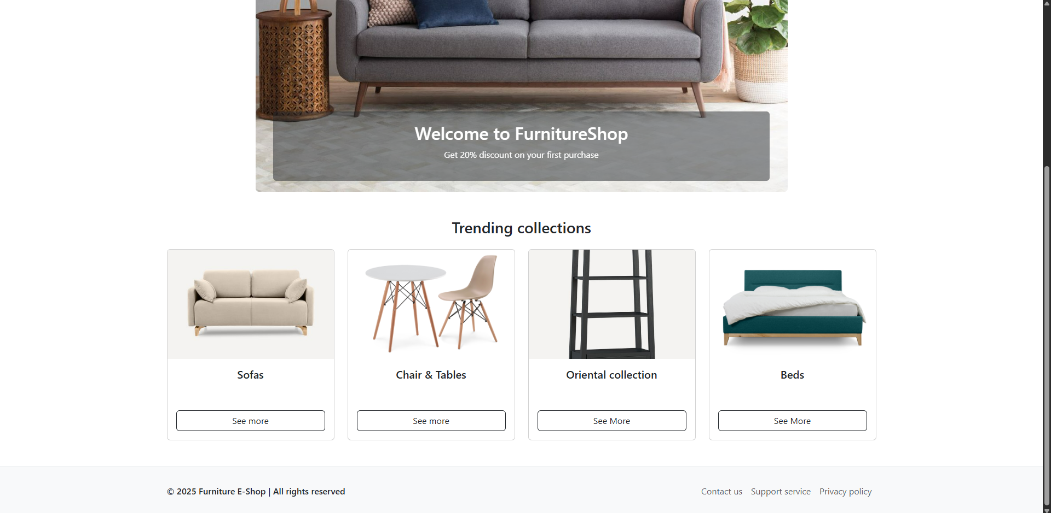
The Products page displays individual furniture items in Bootstrap cards. Each product card includes an image, a title, a price, and an “Add to Cart” button. jQuery is used to add simple animations when hovering over products and to provide feedback when an item is added to the cart.

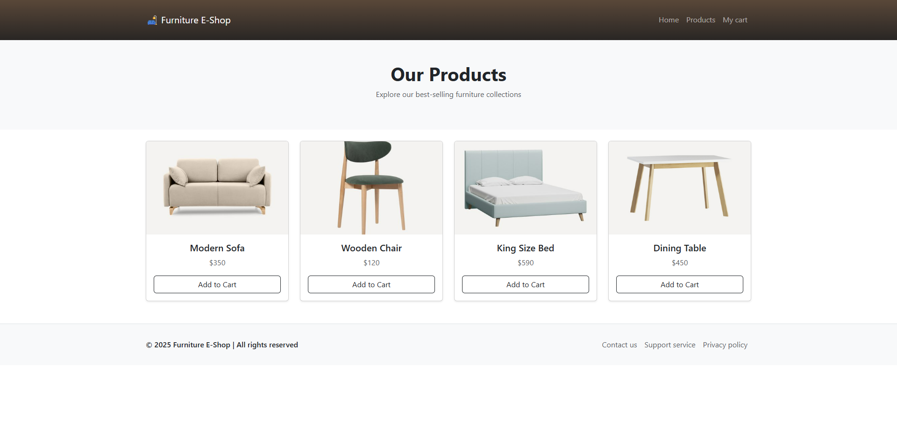
The Cart page dynamically loads items saved in the browser’s local storage. It displays the list of selected products, calculates the total price, and allows the user to clear the cart with one click. This functionality is achieved through JavaScript and DOM manipulation.

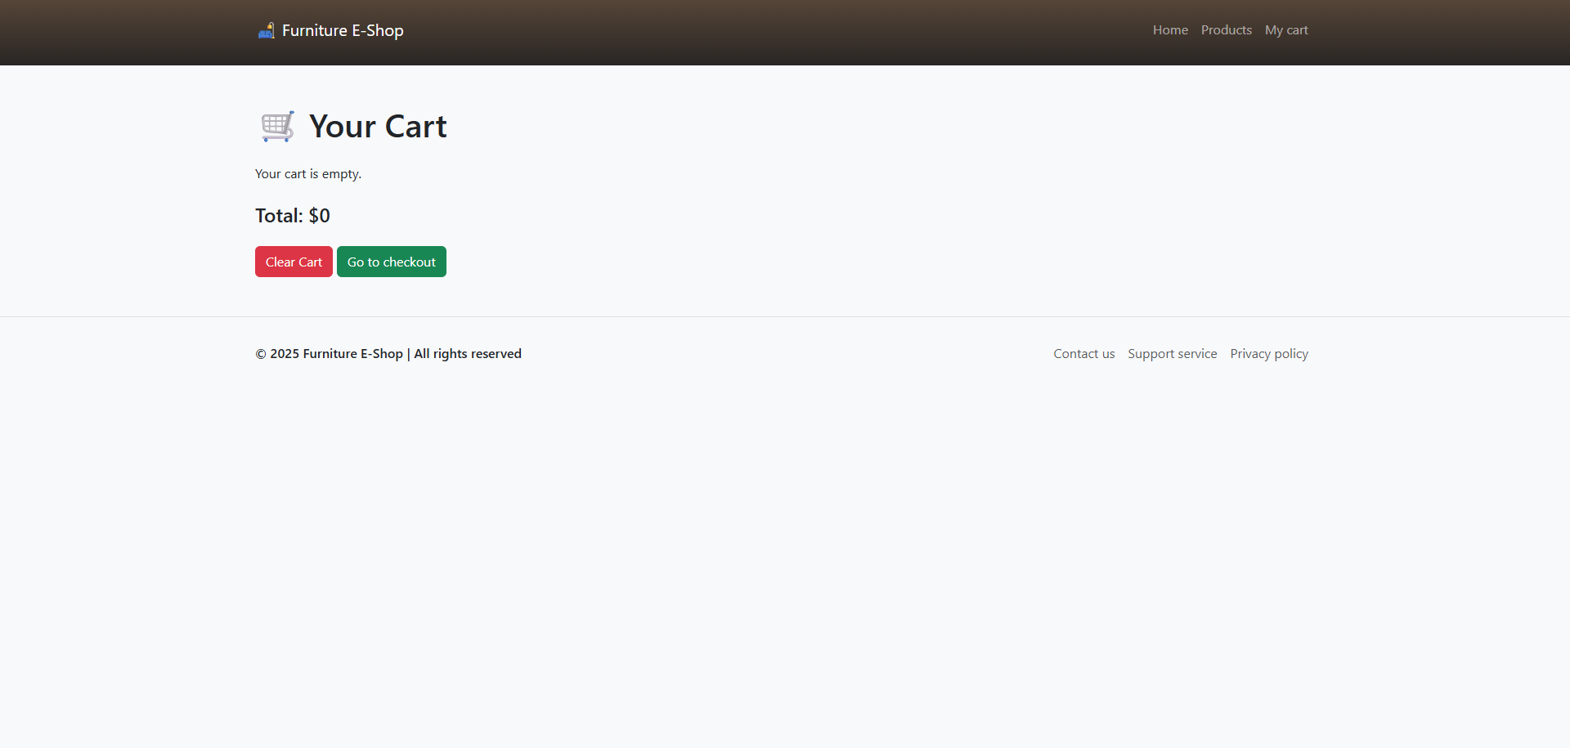 The Checkout page contains a simple form that collects customer information such as name, address, email, and payment method. It includes validation to ensure that all fields are completed before the order is submitted. After the submission, form information goes to Formspree API server, and the results are sent to host’s email.
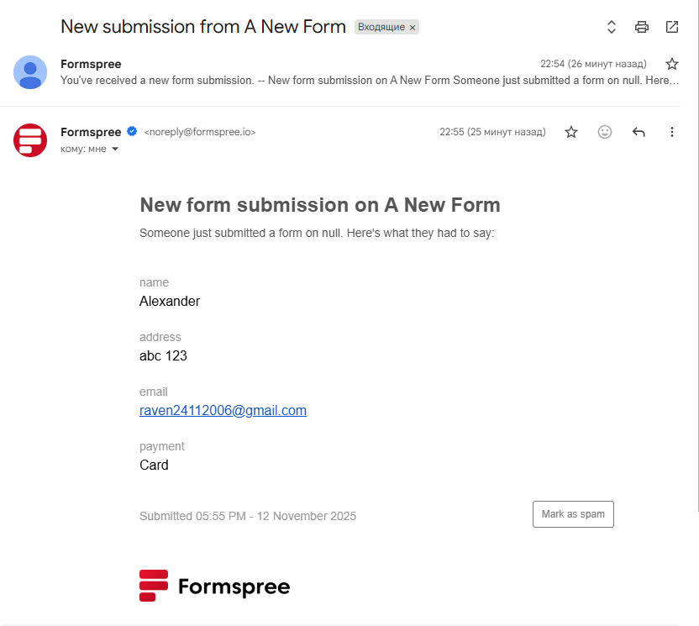

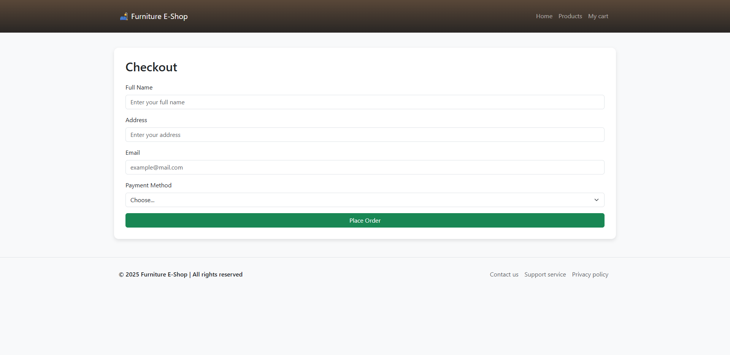
The Contact page provides store information and a contact form. The form uses JavaScript and jQuery for validation and success message animation. Once submitted, the order form hides, the cart is cleared, and a confirmation message appears with a fade-in animation implemented using jQuery. All the form’s data goes to the same Formspree API server as in checkout form.

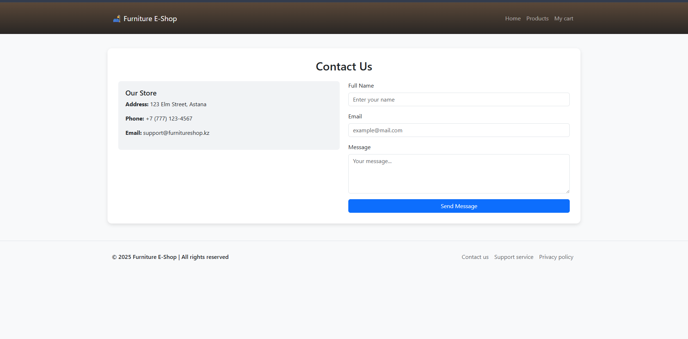
Throughout the project, Bootstrap’s grid and utility classes were used to ensure responsiveness, while custom CSS provided additional styling for cards, forms, and layout adjustments. jQuery was integrated for animations and interactive effects such as fading and sliding elements. Advanced JavaScript is applied for core functionality, including cart management and form validation. To make the form dynamic, I used an AJAX form submission.
In summary, the project demonstrates a complete small-scale e-commerce website structure with consistent design, interactivity, and responsiveness. It combines the main web development technologies required in the assignment and provides a functional foundation that can be further expanded with advanced features such as dark/light mode switching or additional APIs.

