**Task 1: Implement a simple random walk in R**

An elementary example of a random walk is the random walk which starts at 0, and at each step moves +1 or −1 with equal probability.

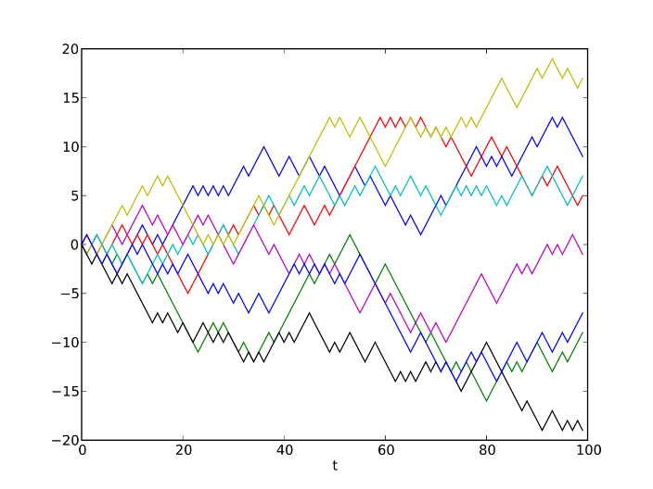

**Task 2: Implement the Rule 30 cellular automaton in R**

**Task 3: Explore the behavior of the automaton with different rules**

**Task 4: Implement Conway’s game of life in R**

1. Any live cell with fewer than two live neighbours dies, as if by underpopulation.
2. Any live cell with two or three live neighbours lives on to the next generation.
3. Any live cell with more than three live neighbours dies, as if by overpopulation.
4. Any dead cell with exactly three live neighbours becomes a live cell, as if by reproduction.
5. All other dead cells remain dead.

