Practical class - Spatial null models in R
Spatial Ecology and Macroecology course
Petr Keil

General instructions

For each task:
- Try to think about the solution for 10 min without AI or looking at the solution.
- Try AI next.
- Compare the AI-generated solution with the solution in the repository
- Once you’re done, call your instructor to have a look

Useful functions and concepts

runif(n, min, max) # draw a random number between min and max
round() # round numbers
sample(x, size=1) # choose size numbers from a vector x
matrix(data, nrow, ncol) # create an empty matrix
x <- M[2,3] # extracts the element of M from 2nd row and 3rd column
M[2,3] <- 1 # inserts number one to 2nd row and 3rd column
rowSums() # sum numbers in each matrix row
colSums() # sum numbers in each matrix row
t() # transpose matrix

for (i in vector) # the vector can be e.g. 1:N, or 2:N, or 2:(N-1)
{
# do something
}

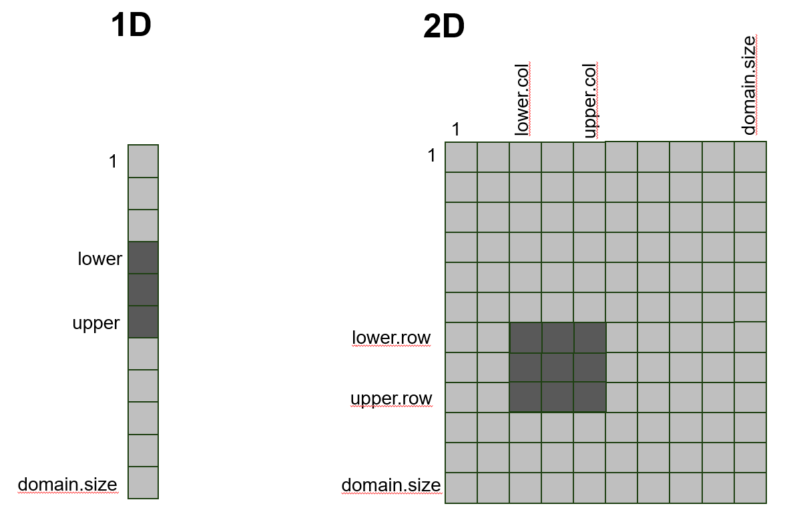

Task 1: Implement random placement of ranges in 1D or ranges with constant size

- Create an empty 1D vector, with its length being domain size. Put a range of a given size randomly on the vector
- Create an empty 2D matrix, with number of columns being the domain size, and number of rows being the number of species (ranges)
- Loop through the species, and put a range on a random location of the domain at each row.
- Use rowSums() or colSums() to get the number of species at each location in the domain, and plot it.

Task 2: Implement random placement of ranges in 1D or ranges with varying size
- Use runif(), rnorm(), or rpois() to randomly vary range sizes.

Task 3: Do the same thing in 2 dimensions.

Ideas for optional tasks to explore
- Try what happens if, instead of compact square ranges, occupied cells are assigned completely randomly for each species.
- Allow ranges to overlap domain boundaries.
- Create an environmental gradient in the domain, and make species ranges more likely to fall in certain environments.
- Make ranges not rectangular, but let them spread from a location by a 2D random walk.

