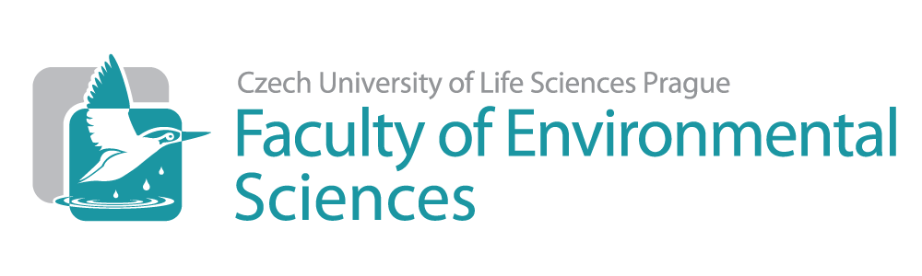
Funded full time PhD position
“Mapping temporal change of biodiversity at local, regional, and continental scales”
Background
We likely face an unprecedented global change of biodiversity caused by humans, which includes species extinctions and invasions over large geographic extents. Yet, we still lack estimates of how fast and where are species being lost or gained. The few published assessments are geographically limited, suffer from data scarcity, and are conduced at incomparable spatial and temporal scales. We are seeking a PhD candidate that will use new computational approaches to tackle these issues. The candidate will join a new team of Dr. Petr Keil (https://petrkeil.github.io/website/) at the Department of Applied Geography and Spatial Planning at the Faculty of Environmental Sciences of Czech University of Life Sciences in Prague, Czech Republic.
The PhD candidate will conduce a case study integrating spatial data on biodiversity change from different sources. The study will be tentatively focused on Europe, particularly on birds, butterflies, or plants, but we are open to working with other taxa/regions. The goals are: (1) Find out how biodiversity change in local communities relates to the change at the landscape, regional, and continental scales. (2) Find out the likely anthropogenic and/or environmental drivers of this change across scales. (3) Improve statistical, GIS, and machine learning tools that enable such cross-scale integration.
The work will involve processing of geographic data and advanced statistical analysis and modelling, establishing a network of international collaborators, and dissemination of project results via high-quality journal publications and conference presentations. The candidate will also participate on workshops and training related to the project, and may be required to assist with teaching or workshop organization.
Requirements
- Master or equivalent degree/diploma in a project-related field (e.g. geography, zoology or botany, ecology, geoinformatics, geostatistics, environmental sciences).
- Background in ecology, geographic information systems, statistics.
- Prior experience with command line-based data analysis (e.g. R or Python), simulations, GIS software (e.g. ArcGIS or QGIS), or databases (e.g. SQL) will be advantageous, but motivation to learn new computational skills is essential.
- Very good spoken and written English communication skills.
- We welcome applicants of all backgrounds, cultures, genders, ages, or countries. We believe that a diverse team will broaden perspective and enhance creativity.
We offer
- Starting income of ca 1,000 EUR/month net. This will be composed partly from university stipend, and partly from employment contract, with funds for the latter available for 3 years. The income will be subject to re-evaluation based on performance, and can also be increased/prolonged from internal grants or by rewards for publishing.
- Full medical insurance (including dental) and social security.
- Resources for travel to conferences or workshops abroad. Well equipped labs and state of the art scientific equipment, software, access to journals and scientific databases.
- International working environment (the working language is English), green spacious campus in Suchdol in the outskirts of Prague, 30 min to Prague city center by public transportation.
- Starting date: October 2020.
Applications
Application deadline is 15 March 2020. Please email your applications as a single merged .pdf (up to 10 MB) to Petr Keil (petr.keil@idiv.de). The .pdf should contain:
- CV, including an account of relevant technical skills/prior experience. It should also enable access to any of your recent outputs relevant for this position (e.g. a link to a publication, report, GitHub repository).
- Cover letter describing your motivation and qualification for the research topic.
- A letter of recommendation from a past professor/supervisor as well as contact details of two other scientific referees.
- Proof of completion of the master’s degree (diploma) + list of grades received in the master’s program (diploma supplement / transcript of records). If pending, please provide the expected date of graduation – before the start of this position – with an explanation of the current status.
Suitable applicants will be invited for a first Skype interview that should happen before 31 March 2020.

