**Welcome to Pumpfaxt.com (Pump it Fast)**

Welcome to [PumpFaxt.com](https://pumpfaxt.com/), where fun meets blockchain innovation! Pumpfaxt is your go-to platform for engaging with memecoins and tokens in a unique and entertaining way. Our platform leverages smart contracts for all significant operations, ensuring transparency and security, while our server primarily acts as a caching layer to enhance performance.

**About Us**

Pumpfaxt.com (Pump it Fast) is designed to provide a seamless, enjoyable, and secure experience for users interested in memecoins and tokens. Our platform stands out with its meme-themed, visually pleasing user interface and a variety of innovative features.

**Key Features**

* **Showcase of Tokens**: Explore a wide range of tokens displayed on our platform. Each token has detailed information, making it easy for users to learn about and engage with their favorite tokens.
* **Engaging UI**: Our platform features a funny and meme-related user interface, combining entertainment with functionality to create an enjoyable user experience.
* **Faucet**: Access free testnet tokens (frEth and Dummy Frax) via our faucet to experiment and engage with the Fraxtal testnet without any financial risk.
* **Intelligent Search**: Our advanced search algorithm helps you find tokens quickly and accurately, ensuring you can always locate the tokens you’re interested in.
* **Random Token Discovery**: Discover new tokens randomly with our "Yes" button, similar to Google's "I'm Feeling Lucky," adding an element of surprise and fun.
* **Launch New Meme Coins**: Create and launch your own meme coins with customizable supply. Store images on IPFS and integrate with Telegram, Twitter, and websites to enhance your token’s visibility and engagement.
* **User Dashboard**: Monitor tokens you’ve deployed and hold. Our dashboard provides a comprehensive overview of your portfolio, making it easy to track and manage your investments.
* **Custom Usernames and Profile Images**: Personalize your profile by purchasing custom usernames and choosing from multiple free profile images.
* **Price History Charts**: Visualize the price history and market cap of tokens with our detailed charts, helping you make informed investment decisions.
* **Token Trading**: Buy and sell tokens directly on our platform. Adjust slippage settings to ensure smooth and efficient trades.
* **Community Voice Channels**: Each token has its own voice channel where users can engage in conversations. These channels support reactions and emojis, fostering a vibrant community.
* **Comment Sections**: Leave comments on each token and interact with the community. Our comment sections encourage discussion and information sharing.
* **Transaction History:** Access a detailed history of your transactions, helping you keep track of your trading activity and financial movements.
* **Bonding Curve**: Implement a bonding curve mechanism. Once a certain threshold is reached, tokens will be listed on the R.A exchange, ensuring liquidity and market participation.
* **Trending Coins**: Stay updated with the latest trending coins on our platform. Discover what’s popular and make informed investment choices.
* **Moderation Policies**: We have strict policies against racist and NSFW tokens. While normal slang is acceptable, anything overtly offensive or provocative is not allowed. This ensures a safe and respectful community environment.

**Future Plans**

We are constantly evolving and have exciting features lined up for the future:

* **Telegram Bot**: Trade tokens faster and automate trades with stop-loss and auto profit-sell features via our Telegram bot.
* **Enhanced Comments**: Add images and reactions to your comments on tokens, making interactions more engaging.
* **Detailed Dashboard**: A comprehensive dashboard similar to Uniswap, showing all tokens, prices, profits, losses, win ratios, and more.
* **User Activity Tracking**: Monitor recent comments, token interactions, and other user activities to stay informed about community engagement.
* **CopyTrading**: Follow and replicate the trades of successful users, leveraging their expertise to improve your own trading outcomes.
* **Advanced Charts**: Integrate better charting tools like Dexscreener or Dexview once they support Fraxtal, providing enhanced visualizations and insights.

**Technicals**

* **Frontend**: Developed using React, TSX, and Tailwind CSS, our frontend is designed for a seamless and responsive user experience.
* **Smart Contracts:** Soldity | All major operations are handled on-chain via smart contracts, ensuring security and transparency.
* **Server**: Acts mainly as a caching layer to improve performance and user experience.

**Get Involved**

We are a community-driven platform, and your feedback is invaluable to us. Join our Beta testing and help shape the future of Pumpfaxt.com! Feel free to engage, and provide feedback.

Website: [pumpfaxt.com](https://dorahacks.io/buidl/pumpfaxt.com)

Faucet: [pumpfaxt.com/faucet](https://dorahacks.io/buidl/faucet.pumpfaxt.com)

**Screenshot**

Landing Page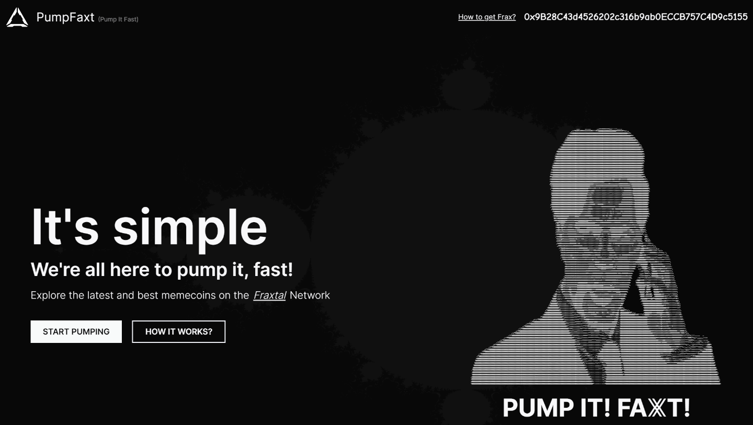

Quick Introduction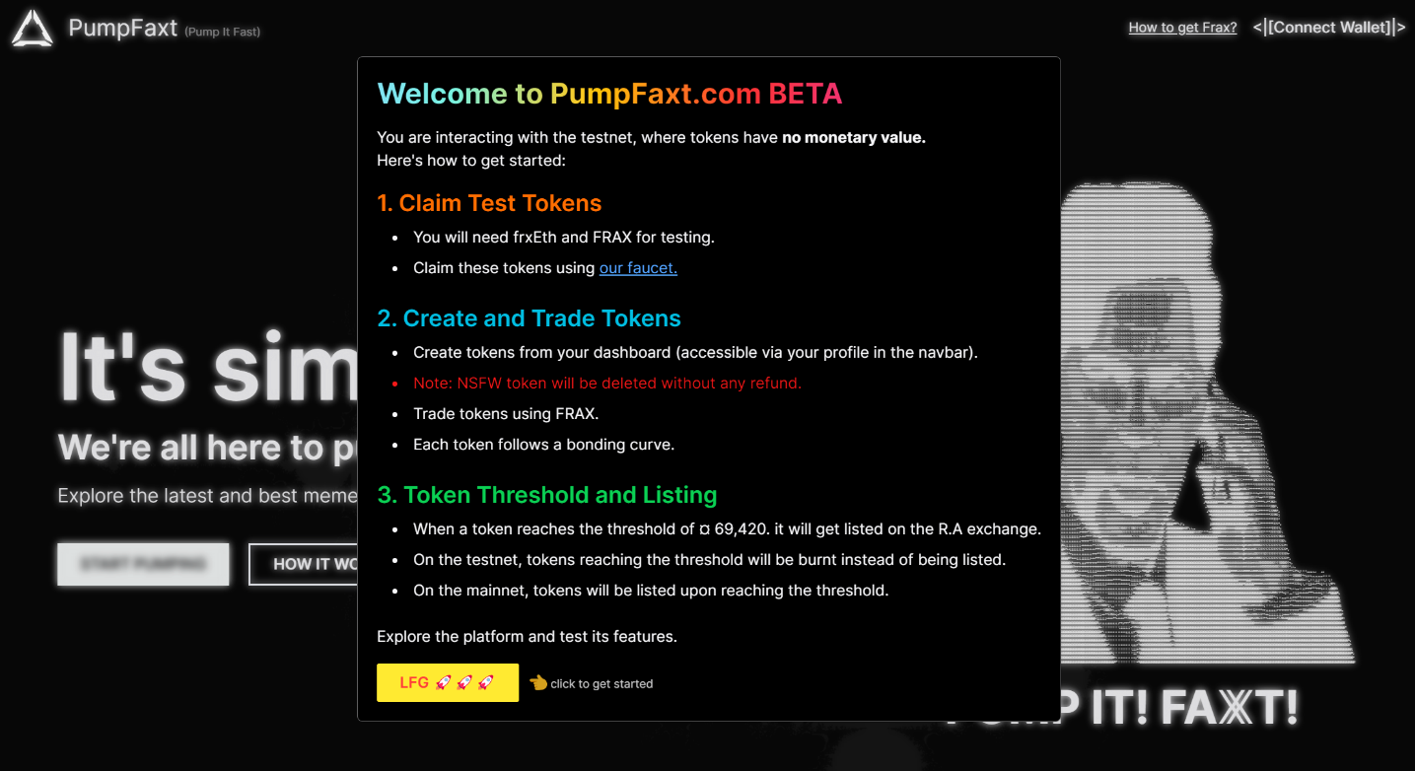

Coins Showcase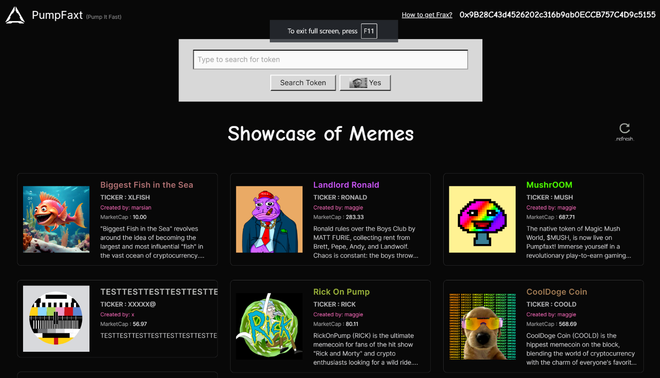

Coin Page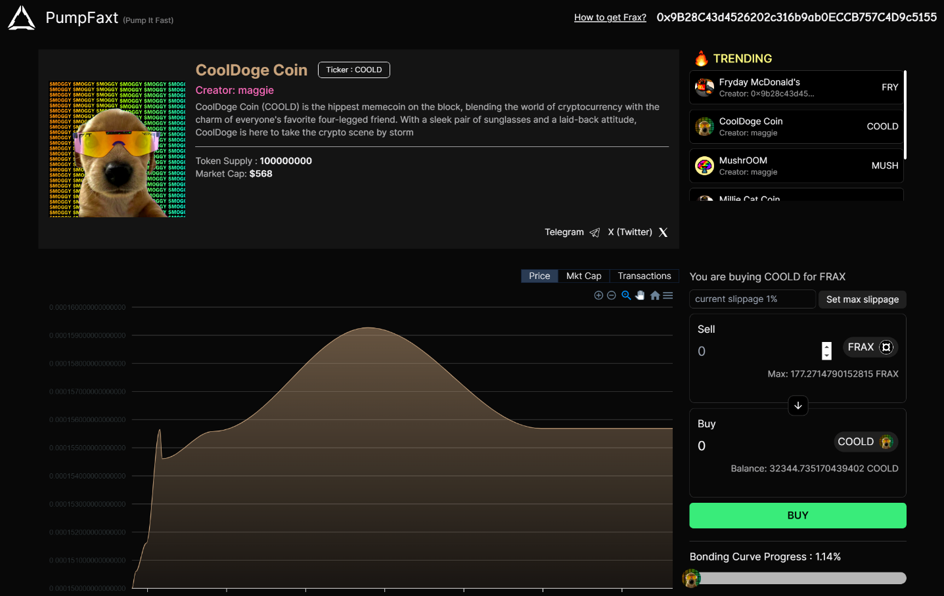

Comments and Voice channel on Coin Page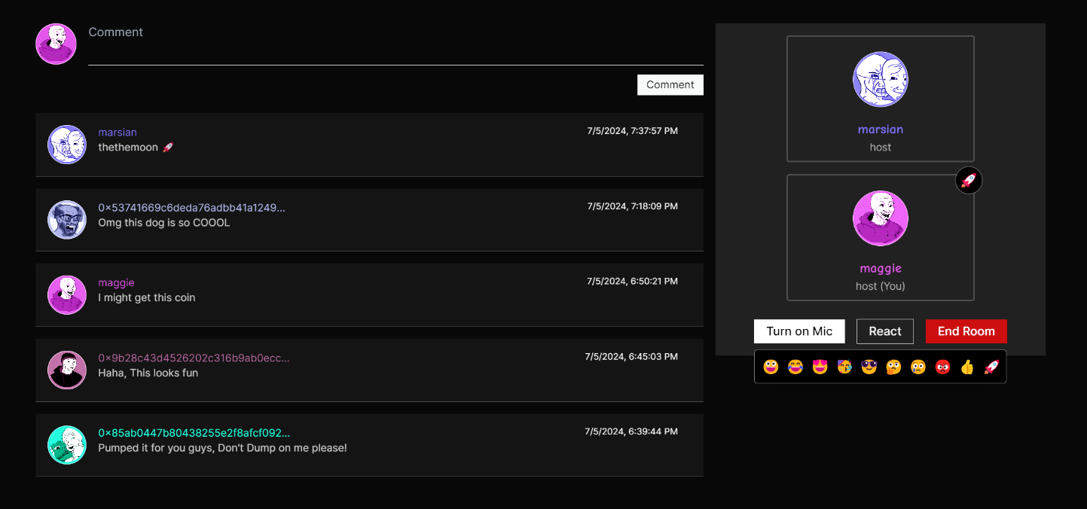

User Dashboard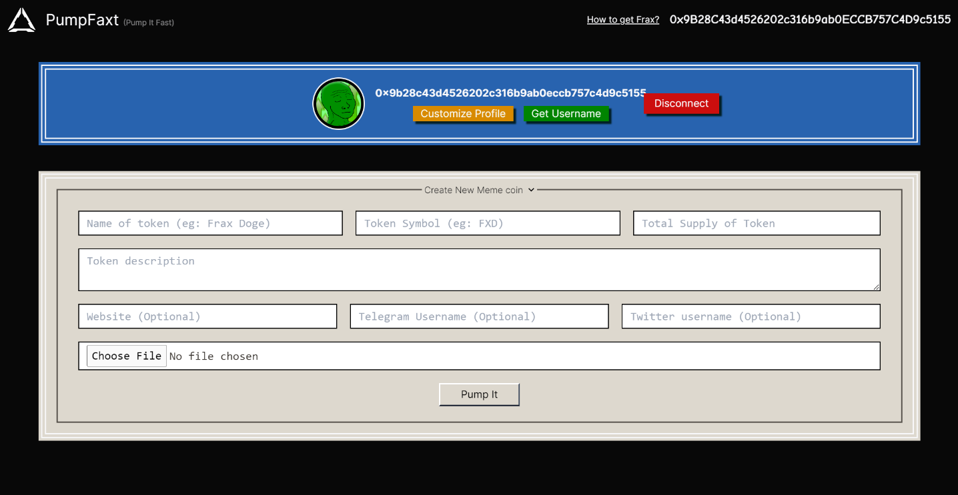

Customize Profile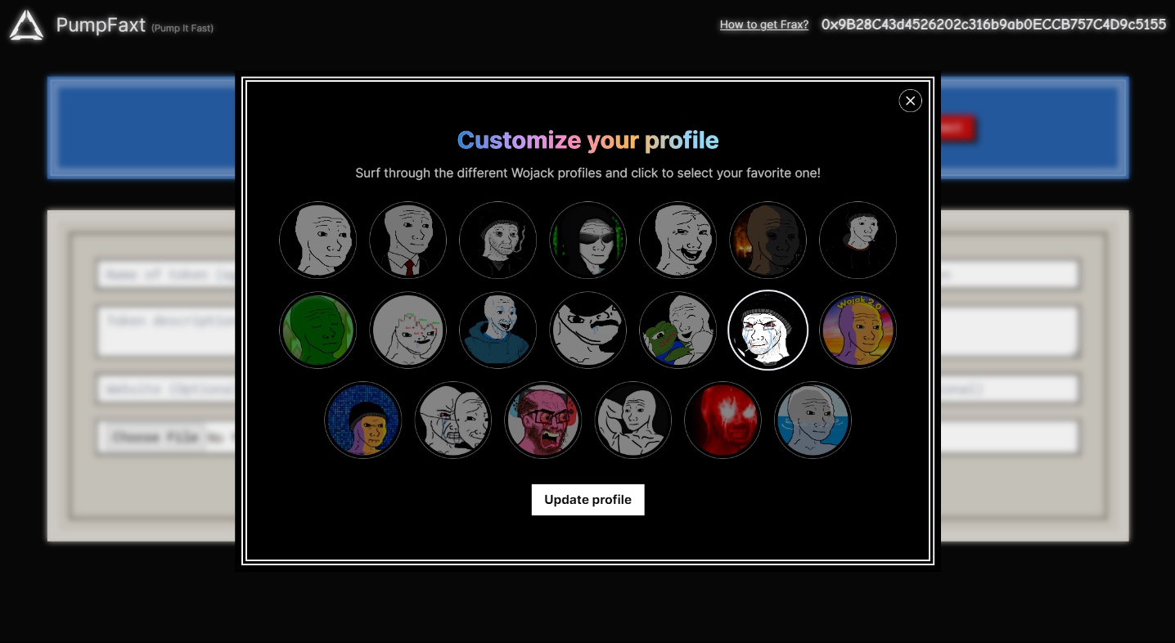

Faucet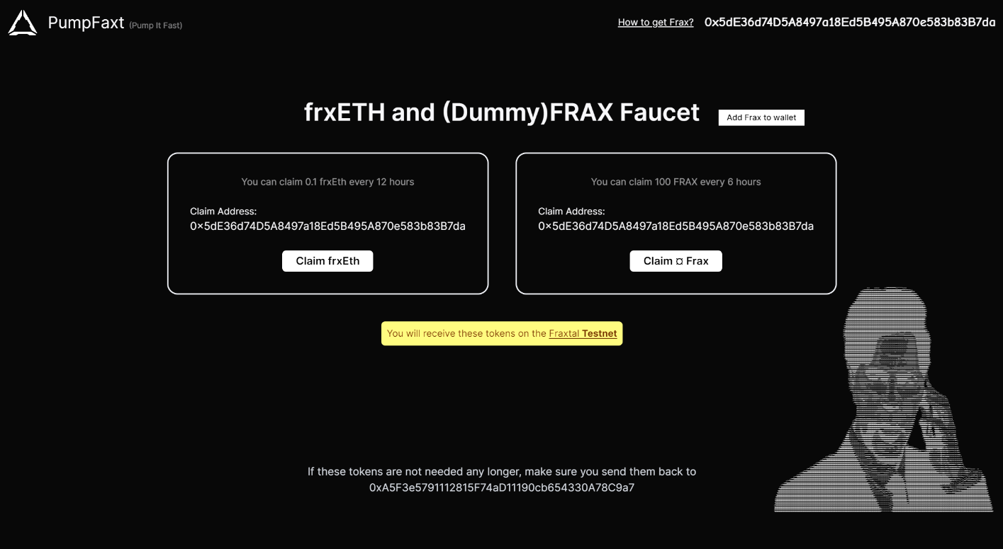

**Team**

* **Spandan Barve (Marsian)**

Linkedin: <https://linkedin.com/in/marsian83>

Github: <https://github.com/marsian83>

Website: [https://marsian.dev](https://marsian.dev/)

* **Riya Jain (Jriyyya)**

Linkedin: <https://linkedin.com/in/jriyyya>

Github: <https://github.com/jriyyya>

Website: [https://jriyyya.dev](https://jriyyya.dev/)