AutoBitStack is a cryptocurrency investment platform that allows users to invest in Bitcoin using Dollar-Cost Averaging (DCA) and limit orders. We leverage [Chainflip](https://chainflip.io/" \t "_blank)'s cross-chain liquidity to execute trades efficiently and securely.

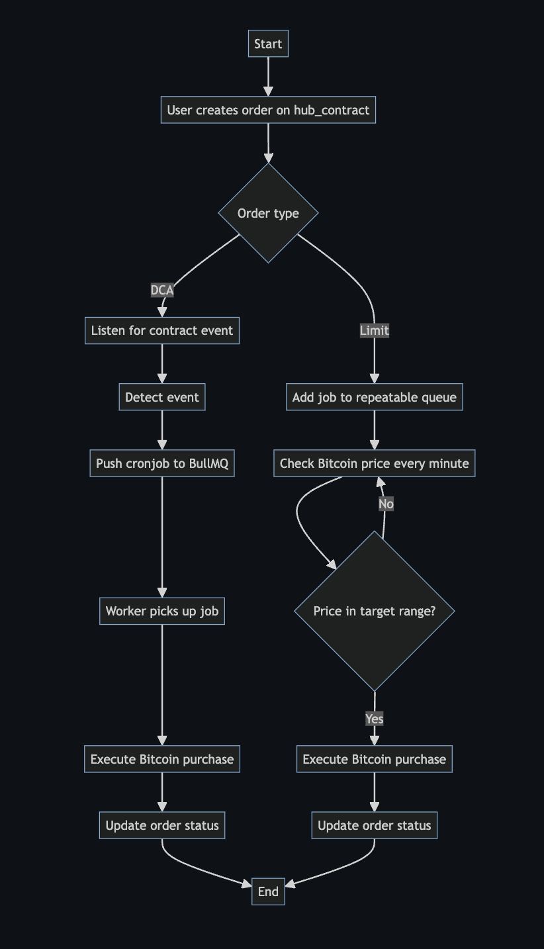

**Overview**

* [View Smart Contract Here](https://github.com/AutoBitStack/sdk/blob/main/src/AutoBitStack.sol)
* [Go to dapp here](https://autobitstack.akbaridria.xyz/)

**Features**

* **Dollar-Cost Averaging (DCA)**: Automatically invest in Bitcoin at regular intervals.
* **Limit Orders**: Set target prices for Bitcoin purchases.
* **Smart Contract Integration**: Secure order creation and management.
* **Automated Execution**: Server-side processing for timely order execution.

**How It Works**

**DCA Flow**

1. User creates a DCA order on our hub\_contract.
2. Our server listens for contract events.
3. When an event is detected, a cronjob is pushed using BullMQ.
4. A worker executes the Bitcoin purchase at the specified intervals.

**Limit Order Flow**

1. User creates a limit order on our hub\_contract.
2. Our server posts a job to a repeatable queue (running every minute).
3. The job checks the current Bitcoin price.
4. If the price is within the target range, it executes the buying order.