**Introduction**

UBITStake is a decentralized staking platform built on the UBIT Blockchain. It is designed to empower users by providing them with a secure and user-friendly way to stake their UBIT tokens and earn rewards. With the growing interest in decentralized finance (DeFi), UBITStake aims to offer a seamless staking experience, leveraging the advanced features of the UBIT Blockchain.

**Project Overview**

UBITStake allows users to participate in various staking pools, earn rewards, and manage their assets with ease. The platform features a comprehensive dashboard that provides real-time updates on staked tokens, rewards, and transaction history. With a focus on security and transparency, UBITStake uses smart contracts to ensure that all staking operations are secure and immutable.

**Key Features**

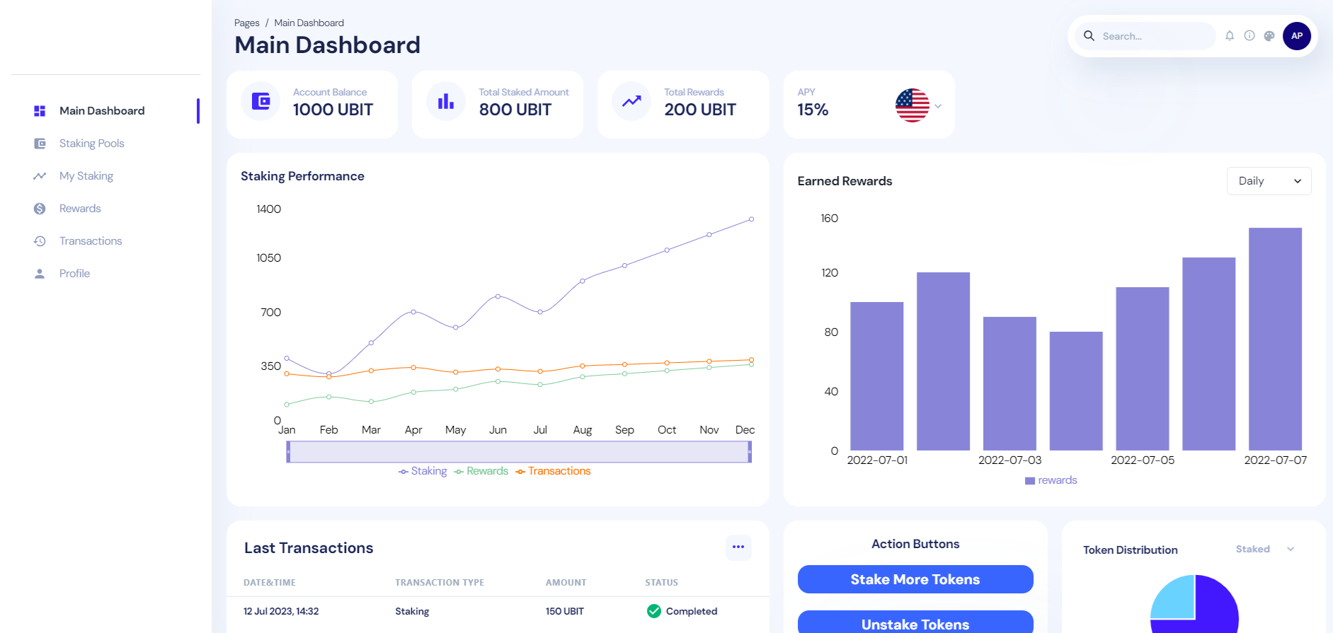

* **👥 User Registration and Authentication**  
  UBITStake offers a secure user registration and authentication process. Users can create accounts, log in, and authenticate using the UBIT Wallet, ensuring a seamless and secure experience.
* **📊 Dashboard**  
  The platform provides a comprehensive dashboard where users can view their staked tokens, rewards, and transaction history. The dashboard updates in real-time, giving users an up-to-date view of their staking activities and rewards.
* **🔗 Staking**  
  Users can stake their UBIT tokens in various staking pools with different reward rates. UBITStake offers a simple and intuitive interface for selecting staking pools and staking amounts, making it easy for users to start earning rewards.

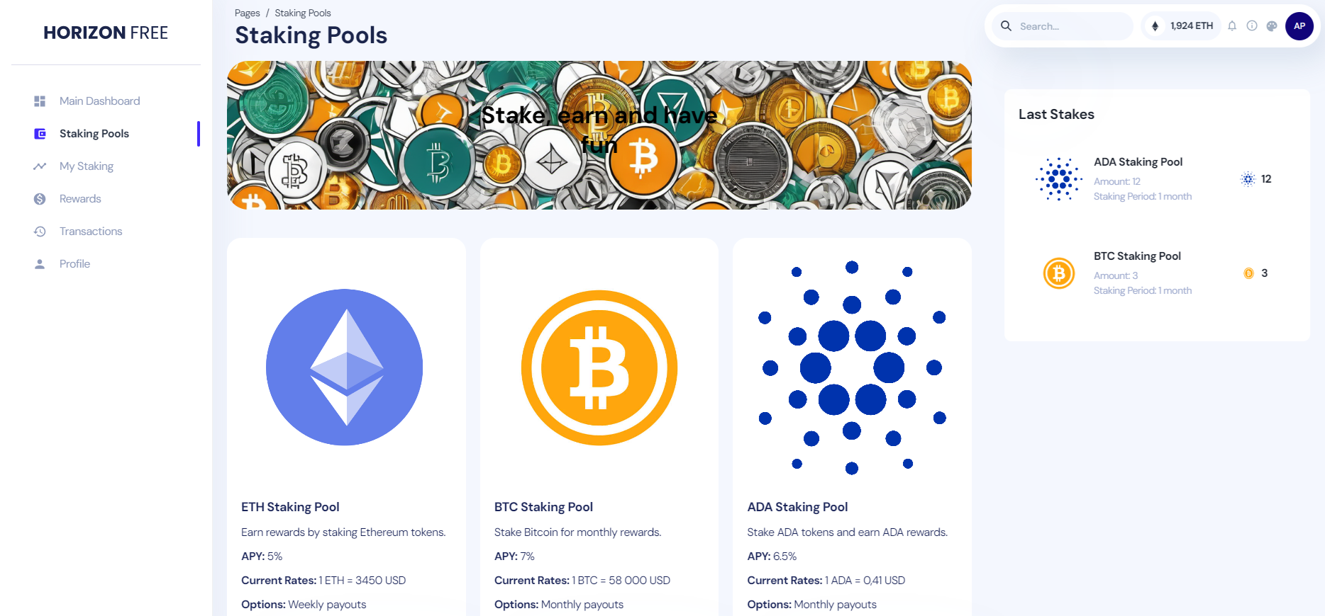

* **♻️ Unstaking**  
  UBITStake allows users to unstake their tokens at any time. The unstaking process is transparent and straightforward, with clear information on any potential penalties for early unstaking.

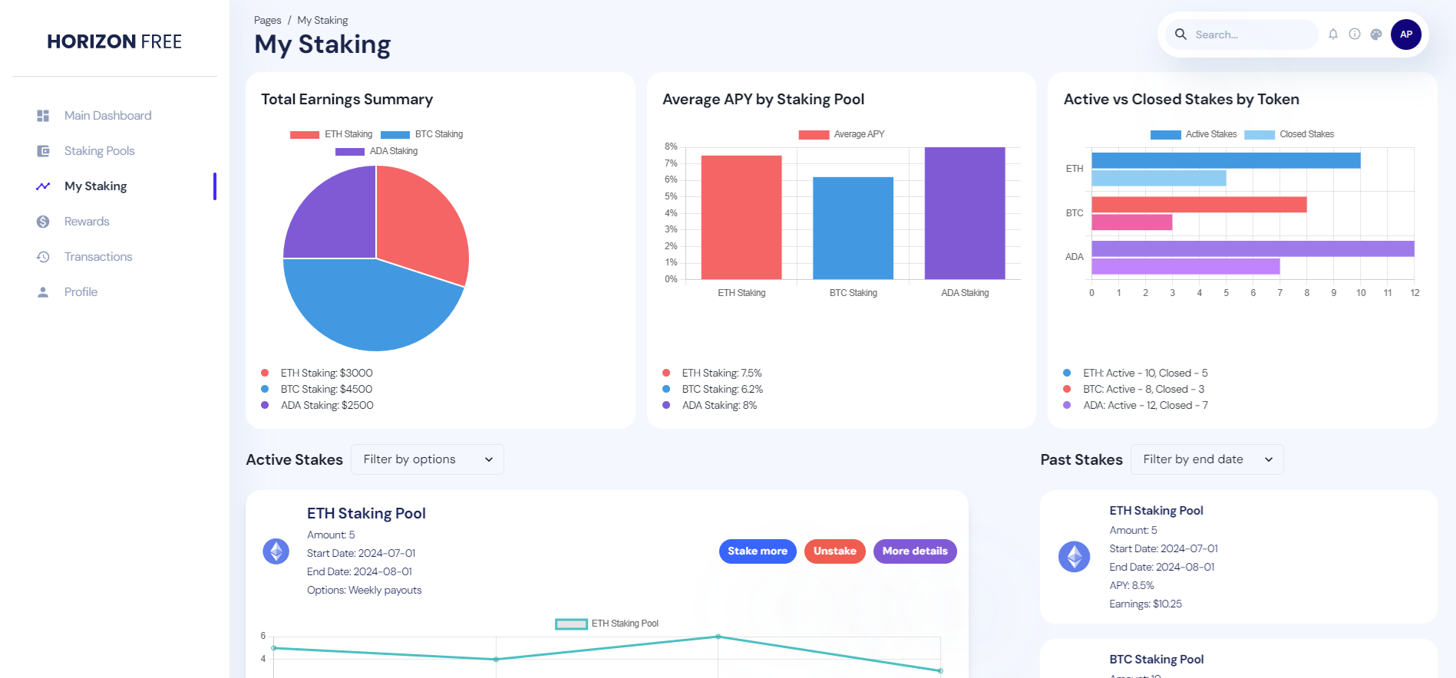

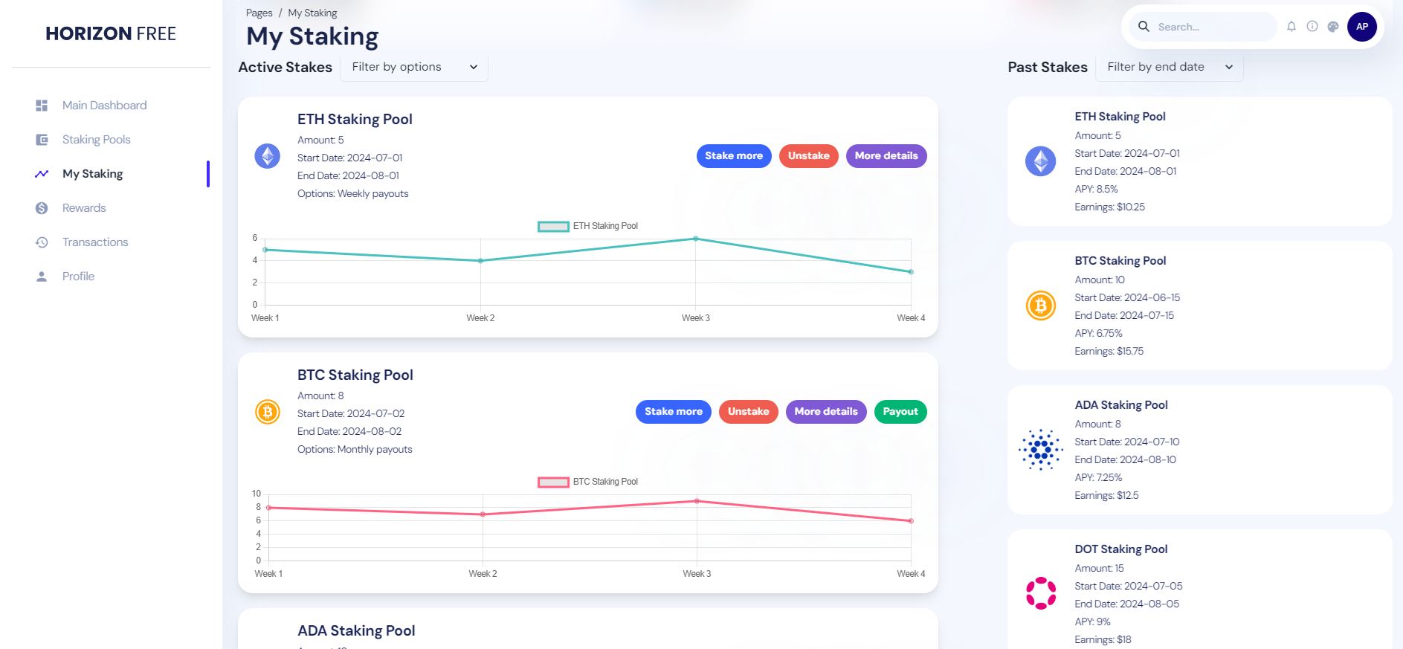

* **🎁 Rewards**  
  Users can earn rewards based on their staked tokens and the staking pool’s reward rate. The platform will calculates and displays rewards in real-time, and users can claim their rewards directly from the dashboard.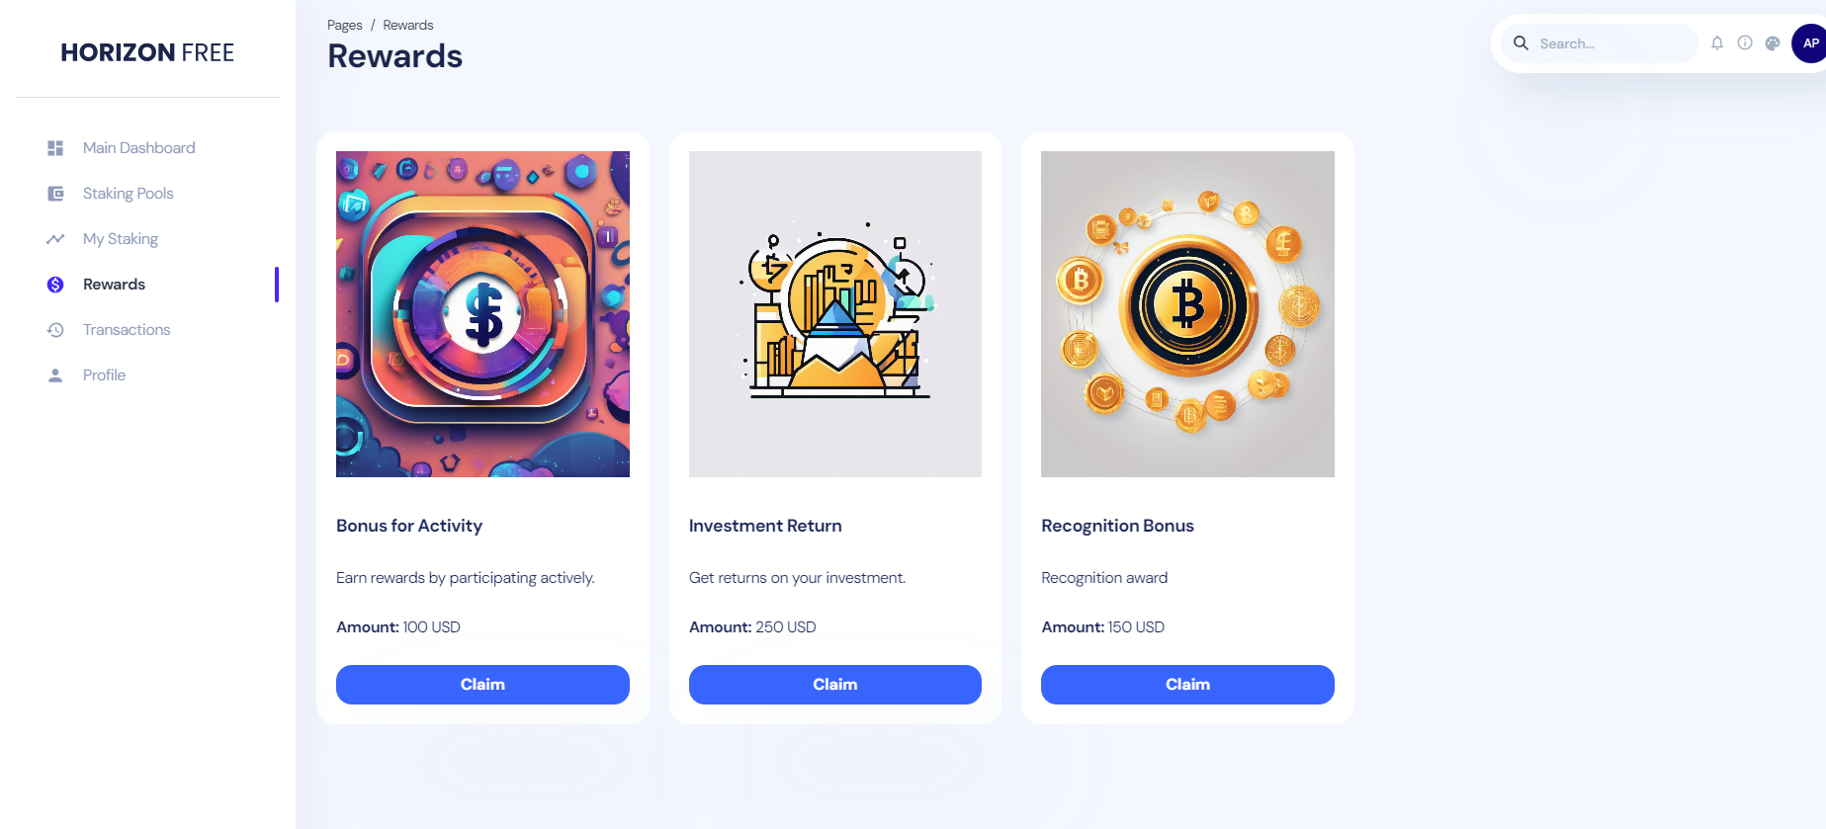

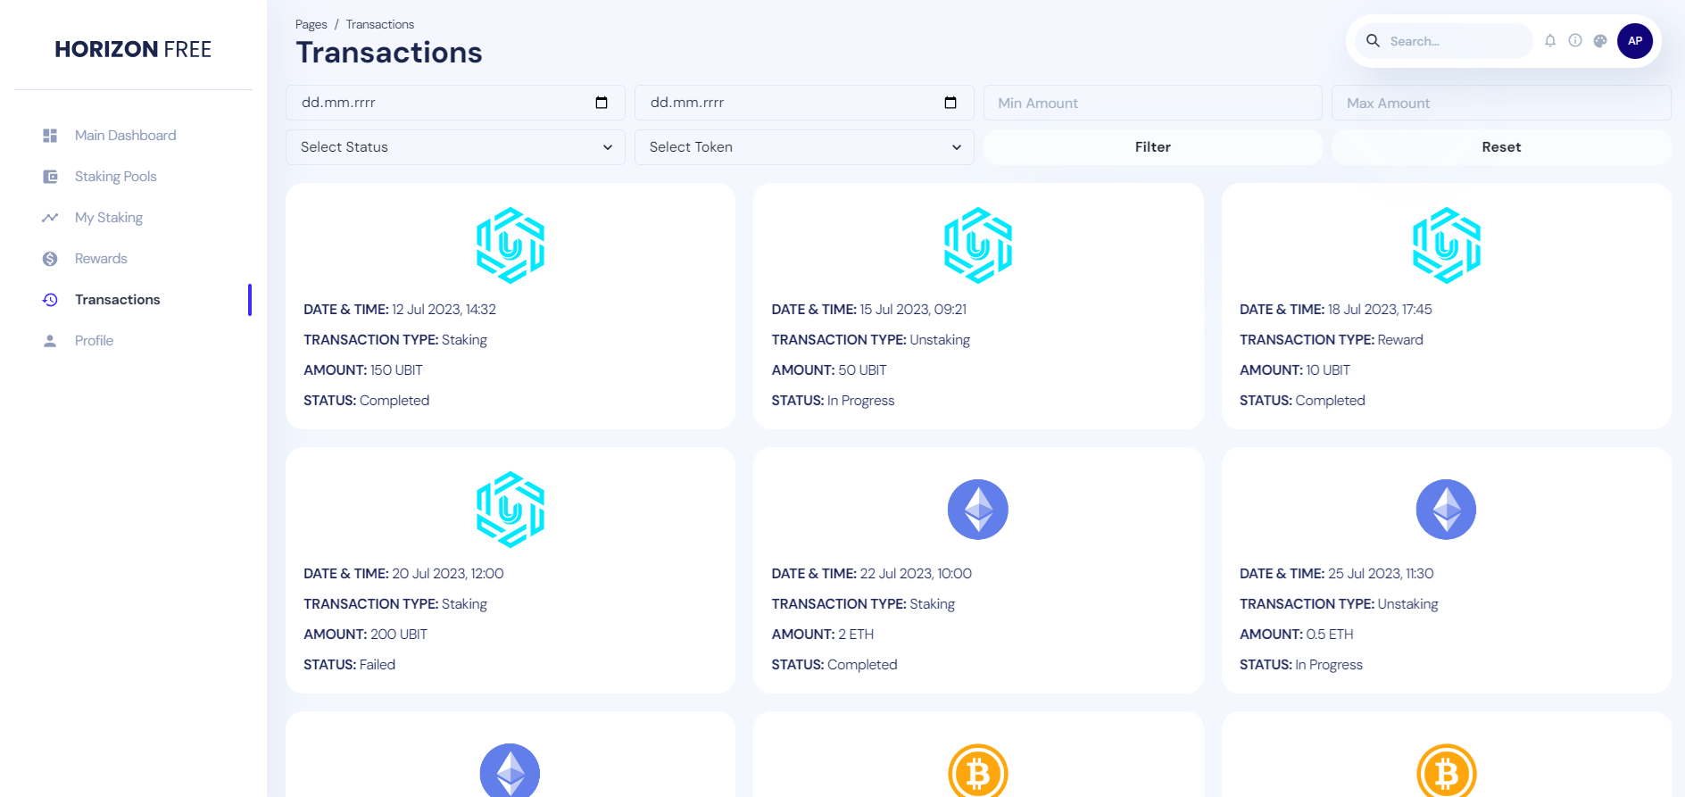

* **🔒 Security**  
  Security is a top priority for UBITStake. The platform will uses the UBIT Blockchain for all transactions, ensuring that they are secure and transparent. Additionally, UBITStake implements two-factor authentication (2FA) for enhanced account security.
* **🛠️ Admin Panel**  
  UBITStake will includes an admin panel for managing the platform. Admins can create and manage staking pools, set reward rates, and monitor platform performance and user activities.

**Technical Details**

* **🌐 Frontend**  
  The frontend of UBITStake is built using React.js, providing a responsive and intuitive user interface.
* **💻 Backend**  
  The backend is developed using Node.js and Express.js, ensuring a robust and scalable server-side application.
* **🔗 Blockchain Integration**  
  UBITStake leverages the UBIT Blockchain for secure and transparent staking operations. Smart contracts, developed in Solidity, handle all staking and unstaking processes.
* **💾 Database**  
  MongoDB is used for storing user data, transaction history, and other platform-related information.
* **🔌 APIs**  
  UBIT Blockchain APIs are integrated to handle transactions and data retrieval, ensuring seamless interaction with the blockchain.

**Long-Term Vision**

Our long-term vision is to become the leading staking platform on the UBIT Blockchain, supporting a diverse range of tokens and offering innovative staking options. We aim to continuously improve the user experience, integrate advanced security features, and expand our services to support cross-chain staking, making UBITStake a central hub for decentralized finance activities.

**Short-Term Vision**

In the short term, our goal is to successfully launch UBITStake, attract a significant number of users, and establish a strong presence in the DeFi community. We aim to ensure that the platform is user-friendly, secure, and reliable, providing an excellent staking experience that encourages user engagement and trust.

**Target Audience**

UBITStake is designed for:

* **🚀 Crypto Enthusiasts:** Individuals who are interested in participating in the DeFi space and earning rewards by staking their tokens.
* **💼 DeFi Investors:** Investors looking for secure and profitable staking options for their digital assets.
* **👨‍💻 Blockchain Developers:\***Developers who want to leverage the UBIT Blockchain for building innovative staking solutions.
* **🌐 Crypto Communities:** Communities that wish to promote staking among their members to grow and support their ecosystems.

<https://ubitscan.io/token/0xb2D262171dE72eAA4245e2235aeC2007a170Eda5/token-transfers>