JUST is the app that connects a user to an attorney through a video call in seconds by a press of one button. The main purpose is to insure no harm from police, avoid an unnecessary arrest and minimize potential charges/citations. JUST can also be thought of as UBER ($104B) or AirBNB ($106B) for legal industry.

JUST application would consist of two parts: the one that customers see on their smartphone and the one that attorneys see on their desktop.

Customers’ End

# Welcome Page

After downloading the application, the customer will be welcomed with the company’s short slogan such as “Making the world JUST with on-demand attorneys” and “While police protects you from criminals we protect you from police”. At the bottom of the welcome page will be a button “**Get started**”. If the client already has an account, have him/her sign in using verification code sent as SMS to mobile phone number (like it’s done in other apps nowadays).

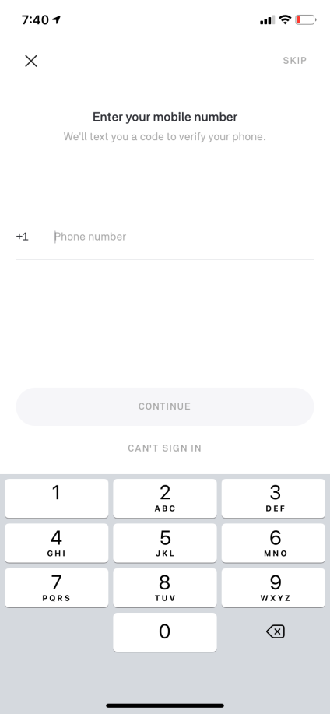

If client doesn’t have an account, have him/her sign up

# Signing-Up

After choosing “Sign-Up” option, client will have to provide his personal information and set his preferences in 6 steps: ‘Personal Information’, ‘Emergency Contacts’, ‘Preferred Lawyer’, ‘Bail Preference’, ‘Billing’, ‘Agree to Policy & Submit’.

Each of the steps would be a screen with fields to fill in, some marked as required, *like on the picture below but with appropriate titles and more modern cool design.*

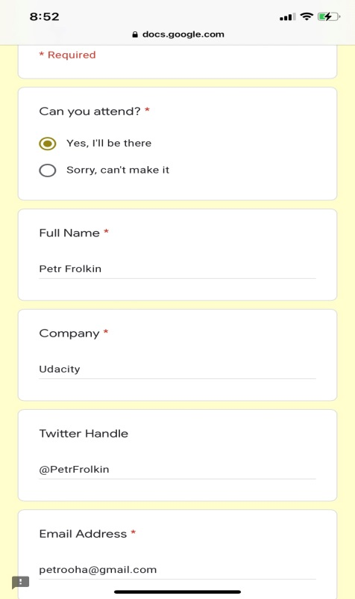

At the top of the screen is displayed the six-bar scale for visualized progress, *like on the picture below but with more modern cool design.*



Personal Information

Personal Information should have required fields: Name, Address, Phone, Email, Date of birth, Residency (Citizen/Permanent Resident/Visa/No Papers/Other). Optional fields: SSN, DL# (*“The more information the attorney has the better he will be able to guide you. You never know which piece of information is critical. Remember! Any information provided to us will never be used against you”).* Addition information an attorney should be aware of (Felonies, Warrants, Medical Conditions, etc.)

Emergency Contacts

On the next screen user is asked: “In case of arrest would you like anyone to be notified?” If user says “Yes”, fields for contact information appear (Name, Phone, Email, method of contact SMS or VM) with “+” at the bottom to add fields for another person.

Next question is “In case of arrest, would you like your employer or school to be notified about potential absence?” If user says “Yes’, fields for contact information for employer appear (same as before). The difference is that the message will be different not disclosing the issue in full detail just informing of emergency issue requiring the absence.

Preferred Lawyer

Then, user is asked if there is a lawyer he prefers to be contacted first from the poll of available attorneys. Selected attorneys will receive an emergency call first before it goes to the entire poll (2-5 seconds advantage to take the call). If user says “Yes” he can start adding attorneys by typing the names and phone numbers, choosing from the list of JUST attorneys or choosing from the list of Premium (more expensive) attorneys.

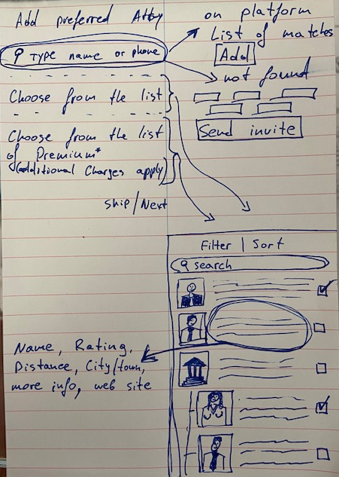When user types the name or the phone number of the attorney the matching attorneys on JUST should come up in the list with box to select attorneys or law firms. If no results found, user can put contact information of his attorney and that attorney will receive an invite to start using JUST.

Pressing “Choose from the list” will show the list of attorneys with their information as shown on the picture. The user can select the whole firm or select attorneys. Information field should also include “more info” button to see what attorney has to say about himself.

List of “Premium” attorneys consist of the same information with addition of information about their charges.

If no attorneys were selected, there should be a button “Skip” at the bottom, otherwise, there should be a button “Next” to move to the next step.

Bail Preference

On this screen ask user “In case of an arrest, would you like to get bailed out or wait for judge’s decision? Different charges may have different bonds’ amounts.”

* I got more time than money
* Always bail out
* Depending on bond amount
  + Enter maximum bond amount

If user chooses anything but first option, ask “How would you like to take care of the bond?”

* Charge my account
* Contact my emergency contact

If user chooses second option, show the list of emergency contacts with check boxes next to the names

Billing

Get bank account and/or credit card information

“Note: it may be too late to update the replaced card during contact with the police since you may not have enough time to start the recorded video call. If you are not on the recorded video call by the beginning of the conversation with police, officers may not allow you to touch your phone, doing so regardless maybe very dangerous for you. Therefore, we suggest to use backup bank account and or credit card.”

Get another bank account and/or credit card information or “skip”

Agree to Policy & Submit

Like in other apps

Possible backgrounds:

   

# Home Screen

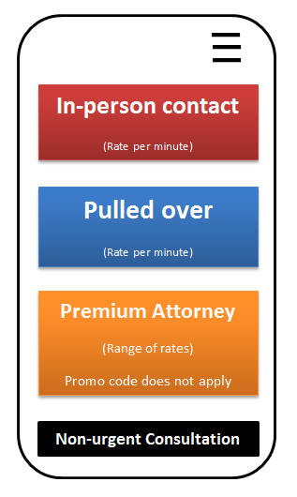

Home screen must be as simple and intuitive as possible. Also it must load as fast as possible (within couple seconds after user clicks on the app’s icon).

Each of the top three buttons starts recording a video and sends the call to poll of all available attorneys specializing either in in-person contacts with police, traffic law or to Premium (more exclusive and more expensive experts).

If the user selected a preferred lawyer while signing up and that attorney is online, the call is going to that attorney first. If that attorney does not take the call in 2 seconds, it goes to the poll of all available now attorneys.

Button with three bars at the top right corner is the drop-down menu. If it requires attention it would be indicated with red dot. It includes 4 buttons “Messages”, “Pending Case(s)”, “Required Action(s)”, “My Account”. Each of 4 buttons may also be indicated with red dot if it requires attention.

* “Messages” would show direct messages from an attorney or JUST support team
* “Pending Case(s)” would contain information about case such as date, type of citation and its number, information about attorney who was on the call and attorney leading the case (if different), and recorded video of the video call. Both attorney and the user can add notes and upload files to the case.
* “Required Action(s)” would show a note from the attorney regarding pending case, such as hearing date (or automatic reminder of such) or a document that user needs to gather.
* “My Account” would contain information provided during Sign-Up.

# Video Call (Key Function)

**Video call is basically the same as in WhatsApp or FaceTime, but also with private message option that attorney can send to the user to make sure that police officer doesn’t hear it. That’s it.**

After the call, app would ask the user if he was arrested, if any citations were given, to rate the attorney out of 5 stars. The interaction with police leads to one of three possible outcomes: **arrest, citation or let go.**

Arrest

If the result of interaction is leading to an arrest, attorney should briefly instruct the user about the best practices at police station and jail/precinct/bookings where he is being taken, and ask whether the user would like the attorney to start working on his case immediately, transfer the case to a different attorney or take no action regarding the case and the user will choose a public defender (this is all done verbally). Once the call is over, attorney selects the user’s choice on his end and takes the following action.

Emergency contacts get notified automatically through email or text automatically. If there is a payment method on file and the correctional facility accepts it, the bond is placed for the user’s soonest release. If not, the information of user’s emergency contact is provided to the highest rated bail and bond service in the area (bail and bond service will contact the person and place the bond on their end to release the user asap).

If the user chooses to **not hire an attorney** on JUST, “Pending Case” will have all information about the case with the notes taken by the attorney during the call and an option to watch/download the recorded video of the call. There also should be a button to hire an attorney for the case, pressing which would show the lawyer who consulted the user on the call and the preferred attorney (or list). One more option the user should have is to “Close the Case” which would remove the case from the “Pending Cases”.

If the user **hires the attorney** through JUST, the attorney starts working on the case immediately, making notes in “Pending Cases” and corresponding with the user through “Messages”, “Required Actions”, and by all other means outside the app. The attorney should give a call to the emergency contact (if there are few – to closest relative). He is also expected to follow up on bail preference to insure that user is out ASAP.

Citation

If the user received citation(s) the app would ask him to put in the citation number and the state where it was issued and take a clear picture of the copy provided by police. If the user does not complete one of the steps after call, he gets a notification on his smartphone’s lock screen and a drop-down menu (three bars) gets marked with red dot so does the “Required Action” button in it.

When all after-call steps are completed by the user, the information will appear in “Pending Cases”. The attorney will have an opportunity to propose a solution and its estimated cost. The proposal would appear in “Messages” and the user will have an option to hire the attorney or not. Most of the time, the attorney should have an estimate ready before the end of the video call since.

Let Go

The information about the interaction would still appear in “Pending Case” to provide the user with an opportunity to download the recorded video call and take notes for his own record and then it will be deleted after one week to save space on the server.

# Non-urgent Consultation

This button is an addition for making JUST a one stop shop for legal services.

At the push of the button the question appears: “Do you have a case or citation number regarding which you need a consultation?” If the user says “Yes”, the fields for case or citation number and for the state where it was issued would appear. Based on that information, the app should retrieve all the information about the citation, such as matter, charge, courthouse, name of the judge, etc. from the court sites. Based on these pieces of information and information about lawyers (location, practice, areas of expertise, preferred judges to deal, etc.) suggest the list of the most suitable lawyers in the same format as in “Preferred Lawyer” but with an indicator showing whether he is offering free consultation through video call and whether he is available for it now. There should also be a button for a consultation request, after pressing which, the user would see a calendar with available time slots indicated by the attorney on his end.

If the user doesn’t have a case number, he is going to be asked few questions about his intention to narrow down all attorneys to the few. At any point of questionnaire, user should be able to skip to the full list of attorneys to search manually.

Attorneys’ End

# Sign Up

During the sign up the attorney should provide his firm’s and own credentials, such as license number and area of the expertise (to be decided on for the final version of the app). Then, he should wait for the validation of the provided information by the JUST’s team before he can start taking video calls and consulting people.

# Home screen

From the home screen, the attorney should be able to see and change his availability status for the new video call consultations “In-person”, “Pull Over” or “Non-urgent”.

Calendar with time slots for non-urgent consultations and ability to manage them – add, remove, edit, cancel. Also, he should be able to click on the user who booked a consultation to see his information or the case number.

Access and manage his and his firm’s account.

Access, manage and edit his pending cases

Send messages to clients and assign them “Required Actions”

# Video Call

When a user presses one of the buttons to start a video call, ALL attorneys with the status ‘available’ will receive the incoming call, the fastest attorney to answer it – starts the call with the user.

As the video call goes on, the attorney is able to take important time-notes by clicking a key to mark the time stamp (when a certain action happened during the call) and type the note of what happened. This will make it easier to manage the case later if the interaction leads to it.

# Rating

Each attorney should have a rating calculated based on his outcomes of video calls, whether they tend to lead to arrests, harm of a client by police, citation, or letting go. Clients’ rating also should be factored in. Attorneys with lower ratings will have a little delay in receiving a call when attorneys with higher ratings are available in their area.

# Managing Clients

Attorney should be able to see and edit his clients’ cases info and respond to non-urgent consultation inquiries.