AI Multilingual FAQ Assistant for Cross-Border E-commerce
This project is a minimum viable model for a multilingual, retrieval-grounded FAQ assistant in cross-border e-commerce. It helps customers access approved FAQ information in English, Chinese and Spanish while keeping the system bounded and safe.

Problem Value and Target Users
Cross-border e-commerce customers often need help with delivery, returns, refunds and order status. The issue is not that FAQ information does not exist, but that it is scattered across help pages, often written in one main language, and hard for customers to match with their own wording. This creates slow answers, inconsistent support, lower trust and extra human-service cost.
The target persona is a multilingual cross-border shopper who may ask in English, Chinese or Spanish and may not use exact policy keywords. The secondary user is a support team that needs answers to stay consistent with approved policy. The project improves a normal FAQ page by turning static help content into a source-grounded assistant that retrieves policy, answers in the customer's language and refuses when the FAQ is not enough.

Why AI and Why a Retrieval Grounded Assistant
A keyword lookup baseline is useful because it is cheap, transparent and realistic for simple FAQ systems. However, keyword lookup is weak when customers use indirect wording, translation or non-keyword expressions. For example, "Where is my money after I sent the item back?" is a refund-status question even though it does not use the phrase "refund status." A multilingual retrieval assistant can map varied customer wording to the same approved FAQ meaning.
I did not build a fully autonomous customer-service agent because this project does not need the system to issue refunds, change addresses or access payment records. A full agent would increase risk and be harder to evaluate safely. I built a bounded retrieval-grounded assistant instead: it retrieves from a controlled FAQ source, answers from that evidence, cites the source, asks for language clarification when needed and refuses unsupported cases.

Minimum Viable Model and Product Scope
The minimum viable model is a working Streamlit prototype. It loads a 50-entry simulated FAQ knowledge base, accepts customer questions in English, Chinese or Spanish, retrieves the best FAQ record, and answers only from that record. It also includes 50 simulated order records with different order statuses, so the demo can show a realistic online-shopping support scenario and a future path toward read-only order tools.
The product scope is intentionally narrow, focusing on common support areas such as orders, delivery and refunds. This smallest first version proves the core workflow before adding live APIs, private customer records or automatic actions. The high-level architecture is shown in the box diagram. The diagram summarises how a customer question or order number is routed through the Streamlit interface into FAQ retrieval, language clarification, or simulated order lookup before producing a grounded answer or demo evidence.
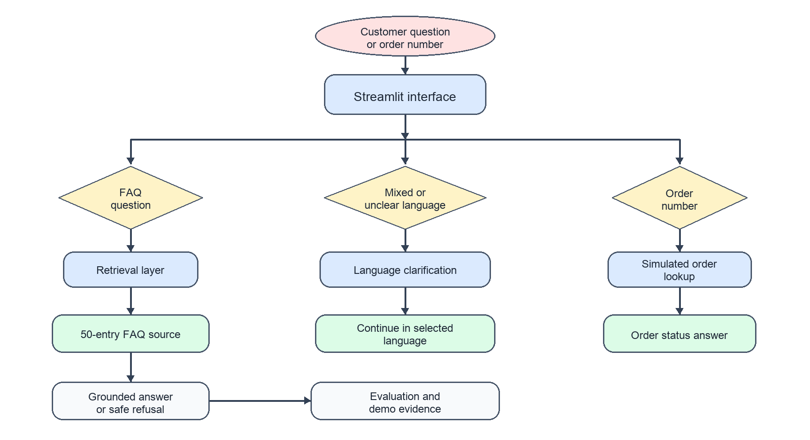

Build Buy and Data Choices
I built the core prototype locally, including the Streamlit interface, FAQ dataset, 50 simulated order records, retrieval logic, refusal rules and evaluation runner. This version does not yet connect to a live LLM API or a real e-commerce backend. This build-buy choice makes the prototype easier to run, avoids API-key and privacy risk for submission, and allows anyone to reproduce the project on another computer by following the README instructions. A future version could connect to a hosted LLM API such as GPT-4o after the retrieval and safety workflow is stable, mainly to improve answer fluency and broader language coverage.
The data choice is deliberate. The project uses 50 carefully written FAQ records and 50 simulated order records, but no real customer data or personally identifiable information. This fits the project scope because the goal is to demonstrate the project workflow, not to process real business data.

Evaluation Baseline Cost and Metrics Performance Critique
The evaluation uses 50 fixed test cases created for this project across English, Chinese and Spanish. Each case has an expected FAQ source, required answer terms and expected language behaviour. The same test set is used for both the assistant and the keyword baseline, so the comparison is consistent. The keyword baseline provides a simple, transparent, low-cost and realistic comparison point because many basic FAQ systems do rely on keyword matching.
Metric | Assistant result | Keyword baseline
Overall pass rate | 50/50, 100% | 33/50, 66%
Source accuracy | 50/50, 100% | 36/50, 72%
Content accuracy | 50/50, 100% | 33/50, 66%
Language match | 50/50, 100% | 50/50, 100%
Estimated cost for 50 cases | USD 0.015558 | USD 0.014670

The table summarises the main evaluation metrics reached by the assistant and the keyword baseline on the same 50-case test set.
The cost estimate uses publicly available OpenAI GPT-4o API pricing as a reference: USD 2.50 per 1M input tokens and USD 10.00 per 1M output tokens. This is a simulated expected token cost used to compare the approximate model-call cost of the assistant and the keyword baseline. A real deployment would usually cost more because it would also include live API usage, monitoring, maintenance, human review and human handoff costs.
The table shows that the assistant's estimated token cost is only about 6.1% higher than the keyword baseline, while its overall pass rate improves by 34 percentage points, source accuracy by 28 percentage points, and content accuracy by 34 percentage points. This accuracy gain has practical deployment value: human review and customer-service handoff are usually more expensive than a single token-based model call, so the assistant can reduce wrong answers, save support time and labour cost, and improve consistency in multilingual customer service.
The metrics performance critique is that the assistant clearly outperforms the keyword baseline inside the fixed test set, but the result should still be interpreted carefully. The test cases are simulated, so they cannot cover all real customer wording, spelling mistakes, policy changes, live account questions or complex language instructions. Therefore, the evaluation proves that the current workflow is effective, but future versions still need more realistic data and stronger regression testing to verify stability.
One difficulty was balancing usefulness and safety: the assistant needed to understand indirect multilingual questions, but still refuse requests not supported by the FAQ. The evaluation process helped address this difficulty rather than only report final results. After comparing the assistant with the keyword baseline, I adjusted retrieval scoring, topic phrases, language detection and refusal thresholds, making the assistant better at matching indirect questions while still refusing unsupported requests.

Improvement Areas and Future Work
Future versions should use anonymised real support questions, human review and regression testing whenever the FAQ changes. This would test whether the system remains stable in more realistic and complex scenarios. Another important direction is connecting the system to a real API and a real e-commerce front end, but this should happen only after the safety boundaries, privacy protection and evaluation workflow are stronger.
The responsible-use principle is not to overclaim the assistant's ability. The assistant cites FAQ sources, refuses low-confidence or unsupported answers, and routes sensitive or account-specific requests to human support. The future path is to connect the same architecture to a live approved help-centre dataset, a real e-commerce front end, authenticated read-only order tools, monitoring and human handoff.

Main Conclusion
This project shows that a retrieval-grounded multilingual FAQ assistant can improve concrete real-world problems in cross-border e-commerce support. It addresses different customer languages, scattered FAQ information, varied customer wording, and the time and labour cost of repetitive support questions. By connecting customer questions to the correct FAQ source, the assistant can improve answer accuracy and consistency, reduce unnecessary human review and handoff cost, and support a more efficient, trustworthy and cost-effective customer-service workflow. This demonstrates the practical value of using AI in a controlled, safe and evaluable way to improve real customer-support processes.

