Title Goes Here

Jane Doe1,2,✉, John Q. Doe1, Peder Ås1, Juan Pérez3, and Max Mustermann

February 3, 2023

Text of abstract

1 Formatting Open Science Group  
2 Federation of Planets  
3 Acme Corporation

✉ Correspondence: [Jane Doe <janedoe@fosg.org>](mailto:janedoe@fosg.org)

Keywords: keyword 1; keyword 2; keyword 3

Highlights: These are the highlights.

# Introduction

Here is a citation (Marwick, 2017)

# Background

# Methods

# Results

# Note the path that we need to use to access our data files when rendering this document  
my_data <- read.csv(here::here('analysis/data/raw_data/my_csv_file.csv'))

plot(rnorm(10))

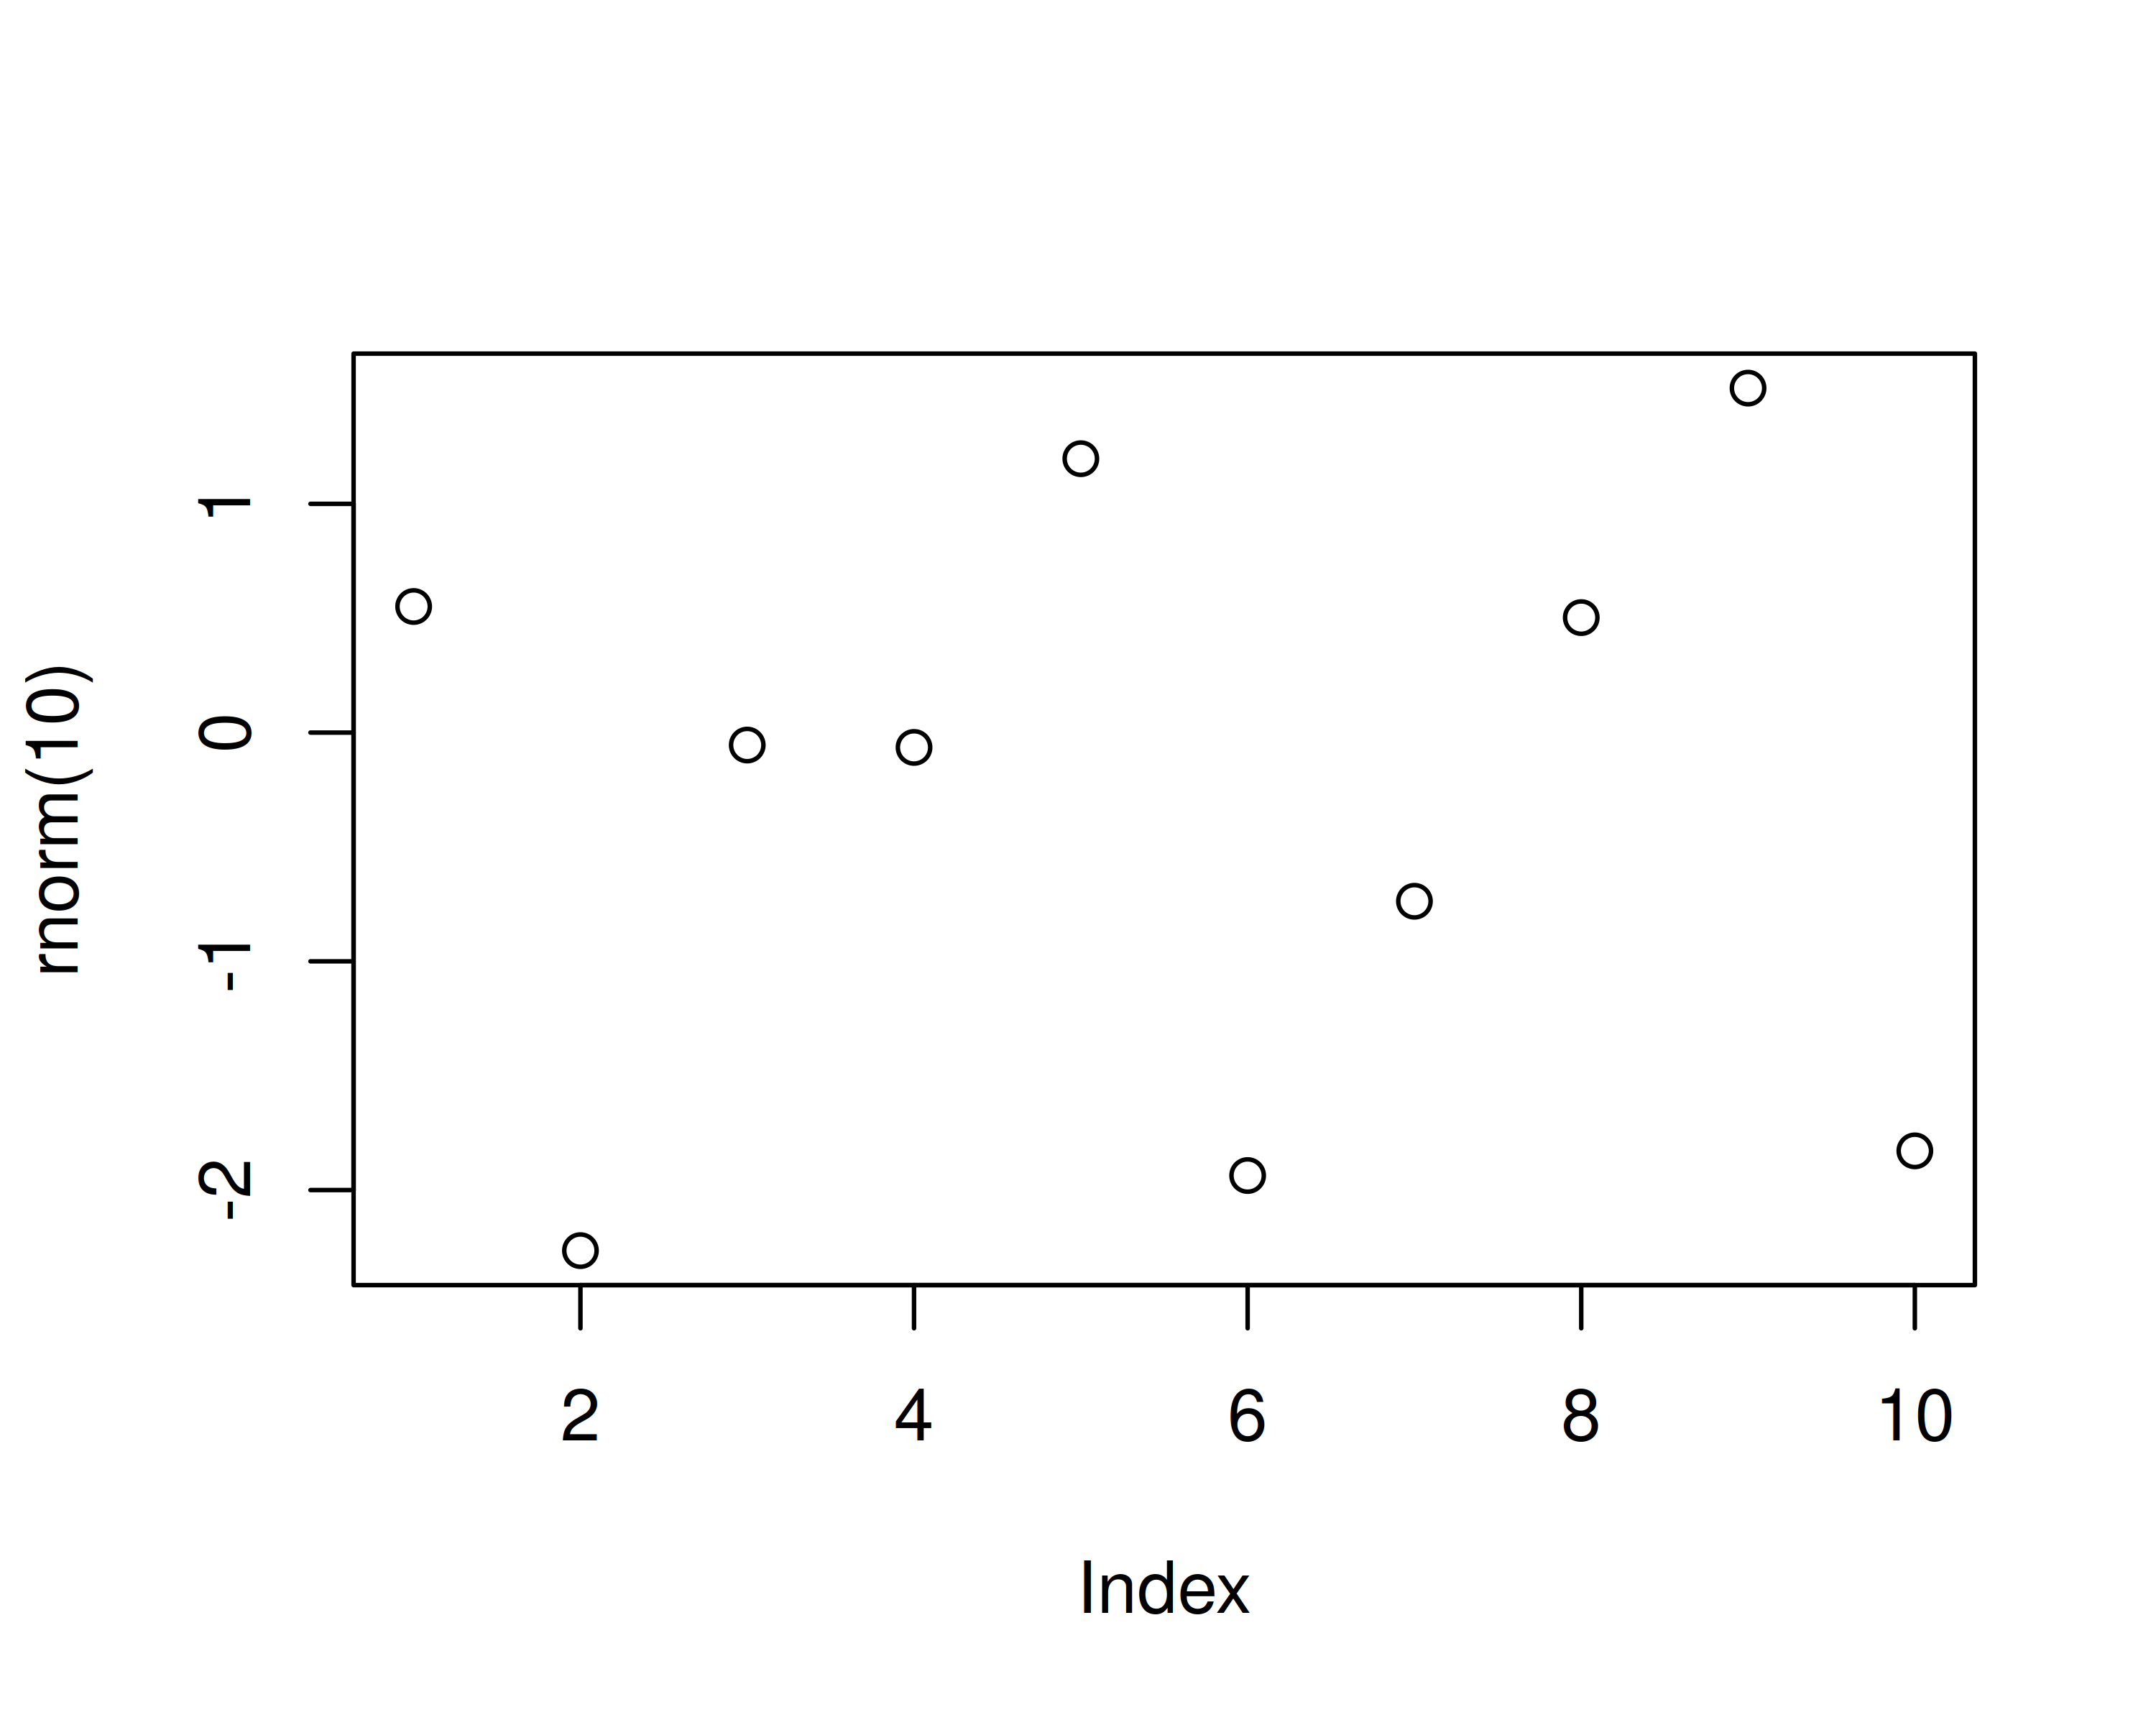

A plot of random numbers

Figure **?@fig-demo-plot** shows how we can have a caption and cross-reference for a plot. Note that figure label and cross-references must both be prefixed with fig-

Here is an example of inline code 3.14 in the middle of a sentence.

# Discussion

Example of a citation Earl et al. (2013).

library(ggplot2)  
  
ggplot(mtcars) +  
 aes(mpg, hp, color = factor(gear)) +  
 geom_point()

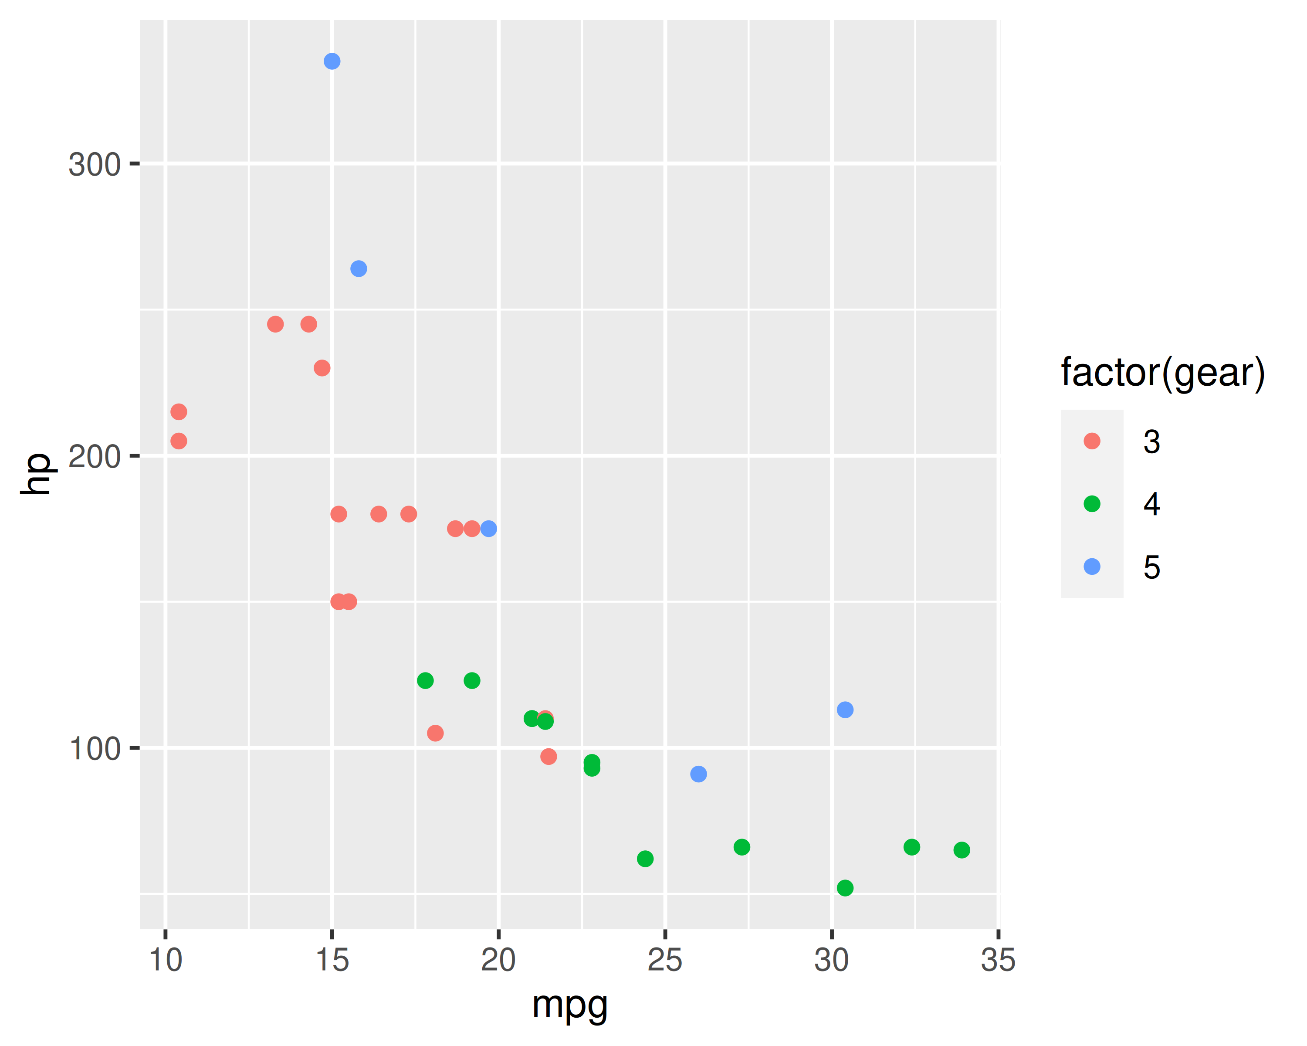

Scatterplot of a miles per gallon by horsepower.

I am referencing a Figure **?@fig-mtcars-scatter**.

# Conclusion

# Acknowledgements

# References

Earl, G., Sly, T., Chrysanthi, A., Murrieta-Flores, P., Papadopoulos, C., Romanowska, I., Wheatley, D. (Eds.), 2013. Archaeology in the digital era: Papers from the 40th annual conference of computer applications and quantitative methods in archaeology (CAA), southampton, 26-29 march 2012. Amsterdam University Press, Amsterdam.

Marwick, B., 2017. Computational reproducibility in archaeological research: Basic principles and a case study of their implementation. Journal of Archaeological Method and Theory 24, 424–450. <https://doi.org/10.1007/s10816-015-9272-9>

### Colophon

This report was generated on 2023-02-03 12:09:20 using the following computational environment and dependencies:

# which R packages and versions?  
if ("devtools" %in% installed.packages()) devtools::session_info()

─ Session info ───────────────────────────────────────────────────────────────  
 setting value  
 version R version 4.2.2 (2022-10-31)  
 os ArchLabs Linux  
 system x86_64, linux-gnu  
 ui X11  
 language (EN)  
 collate en_US.UTF-8  
 ctype en_US.UTF-8  
 tz Europe/Prague  
 date 2023-02-03  
 pandoc 3.0.1 @ /usr/bin/ (via rmarkdown)  
  
─ Packages ───────────────────────────────────────────────────────────────────  
 package * version date (UTC) lib source  
 cachem 1.0.6 2021-08-19 [1] CRAN (R 4.2.1)  
 callr 3.7.3 2022-11-02 [1] CRAN (R 4.2.2)  
 cli 3.6.0 2023-01-09 [1] CRAN (R 4.2.2)  
 colorspace 2.1-0 2023-01-23 [1] CRAN (R 4.2.2)  
 crayon 1.5.2 2022-09-29 [1] CRAN (R 4.2.1)  
 devtools 2.4.5 2022-10-11 [1] CRAN (R 4.2.1)  
 digest 0.6.31 2022-12-11 [1] CRAN (R 4.2.2)  
 dplyr 1.1.0 2023-01-29 [1] CRAN (R 4.2.2)  
 ellipsis 0.3.2 2021-04-29 [1] CRAN (R 4.2.1)  
 evaluate 0.20 2023-01-17 [1] CRAN (R 4.2.2)  
 fansi 1.0.4 2023-01-22 [1] CRAN (R 4.2.2)  
 farver 2.1.1 2022-07-06 [1] CRAN (R 4.2.1)  
 fastmap 1.1.0 2021-01-25 [1] CRAN (R 4.2.1)  
 fs 1.6.0 2023-01-23 [1] CRAN (R 4.2.2)  
 generics 0.1.3 2022-07-05 [1] CRAN (R 4.2.1)  
 ggplot2 * 3.4.0 2022-11-04 [1] CRAN (R 4.2.2)  
 glue 1.6.2 2022-02-24 [1] CRAN (R 4.2.1)  
 gtable 0.3.1 2022-09-01 [1] CRAN (R 4.2.1)  
 htmltools 0.5.4 2022-12-07 [1] CRAN (R 4.2.2)  
 htmlwidgets 1.6.1 2023-01-07 [1] CRAN (R 4.2.2)  
 httpuv 1.6.8 2023-01-12 [1] CRAN (R 4.2.2)  
 jsonlite 1.8.4 2022-12-06 [1] CRAN (R 4.2.2)  
 knitr 1.42 2023-01-25 [1] CRAN (R 4.2.2)  
 labeling 0.4.2 2020-10-20 [1] CRAN (R 4.2.1)  
 later 1.3.0 2021-08-18 [1] CRAN (R 4.2.1)  
 lifecycle 1.0.3 2022-10-07 [1] CRAN (R 4.2.1)  
 magrittr 2.0.3 2022-03-30 [1] CRAN (R 4.2.1)  
 memoise 2.0.1 2021-11-26 [1] CRAN (R 4.2.1)  
 mime 0.12 2021-09-28 [1] CRAN (R 4.2.1)  
 miniUI 0.1.1.1 2018-05-18 [1] CRAN (R 4.2.1)  
 munsell 0.5.0 2018-06-12 [1] CRAN (R 4.2.1)  
 pillar 1.8.1 2022-08-19 [1] CRAN (R 4.2.1)  
 pkgbuild 1.4.0 2022-11-27 [1] CRAN (R 4.2.2)  
 pkgconfig 2.0.3 2019-09-22 [1] CRAN (R 4.2.1)  
 pkgload 1.3.2 2022-11-16 [1] CRAN (R 4.2.2)  
 prettyunits 1.1.1 2020-01-24 [1] CRAN (R 4.2.1)  
 processx 3.8.0 2022-10-26 [1] CRAN (R 4.2.1)  
 profvis 0.3.7 2020-11-02 [1] CRAN (R 4.2.1)  
 promises 1.2.0.1 2021-02-11 [1] CRAN (R 4.2.1)  
 ps 1.7.2 2022-10-26 [1] CRAN (R 4.2.1)  
 purrr 1.0.1 2023-01-10 [1] CRAN (R 4.2.2)  
 R6 2.5.1 2021-08-19 [1] CRAN (R 4.2.1)  
 Rcpp 1.0.10 2023-01-22 [1] CRAN (R 4.2.2)  
 remotes 2.4.2 2021-11-30 [1] CRAN (R 4.2.1)  
 rlang 1.0.6 2022-09-24 [1] CRAN (R 4.2.1)  
 rmarkdown 2.20 2023-01-19 [1] CRAN (R 4.2.2)  
 rstudioapi 0.14 2022-08-22 [1] CRAN (R 4.2.1)  
 scales 1.2.1 2022-08-20 [1] CRAN (R 4.2.1)  
 sessioninfo 1.2.2 2021-12-06 [1] CRAN (R 4.2.1)  
 shiny 1.7.4 2022-12-15 [1] CRAN (R 4.2.2)  
 stringi 1.7.12 2023-01-11 [1] CRAN (R 4.2.2)  
 stringr 1.5.0 2022-12-02 [1] CRAN (R 4.2.2)  
 tibble 3.1.8 2022-07-22 [1] CRAN (R 4.2.1)  
 tidyselect 1.2.0 2022-10-10 [1] CRAN (R 4.2.1)  
 urlchecker 1.0.1 2021-11-30 [1] CRAN (R 4.2.1)  
 usethis 2.1.6 2022-05-25 [1] CRAN (R 4.2.1)  
 utf8 1.2.3 2023-01-31 [1] CRAN (R 4.2.2)  
 vctrs 0.5.2 2023-01-23 [1] CRAN (R 4.2.2)  
 withr 2.5.0 2022-03-03 [1] CRAN (R 4.2.1)  
 xfun 0.37 2023-01-31 [1] CRAN (R 4.2.2)  
 xtable 1.8-4 2019-04-21 [1] CRAN (R 4.2.1)  
 yaml 2.3.7 2023-01-23 [1] CRAN (R 4.2.2)  
  
 [1] /home/knytt/R/x86_64-pc-linux-gnu-library/4.2  
 [2] /usr/lib/R/library  
  
──────────────────────────────────────────────────────────────────────────────

The current Git commit details are:

# what commit is this file at?   
if ("git2r" %in% installed.packages() & git2r::in_repository(path = ".")) git2r::repository(here::here())

Local: /mnt/data/Desktop/test  
Head: nothing commited (yet)