Players: 2-10
Age: 7+
Length: 15-90 minutes

Rules

Small accident happened at Tronliud4 planet and several robots was trapped inside the facility. Robots are severely damaged, and can’t operate on their own. They are in close proximity, and could try to fix each other.

To win the game, player should complete his own hidden objective.

This game is physically intensive. Stop game if you feel pain or uncomfortable.

Easy coop rules
- Prepare game
  - 6 cards in 3 columns
  - coop objectives by number of players
- Start malfunctioning
- Make turns
  - Move repairkit
  - Transfer malfunction card
  - Maybe get card discarded
- Announce end of the game and the winners.

Game preparation
- Place repair kits to the center of the table. There should be distanceof few centimeters between them.
- Place player tokens to the center of table around tokens.
- First player (one, who was latest injured) take card and place it in front of him face up. Then next player clockwise do same, until everyone have 6 cards.
  - Cards should form colored columns (2 colors per column, see end of rules, how to combine colors).
  - Place first card closer to you. Next card of same color should go towards the center of the table.
  - For each column, only closest card to the center of table is active. Other cards in column are in queue and not active. Don’t change the order of the cards.
- Everyone get the objective card.
  - Coop mode: place objective cards next to you face up.
  - Competitive: look at card secretly and keep it face down next ot player. Players could look at that card at any time, but can’t show it to anyone else.
- Everyone apply malfunctions that is active on their active cards (active cards located on top of the column). Malfunction should happened along the whole game.
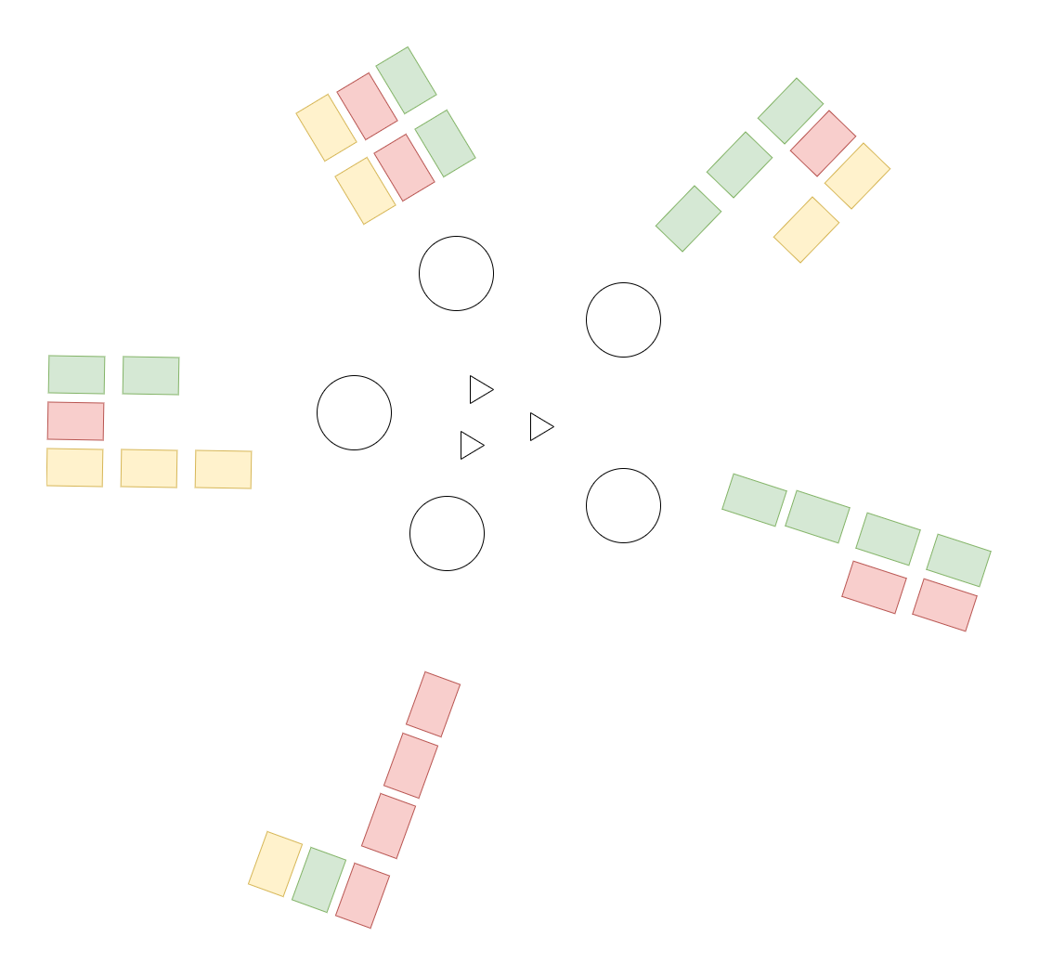
  - When someone break his malfunction rules, he lost power, and become suspended.

Example of intial setup for 5 players.
Game ends when any of the following happens:
- Nobody could make any action -> everyone loses.
- More than half of the players are suspended -> everyone loses.
- No more malfunction cards to pickup, -> everyone loses.
- One of the players complete objective and announce that he win on his own turn.

First player starts.

Turns.
- Player move repair kit to one of the other player tokens. When any new connection between player tokens or repair kits happens, move phase ends.
  - If player can’t act or interact with gameboard for whatever reason, his turn ends.
- If other player token form new connection, and currently 2 or more repair kits touching that token. Affected player should take new malfunction card and add it to the top of the column.
- If other player token form new connection, and only one kit is touching his token.
  - Current player should remove one the active malfunction from affected player by taking that malfunction card to his own corresponding column.
  - Affected player might (if he want and could) remove one of the active player malfunctions of his choice. He should turn it face down and move aside.
- Turn ends, and next player to ther left of active player (clockwize continue).

Suspended player
Suspension is a way for players to take rest and relax. Some players may make it intentionally, but if to many players try to become suspended at the same time, the game ends.
Player need to turn his back towards the game area, and can’t interact with board or other players. He can’t speak or make other sounds intentionally. Suspended player is allowed to use his arms to make any visuals he want to entertain remaining players.
Player resumed to game, when new reapirkit touches his token.

How to become suspended.
- Violate any of your own malfunctions.
- Touch any player tokens with your body parts.
- Make new connection that involve your own token.
- Try to use mouth to interact game board or cards.

Suspended player diagram TODO

Other notes

Number fo repair kits per player:
players 2-4: 2 kits
players 5-7: 3 kits
players 8-10: 4 kits

Combining colors cards makes game easier and faster. There are total of 63 malfunction cards (3 of each card). There are total of 13 objective cards. “table” and “head” objectives match to ~45% of cards each, so could be unfair in small competitive games.
Suggested combination of rules:

easy coop (15 minutes)
- 2-6 players
- combine red-purple, orange-yellow and green-blue so you have max 3 columns
- use all objectives except “no winner” to draw common objectives, put them face up, they all need to be fulfilled to win game
- each one take 6 malfunction cards

easy competitive (30 minutes)
- 3-5 players
- combine red-purple, orange-yellow and green-blue so you have max 3 columns
- use all objectives except “no winner”, “table”, “head”, every player keep it in secret
- it is ok, that during first 20 minutes, only one player could actually do anything
- each one take 7 malfunction cards

true robots (90 minutes)
- 4-5 players
- each color to own column
- use all objectives, every player keep it in secret
- it is ok, that during first 20 minutes, only one player could actually do anything
- each one take 10 malfunction cards

faction wars (60 minutes)
- 2-3 teams of 3-4 players
- use all objectives (except “no winner”)
- when player complete objective, he could dicard any card from any other player
- if all members of same team complete their objectives, they win
- combine red-purple, orange-yellow and green-blue so you have max 3 columns
- each one take 8 malfunction cards

Card meanings
“No winner” - objective completed, if everyone loses
“No table”, “No chair”, “No Leg” - objective completed when there is no corresponding mulfunction card face up on the table
“No head” - objective completed, when there is no “nouse”, “ear”, “eye”, “mouth” on the face up malfunction cards on the table.
“Fixed on … (C/CW)” - when player on the left or right is completely functional.

