Game description.
Game is for 2 players to find who have faster reaction.

Goal: press button faster than opponent when game starts.

Preparation:
When power is connected, game indicate that it is loaded by slowly blinking 3 times (both leds). [STATE_PREP ]

Press both buttons to start game. When both buttons pressed, game start blinking fast indicating that it is prepared. [ STATE_READY]

Game:
When both buttons are released, blinking stops, and there will be random 1-5 second delay.
If someone hold button when leds should switch on, he will lose. [STATE_FALSE_START]

Now when leds on, whoever press button first – wins the game. [STATE_GAME ]

When at least one button pressed, leds goes off.

Result: After short delay, one o both leds will on, indicating winner(s). [STATE_RESULT ]
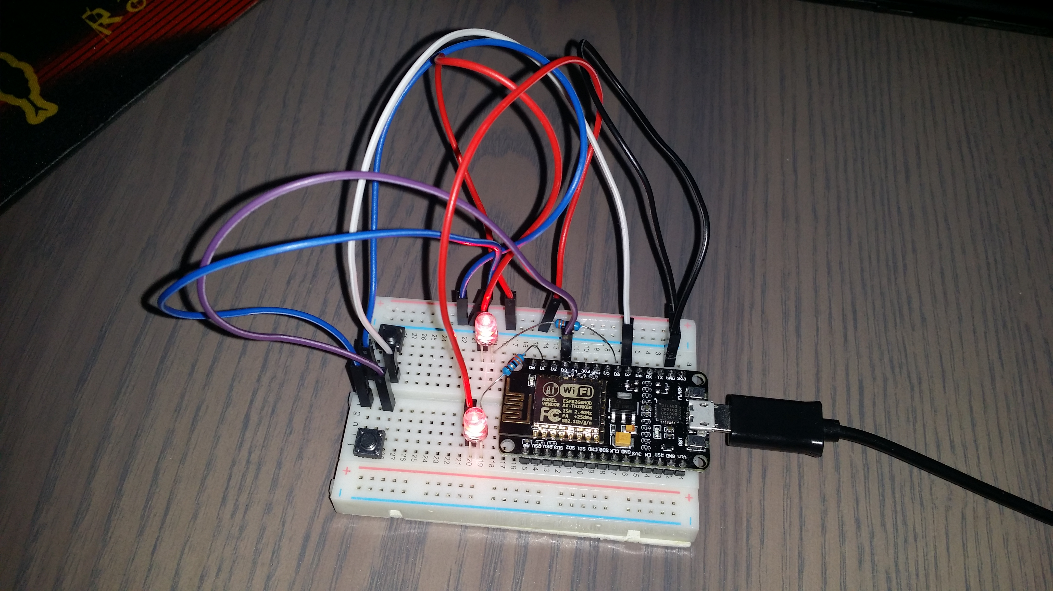
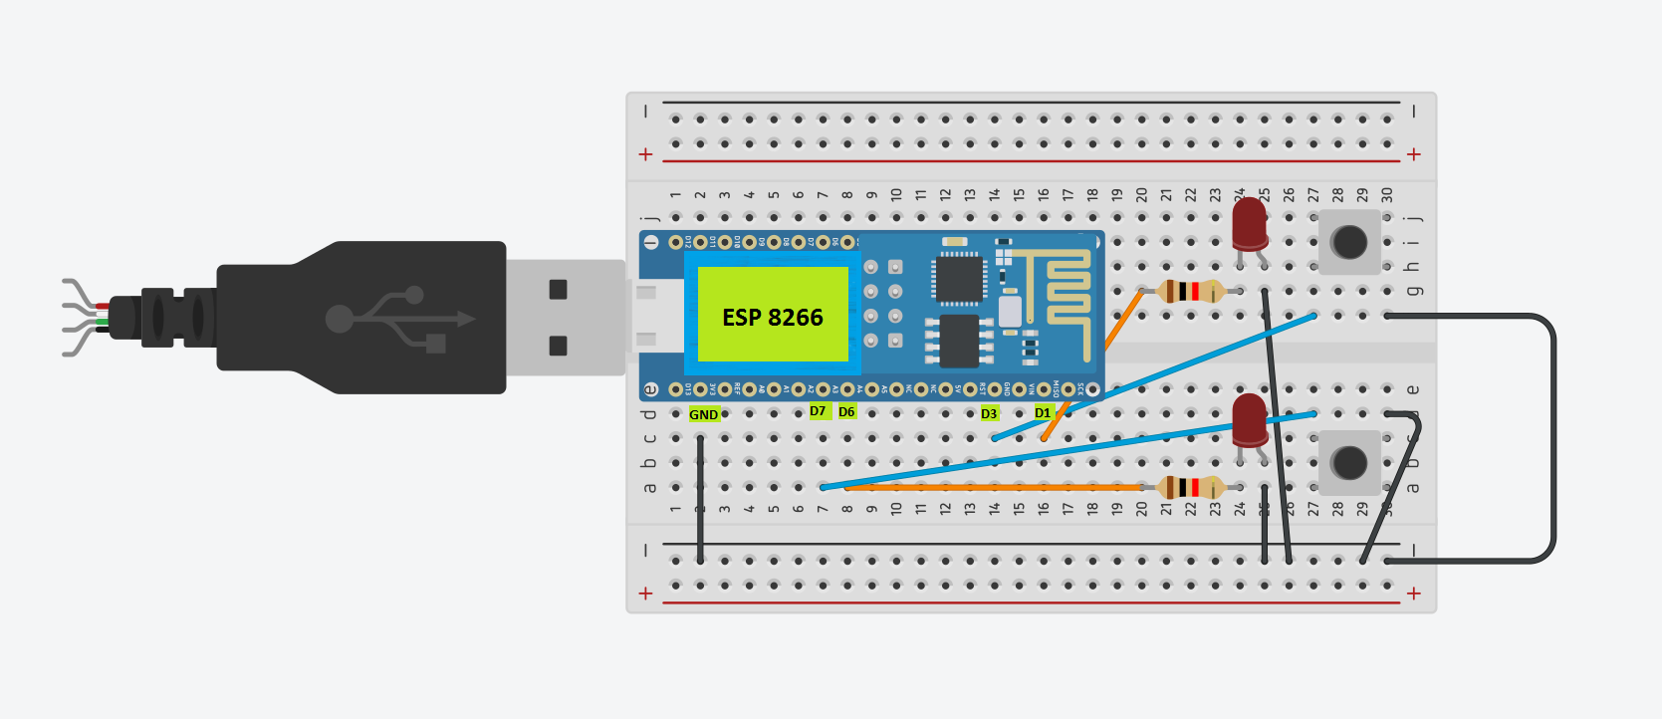
Arduino code

void setup() { } - Run once, after power connected.
void loop() { } - As soon as loop returns, it is called again.
delay(1000) – pause execution for 1000ms (1 second)
pinMode(5, OUTPUT) – set pin 5 to output mode
digitalWrite(5, HIGH) – put power to pin 5
digitalRead(13) – check voltage on pin 13; with 2-pin button, pressed button means LOW (as it shortcircuit to ground)

Tasks

Check what you need to do, to change BUTTON2 connection from D3 (GPIO 0) to D4 (GPIO 2).

Check what you need to do, to change LED2 connection from D1 (GPIO 5) to D2 (GPIO 4).

Challenges

- BlinkBlink. When player wis, led should blink (now it only on).
- Faster than light. Be able to play 3 games in 25 seconds.
- Blind guess. Change game, so delay before start is always 3 seconds. When playing game, close eyes after start phase.

Extra challenges (could be hard)
- change code, so only 1 player wins always
- change code, so one player get 2 sec advantage
- change code, so AI act instead of player 2 (e.g. Simulate press button after 0.5 sec delay)

Think about situations where you could apply ESP with buttons, leds, etc during next month (home, games, school, projects).

