Queer Little Folks
Beecher Stowe, Harriet
2001-01-01

Queer Little Folks
By
Harriet Beecher Stowe
With Illustrations

London:
T. Nelson And Sons, Paternoster Row.
Edinburgh; And New York.
1897
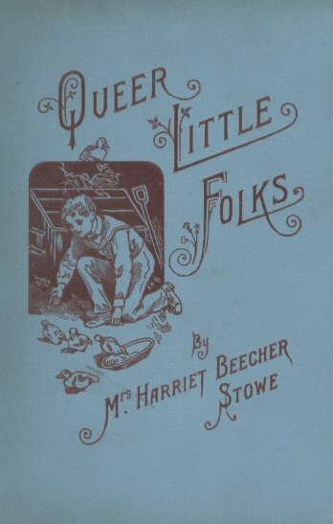

Contents. /x/
Hen that Hatched Ducks | 11
The Nutcrackers of Nutcracker Lodge | 29
The History of Tip-Top | 43
Miss Katy-Did and Miss Cricket | 61
Mother Magpie’s Mischief | 70
The Squirrels that live in a House | 80
Hum, the Son of Buz | 93
Our Country Neighbours | 106
The Diverting History of Little Whiskey | 117

List of Illustrations.
The Brood Hatched | 19
Feeding the Fame Robin | 59
Erecting the Hen-House | 15
The Hen that Hatched Ducks | 25
Enemies in Waiting | 39
The Nest in the Apple-Tree | 47
Tip-Top in bad Company | 57
Venturous Squirrels | 89

Hen That Hatched Ducks
A Story
Once there was a nice young hen that we will call Mrs. Feathertop. She was a hen of most excellent family, being a direct descendant of the Bolton Grays, and as pretty a young fowl as you could wish to see of a summer’s day. She was, moreover, as fortunately situated in life as it was possible for a hen to be. She was bought by young Master Fred Little John, with four or five family connections of hers, and a lively young cock, who was held to be as brisk a scratcher and as capable a head of a family as any half-dozen sensible hens could desire.
I can’t say that at first Mrs. Feathertop was a very sensible hen. She was very pretty and lively, to be sure, and a great favourite with Master Bolton Gray Cock, on account of her bright eyes, her finely shaded feathers, and certain saucy dashing ways that she had which seemed greatly to take his fancy. But old Mrs. Scratchard, living in the neighbouring yard, assured all the neighbourhood that Gray Cock was a fool for thinking so much of that flighty young thing; that she had not the smallest notion how to get on in life, and thought of nothing in the world but her own pretty feathers. “Wait till she comes to have chickens,” said Mrs. Scratchard; “then you will see. I have brought up ten broods myself—as likely and respectable chickens as ever were a blessing to society—and I think I ought to know a good hatcher and brooder when I see her; and I know that fine piece of trumpery, with her white feathers tipped with gray, never will come down to family life. She scratch for chickens! Bless me, she never did anything in all her days but run round and eat the worms which somebody else scratched up for her.”
When Master Bolton Gray heard this he crowed very loudly, like a cock of spirit, and declared that old Mrs. Scratchard was envious, because she had lost all her own tail-feathers, and looked more like a worn-out old feather-duster than a respectable hen, and that therefore she was filled with sheer envy of anybody that was young and pretty. So young Mrs. Feathertop cackled gay defiance at her busy rubbishy neighbour, as she sunned herself under the bushes on fine June afternoons.
Now Master Fred Little John had been allowed to have these hens by his mamma on the condition that he would build their house himself, and take all the care of it; and to do Master Fred justice, he executed the job in a small way quite creditably. He chose a sunny sloping bank covered with a thick growth of bushes, and erected there a nice little hen-house with two glass windows, a little door, and a good pole for his family to roost on. He made, moreover, a row of nice little boxes with hay in them for nests, and he bought three or four little smooth white china eggs to put in them, so that, when his hens did lay, he might carry off their eggs without their being missed. This hen-house stood in a little grove that sloped down to a wide river, just where there was a little cove which reached almost to the hen-house.
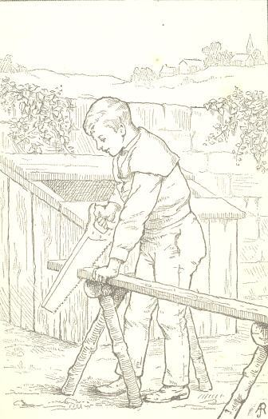
This situation inspired one of Master Fred’s boy advisers with a new scheme in relation to his poultry enterprise. “Hallo! I say, Fred,” said Tom Seymour, “you ought to raise ducks; you’ve got a capital place for ducks there.”
“Yes; but I’ve bought hens, you see,” said Freddy; “so it’s no use trying.”
“No use! Of course there is. Just as if your hens couldn’t hatch ducks’ eggs. Now you just wait till one of your hens wants to sit, and you put ducks’ eggs under her, and you’ll have a family of ducks in a twinkling. You can buy ducks’ eggs a plenty of old Sam under the hill. He always has hens hatch his ducks.”
So Freddy thought it would be a good experiment, and informed his mother the next morning that he intended to furnish the ducks for the next Christmas dinner and when she wondered how he was to come by them, he said mysteriously, “Oh, I will show you how,” but did not further explain himself. The next day he went with Tom Seymour and made a trade with old Sam, and gave him a middle-aged jack-knife for eight of his ducks’ eggs. Sam, by-the-by, was a woolly-headed old negro man, who lived by the pond hard by, and who had long cast envying eyes on Fred’s jack-knife, because it was of extra fine steel, having been a Christmas present the year before. But Fred knew very well there were any number more of jack-knives where that came from, and that, in order to get a new one, he must dispose of the old; so he made the purchase and came home rejoicing.
Now about this time Mrs. Feathertop, having laid her eggs daily with great credit to herself, notwithstanding Mrs. Scratchard’s predictions, began to find herself suddenly attacked with nervous symptoms. She lost her gay spirits, grew dumpish and morose, stuck up her feathers in a bristling way, and pecked at her neighbours if they did so much as look at her. Master Gray Cock was greatly concerned, and went to old Dr. Peppercorn, who looked solemn, and recommended an infusion of angle-worms, and said he would look in on the patient twice a day till she was better.
“Gracious me, Gray Cock!” said old Goody Kertarkut, who had been lolling at the corner as he passed, “ain’t you a fool?—cocks always are fools. Don’t you know what’s the matter with your wife? She wants to sit, that’s all; and you just let her sit. A fiddlestick for Dr. Peppercorn! Why, any good old hen that has brought up a family knows more than a doctor about such things. You just go home and tell her to sit if she wants to, and behave herself.”
When Gray Cock came home, he found that Master Freddy had been before him, and had established Mrs. Feathertop upon eight nice eggs, where she was sitting in gloomy grandeur. He tried to make a little affable conversation with her, and to relate his interview with the doctor and Goody Kertarkut; but she was morose and sullen, and only pecked at him now and then in a very sharp, unpleasant way. So after a few more efforts to make himself agreeable he left her, and went out promenading with the captivating Mrs. Red Comb, a charming young Spanish widow, who had just been imported into the neighbouring yard.
“Bless my soul,” said he, “you’ve no idea how cross my wife is.”
“O you horrid creature!” said Mrs. Red Comb. “How little you feel for the weaknesses of us poor hens!”
“On my word, ma’am,” said Gray Cock, “you do me injustice. But when a hen gives way to temper, ma’am, and no longer meets her husband with a smile—when she even pecks at him whom she is bound to honour and obey—”
“Horrid monster! talking of obedience! I should say, sir, you came straight from Turkey.” And Mrs. Red Comb tossed her head with a most bewitching air, and pretended to run away; and old Mrs. Scratchard looked out of her coop and called to Goody Kertarkut,—
“Look how Mr. Gray Cock is flirting with that widow. I always knew she was a baggage.”
“And his poor wife left at home alone,” said Goody Kertarkut. “It’s the way with ’em all!”
“Yes, yes,” said Dame Scratchard, “she’ll know what real life is now, and she won’t go about holding her head so high, and looking down on her practical neighbours that have raised families.”
“Poor thing! what’ll she do with a family?” said Goody Kertarkut.
“Well, what business have such young flirts to get married?” said Dame Scratchard. “I don’t expect she’ll raise a single chick; and there’s Gray Cock flirting about, fine as ever. Folks didn’t do so when I was young. I’m sure my husband knew what treatment a sitting hen ought to have,—poor old Long Spur! he never minded a peck or so and then. I must say these modern fowls ain’t what fowls used to be.”
Meanwhile the sun rose and set, and Master Fred was almost the only friend and associate of poor little Mrs. Feathertop, whom he fed daily with meal and water, and only interrupted her sad reflections by pulling her up occasionally to see how the eggs were coming on.
At last “Peep, peep, peep,” began to be heard in the nest, and one little downy head after another poked forth from under the feathers, surveying the world with round, bright, winking eyes; and gradually the brood were hatched, and Mrs. Feathertop arose, a proud and happy mother, with all the bustling, scratching, care-taking instincts of family-life warm within her breast. She clucked and scratched, and cuddled the little downy bits of things as handily and discreetly as a seven-year-old hen could have done, exciting thereby the wonder of the community.
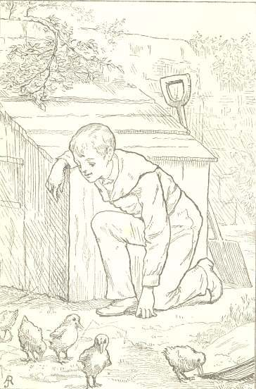
Master Gray Cock came home in high spirits, and complimented her; told her she was looking charmingly once more, and said, “Very well, very nice,” as he surveyed the young brood. So that Mrs. Feathertop began to feel the world going well with her, when suddenly in came Dame Scratchard and Goody Kertarkut to make a morning call.
“Let’s see the chicks,” said Dame Scratchard.
“Goodness me,” said Goody Kertarkut, “what a likeness to their dear papa!”
“Well, but bless me, what’s the matter with their bills?” said Dame Scratchard. “Why, my dear, these chicks are deformed! I’m sorry for you, my dear; but it’s all the result of your inexperience. You ought to have eaten pebble-stones with your meal when you were sitting. Don’t you see, Dame Kertarkut, what bills they have? That’ll increase, and they’ll be frightful!”
“What shall I do?” said Mrs. Feathertop, now greatly alarmed.
“Nothing, as I know of,” said Dame Scratchard, “since you didn’t come to me before you sat. I could have told you all about it. Maybe it won’t kill ’em, but they’ll always be deformed.”
And so the gossips departed, leaving a sting under the pin-feathers of the poor little hen mamma, who began to see that her darlings had curious little spoon-bills, different from her own, and to worry and fret about it.
“My dear,” she said to her spouse, “do get Dr. Peppercorn to come in and look at their bills, and see if anything can be done.”
Dr. Peppercorn came in, and put on a monstrous pair of spectacles, and said, “Hum! ha! extraordinary case; very singular.”
“Did you ever see anything like it, doctor?” said both parents in a breath.
“I’ve read of such cases. It’s a calcareous enlargement of the vascular bony tissue, threatening ossification,” said the doctor.
“Oh, dreadful! Can it be possible?” shrieked both parents. “Can anything be done?”
“Well, I should recommend a daily lotion made of mosquitoes’ horns and bicarbonate of frogs’ toes, together with a powder, to be taken morning and night, of muriate of fleas. One thing you must be careful about: they must never wet their feet, nor drink any water.”
“Dear me, doctor, I don’t know what I shall do, for they seem to have a particular fancy for getting into water.”
“Yes, a morbid tendency often found in these cases of bony tumification of the vascular tissue of the mouth; but you must resist it, ma’am, as their life depends upon it.” And with that Dr. Peppercorn glared gloomily on the young ducks, who were stealthily poking the objectionable little spoon-bills out from under their mother’s feathers.
After this poor Mrs. Feathertop led a weary life of it; for the young fry were as healthy and enterprising a brood of young ducks as ever carried saucepans on the end of their noses, and they most utterly set themselves against the doctor’s prescriptions, murmured at the muriate of fleas and the bicarbonate of frogs’ toes, and took every opportunity to waddle their little ways down to the mud and water which was in their near vicinity. So their bills grew larger and larger, as did the rest of their bodies, and family government grew weaker and weaker.
“You’ll wear me out, children, you certainly will,” said poor Mrs. Feathertop.
“You’ll go to destruction, do ye hear?” said Master Gray Cock.
“Did you ever see such frights as poor Mrs. Feathertop has got?” said Dame Scratchard. “I knew what would come of her family—all deformed, and with a dreadful sort of madness which makes them love to shovel mud with those shocking spoon-bills of theirs.”
“It’s a kind of idiocy,” said Goody Kertarkut. “Poor things! they can’t be kept from the water, nor made to take powders, and so they get worse and worse.”
“I understand it’s affecting their feet so that they can’t walk, and a dreadful sort of net is growing between their toes. What a shocking visitation!”
“She brought it on herself,” said Dame Scratchard. “Why didn’t she come to me before she sat? She was always an upstart, self-conceited thing; but I’m sure I pity her.”
Meanwhile the young ducks throve apace. Their necks grew glossy, like changeable green and gold satin, and though they would not take the doctor’s medicine, and would waddle in the mud and water—for which they always felt themselves to be very naughty ducks—yet they grew quite vigorous and hearty. At last one day the whole little tribe waddled off down to the bank of the river. It was a beautiful day, and the river was dancing and dimpling and winking as the little breezes shook the trees that hung over it.
“Well,” said the biggest of the little ducks, “in spite of Dr. Peppercorn, I can’t help longing for the water. I don’t believe it is going to hurt me; at any rate, here goes,” and in he plumped, and in went every duck after him, and they threw out their great brown feet as cleverly as if they had taken swimming lessons all their lives, and sailed off on the river, away, away among the ferns, under the pink azaleas, through reeds and rushes, and arrow-heads and pickerel-weed, the happiest ducks that ever were born; and soon they were quite out of sight.
“Well, Mrs. Feathertop, this is a dispensation!” said Mrs. Scratchard. “Your children are all drowned at last, just as I knew they’d be. The old music-teacher, Master Bullfrog, that lives down in Water-Dock Lane, saw ’em all plump madly into the water together this morning. That’s what comes of not knowing how to bring up a family!”
Mrs. Feathertop gave only one shriek and fainted dead away, and was carried home on a cabbage-leaf; and Mr. Gray Cock was sent for, where he was waiting on Mrs. Red Comb through the squash-vines.
“It’s a serious time in your family, sir,” said Goody Kertarkut, “and you ought to be at home supporting your wife. Send for Dr. Peppercorn without delay.”
Now as the case was a very dreadful one, Dr. Peppercorn called a council from the barn-yard of the squire, two miles off, and a brisk young Dr. Partlett appeared, in a fine suit of brown and gold, with tail-feathers like meteors. A fine young fellow he was, lately from Paris, with all the modern scientific improvements fresh in his head.
When he had listened to the whole story, he clapped his spur into the ground, and leaning back laughed so loudly that all the cocks in the neighbourhood crowed.
Mrs. Feathertop rose up out of her swoon, and Mr. Gray Cock was greatly enraged.
“What do you mean, sir, by such behaviour in the house of mourning?”
“My dear sir, pardon me; but there is no occasion for mourning. My dear madam, let me congratulate you. There is no harm done. The simple matter is, dear madam, you have been under a hallucination all along. The neighbourhood and my learned friend the doctor have all made a mistake in thinking that these children of yours were hens at all. They are ducks, ma’am, evidently ducks, and very finely-formed ducks I daresay.”
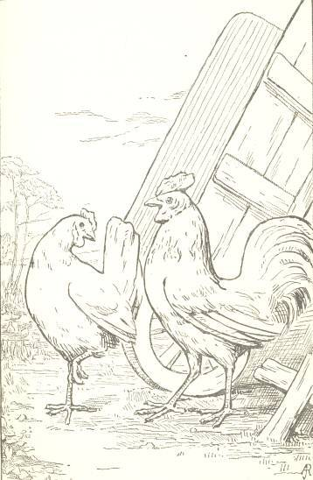
At this moment a quack was heard, and at a distance the whole tribe were seen coming waddling home, their feathers gleaming in green and gold, and they themselves in high good spirits.
“Such a splendid day as we have had!” they all cried in a breath. “And we know now how to get our own living; we can take care of ourselves in future, so you need have no further trouble with us.”
“Madam,” said the doctor, making a bow with an air which displayed his tail-feathers to advantage, “let me congratulate you on the charming family you have raised. A finer brood of young, healthy ducks I never saw. Give me your claw, my dear friend,” he said, addressing the eldest son. “In our barn-yard no family is more respected than that of the ducks.”
And so Madam Feathertop came off glorious at last. And when after this the ducks used to go swimming up and down the river like so many nabobs among the admiring hens, Dr. Peppercorn used to look after them and say, “Ah, I had the care of their infancy!” and Mr. Gray Cock and his wife used to say, “It was our system of education did that!”

The Nutcrackers Of Nutcracker Lodge
Mr. and Mrs. Nutcracker were as respectable a pair of squirrels as ever wore gray brushes over their backs. They were animals of a settled and serious turn of mind, not disposed to run after vanities and novelties, but filling their station in life with prudence and sobriety. Nutcracker Lodge was a hole in a sturdy old chestnut overhanging a shady dell, and was held to be as respectably kept an establishment as there was in the whole forest. Even Miss Jenny Wren, the greatest gossip of the neighbourhood, never found anything to criticise in its arrangements; and old Parson Too-whit, a venerable owl who inhabited a branch somewhat more exalted, as became his profession, was in the habit of saving himself much trouble in his parochial exhortations by telling his parishioners in short to “look at the Nutcrackers” if they wanted to see what it was to live a virtuous life. Everything had gone on prosperously with them, and they had reared many successive families of young Nutcrackers, who went forth to assume their places in the forest of life, and to reflect credit on their bringing up,—so that naturally enough they began to have a very easy way of considering themselves models of wisdom.
But at last it came along, in the course of events, that they had a son named Featherhead, who was destined to bring them a great deal of anxiety. Nobody knows what the reason is, but the fact was, that Master Featherhead was as different from all the former children of this worthy couple as if he had been dropped out of the moon into their nest, instead of coming into it in the general way. Young Featherhead was a squirrel of good parts and a lively disposition, but he was sulky and contrary and unreasonable, and always finding matter of complaint in everything his respectable papa and mamma did. Instead of assisting in the cares of a family,—picking up nuts and learning other lessons proper to a young squirrel,—he seemed to settle himself from his earliest years into a sort of lofty contempt for the Nutcrackers, for Nutcracker Lodge, and for all the good old ways and institutions of the domestic hole, which he declared to be stupid and unreasonable, and entirely behind the times. To be sure, he was always on hand at meal-times, and played a very lively tooth on the nuts which his mother had collected, always selecting the very best for himself; but he seasoned his nibbling with so much grumbling and discontent, and so many severe remarks, as to give the impression that he considered himself a peculiarly ill-used squirrel in having to “eat their old grub,” as he very unceremoniously called it.
Papa Nutcracker, on these occasions, was often fiercely indignant, and poor little Mamma Nutcracker would shed tears, and beg her darling to be a little more reasonable; but the young gentleman seemed always to consider himself as the injured party.
Now nobody could tell why or wherefore Master Featherhead looked upon himself as injured or aggrieved, since he was living in a good hole, with plenty to eat, and without the least care or labour of his own; but he seemed rather to value himself upon being gloomy and dissatisfied. While his parents and brothers and sisters were cheerfully racing up and down the branches, busy in their domestic toils, and laying up stores for the winter, Featherhead sat gloomily apart, declaring himself weary of existence, and feeling himself at liberty to quarrel with everybody and everything about him. Nobody understood him, he said;—he was a squirrel of a peculiar nature, and needed peculiar treatment, and nobody treated him in a way that did not grate on the finer nerves of his feelings. He had higher notions of existence than could be bounded by that old rotten hole in a hollow tree; he had thoughts that soared far above the miserable, petty details of every-day life, and he could not and would not bring down these soaring aspirations to the contemptible toil of laying up a few chestnuts or hickory-nuts for winter.
“Depend upon it, my dear,” said Mrs. Nutcracker solemnly, “that fellow must be a genius.”
“Fiddlestick on his genius!” said old Mr. Nutcracker; “what does he do?”
“Oh, nothing, of course; that’s one of the first marks of genius. Geniuses, you know, never can come down to common life.”
“He eats enough for any two,” remarked old Nutcracker, “and he never helps to gather nuts.”
“My dear, ask Parson Too-whit. He has conversed with him, and quite agrees with me that he says very uncommon things for a squirrel of his age; he has such fine feelings,—so much above those of the common crowd.”
“Fine feelings be hanged!” said old Nutcracker. “When a fellow eats all the nuts that his mother gives him, and then grumbles at her, I don’t believe much in his fine feelings. Why don’t he set himself about something? I’m going to tell my fine young gentleman that, if he doesn’t behave himself, I’ll tumble him out of the nest, neck and crop, and see if hunger won’t do something towards bringing down his fine airs.”
But then Mrs. Nutcracker fell on her husband’s neck with both paws, and wept, and besought him so piteously to have patience with her darling, that old Nutcracker, who was himself a soft-hearted old squirrel, was prevailed upon to put up with the airs and graces of his young scapegrace a little longer; and secretly in his silly old heart he revolved the question whether possibly it might not be that a great genius was actually to come of his household.
The Nutcrackers belonged to the old-established race of the Grays, but they were sociable, friendly people, and kept on the best of terms with all branches of the Nutcracker family. The Chipmunks of Chipmunk Hollow were a very lively, cheerful, sociable race, and on the very best of terms with the Nutcracker Grays. Young Tip Chipmunk, the oldest son, was in all respects a perfect contrast to Master Featherhead. He was always lively and cheerful, and so very alert in providing for the family, that old Mr. and Mrs. Chipmunk had very little care, but could sit sociably at the door of their hole and chat with neighbours, quite sure that Tip would bring everything out right for them, and have plenty laid up for winter.
Now Featherhead took it upon him, for some reason or other, to look down upon Tip Chipmunk, and on every occasion to disparage him in the social circle, as a very common kind of squirrel, with whom it would be best not to associate too freely.
“My dear,” said Mrs. Nutcracker one day, when he was expressing these ideas, “it seems to me that you are too hard on poor Tip; he is a most excellent son and brother, and I wish you would be civil to him.”
“Oh, I don’t doubt that Tip is good enough,” said Featherhead carelessly; “but then he is so very common! he hasn’t an idea in his skull above his nuts and his hole. He is good-natured enough, to be sure,—these very ordinary people often are good-natured,—but he wants manner; he has really no manner at all; and as to the deeper feelings, Tip hasn’t the remotest idea of them. I mean always to be civil to Tip when he comes in my way, but I think the less we see of that sort of people the better; and I hope, mother, you won’t invite the Chipmunks at Christmas,—these family dinners are such a bore!”
“But, my dear, your father thinks a great deal of the Chipmunks; and it is an old family custom to have all the relatives here at Christmas.”
“And an awful bore it is! Why must people of refinement and elevation be forever tied down because of some distant relationship? Now there are our cousins the High-Flyers,—if we could get them, there would be some sense in it. Young Whisk rather promised me for Christmas; but it’s seldom now you can get a flying squirrel to show himself in our parts, and if we are intimate with the Chipmunks it isn’t to be expected.”
“Confound him for a puppy!” said old Nutcracker, when his wife repeated these sayings to him. “Featherhead is a fool. Common, forsooth! I wish good, industrious, painstaking sons like Tip Chipmunk were common. For my part, I find these uncommon people the most tiresome. They are not content with letting us carry the whole load, but they sit on it, and scold at us while we carry them.”
But old Mr. Nutcracker, like many other good old gentlemen squirrels, found that Christmas dinners and other things were apt to go as his wife said, and his wife was apt to go as young Featherhead said; and so, when Christmas came, the Chipmunks were not invited, for the first time in many years. The Chipmunks, however, took all pleasantly, and accepted poor old Mrs. Nutcracker’s awkward apologies with the best possible grace; and young Tip looked in on Christmas morning with the compliments of the season and a few beech-nuts, which he had secured as a great dainty. The fact was, that Tip’s little striped fur coat was so filled up and overflowing with cheerful good-will to all, that he never could be made to understand that any of his relations could want to cut him; and therefore Featherhead looked down on him with contempt, and said he had no tact, and couldn’t see when he was not wanted.
It was wonderful to see how, by means of persisting in remarks like these, young Featherhead at last got all his family to look up to him as something uncommon. Though he added nothing to the family, and required more to be done for him than all the others put together,—though he showed not the smallest real perseverance or ability in anything useful,—yet somehow all his brothers and sisters, and his poor foolish old mother, got into a way of regarding him as something wonderful, and delighting in his sharp sayings as if they had been the wisest things in the world.
But at last old papa declared that it was time for Featherhead to settle himself to some business in life, roundly declaring that he could not always have him as a hanger-on in the paternal hole.
“What are you going to do, my boy?” said Tip Chipmunk to him one day. “We are driving now a thriving trade in hickory-nuts, and if you would like to join us—”
“Thank you,” said Featherhead; “but I confess I have no fancy for anything so slow as the hickory trade; I never was made to grub and delve in that way.”
The fact was that Featherhead had lately been forming alliances such as no reputable squirrel should even think of. He had more than once been seen going out evenings with the Rats of Rat Hollow,—a race whose reputation for honesty was more than doubtful. The fact was, further, that old Longtooth Rat, an old sharper and money-lender, had long had his eye on Featherhead as just about silly enough for their purposes,—engaging him in what he called a speculation, but which was neither more nor less than downright stealing.
Near by the chestnut-tree where Nutcracker Lodge was situated was a large barn filled with corn and grain, besides many bushels of hazel-nuts, chestnuts, and walnuts. Now old Longtooth proposed to young Featherhead that he should nibble a passage into this loft, and there establish himself in the commission business, passing the nuts and corn to him as he wanted them. Old Longtooth knew what he was about in the proposal, for he had heard talk of a brisk Scotch terrier that was about to be bought to keep the rats from the grain; but you may be sure he kept his knowledge to himself, so that Featherhead was none the wiser for it.
“The nonsense of fellows like Tip Chipmunk!” said Featherhead to his admiring brothers and sisters—“the perfectly stupid nonsense! There he goes, delving and poking, picking up a nut here and a grain there, when I step into property at once.”
“But I hope, my son, you are careful to be honest in your dealings,” said old Nutcracker, who was a very moral squirrel.
With that, young Featherhead threw his tail saucily over one shoulder, winked knowingly at his brothers, and said, “Certainly, sir! If honesty consists in getting what you can while it is going, I mean to be honest.”
Very soon Featherhead appeared to his admiring companions in the height of prosperity. He had a splendid hole in the midst of a heap of chestnuts, and he literally seemed to be rolling in wealth; he never came home without showering lavish gifts on his mother and sisters; he wore his tail over his back with a buckish air, and patronized Tip Chipmunk with a gracious nod whenever he met him, and thought that the world was going well with him.
But one luckless day, as Featherhead was lolling in his hole, up came two boys with the friskiest, wiriest Scotch terrier you ever saw. His eyes blazed like torches, and poor Featherhead’s heart died within him as he heard the boys say, “Now we’ll see if we can’t catch the rascal that eats our grain.”
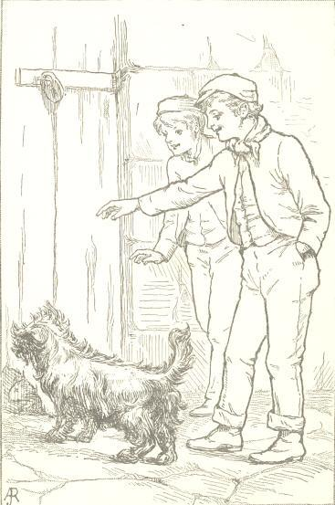
Featherhead tried to slink out at the hole he had gnawed to come in by, but found it stopped.
“Oh, you are there, are you, mister?” said the boy. “Well, you don’t get out; and now for a chase!”
And, sure enough, poor Featherhead ran distracted with terror up and down, through the bundles of hay, between barrels, and over casks, but with the barking terrier ever at his heels, and the boys running, shouting, and cheering his pursuer on. He was glad at last to escape through a crack, though he left half of his fine brush behind him; for Master Wasp the terrier made a snap at it just as he was going, and cleaned all the hair off of it, so that it was bare as a rat’s tail.
Poor Featherhead limped off, bruised and beaten and bedraggled, with the boys and dog still after him; and they would have caught him, after all, if Tip Chipmunk’s hole had not stood hospitably open to receive him. Tip took him in, like a good-natured fellow as he was, and took the best of care of him; but the glory of Featherhead’s tail had departed for ever. He had sprained his left paw, and got a chronic rheumatism, and the fright and fatigue which he had gone through had broken up his constitution, so that he never again could be what he had been; but, Tip gave him a situation as under-clerk in his establishment, and from that time he was a sadder and a wiser squirrel than he ever had been before.

The History Of Tip-Top
Under the window of a certain pretty little cottage there grew a great old apple-tree, which in the spring had thousands and thousands of lovely pink blossoms on it, and in the autumn had about half as many bright red apples as it had blossoms in the spring.
The nursery of this cottage was a little bower of a room, papered with mossy-green paper, and curtained with white muslin; and here five little children used to come, in their white nightgowns, to be dressed and have their hair brushed and curled every morning.
First, there were Alice and Mary, bright-eyed, laughing little girls, of seven and eight years; and then came stout little Jamie, and Charlie; and finally little Puss, whose real name was Ellen, but who was called Puss, and Pussy, and Birdie, and Toddlie, and any other pet name that came to mind.
Now it used to happen, every morning, that the five little heads would be peeping out of the window, together, into the flowery boughs of the apple-tree; and the reason was this. A pair of robins had built a very pretty, smooth-lined nest in a fork of the limb that came directly under the window, and the building of this nest had been superintended, day by day, by the five pairs of bright eyes of these five children. The robins at first had been rather shy of this inspection; but as they got better acquainted, they seemed to think no more of the little curly heads in the window than of the pink blossoms about them, or the daisies and buttercups at the foot of the tree.
All the little hands were forward to help; some threw out flossy bits of cotton,—for which, we grieve to say, Charlie had cut a hole in the crib quilt,—and some threw out bits of thread and yarn, and Allie ravelled out a considerable piece from one of her garters, which she threw out as a contribution; and they exulted in seeing the skill with which the little builders wove everything in. “Little birds, little birds,” they would say, “you shall be kept warm, for we have given you cotton out of our crib quilt, and yarn out of our stockings.” Nay, so far did this generosity proceed, that Charlie cut a flossy, golden curl from Toddlie’s head and threw it out; and when the birds caught it up the whole flock laughed to see Toddlie’s golden hair figuring in a bird’s-nest.
When the little thing was finished, it was so neat, and trim, and workman-like, that the children all exulted over it, and called it “our nest,” and the two robins they called “our birds.” But wonderful was the joy when the little eyes, opening one morning, saw in the nest a beautiful pale-green egg; and the joy grew from day to day, for every day there came another egg, and so on till there were five little eggs; and then the oldest girl, Alice, said, “There are five eggs: that makes one for each of us, and each of us will have a little bird by-and-by;”—at which all the children laughed and jumped for glee.
When the five little eggs were all laid, the mother-bird began to sit on them; and at any time of day or night, when a little head peeped out of the nursery window, might be seen a round, bright, patient pair of bird’s eyes contentedly waiting for the young birds to come. It seemed a long time for the children to wait; but every day they put some bread and cake from their luncheon on the window-sill, so that the birds might have something to eat; but still there she was, patiently sitting!
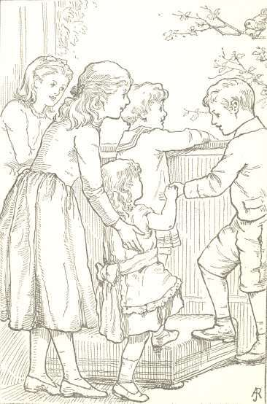
“How long, long, long she waits!” said Jamie impatiently. “I don’t believe she’s ever going to hatch.”
“Oh, yes she is!” said grave little Alice. “Jamie, you don’t understand about these things; it takes a long, long time to hatch eggs. Old Sam says his hens sit three weeks;—only think, almost a month!”
Three weeks looked a long time to the five bright pairs of little watching eyes; but Jamie said the eggs were so much smaller than hens’ eggs that it wouldn’t take so long to hatch them, he knew. Jamie always thought he knew all about everything, and was so sure of it that he rather took the lead among the children. But one morning, when they pushed their five heads out of the window, the round, patient little bird-eyes were gone, and there seemed to be nothing in the nest but a bunch of something hairy.
Upon this they all cried out, “O mamma, do come here! the bird is gone and left her nest?” And when they cried out, they saw five wide little red mouths open in the nest, and saw that the hairy bunch of stuff was indeed the first of five little birds.
“They are dreadful-looking things,” said Mary; “I didn’t know that little birds began by looking so badly.”
“They seem to be all mouth,” said Jamie.
“We must feed them,” said Charlie.—“Here, little birds, here’s some gingerbread for you,” he said; and he threw a bit of his gingerbread, which fortunately only hit the nest on the outside, and fell down among the buttercups, where two crickets made a meal of it, and agreed that it was as excellent gingerbread as if old Mother Cricket herself had made it.
“Take care, Charlie,” said his mamma; “we do not know enough to feed young birds. We must leave that to their papa and mamma, who probably started out bright and early in the morning to get breakfast for them.”
Sure enough, while they were speaking, back came Mr. and Mrs. Robin, whirring through the green shadows of the apple tree; and thereupon all the five little red mouths flew open, and the birds put something into each.
It was great amusement, after this, to watch the daily feeding of the little birds, and to observe how, when not feeding them, the mother sat brooding on the nest, warming them under her soft wings, while the father-bird sat on the topmost bough of the apple-tree and sang to them. In time they grew and grew, and, instead of a nest full of little red mouths, there was a nest full of little, fat, speckled robins, with round, bright, cunning eyes, just like their parents; and the children began to talk together about their birds.
“I’m going to give my robin a name,” said Mary. “I call him Brown-Eyes.”
“And I call mine Tip-Top,” said Jamie, “because I know he’ll be a tip-top bird.”
“And I call mine Singer,” said Alice.
“I ’all mine Toddy,” said little Toddlie, who would not be behindhand in anything that was going on.
“Hurrah for Toddlie!” said Charlie; “hers is the best of all. For my part, I call mine Speckle.”
So then the birds were all made separate characters by having each a separate name given it.
Brown-Eyes, Tip-Top, Singer, Toddy, and Speckle made, as they grew bigger, a very crowded nestful of birds.
Now the children had early been taught to say in a little hymn:—
“Birds in their little nests agree;
And ’tis a shameful sight
When children of one family
Fall out, and chide, and fight;”—
and they thought anything really written and printed in a hymn must be true; therefore they were very much astonished to see, from day to day, that their little birds in their nest did not agree.
Tip-Top was the biggest and strongest bird, and he was always shuffling and crowding the others, and clamouring for the most food; and when Mrs. Robin came in with a nice bit of anything, Tip-Top’s red mouth opened so wide, and he was so noisy, that one would think the nest was all his. His mother used to correct him for these gluttonous ways, and sometimes made him wait till all the rest were helped before she gave him a mouthful; but he generally revenged himself in her absence by crowding the others and making the nest generally uncomfortable. Speckle, however, was a bird of spirit, and he used to peck at Tip-Top; so they would sometimes have a regular sparring-match across poor Brown-Eyes, who was a meek, tender little fellow, and would sit winking and blinking in fear while his big brothers quarrelled. As to Toddy and Singer, they turned out to be sister birds, and showed quite a feminine talent for chattering; they used to scold their badly behaving brothers in a way that made the nest quite lively.
On the whole Mr. and Mrs. Robin did not find their family circle the peaceable place the poet represents.
“I say,” said Tip-Top one day to them, “this old nest is a dull, mean, crowded hole, and it’s quite time some of us were out of it. Just give us lessons in flying, won’t you? and let us go.”
“My dear boy,” said Mother Robin, “we shall teach you to fly as soon as your wings are strong enough.”
“You are a very little bird,” said his father, “and ought to be good and obedient, and wait patiently till your wing-feathers grow; and then you can soar away to some purpose.”
“Wait for my wing-feathers? Humbug!” Tip-Top would say, as he sat balancing with his little short tail on the edge of the nest, and looking down through the grass and clover-heads below, and up into the blue clouds above. “Father and mother are slow old birds; they keep a fellow back with their confounded notions. If they don’t hurry up, I’ll take matters into my own claws, and be off some day before they know it. Look at those swallows, skimming and diving through the blue air! That’s the way I want to do.”
“But, dear brother, the way to learn to do that is to be good and obedient while we are little, and wait till our parents think it best for us to begin.”
“Shut up your preaching,” said Tip-Top; “what do you girls know of flying?”
“About as much as you,” said Speckle. “However, I’m sure I don’t care how soon you take yourself off, for you take up more room than all the rest put together.”
“You mind yourself, Master Speckle, or you’ll get something you don’t like,” said Tip-Top, still strutting in a very cavalier way on the edge of the nest, and sticking up his little short tail quite valiantly.
“O my darlings,” said their mamma, now fluttering home, “cannot I ever teach you to live in love?”
“It’s all Tip-Top’s fault,” screamed the other birds in a flutter.
“My fault? Of course, everything in this nest that goes wrong is laid to me,” said Tip-Top; “and I’ll leave it to anybody, now, if I crowd anybody. I’ve been sitting outside, on the very edge of the nest, and there’s Speckle has got my place.”
“Who wants your place?” said Speckle. “I’m sure you can come in, if you please.”
“My dear boy,” said the mother, “do go into the nest and be a good little bird, and then you will be happy.”
“That’s always the talk,” said Tip-Top. “I’m too big for the nest, and I want to see the world. It’s full of beautiful things, I know. Now there’s the most lovely creature, with bright eyes, that comes under the tree every day, and wants me to come down in the grass and play with her.”
“My son, my son, beware!” said the frightened mother; “that lovely-seeming creature is our dreadful enemy, the cat,—a horrid monster, with teeth and claws.”
At this, all the little birds shuddered and cuddled deeper in the nest; only Tip-Top in his heart disbelieved it. “I’m too old a bird,” said he to himself, “to believe that story; mother is chaffing me. But I’ll show her that I can take care of myself.”
So the next morning, after the father and mother were gone, Tip-Top got on the edge of the nest again, and looked over and saw lovely Miss Pussy washing her face among the daisies under the tree, and her hair was sleek and white as the daisies, and her eyes were yellow and beautiful to behold, and she looked up to the tree bewitchingly, and said, “Little birds, little birds, come down; Pussy wants to play with you.”
“Only look at her!” said Tip-Top; “her eyes are like gold.”
“No, don’t look,” said Singer and Speckle. “She will bewitch you, and then eat you up.”
“I’d like to see her try to eat me up,” said Tip-Top, again balancing his short tail over the nest. “Just as if she would. She’s just the nicest, most innocent creature going, and only wants us to have fun. We never do have any fun in this old nest!”
Then the yellow eyes below shot a bewildering light into Tip-Top’s eyes, and a voice sounded sweet as silver: “Little birds, little birds, come down; Pussy wants to play with you.”
“Her paws are as white as velvet,” said Tip-Top, “and so soft! I don’t believe she has any claws.”
“Don’t go, brother, don’t!” screamed both sisters.
All we know about it is, that a moment after a direful scream was heard from the nursery window. “O mamma, mamma, do come here! Tip-Top’s fallen out of the nest, and the cat has got him!”
Away ran Pussy with foolish little Tip-Top in her mouth, and he squeaked dolefully when he felt her sharp teeth. Wicked Miss Pussy had no mind to eat him at once; she meant just as she said, to “play with him.” So she ran off to a private place among the currant-bushes, while all the little curly heads were scattered up and down looking for her.
Did you ever see a cat play with a bird or a mouse? She sets it down, and seems to go off and leave it; but the moment it makes the first movement to get away,—pounce! she springs on it, and shakes it in her mouth; and so she teases and tantalizes it, till she gets ready to kill and eat it. I can’t say why she does it, except that it is a cat’s nature; and it is a very bad nature for foolish young robins to get acquainted with.
“Oh, where is he? where is he? Do find my poor Tip-Top,” said Jamie, crying as loud as he could scream. “I’ll kill that horrid cat,—I’ll kill her!”
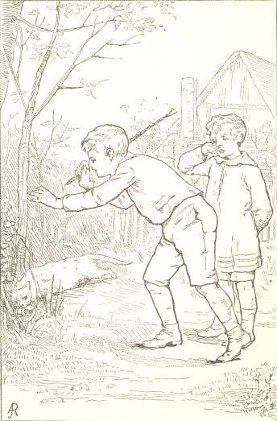
Mr. and Mrs. Robin, who had come home meantime, joined their plaintive chirping to the general confusion; and Mrs. Robin’s bright eyes soon discovered her poor little son, where Pussy was patting and rolling him from one paw to the other under the currant-bushes; and settling on the bush above, she called the little folks to the spot by her cries.
Jamie plunged under the bush, and caught the cat with luckless Tip-Top in her mouth; and, with one or two good thumps, he obliged her to let him go. Tip-Top was not dead, but in a sadly draggled and torn state. Some of his feathers were torn out, and one of his wings was broken, and hung down in a melancholy way.
“Oh, what shall we do for him? He will die. Poor Tip-Top!” said the children.
“Let’s put him back into the nest, children,” said mamma. “His mother will know best what to do with him.”
So a ladder was got, and papa climbed up and put poor Tip-Top safely into the nest. The cat had shaken all the nonsense well out of him; he was a dreadfully humbled young robin.
The time came at last when all the other birds in the nest learned to fly, and fluttered and flew about everywhere; but poor melancholy Tip-Top was still confined to the nest with a broken wing. Finally, as it became evident that it would be long before he could fly, Jamie took him out of the nest, and made a nice little cage for him, and used to feed him every day, and he would hop about and seem tolerably contented; but it was evident that he would be a lame-winged robin all his days.
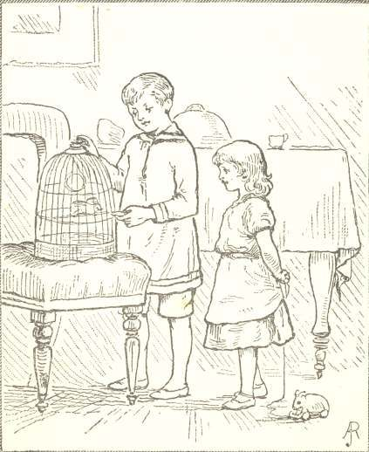
Jamie’s mother told him that Tip-Top’s history was an allegory.
“I don’t know what you mean, mamma,” said Jamie.
“When something in a bird’s life is like something in a boy’s life, or when a story is similar in its meaning to reality, we call it an allegory. Little boys, when they are about half grown up, sometimes do just as Tip-Top did. They are in a great hurry to get away from home into the great world; and then temptation comes, with bright eyes and smooth velvet paws, and promises them fun; and they go to bad places; they get to smoking, and then to drinking; and, finally, the bad habit gets them in its teeth and claws, and plays with them as a cat does with a mouse. They try to reform, just as your robin tried to get away from the cat; but their bad habits pounce on them and drag them back. And so, when the time comes that they want to begin life, they are miserable, broken-down creatures, like your broken-winged robin.
“So, Jamie, remember, and don’t try to be a man before your time, and let your parents judge for you while you are young; and never believe in any soft white Pussy, with golden eyes, that comes and wants to tempt you to come down and play with her. If a big boy offers to teach you to smoke a cigar, that is Pussy. If a boy wants you to go into a billiard-saloon, that is Pussy. If a boy wants you to learn to drink anything with spirit in it, however sweetened and disguised, remember Pussy is there. And Pussy’s claws are long, and Pussy’s teeth are strong; and if she gives you one shake in your youth, you will be like a broken-winged robin all your days.”

Miss Katy-Did And Miss Cricket
Miss Katy-did sat on the branch of a flowering azalea, in her best suit of fine green and silver, with wings of point-lace from Mother Nature’s finest web.
Miss Katy was in the very highest possible spirits, because her gallant cousin, Colonel Katy-did, had looked in to make her a morning visit. It was a fine morning, too, which goes for as much among the Katy-dids as among men and women. It was, in fact, a morning that Miss Katy thought must have been made on purpose for her to enjoy herself in. There had been a patter of rain the night before, which had kept the leaves awake talking to each other till nearly morning; but by dawn the small winds had blown brisk little puffs, and whisked the heavens clear and bright with their tiny wings, as you have seen Susan clear away the cobwebs in your mamma’s parlour; and so now there were only left a thousand blinking, burning water-drops, hanging like convex mirrors at the end of each leaf, and Miss Katy admired herself in each one.
“Certainly I am a pretty creature,” she said to herself; and when the gallant colonel said something about being dazzled by her beauty, she only tossed her head and took it as quite a matter of course.
“The fact is, my dear colonel,” she said, “I am thinking of giving a party, and you must help me to make out the lists.”
“My dear, you make me the happiest of Katy-dids.”
“Now,” said Miss Katy-did, drawing an azalea-leaf towards her, “let us see—whom shall we have? The Fireflies, of course; everybody wants them, they are so brilliant,—a little unsteady, to be sure, but quite in the higher circles.”
“Yes, we must have the Fireflies,” echoed the colonel.
“Well, then, and the Butterflies and the Moths. Now, there’s a trouble. There’s such an everlasting tribe of those Moths; and if you invite dull people they’re always sure all to come, every one of them. Still, if you have the Butterflies, you can’t leave out the Moths.”
“Old Mrs. Moth has been laid up lately with a gastric fever, and that may keep two or three of the Misses Moth at home,” said the colonel.
“Whatever could give the old lady such a turn?” said Miss Katy. “I thought she never was sick.”
“I suspect it’s high living. I understand she and her family ate up a whole ermine cape last month, and it disagreed with them.”
“For my part, I can’t conceive how the Moths can live as they do,” said Miss Katy, with a face of disgust. “Why, I could no more eat worsted and fur, as they do—”
“That is quite evident from the fairy-like delicacy of your appearance,” said the colonel. “One can see that nothing so gross or material has ever entered into your system.”
“I’m sure,” said Miss Katy, “mamma says she don’t know what does keep me alive; half a dewdrop and a little bit of the nicest part of a rose-leaf, I assure you, often last me for a day. But we are forgetting our list. Let’s see—the Fireflies, Butterflies, Moths. The Bees must come, I suppose.”
“The Bees are a worthy family,” said the colonel.
“Worthy enough, but dreadfully humdrum,” said Miss Katy. “They never talk about anything but honey and housekeeping; still, they are a class of people one cannot neglect.”
“Well, then, there are the Bumble-Bees.”
“Oh, I dote on them! General Bumble is one of the most dashing, brilliant fellows of the day.”
“I think he is shockingly corpulent,” said Colonel Katy-did, not at all pleased to hear him praised; “don’t you?”
“I don’t know but he is a little stout,” said Miss Katy; “but so distinguished and elegant in his manners—something quite martial and breezy about him.”
“Well, if you invite the Bumble-Bees, you must have the Hornets.”
“Those spiteful Hornets! I detest them!”
“Nevertheless, dear Miss Katy, one does not like to offend the Hornets.”
“No, one can’t. There are those five Misses Hornet—dreadful old maids!—as full of spite as they can live. You may be sure they will every one come, and be looking about to make spiteful remarks. Put down the Hornets, though.”
“How about the Mosquitoes!” said the colonel.
“Those horrid Mosquitoes—they are dreadfully plebeian! Can’t one cut them?”
“Well dear Miss Katy,” said the colonel, “if you ask my candid opinion as a friend, I should say not. There’s young Mosquito, who graduated last year, has gone into literature, and is connected with some of our leading papers, and they say he carries the sharpest pen of all the writers. It won’t do to offend him.”
“And so I suppose we must have his old aunts, and all six of his sisters, and all his dreadfully common relations.”
“It is a pity,” said the colonel; “but one must pay one’s tax to society.”
Just at this moment the conference was interrupted by a visitor, Miss Keziah Cricket, who came in with her work-bag on her arm to ask a subscription for a poor family of Ants who had just had their house hoed up in clearing the garden-walks.
“How stupid of them,” said Katy, “not to know better than to put their house in the garden-walk; that’s just like those Ants.”
“Well, they are in great trouble; all their stores destroyed, and their father killed—cut quite in two by a hoe.”
“How very shocking! I don’t like to hear of such disagreeable things; it affects my nerves terribly. Well, I’m sure I haven’t anything to give. Mamma said yesterday she was sure she didn’t know how our bills were to be paid; and there’s my green satin with point-lace yet to come home.” And Miss Katy-did shrugged her shoulders and affected to be very busy with Colonel Katy-did, in just the way that young ladies sometimes do when they wish to signify to visitors that they had better leave.
Little Miss Cricket perceived how the case stood, and so hopped briskly off, without giving herself even time to be offended. “Poor extravagant little thing!” said she to herself, “it was hardly worth while to ask her.”
“Pray, shall you invite the Crickets?” said Colonel Katy-did.
“Who? I? Why, colonel, what a question! Invite the Crickets? Of what can you be thinking?”
“And shall you not ask the Locusts, and the Grasshoppers?”
“Certainly. The Locusts, of course,—a very old and distinguished family; and the Grasshoppers are pretty well, and ought to be asked. But we must draw a line somewhere,—and the Crickets! why, it’s shocking even to think of!”
“I thought they were nice, respectable people.”
“Oh, perfectly nice and respectable,—very good people, in fact, so far as that goes. But then you must see the difficulty.”
“My dear cousin, I am afraid you must explain.”
“Why, their colour, to be sure. Don’t you see?”
“Oh!” said the colonel. “That’s it, is it? Excuse me, but I have been living in France, where these distinctions are wholly unknown, and I have not yet got myself in the train of fashionable ideas here.”
“Well, then, let me teach you,” said Miss Katy. “You know we republicans go for no distinctions except those created by Nature herself, and we found our rank upon colour, because that is clearly a thing that none has any hand in but our Maker. You see?”
“Yes; but who decides what colour shall be the reigning colour?”
“I’m surprised to hear the question! The only true colour—the only proper one—is our colour, to be sure. A lovely pea-green is the precise shade on which to found aristocratic distinction. But then we are liberal;—we associate with the Moths, who are gray; with the Butterflies, who are blue-and-gold coloured; with the Grasshoppers, yellow and brown; and society would become dreadfully mixed if it were not fortunately ordered that the Crickets are black as jet. The fact is, that a class to be looked down upon is necessary to all elegant society; and if the Crickets were not black, we could not keep them down, because, as everybody knows, they are often a great deal cleverer than we are. They have a vast talent for music and dancing; they are very quick at learning, and would be getting to the very top of the ladder if we once allowed them to climb. But their being black is a convenience; because, as long as we are green and they black, we have a superiority that can never be taken from us. Don’t you see now?”
“Oh yes, I see exactly,” said the colonel.
“Now that Keziah Cricket, who just came in here, is quite a musician, and her old father plays the violin beautifully;—by the way, we might engage him for our orchestra.”

And so Miss Katy’s ball came off, and the performers kept it up from sundown till daybreak, so that it seemed as if every leaf in the forest were alive. The Katy-dids and the Mosquitoes, and the Locusts, and a full orchestra of Crickets made the air perfectly vibrate, insomuch that old Parson Too-Whit, who was preaching a Thursday evening lecture to a very small audience, announced to his hearers that he should certainly write a discourse against dancing for the next weekly occasion.
The good doctor was even with his word in the matter, and gave out some very sonorous discourses, without in the least stopping the round of gaieties kept up by these dissipated Katy-dids, which ran on, night after night, till the celebrated Jack Frost epidemic, which occurred somewhere about the first of September.
Poor Miss Katy, with her flimsy green satin and point-lace, was one of the first victims, and fell from the bough in company with a sad shower of last year’s leaves. The worthy Cricket family, however, avoided Jack Frost by emigrating in time to the chimney-corner of a nice little cottage that had been built in the wood that summer.
There good old Mr. and Mrs. Cricket, with sprightly Miss Keziah and her brothers and sisters, found a warm and welcome home; and when the storm howled without, and lashed the poor naked trees, the Crickets on the warm hearth would chirp out cheery welcome to papa as he came in from the snowy path, or mamma as she sat at her work-basket.
“Cheep, cheep, cheep!” little Freddy would say. “Mamma, who is it says ‘cheep’?”
“Dear Freddy, it’s our own dear little cricket, who loves us and comes to sing to us when the snow is on the ground.”
So when poor Miss Katy-did’s satin and lace were all swept away, the warm home-talents of the Crickets made for them a welcome refuge.

Mother Magpie’s Mischief
Old Mother Magpie was about the busiest character in the forest. But you must know that there is a great difference between being busy and being industrious. One may be very busy all the time, and yet not in the least industrious; and this was the case with Mother Magpie.
She was always full of everybody’s business but her own—up and down, here and there, everywhere but in her own nest, knowing everyone’s affairs, telling what everybody had been doing or ought to do, and ready to cast her advice gratis at every bird and beast of the woods.
Now she bustled up to the parsonage at the top of the oak-tree, to tell old Parson Too-Whit what she thought he ought to preach for his next sermon, and how dreadful the morals of the parish were becoming. Then, having perfectly bewildered the poor old gentleman, who was always sleepy of a Monday morning, Mother Magpie would take a peep into Mrs. Oriole’s nest, sit chattering on a bough above, and pour forth floods of advice, which, poor little Mrs. Oriole used to say to her husband, bewildered her more than a hard north-east storm.
“Depend upon it, my dear,” Mother Magpie would say, “that this way of building your nest, swinging like an old empty stocking from a bough, isn’t at all the thing. I never built one so in my life, and I never have headaches. Now you complain always that your head aches whenever I call upon you. It’s all on account of this way of swinging and swaying about in such an absurd manner.”
“But, my dear,” piped Mrs. Oriole timidly, “the Orioles always have built in this manner, and it suits our constitution.”
“A fiddle on your constitution! How can you tell what agrees with your constitution unless you try? You own you are not well; you are subject to headaches; and every physician will tell you that a tilting motion disorders the stomach and acts upon the brain. Ask old Dr. Kite. I was talking with him about your case only yesterday, and says he, ‘Mrs. Magpie, I perfectly agree with you.’”
“But my husband prefers this style of building.”
“That’s only because he isn’t properly instructed. Pray, did you ever attend Dr. Kite’s lectures on the nervous system?”
“No, I have no time to attend lectures. Who would sit on the eggs?”
“Why, your husband, to be sure; don’t he take his turn in sitting? If he don’t, he ought to. I shall speak to him about it. My husband always sits regularly half the time, that I may have time to go about and exercise.”
“O Mrs. Magpie, pray don’t speak to my husband; he will think I’ve been complaining.”
“No, no, he won’t. Let me alone. I understand just how to say the thing. I’ve advised hundreds of young husbands in my day, and I never gave offence.”
“But I tell you, Mrs. Magpie, I don’t want any interference between my husband and me, and I will not have it,” says Mrs. Oriole, with her little round eyes flashing with indignation.
“Don’t put yourself in a passion, my dear; the more you talk, the more sure I am that your nervous system is running down, or you wouldn’t forget good manners in this way. You’d better take my advice, for I understand just what to do,”—and away sails Mother Magpie; and presently young Oriole comes home all in a flutter.
“I say, my dear, if you will persist in gossiping over our private family matters with that old Mother Magpie—”
“My dear, I don’t gossip. She comes and bores me to death with talking, and then goes off and mistakes what she has been saying for what I said.”
“But you must cut her.”
“I try to, all I can; but she won’t be cut.”
“It’s enough to make a bird swear,” said Tommy Oriole.
Tommy Oriole, to say the truth, had as good a heart as ever beat under bird’s feathers; but then he had a weakness for concerts and general society, because he was held to be, by all odds, the handsomest bird in the woods, and sung like an angel; and so the truth was he didn’t confine himself so much to the domestic nest as Tom Titmouse or Billy Wren. But he determined that he wouldn’t have old Mother Magpie interfering with his affairs.
“The fact is,” quoth Tommy, “I am a society bird, and Nature has marked out for me a course beyond the range of the commonplace, and my wife must learn to accommodate. If she has a brilliant husband, whose success gratifies her ambition and places her in a distinguished public position, she must pay something for it. I’m sure Billy Wren’s wife would give her very bill to see her husband in the circles where I am quite at home. To say the truth, my wife was all well enough content till old Mother Magpie interfered. It is quite my duty to take strong ground, and show that I cannot be dictated to.”
So, after this, Tommy Oriole went to rather more concerts, and spent less time at home than ever he did before, which was all that Mother Magpie effected in that quarter. I confess this was very bad in Tommy; but then birds are no better than men in domestic matters, and sometimes will take the most unreasonable courses, if a meddlesome Magpie gets her claw into their nest.
But old Mother Magpie had now got a new business in hand in another quarter. She bustled off down to Water-Dock Lane, where, as we said in a former narrative, lived the old music-teacher, Dr. Bullfrog. The poor old doctor was a simple-minded, good, amiable creature, who had played the double-bass and led the forest choir on all public occasions since nobody knows when. Latterly some youngsters had arisen who sneered at his performances as behind the age. In fact, since a great city had grown up in the vicinity of the forest, tribes of wandering boys broke up the simple tastes and quiet habits which old Mother Nature had always kept up in those parts. They pulled the young checkerberry before it even had time to blossom, rooted up the sassafras shrubs and gnawed their roots, fired off guns at the birds, and on several occasions, when old Dr. Bullfrog was leading a concert, had dashed in and broken up the choir by throwing stones.
This was not the worst of it. The little varlets had a way of jeering at the simple old doctor and his concerts, and mimicking the tones of his bass-viol. “There you go, Paddy-go-donk, Paddy-go-donk—umph—chunk,” some rascal of a boy would shout, while poor old Bullfrog’s yellow spectacles would be bedewed with tears of honest indignation. In time, the jeers of these little savages began to tell on the society in the forest, and to corrupt their simple manners; and it was whispered among the younger and more heavy birds and squirrels that old Bullfrog was a bore, and that it was time to get up a new style of music in the parish, and to give the charge of it to some more modern performer.
Poor old Dr. Bullfrog knew nothing of this, however, and was doing his simple best, in peace, when Mother Magpie called in upon him one morning.
“Well, neighbour, how unreasonable people are! Who would have thought that the youth of our generation should have no more consideration for established merit? Now, for my part, I think your music-teaching never was better; and as for our choir, I maintain constantly that it never was in better order, but—Well, one may wear her tongue out, but one can never make these young folks listen to reason.”
“I really don’t understand you, ma’am,” said poor Dr. Bullfrog.
“What! you haven’t heard of a committee that is going to call on you, to ask you to resign the care of the parish music?”
“Madam,” said Dr. Bullfrog, with all that energy of tone for which he was remarkable, “I don’t believe it,—I can’t believe it. You must have made a mistake.”
“I mistake! No, no, my good friend; I never make mistakes. What I know, I know certainly. Wasn’t it I that said I knew there was an engagement between Tim Chipmunk and Nancy Nibble, who are married this very day? I knew that thing six weeks before any bird or beast in our parts; and I can tell you, you are going to be scandalously and ungratefully treated, Dr. Bullfrog.”
“Bless me, we shall all be ruined!” said Mrs. Bullfrog; “my poor husband—”
“Oh, as to that, if you take things in time, and listen to my advice,” said Mother Magpie, “we may yet pull you through. You must alter your style a little,—adapt it to modern times. Everybody now is a little touched with the operatic fever, and there’s Tommy Oriole has been to New Orleans and brought back a touch of the artistic. If you would try his style a little,—something Tyrolean, you see.”
“Dear madam, consider my voice. I never could hit the high notes.”
“How do you know? It’s all practice; Tommy Oriole says so. Just try the scales. As to your voice, your manner of living has a great deal to do with it. I always did tell you that your passion for water injured your singing. Suppose Tommy Oriole should sit half his days up to his hips in water, as you do,—his voice would be as hoarse and rough as yours. Come up on the bank and learn to perch, as we birds do. We are the true musical race.”
And so poor Mr. Bullfrog was persuaded to forego his pleasant little cottage under the cat-tails, where his green spectacles and honest round back had excited, even in the minds of the boys, sentiments of respect and compassion. He came up into the garden, and established himself under a burdock, and began to practise Italian scales.
The result was, that poor old Dr. Bullfrog, instead of being considered as a respectable old bore, got himself universally laughed at for aping fashionable manners. Every bird and beast in the forest had a gibe at him; and even old Parson Too-Whit thought it worth his while to make him a pastoral call, and admonish him about courses unbefitting his age and standing. As to Mother Magpie, you may be sure that she assured every one how sorry she was that dear old Dr. Bullfrog had made such a fool of himself; if he had taken her advice, he would have kept on respectably as a nice old Bullfrog should.
But the tragedy for the poor old music-teacher grew even more melancholy in its termination; for one day, as he was sitting disconsolately under a currant-bush in the garden, practising his poor old notes in a quiet way, thump came a great blow of a hoe, which nearly broke his back.
“Hallo! what ugly beast have we got here?” said Tom Noakes, the gardener’s boy. “Here, here, Wasp, my boy.”
What a fright for a poor, quiet, old Bullfrog, as little wiry, wicked Wasp came at him, barking and yelping. He jumped with all his force sheer over a patch of bushes into the river, and swam back to his old home among the cat-tails. And always after that it was observable that he was very low-spirited, and took very dark views of life; but nothing made him so angry as any allusion to Mother Magpie, of whom, from that time, he never spoke except as Old Mother Mischief.

The Squirrels That Live In A House
Once upon a time a gentleman went out into a great forest, and cut away the trees, and built there a very nice little cottage. It was set very low on the ground, and had very large bow-windows, and so much of it was glass that one could look through it on every side and see what was going on in the forest. You could see the shadows of the fern-leaves, as they flickered and wavered over the ground, and the scarlet partridge-berry and winter-green plums that matted round the roots of the trees, and the bright spots of sunshine that fell through their branches and went dancing about among the bushes and leaves at their roots. You could see the chirping sparrows and the thrushes and robins and bluebirds building their nests here and there among the branches, and watch them from day to day as they laid their eggs and hatched their young. You could also see red squirrels, and gray squirrels, and little striped chip-squirrels, darting and springing about, here and there and everywhere, running races with each other from bough to bough, and chattering at each other in the gayest possible manner.
You may be sure that such a strange thing as a house for human beings to live in did not come into this wild wood without making quite a stir and excitement among the inhabitants that lived there before. All the time it was building, there was the greatest possible commotion in the breasts of all the older population; and there wasn’t even a black ant, or a cricket, that did not have his own opinion about it, and did not tell the other ants and crickets just what he thought the world was coming to in consequence.
Old Mrs. Rabbit declared that the hammering and pounding made her nervous, and gave her most melancholy forebodings of evil times. “Depend upon it, children,” she said to her long-eared family, “no good will come to us from this establishment. Where man is, there comes always trouble for us poor rabbits.”
The old chestnut-tree, that grew on the edge of the woodland ravine, drew a great sigh which shook all his leaves, and expressed it as his conviction that no good would ever come of it,—a conviction that at once struck to the heart of every chestnut-burr. The squirrels talked together of the dreadful state of things that would ensue. “Why!” said old Father Gray, “it’s evident that Nature made the nuts for us; but one of these great human creatures will carry off and gormandize upon what would keep a hundred poor families of squirrels in comfort.” Old Ground-mole said it did not require very sharp eyes to see into the future, and it would just end in bringing down the price of real estate in the whole vicinity, so that every decent-minded and respectable quadruped would be obliged to move away;—for his part, he was ready to sell out for anything he could get. The bluebirds and bobolinks, it is true, took more cheerful views of matters; but then, as old Mrs. Ground-mole observed, they were a flighty set,—half their time careering and dissipating in the Southern States,—and could not be expected to have that patriotic attachment to their native soil that those had who had grubbed in it from their earliest days.
“This race of man,” said the old chestnut-tree, “is never ceasing in its restless warfare on Nature. In our forest solitudes hitherto how peacefully, how quietly, how regularly has everything gone on! Not a flower has missed its appointed time of blossoming, or failed to perfect its fruit. No matter how hard has been the winter, how loud the winds have roared, and how high the snow-banks have been piled, all has come right again in spring. Not the least root has lost itself under the snows, so as not to be ready with its fresh leaves and blossoms when the sun returns to melt the frosty chains of winter. We have storms sometimes that threaten to shake everything to pieces,—the thunder roars, the lightning flashes, and the winds howl and beat; but, when all is past, everything comes out better and brighter than before,—not a bird is killed, not the frailest flower destroyed. But man comes, and in one day he will make a desolation that centuries cannot repair. Ignorant boor that he is, and all incapable of appreciating the glorious works of Nature, it seems to be his glory to be able to destroy in a few hours what it was the work of ages to produce. The noble oak, that has been cut away to build this contemptible human dwelling, had a life older and wiser than that of any man in this country. That tree has seen generations of men come and go. It was a fresh young tree when Shakespeare was born; it was hardly a middle-aged tree when he died; it was growing here when the first ship brought the white men to our shores, and hundreds and hundreds of those whom they call bravest, wisest, strongest,—warriors, statesmen, orators, and poets,—have been born, have grown up, lived, and died, while yet it has outlived them all. It has seen more wisdom than the best of them; but two or three hours of brutal strength sufficed to lay it low. Which of these dolts could make a tree? I’d like to see them do anything like it. How noisy and clumsy are all their movements,—chopping, pounding, rasping, hammering. And, after all, what do they build? In the forest we do everything so quietly. A tree would be ashamed of itself that could not get its growth without making such a noise and dust and fuss. Our life is the perfection of good manners. For my part, I feel degraded at the mere presence of these human beings; but, alas! I am old; a hollow place at my heart warns me of the progress of decay, and probably it will be seized upon by these rapacious creatures as an excuse for laying me as low as my noble green brother.”
In spite of all this disquiet about it, the little cottage grew and was finished. The walls were covered with pretty paper, the floors carpeted with pretty carpets; and, in fact, when it was all arranged, and the garden walks laid out, and beds of flowers planted around, it began to be confessed, even among the most critical, that it was not after all so bad a thing as was to have been feared.
A black ant went in one day and made a tour of exploration up and down, over chairs and tables, up the ceilings and down again, and, coming out, wrote an article for the Crickets’ Gazette, in which he described the new abode as a veritable palace. Several butterflies fluttered in and sailed about and were wonderfully delighted, and then a bumble-bee and two or three honey-bees, who expressed themselves well pleased with the house, but more especially enchanted with the garden. In fact, when it was found that the proprietors were very fond of the rural solitudes of Nature, and had come out there for the purpose of enjoying them undisturbed; that they watched and spared the anemones, and the violets, and bloodroots, and dog’s-tooth violets, and little woolly rolls of fern that began to grow up under the trees in spring; that they never allowed a gun to be fired to scare the birds, and watched the building of their nests with the greatest interest,—then an opinion in favour of human beings began to gain ground, and every cricket and bird and beast was loud in their praise.
“Mamma,” said young Tit-bit, a frisky young squirrel, to his mother one day, “why won’t you let Frisky and me go into that pretty new cottage to play?”
“My dear,” said his mother, who was a very wary and careful old squirrel, “how can you think of it? The race of man are full of devices for traps and pitfalls, and who could say what might happen if you put yourself in their power? If you had wings like the butterflies and bees, you might fly in and out again, and so gratify your curiosity; but, as matters stand, it’s best for you to keep well out of their way.”
“But, mother, there is such a nice, good lady lives there! I believe she is a good fairy, and she seems to love us all so; she sits in the bow-window and watches us for hours, and she scatters corn all round at the roots of the tree for us to eat.”
“She is nice enough,” said the old mother-squirrel, “if you keep far enough off; but I tell you, you can’t be too careful.”
Now this good fairy that the squirrels discoursed about was a nice little old lady that the children used to call Aunt Esther, and she was a dear lover of birds and squirrels, and all sorts of animals, and had studied their little ways till she knew just what would please them; and so she would every day throw out crumbs for the sparrows, and little bits of bread and wool and cotton to help the birds that were building their nests, and would scatter corn and nuts for the squirrels; and while she sat at her work in the bow-window she would smile to see the birds flying away with the wool, and the squirrels nibbling their nuts. After a while the birds grew so tame that they would hop into the bow-window and eat their crumbs off the carpet.
“There, mamma,” said Tit-bit and Frisky, “only see Jenny Wren and Cock Robin have been in at the bow-window, and it didn’t hurt them, and why can’t we go?”
“Well, my dears,” said old Mother Squirrel, “you must do it very carefully; never forget that you haven’t wings like Jenny Wren and Cock Robin.”
So the next day Aunt Esther laid a train of corn from the roots of the trees to the bow-window, and then from the bow-window to her work-basket, which stood on the floor beside her; and then she put quite a handful of corn in the work-basket, and sat down by it, and seemed intent on her sewing. Very soon, creep, creep, creep, came Tit-bit and Frisky to the window, and then into the room, just as sly and as still as could be, and Aunt Esther sat just like a statue for fear of disturbing them. They looked all around in high glee, and when they came to the basket it seemed to them a wonderful little summer-house, made on purpose for them to play in. They nosed about in it, and turned over the scissors and the needle-book, and took a nibble at her white wax, and jostled the spools, meanwhile stowing away the corn on each side of their little chops, till they both of them looked as if they had the mumps.
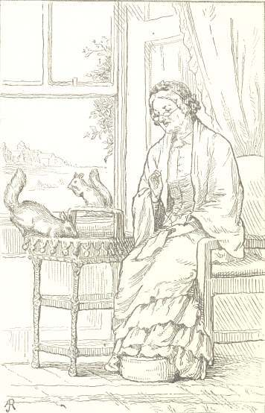
At last Aunt Esther put out her hand to touch them, when, whisk-frisk, out they went, and up the trees, chattering and laughing before she had time even to wink.
But after this they used to come in every day, and when she put corn in her hand and held it very still they would eat out of it; and finally they would get into her hand, until one day she gently closed it over them, and Frisky and Tit-bit were fairly caught.
Oh, how their hearts beat! but the good fairy only spoke gently to them, and soon unclosed her hand and let them go again. So day after day they grew to have more and more faith in her, till they would climb into her work-basket, sit on her shoulder, or nestle away in her lap as she sat sewing. They made also long exploring voyages all over the house, up and through all the chambers, till finally, I grieve to say, poor Frisky came to an untimely end by being drowned in the water-tank at the top of the house.
The dear good fairy passed away from the house in time, and went to a land where the flowers never fade and the birds never die; but the squirrels still continue to make the place a favourite resort.
“In fact, my dear,” said old Mother Red one winter to her mate, “what is the use of one’s living in this cold, hollow tree, when these amiable people have erected this pretty cottage, where there is plenty of room for us and them too? Now I have examined between the eaves, and there is a charming place where we can store our nuts, and where we can whip in and out of the garret, and have the free range of the house; and, say what you will, these humans have delightful ways of being warm and comfortable in winter.”
So Mr. and Mrs. Red set up housekeeping in the cottage, and had no end of nuts and other good things stored up there. The trouble of all this was, that, as Mrs. Red was a notable body, and got up to begin her housekeeping operations, and woke up all her children, at four o’clock in the morning, the good people often were disturbed by a great rattling and fuss in the walls, while yet it seemed dark night. Then sometimes, too, I grieve to say, Mrs. Squirrel would give her husband vigorous curtain lectures in the night, which made him so indignant that he would rattle off to another quarter of the garret to sleep by himself; and all this broke the rest of the worthy people who built the house.
What is to be done about this we don’t know. What would you do about it? Would you let the squirrels live in your house or not? When our good people come down of a cold winter morning, and see the squirrels dancing and frisking down the trees, and chasing each other so merrily over the garden chair between them, or sitting with their tails saucily over their backs, they look so jolly and jaunty and pretty that they almost forgive them for disturbing their night’s rest, and think that they will not do anything to drive them out of the garret to-day. And so it goes on; but how long the squirrels will rent the cottage in this fashion, I’m sure I dare not undertake to say.

Hum, The Son Of Buz
At Rye Beach, during our summer’s vacation, there came, as there always will to seaside visitors, two or three cold, chilly, rainy days,—days when the skies that long had not rained a drop seemed suddenly to bethink themselves of their remissness, and to pour down water, not by drops, but by pailfuls. The chilly wind blew and whistled, the water dashed along the ground and careered in foamy rills along the roadside, and the bushes bent beneath the constant flood. It was plain that there was to be no sea-bathing on such a day, no walks, no rides; and so, shivering and drawing our blanket-shawls close about us, we sat down at the window to watch the storm outside.
The rose-bushes under the window hung dripping under their load of moisture, each spray shedding a constant shower on the spray below it. On one of these lower sprays, under the perpetual drip, what should we see but a poor little humming-bird, drawn up into the tiniest shivering ball, and clinging with a desperate grasp to his uncomfortable perch. A humming-bird we knew him to be at once, though his feathers were so matted and glued down by the rain that he looked not much bigger than a honey-bee, and as different as possible from the smart, pert, airy little character that we had so often seen flirting with the flowers. He was evidently a humming-bird in adversity, and whether he ever would hum again looked to us exceedingly doubtful. Immediately, however, we sent out to have him taken in. When the friendly hand seized him, he gave a little, faint, watery squeak, evidently thinking that his last hour was come, and that grim death was about to carry him off to the land of dead birds. What a time we had reviving him,—holding the little wet thing in the warm hollow of our hands, and feeling him shiver and palpitate! His eyes were fast closed; his tiny claws, which looked slender as cobwebs, were knotted close to his body, and it was long before one could feel the least motion in them. Finally, to our great joy, we felt a brisk little kick, and then a flutter of wings, and then a determined peck of the beak, which showed that there was some bird left in him yet, and that he meant at any rate to find out where he was.
Unclosing our hands a small space, out popped the little head with a pair of round brilliant eyes. Then we bethought ourselves of feeding him, and forthwith prepared him a stiff glass of sugar and water, a drop of which we held to his bill. After turning his head attentively, like a bird who knew what he was about and didn’t mean to be chaffed, he briskly put out a long, flexible tongue, slightly forked at the end, and licked off the comfortable beverage with great relish. Immediately he was pronounced out of danger by the small humane society which had undertaken the charge of his restoration, and we began to cast about for getting him a settled establishment in our apartment. I gave up my work-box to him for a sleeping-room, and it was medically ordered that he should take a nap. So we filled the box with cotton, and he was formally put to bed, with a folded cambric handkerchief round his neck, to keep him from beating his wings. Out of his white wrappings he looked forth green and grave as any judge with his bright round eyes. Like a bird of discretion, he seemed to understand what was being done to him, and resigned himself sensibly to go to sleep.
The box was covered with a sheet of paper perforated with holes for purposes of ventilation; for even humming-birds have a little pair of lungs, and need their own little portion of air to fill them, so that they may make bright scarlet little drops of blood to keep life’s fire burning in their tiny bodies. Our bird’s lungs manufactured brilliant blood, as we found out by experience; for in his first nap he contrived to nestle himself into the cotton of which his bed was made, and to get more of it than he needed into his long bill. We pulled it out as carefully as we could, but there came out of his bill two round, bright scarlet, little drops of blood. Our chief medical authority looked grave, pronounced a probable hemorrhage from the lungs, and gave him over at once. We, less scientific, declared that we had only cut his little tongue by drawing out the filaments of cotton, and that he would do well enough in time,—as it afterwards appeared he did, for from that day there was no more bleeding. In the course of the second day he began to take short flights about the room, though he seemed to prefer to return to us; perching on our fingers or heads or shoulders, and sometimes choosing to sit in this way for half an hour at a time. “These great giants,” he seemed to say to himself, “are not bad people after all; they have a comfortable way with them; how nicely they dried and warmed me! Truly a bird might do worse than to live with them.”
So he made up his mind to form a fourth in the little company of three that usually sat and read, worked and sketched, in that apartment, and we christened him “Hum, the son of Buz.” He became an individuality, a character, whose little doings formed a part of every letter, and some extracts from these will show what some of his little ways were:—
“Hum has learned to sit upon my finger, and eat his sugar and water out of a teaspoon with most Christian-like decorum. He has but one weakness—he will occasionally jump into the spoon and sit in his sugar and water, and then appear to wonder where it goes to. His plumage is in rather a drabbled state, owing to these performances. I have sketched him as he sat to-day on a bit of Spiræa which I brought in for him. When absorbed in reflection, he sits with his bill straight up in the air, as I have drawn him. Mr. A— reads Macaulay to us, and you should see the wise air with which, perched on Jenny’s thumb, he cocked his head now one side and then the other, apparently listening with most critical attention. His confidence in us seems unbounded: he lets us stroke his head, smooth his feathers, without a flutter; and is never better pleased than when sitting, as he has been doing all this while, on my hand, turning up his bill, and watching my face with great edification.
“I have just been having a sort of maternal struggle to make him go to bed in his box; but he evidently considers himself sufficiently convalescent to make a stand for his rights as a bird, and so scratched indignantly out of his wrappings, and set himself up to roost on the edge of the box, with an air worthy of a turkey, at the very least. Having brought in a lamp, he has opened his eyes round and wide, and sits cocking his little head at me reflectively.”
When the weather cleared away, and the sun came out bright, Hum became entirely well, and seemed resolved to take the measure of his new life with us. Our windows were closed in the lower part of the sash by frames with mosquito gauze, so that the sun and air found free admission, and yet our little rover could not pass out. On the first sunny day he took an exact survey of our apartment from ceiling to floor, humming about, examining every point with his bill—all the crevices, mouldings, each little indentation in the bed-posts, each window-pane, each chair and stand; and, as it was a very simply furnished seaside apartment, his scrutiny was soon finished. We wondered at first what this was all about; but on watching him more closely, we found that he was actively engaged in getting his living, by darting out his long tongue hither and thither, and drawing in all the tiny flies and insects which in summer time are to be found in an apartment. In short, we found that, though the nectar of flowers was his dessert, yet he had his roast beef and mutton-chop to look after, and that his bright, brilliant blood was not made out of a simple vegetarian diet. Very shrewd and keen he was, too, in measuring the size of insects before he attempted to swallow them. The smallest class were whisked off with lightning speed; but about larger ones he would sometimes wheel and hum for some minutes, darting hither and thither, and surveying them warily, and if satisfied that they could be carried, he would come down with a quick, central dart which would finish the unfortunate at a snap. The larger flies seemed to irritate him, especially when they intimated to him that his plumage was sugary, by settling on his wings and tail; when he would lay about him spitefully, wielding his bill like a sword. A grasshopper that strayed in, and was sunning himself on the window-seat, gave him great discomposure. Hum evidently considered him an intruder, and seemed to long to make a dive at him; but, with characteristic prudence, confined himself to threatening movements, which did not exactly hit. He saw evidently that he could not swallow him whole, and what might ensue from trying him piecemeal he wisely forbore to essay.
Hum had his own favourite places and perches. From the first day he chose for his nightly roost a towel-line which had been drawn across the corner over the wash-stand, where he every night established himself with one claw in the edge of the towel and the other clasping the line, and, ruffling up his feathers till he looked like a little chestnut-burr, he would resign himself to the soundest sleep. He did not tuck his head under his wing, but seemed to sink it down between his shoulders, with his bill almost straight up in the air. One evening one of us, going to use the towel, jarred the line, and soon after found that Hum had been thrown from his perch, and was hanging head downward, fast asleep, still clinging to the line. Another evening, being discomposed by somebody coming to the towel-line after he had settled himself, he fluttered off; but so sleepy that he had not discretion to poise himself again, and was found clinging, like a little bunch of green floss silk, to the mosquito netting of the window.
A day after this we brought in a large green bough, and put it up over the looking-glass. Hum noticed it before it had been there five minutes, flew to it, and began a regular survey, perching now here, now there, till he seemed to find a twig that exactly suited him; and after that he roosted there every night. Who does not see in this change all the signs of reflection and reason that are shown by us in thinking over our circumstances, and trying to better them? It seemed to say in so many words: “That towel-line is an unsafe place for a bird; I get frightened, and wake from bad dreams to find myself head downwards; so I will find a better roost on this twig.”
When our little Jenny one day put on a clean white muslin gown embellished with red sprigs, Hum flew towards her, and with his bill made instant examination of these new appearances; and one day, being very affectionately disposed, perched himself on her shoulder, and sat some time. On another occasion, while Mr. A was reading, Hum established himself on the top of his head just over the middle of his forehead, in the precise place where our young belles have lately worn stuffed humming-birds, making him look as if dressed out for a party. Hum’s most favourite perch was the back of the great rocking-chair, which, being covered by a tidy, gave some hold into which he could catch his little claws. There he would sit, balancing himself cleverly if its occupant chose to swing to and fro, and seeming to be listening to the conversation or reading.
Hum had his different moods, like human beings. On cold, cloudy, gray days he appeared to be somewhat depressed in spirits, hummed less about the room, and sat humped up with his feathers ruffled, looking as much like a bird in a great-coat as possible. But on hot, sunny days, every feather sleeked itself down, and his little body looked natty and trim, his head alert, his eyes bright, and it was impossible to come near him, for his agility. Then let mosquitoes and little flies look about them! Hum snapped them up without mercy, and seemed to be all over the ceiling in a moment, and resisted all our efforts at any personal familiarity with a saucy alacrity.
Hum had his established institutions in our room, the chief of which was a tumbler with a little sugar and water mixed in it, and a spoon laid across, out of which he helped himself whenever he felt in the mood—sitting on the edge of the tumbler, and dipping his long bill, and lapping with his little forked tongue like a kitten. When he found his spoon accidentally dry, he would stoop over and dip his bill in the water in the tumbler; which caused the prophecy on the part of some of his guardians that he would fall in some—day and be drowned. For which reason it was agreed to keep only an inch in depth of the fluid at the bottom of the tumbler. A wise precaution this proved; for the next morning I was awaked, not by the usual hum over my head, but by a sharp little flutter, and found Mr. Hum beating his wings in the tumbler—having actually tumbled in during his energetic efforts to get his morning coffee before I was awake.
Hum seemed perfectly happy and satisfied in his quarters; but one day, when the door was left open, he made a dart out, and so into the open sunshine. Then, to be sure, we thought we had lost him. We took the mosquito netting, out of all the windows, and, setting his tumbler of sugar and water in a conspicuous place, went about our usual occupations. We saw him joyous and brisk among the honeysuckles outside the window, and it was gravely predicted that he would return no more. But at dinner-time in came Hum, familiar as possible, and sat down to his spoon as if nothing had happened. Instantly we closed our windows and had him secure once more.
At another time I was going to ride to the Atlantic House, about a mile from my boarding-place. I left all secure, as I supposed, at home. While gathering moss on the walls there, I was surprised by a little green humming-bird flying familiarly right towards my face and humming above my head. I called out, “Here is Hum’s very brother.” But, on returning home, I saw that the door of the room was open, and Hum was gone. Now certainly we gave him up for lost. I sat down to painting, and in a few minutes in flew Hum, and settled on the edge of my tumbler in a social, confidential way, which seemed to say, “Oh, you’ve got back then.” After taking his usual drink of sugar and water, he began to fly about the ceiling as usual, and we gladly shut him in.
When our five weeks at the seaside were up, and it was time to go home, we had great questionings what was to be done with Hum. To get him home with us was our desire; but who ever heard of a humming-bird travelling by railroad? Great were the consultings. A little basket of Indian work was filled up with cambric handkerchiefs, and a bottle of sugar and water provided, and we started with him for a day’s journey. When we arrived at night the first care was to see what had become of Hum, who had not been looked at since we fed him with sugar and water in Boston. We found him alive and well, but so dead asleep that we could not wake him to roost; so we put him to bed on a toilet cushion, and arranged his tumbler for morning. The next day found him alive and humming, exploring the room and pictures, perching now here and now there; but as the weather was chilly, he sat for the most part of the time in a humped-up state on the tip of a pair of stag’s horns. We moved him to a more sunny apartment; but, alas! the equinoctial storm came on, and there was no sun to be had for days. Hum was blue; the pleasant seaside days were over; his room was lonely, the pleasant three that had enlivened the apartment at Rye no longer came in and out; evidently he was lonesome, and gave way to depression. One chilly morning he managed again to fall into his tumbler, and wet himself through; and notwithstanding warm bathings and tender nursings, the poor little fellow seemed to get diphtheria, or something quite as bad for humming-birds.
We carried him to a neighbouring sunny parlour, where ivy embowers all the walls and the sun lies all day. There he revived a little, danced up and down, perched on a green spray that was wreathed across the breast of a Psyche, and looked then like a little flitting soul returning to its rest. Towards evening he drooped; and, having been nursed and warmed and cared for, he was put to sleep on a green twig laid on the piano. In that sleep the little head drooped—nodded—fell; and little Hum went where other bright dreams go—to the Land of the Hereafter.

Our Country Neighbours
We have just built our house in rather an out-of-the-way place—on the bank of a river, and under the shade of a patch of woods which is a veritable remain of quite an ancient forest. The checkerberry and partridge-plum, with their glossy green leaves and scarlet berries, still carpet the ground under its deep shadows; and prince’s-pine and other kindred evergreens declare its native wildness,—for these are children of the wild woods, that never come after plough and harrow have once broken a soil.
When we tried to look out the spot for our house, we had to get a surveyor to go before us and cut a path through the dense underbrush that was laced together in a general network of boughs and leaves, and grew so high as to overtop our heads. Where the house stands, four or five great old oaks and chestnuts had to be cut away to let it in; and now it stands on the bank of the river, the edges of which are still overhung with old forest-trees, chestnuts and oaks, which look at themselves in the glassy stream.
A little knoll near the house was chosen for a garden-spot; a dense, dark mass of trees above, of bushes in mid-air, and of all sorts of ferns and wild-flowers and creeping vines on the ground. All these had to be cleared out, and a dozen great trees cut down and dragged off to a neighbouring saw-mill, there to be transformed into boards to finish off our house. Then, fetching a great machine, such as might be used to pull a giant’s teeth, with ropes, pulleys, oxen, and men, and might and main, we pulled out the stumps, with their great prongs and their network of roots and fibres; and then, alas! we had to begin with all the pretty wild, lovely bushes, and the checkerberries and ferns and wild blackberries and huckleberry-bushes, and dig them up remorselessly, that we might plant our corn and squashes. And so we got a house and a garden right out of the heart of our piece of wild wood, about a mile from the city of H-.
Well, then, people said it was a lonely place, and far from neighbours,—by which they meant that it was a good way for them to come to see us. But we soon found that whoever goes into the woods to live finds neighbours of a new kind, and some to whom it is rather hard to become accustomed.
For instance, on a fine day early in April, as we were crossing over to superintend the building of our house, we were startled by a striped snake, with his little bright eyes, raising himself to look at us, and putting out his red, forked tongue. Now there is no more harm in these little garden-snakes than there is in a robin or a squirrel—they are poor little, peaceable, timid creatures, which could not do any harm if they would; but the prejudices of society are so strong against them that one does not like to cultivate too much intimacy with them. So we tried to turn out of our path into a tangle of bushes; and there, instead of one, we found four snakes. We turned on the other side, and there were two more. In short, everywhere we looked, the dry leaves were rustling and coiling with them; and we were in despair. In vain we said that they were harmless as kittens, and tried to persuade ourselves that their little bright eyes were pretty, and that their serpentine movements were in the exact line of beauty: for the life of us, we could not help remembering their family name and connections; we thought of those disagreeable gentlemen the anacondas, the rattlesnakes, and the copper-heads, and all of that bad line, immediate family friends of the old serpent to whom we are indebted for all the mischief that is done in this world. So we were quite apprehensive when we saw how our new neighbourhood was infested by them, until a neighbour calmed our fears by telling us that snakes always crawled out of their holes to sun themselves in the spring, and that in a day or two they would all be gone.
So it proved. It was evident they were all out merely to do their spring shopping, or something that serves with them the same purpose that spring shopping does with us; and where they went afterwards we do not know. People speak of snakes’ holes, and we have seen them disappearing into such subterranean chambers; but we never opened one to see what sort of underground housekeeping went on there. After the first few days of spring, a snake was a rare visitor, though now and then one appeared.
One was discovered taking his noontide repast one day in a manner which excited much prejudice. He was, in fact, regaling himself by sucking down into his maw a small frog, which he had begun to swallow at the toes, and had drawn about half down. The frog, it must be confessed, seemed to view this arrangement with great indifference, making no struggle, and sitting solemnly, with his great unwinking eyes, to be sucked in at the leisure of his captor. There was immense sympathy, however, excited for him in the family circle; and it was voted that a snake which indulged in such very disagreeable modes of eating his dinner was not to be tolerated in our vicinity. So I have reason to believe that that was his last meal.
Another of our wild woodland neighbours made us some trouble. It was no other than a veritable woodchuck, whose hole we had often wondered at when we were scrambling through the underbrush after spring flowers. The hole was about the size of a peck-measure, and had two openings about six feet apart. The occupant was a gentleman we never had had the pleasure of seeing, but we soon learned his existence from his ravages in our garden. He had a taste, it appears, for the very kind of things we wanted to eat ourselves, and helped himself without asking. We had a row of fine, crisp heads of lettuce, which were the pride of our gardening, and out of which he would from day to day select for his table just the plants we had marked for ours. He also nibbled our young beans; and so at last we were reluctantly obliged to let John Gardiner set a trap for him. Poor old simple-minded hermit, he was too artless for this world! He was caught at the very first snap, and found dead in the trap,—the agitation and distress having broken his poor woodland heart, and killed him. We were grieved to the very soul when the poor fat old fellow was dragged out, with his useless paws standing up stiff and imploring. As it was, he was given to Denis, our pig, which, without a single scruple of delicacy, ate him up as thoroughly as he ate up the lettuce.
This business of eating, it appears, must go on all through creation. We eat ducks, turkeys, and chickens, though we don’t swallow them whole, feathers and all. Our four-footed friends, less civilized, take things with more directness and simplicity, and chew each other up without ceremony, or swallow each other alive. Of these unceremonious habits we had other instances.
Our house had a central court on the southern side, into which looked the library, dining-room, and front hall, as well as several of the upper chambers. It was designed to be closed in with glass, to serve as a conservatory in winter; and meanwhile we had filled it with splendid plumy ferns, taken up out of the neighbouring wood. In the centre was a fountain surrounded by stones, shells, mosses, and various water-plants. We had bought three little goldfish to swim in our basin; and the spray of it, as it rose in the air and rippled back into the water, was the pleasantest possible sound of a hot day. We used to lie on the sofa in the hall, and look into the court, and fancy we saw some scene of fairy-land, and water-sprites coming up from the fountain. Suddenly a new-comer presented himself,—no other than an immense bull-frog, that had hopped up from the neighbouring river, apparently with a view to making a permanent settlement in and about our fountain. He was to be seen, often for hours, sitting reflectively on the edge of it, beneath the broad shadow of the calla-leaves. When sometimes missed thence, he would be found under the ample shield of a great bignonia, whose striped leaves grew hard by.
The family were prejudiced against him. What did he want there? It was surely some sinister motive impelled him. He was probably watching for an opportunity to gobble up the goldfish. We took his part, however, and strenuously defended his moral character, and patronized him in all ways. We gave him the name of Unke, and maintained that he was a well-conducted, philosophical old water-sprite, who showed his good taste in wanting to take up his abode in our conservatory. We even defended his personal appearance, praised the invisible-green coat which he wore on his back, and his gray vest, and solemn gold spectacles; and though he always felt remarkably slimy when we touched him, yet, as he would sit still and allow us to stroke his head and pat his back, we concluded his social feelings might be warm, notwithstanding a cold exterior. Who knew, after all, but he might be a beautiful young prince, enchanted there till the princess should come to drop the golden ball into the fountain, and so give him a chance to marry her and turn into a man again? Such things, we are credibly informed, are matters of frequent occurrence in Germany. Why not here?
By-and-by there came to our fountain another visitor,—a frisky, green young frog of the identical kind spoken of by the poet:—
“There was a frog lived in a well,
Rig dum pully metakimo.”
This thoughtless, dapper individual, with his bright green coat, his faultless white vest, and sea-green tights, became rather the popular favourite. He seemed just rakish and gallant enough to fulfil the conditions of the song:—
“The frog he would a-courting ride,
With sword and pistol by his side.”
This lively young fellow, whom we shall call Cri-Cri, like other frisky and gay young people, carried the day quite over the head of the solemn old philosopher under the calla-leaves. At night, when all was still, he would trill a joyous little note in his throat, while old Unke would answer only with a cracked guttural more singular than agreeable; and to all outward appearance the two were as good friends as their different natures would allow.
One day, however, the conservatory became the scene of a tragedy of the deepest dye. We were summoned below by shrieks and howls of horror. “Do pray come down and see what this vile, nasty, horrid old frog has been doing!” Down we came; and there sat our virtuous old philosopher, with his poor little brother’s hind legs still sticking out of the corner of his mouth, as if he were smoking them for a cigar, all helplessly palpitating as they were. In fact, our solemn old friend had done what many a solemn hypocrite before has done,—swallowed his poor brother, neck and crop,—and sat there with the most brazen indifference, looking as if he had done the most proper and virtuous thing in the world.
Immediately he was marched out of the conservatory at the point of a walking-stick, and made to hop down to the river, into whose waters he splashed, and we saw him no more. We regret to say that the popular indignation was so precipitate in its results; otherwise the special artist who sketched Hum, the son of Buz, intended to have made a sketch of the old villain, as he sat with his luckless victim’s hind legs projecting from his solemn mouth. With all his moral faults, he was a good sitter, and would probably have sat immovable any length of time that could be desired.
Of other woodland neighbours there were some which we saw occasionally. The shores of the river were lined here and there with the holes of the muskrats; and in rowing by their settlements, we were sometimes strongly reminded of them by the overpowering odour of the perfume from which they get their name. There were also owls, whose nests were high up in some of the old chestnut-trees. Often in the lonely hours of the night we could hear them gibbering with a sort of wild, hollow laugh among the distant trees. But one tenant of the woods made us some trouble in the autumn. It was a little flying-squirrel, who took to making excursions into our house in the night season, coming down the chimney into the chambers, rustling about among the clothes, cracking nuts or nibbling at any morsels of anything that suited his fancy. For a long time the inmates of the rooms were awakened in the night by mysterious noises, thumps, and rappings, and so lighted candles, and searched in vain to find whence they came; for the moment any movement was made, the rogue whipped up the chimney, and left us a prey to the most mysterious alarms. What could it be?
But one night our fine gentleman bounced in at the window of another room, which had no fireplace; and the fair occupant, rising in the night, shut the window, without suspecting that she had cut off the retreat of any of her woodland neighbours. The next morning she was startled by what she thought a gray rat running past her bed. She rose to pursue him, when he ran up the wall, and clung against the plastering, showing himself very plainly a gray flying-squirrel, with large, soft eyes, and wings which consisted of a membrane uniting the fore paws to the hind ones, like those of a bat. He was chased into the conservatory, and a window being opened, out he flew upon the ground, and made away for his native woods, and thus put an end to many fears as to the nature of our nocturnal rappings.
So you see how many neighbours we found by living in the woods, and, after all, no worse ones than are found in the great world.

The Diverting History Of Little Whiskey
And now, at the last, I am going to tell you something of the ways and doings of one of the queer little people, whom I shall call Whiskey.
You cannot imagine how pretty he is. His back has the most beautiful smooth shining stripes of reddish brown and black, his eyes shine like bright glass beads, and he sits up jauntily on his hind quarters, with his little tail thrown over his back like a ruffle.
And where does he live? Well, “that is telling,” as we children say. It was somewhere up in the mountains of Berkshire, in a queer, quaint, old-fashioned garden, that I made Mr. Whiskey’s acquaintance.
Here there lives a young parson, who preaches every Sunday in a little brown church, and during week-days goes through all these hills and valleys, visiting the poor, and gathering children into Sunday schools.
His wife is a very small-sized lady—not much bigger than you, my little Mary—but very fond of all sorts of dumb animals; and by constantly watching their actions and ways, she has come to have quite a strange power over them, as I shall relate.
The little lady fixed her mind on Whiskey, and gave him his name without consulting him upon the subject. She admired his bright eyes, and resolved to cultivate his acquaintance.
By constant watching, she discovered that he had a small hole of his own in the grass-plot a few paces from her back-door. So she used to fill her pocket with hazel-nuts, and go out and sit in the back porch, and make a little noise, such as squirrels make to each other, to attract his attention.
In a minute or two up would pop the little head with the bright eyes, in the grass-plot, and Master Whiskey would sit on his haunches and listen, with one small ear cocked towards her. Then she would throw him a hazel-nut, and he would slip instantly down into his hole again. In a minute or two, however, his curiosity would get the better of his prudence; and she, sitting quiet, would see the little brown-striped head slowly, slowly coming up again, over the tiny green spikes of the grass-plot. Quick as a flash he would dart at the nut, whisk it into a little bag on one side of his jaws, which Madam Nature has furnished him with for his provision-pouch, and down into his hole again. An ungrateful, suspicious little brute he was too; for though in this way he bagged and carried off nut after nut, until the patient little woman had used up a pound of hazel-nuts, still he seemed to have the same wild fright at sight of her, and would whisk off and hide himself in his hole the moment she appeared. In vain she called, “Whiskey, Whiskey, Whiskey,” in the most flattering tones; in vain she coaxed and cajoled. No, no; he was not to be caught napping. He had no objection to accepting her nuts, as many as she chose to throw to him; but as to her taking any personal liberty with him, you see, it was by no means to be thought of.
But at last patience and perseverance began to have their reward. Little Master Whiskey said to himself, “Surely this is a nice, kind lady, to take so much pains to give me nuts; she is certainly very considerate;” and with that he edged a little nearer and nearer every day, until, quite to the delight of the small lady, he would come and climb into her lap and seize the nuts, when she rattled them there, and after that he seemed to make exploring voyages all over her person. He would climb up and sit on her shoulder; he would mount and perch himself on her head; and when she held a nut for him between her teeth, he would take it out of her mouth.
After a while he began to make tours of discovery in the house. He would suddenly appear on the minister’s writing-table when he was composing his Sunday sermon, and sit cocking his little pert head at him, seeming to wonder what he was about. But in all his explorations he proved himself a true Yankee squirrel, having always a shrewd eye on the main chance. If the parson dropped a nut on the floor, down went Whiskey after it, and into his provision-bag it went, and then he would look up as if he expected another; for he had a wallet on each side of his jaws, and he always wanted both sides handsomely filled before he made for his hole. So busy and active and always intent on this one object was he, that before long the little lady found he had made way with six pounds of hazel-nuts. His general rule was to carry off four nuts at a time—three being stuffed into the side-pockets of his jaws, and the fourth held in his teeth. When he had furnished himself in this way, he would dart like lightning for his hole, and disappear in a moment; but in a short time up he would come, brisk and wide-awake, and ready for the next supply.
Once a person who had the curiosity to dig open a chipping squirrel’s hole found in it two quarts of buckwheat, a quantity of grass-seed, nearly a peck of acorns, some Indian corn, and a quart of walnuts; a pretty handsome supply for a squirrel’s winter store-room—don’t you think so?
Whiskey learned in time to work for his living in many artful ways that his young mistress devised. Sometimes she would tie his nuts up in a paper package, which he would attack with great energy, gnawing the strings, and rustling the nuts out of the paper in wonderfully quick time. Sometimes she would tie a nut to the end of a bit of twine and swing it backward and forward over his head; and after a succession of spry jumps, he would pounce upon it, and hang swinging on the twine, till he had gnawed the nut away.
Another squirrel, doubtless hearing of Whiskey’s good luck, began to haunt the same yard; but Whiskey would by no means allow him to cultivate his young mistress’s acquaintance. No indeed! he evidently considered that the institution would not support two. Sometimes he would appear to be conversing with the stranger on the most familiar and amicable terms in the back-yard; but if his mistress called his name, he would immediately start and chase his companion quite out of sight, before he came back to her.
So you see that self-seeking is not confined to men alone, and that Whiskey’s fine little fur coat covers a very selfish heart.
As winter comes on, Whiskey will go down into his hole, which has many long galleries and winding passages, and a snug little bedroom well lined with leaves. Here he will doze and dream away his long winter months, and nibble out the inside of his store of nuts.
If I hear any more of his cunning tricks, I will tell you of them.

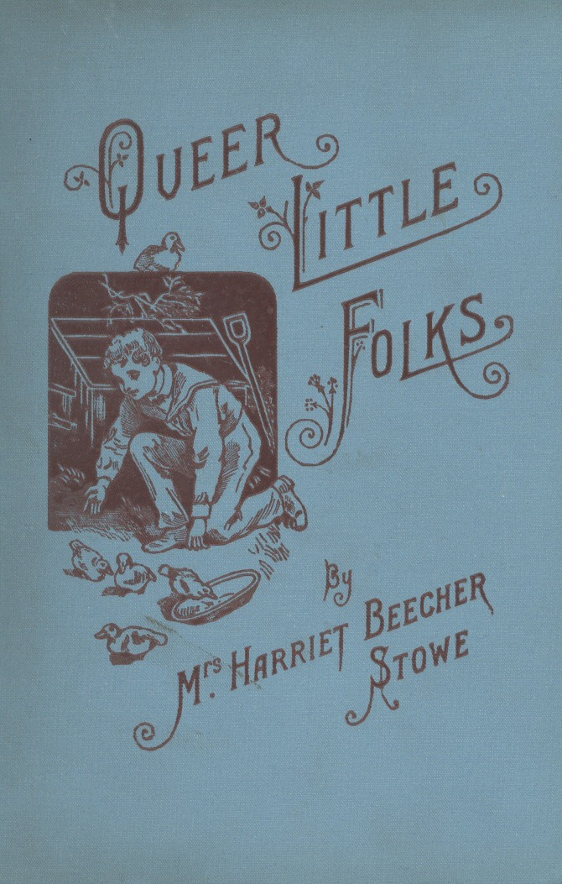

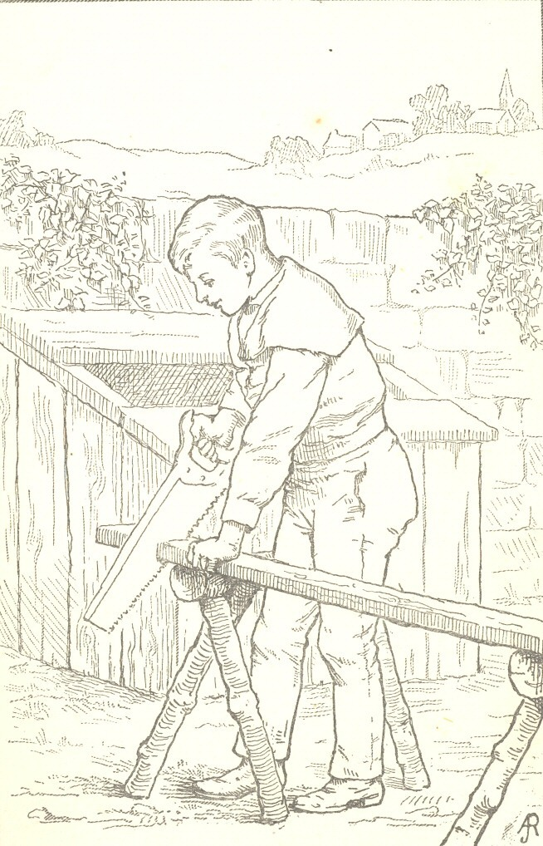

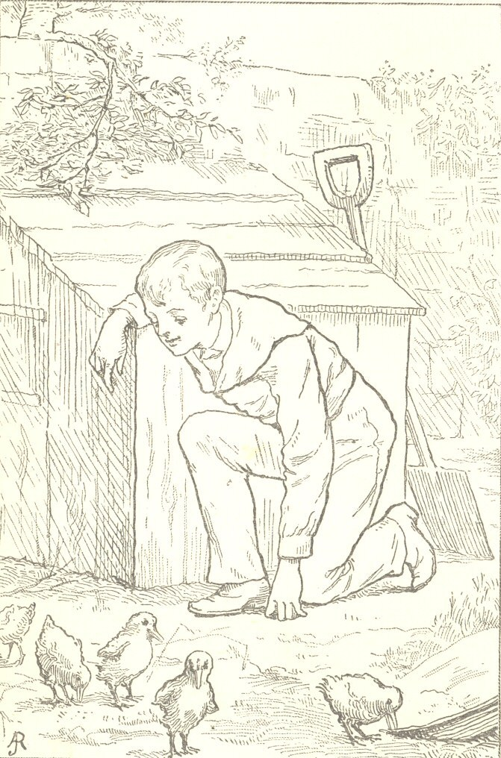

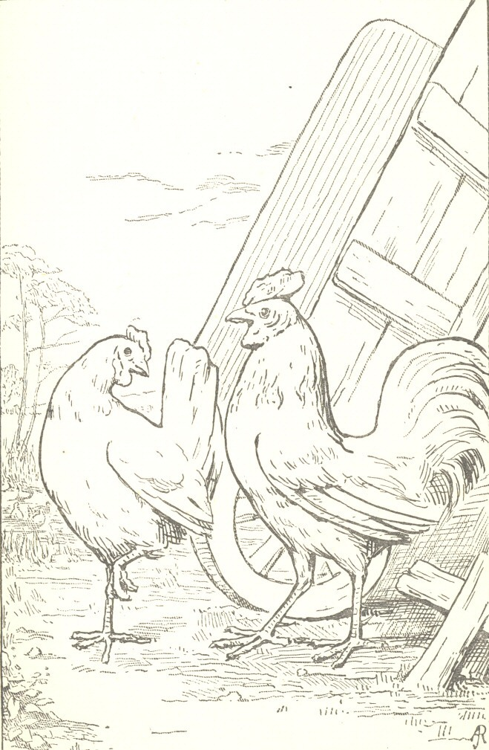

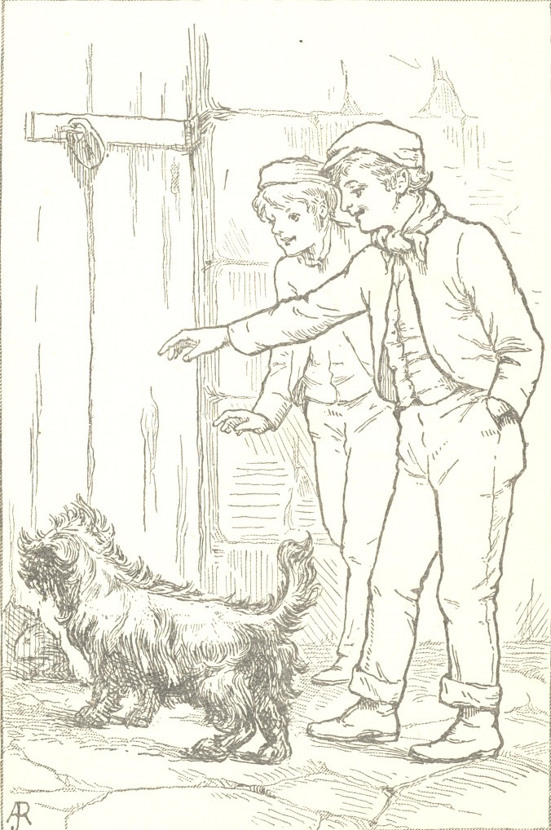

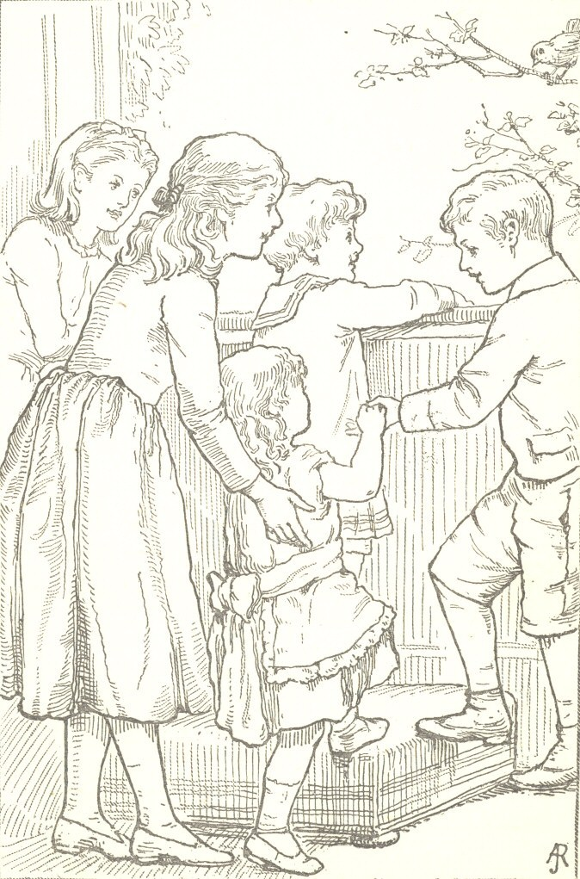

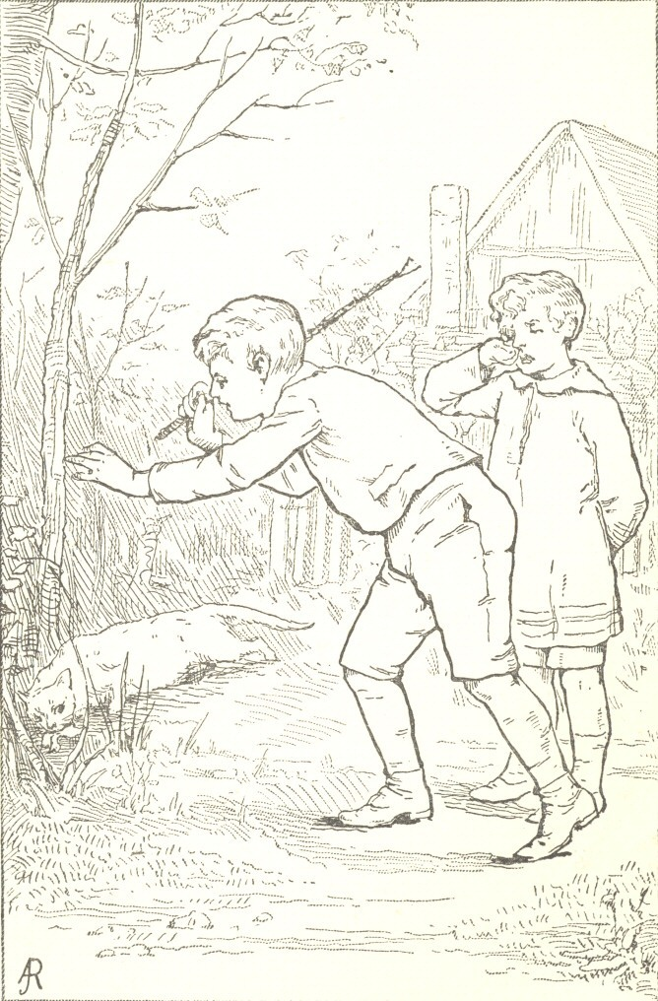

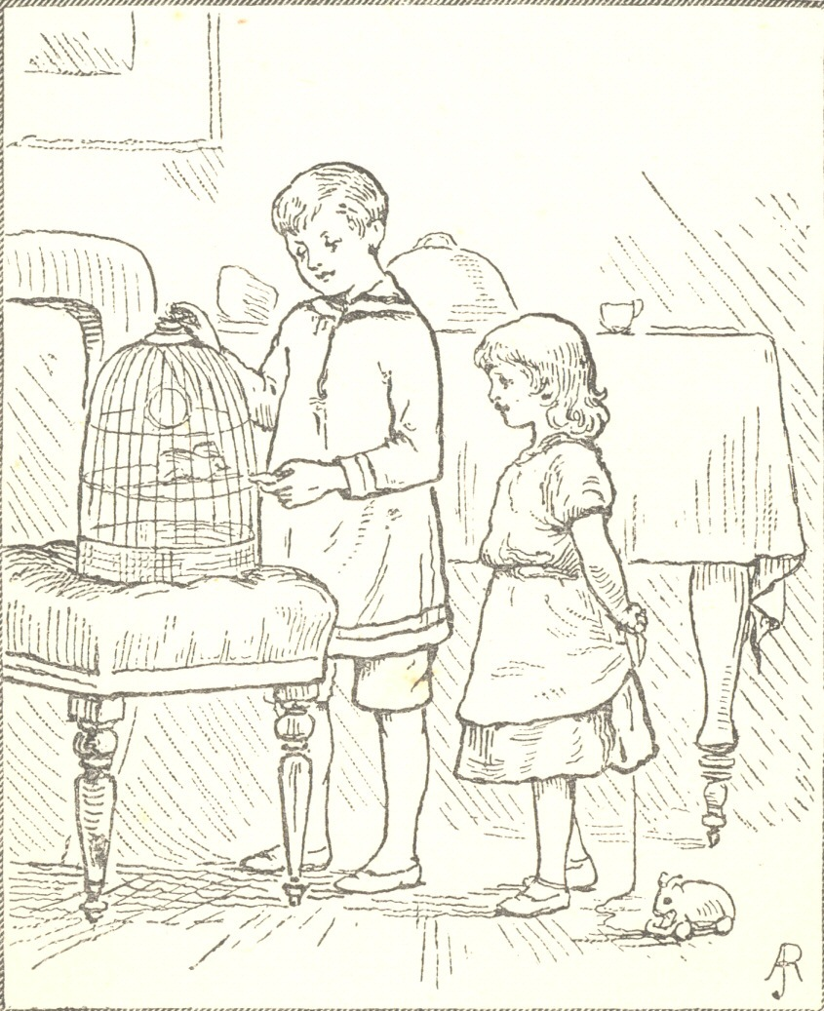

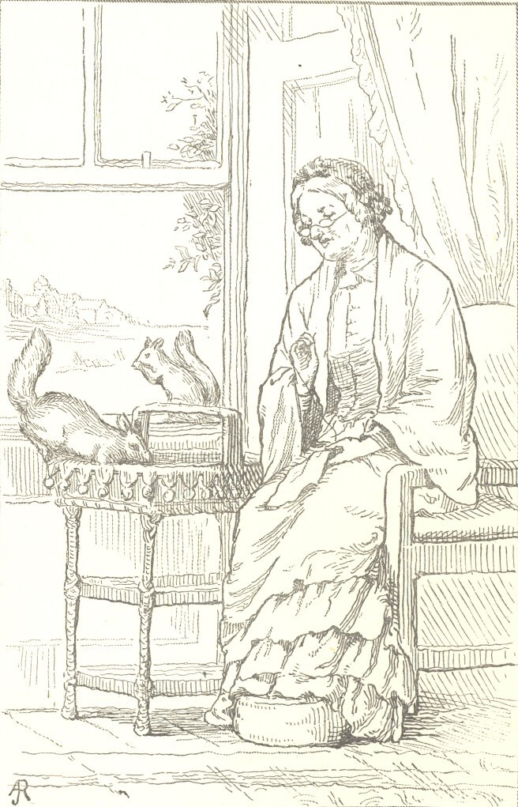

The Full Project Gutenberg License
Please Read This Before You Distribute Or Use This Work
To protect the Project Gutenberg™ mission of promoting the free distribution of electronic works, by using or distributing this work (or any other work associated in any way with the phrase “Project Gutenberg”), you agree to comply with all the terms of the Full Project Gutenberg™ License available with this file or online at www.gutenberg.org/license.
Section 1. General Terms of Use and Redistributing Project Gutenberg™ electronic works
1.A. By reading or using any part of this Project Gutenberg™ electronic work, you indicate that you have read, understand, agree to and accept all the terms of this license and intellectual property (trademark/copyright) agreement. If you do not agree to abide by all the terms of this agreement, you must cease using and return or destroy all copies of Project Gutenberg™ electronic works in your possession. If you paid a fee for obtaining a copy of or access to a Project Gutenberg™ electronic work and you do not agree to be bound by the terms of this agreement, you may obtain a refund from the person or entity to whom you paid the fee as set forth in paragraph 1.E.8.
1.B. “Project Gutenberg” is a registered trademark. It may only be used on or associated in any way with an electronic work by people who agree to be bound by the terms of this agreement. There are a few things that you can do with most Project Gutenberg™ electronic works even without complying with the full terms of this agreement. See paragraph 1.C below. There are a lot of things you can do with Project Gutenberg™ electronic works if you follow the terms of this agreement and help preserve free future access to Project Gutenberg™ electronic works. See paragraph 1.E below.
1.C. The Project Gutenberg Literary Archive Foundation (“the Foundation” or PGLAF), owns a compilation copyright in the collection of Project Gutenberg™ electronic works. Nearly all the individual works in the collection are in the public domain in the United States. If an individual work is unprotected by copyright law in the United States and you are located in the United States, we do not claim a right to prevent you from copying, distributing, performing, displaying or creating derivative works based on the work as long as all references to Project Gutenberg are removed. Of course, we hope that you will support the Project Gutenberg™ mission of promoting free access to electronic works by freely sharing Project Gutenberg™ works in compliance with the terms of this agreement for keeping the Project Gutenberg™ name associated with the work. You can easily comply with the terms of this agreement by keeping this work in the same format with its attached full Project Gutenberg™ License when you share it without charge with others.
1.D. The copyright laws of the place where you are located also govern what you can do with this work. Copyright laws in most countries are in a constant state of change. If you are outside the United States, check the laws of your country in addition to the terms of this agreement before downloading, copying, displaying, performing, distributing or creating derivative works based on this work or any other Project Gutenberg™ work. The Foundation makes no representations concerning the copyright status of any work in any country other than the United States.
1.E. Unless you have removed all references to Project Gutenberg:
1.E.1. The following sentence, with active links to, or other immediate access to, the full Project Gutenberg™ License must appear prominently whenever any copy of a Project Gutenberg™ work (any work on which the phrase “Project Gutenberg” appears, or with which the phrase “Project Gutenberg” is associated) is accessed, displayed, performed, viewed, copied or distributed:
This eBook is for the use of anyone anywhere in the United States and most other parts of the world at no cost and with almost no restrictions whatsoever. You may copy it, give it away or re-use it under the terms of the Project Gutenberg License included with this eBook or online at www.gutenberg.org. If you are not located in the United States, you will have to check the laws of the country where you are located before using this eBook.
1.E.2. If an individual Project Gutenberg™ electronic work is derived from texts not protected by U.S. copyright law (does not contain a notice indicating that it is posted with permission of the copyright holder), the work can be copied and distributed to anyone in the United States without paying any fees or charges. If you are redistributing or providing access to a work with the phrase “Project Gutenberg” associated with or appearing on the work, you must comply either with the requirements of paragraphs 1.E.1 through 1.E.7 or obtain permission for the use of the work and the Project Gutenberg™ trademark as set forth in paragraphs 1.E.8 or 1.E.9.
1.E.3. If an individual Project Gutenberg™ electronic work is posted with the permission of the copyright holder, your use and distribution must comply with both paragraphs 1.E.1 through 1.E.7 and any additional terms imposed by the copyright holder. Additional terms will be linked to the Project Gutenberg™ License for all works posted with the permission of the copyright holder found at the beginning of this work.
1.E.4. Do not unlink or detach or remove the full Project Gutenberg™ License terms from this work, or any files containing a part of this work or any other work associated with Project Gutenberg™.
1.E.5. Do not copy, display, perform, distribute or redistribute this electronic work, or any part of this electronic work, without prominently displaying the sentence set forth in paragraph 1.E.1 with active links or immediate access to the full terms of the Project Gutenberg™ License.
1.E.6. You may convert to and distribute this work in any binary, compressed, marked up, nonproprietary or proprietary form, including any word processing or hypertext form. However, if you provide access to or distribute copies of a Project Gutenberg™ work in a format other than “Plain Vanilla ASCII” or other format used in the official version posted on the official Project Gutenberg™ website (www.gutenberg.org), you must, at no additional cost, fee or expense to the user, provide a copy, a means of exporting a copy, or a means of obtaining a copy upon request, of the work in its original “Plain Vanilla ASCII” or other form. Any alternate format must include the full Project Gutenberg™ License as specified in paragraph 1.E.1.
1.E.7. Do not charge a fee for access to, viewing, displaying, performing, copying or distributing any Project Gutenberg™ works unless you comply with paragraph 1.E.8 or 1.E.9.
1.E.8. You may charge a reasonable fee for copies of or providing access to or distributing Project Gutenberg™ electronic works provided that:
• You pay a royalty fee of 20% of the gross profits you derive from the use of Project Gutenberg™ works calculated using the method you already use to calculate your applicable taxes. The fee is owed to the owner of the Project Gutenberg™ trademark, but he has agreed to donate royalties under this paragraph to the Project Gutenberg Literary Archive Foundation. Royalty payments must be paid within 60 days following each date on which you prepare (or are legally required to prepare) your periodic tax returns. Royalty payments should be clearly marked as such and sent to the Project Gutenberg Literary Archive Foundation at the address specified in Section 4, “Information about donations to the Project Gutenberg Literary Archive Foundation.”
• You provide a full refund of any money paid by a user who notifies you in writing (or by e-mail) within 30 days of receipt that s/he does not agree to the terms of the full Project Gutenberg™ License. You must require such a user to return or destroy all copies of the works possessed in a physical medium and discontinue all use of and all access to other copies of Project Gutenberg™ works.
• You provide, in accordance with paragraph 1.F.3, a full refund of any money paid for a work or a replacement copy, if a defect in the electronic work is discovered and reported to you within 90 days of receipt of the work.
• You comply with all other terms of this agreement for free distribution of Project Gutenberg™ works.
1.E.9. If you wish to charge a fee or distribute a Project Gutenberg™ electronic work or group of works on different terms than are set forth in this agreement, you must obtain permission in writing from the Project Gutenberg Literary Archive Foundation, the manager of the Project Gutenberg™ trademark. Contact the Foundation as set forth in Section 3 below.
1.F.
1.F.1. Project Gutenberg volunteers and employees expend considerable effort to identify, do copyright research on, transcribe and proofread works not protected by U.S. copyright law in creating the Project Gutenberg™ collection. Despite these efforts, Project Gutenberg™ electronic works, and the medium on which they may be stored, may contain “Defects,” such as, but not limited to, incomplete, inaccurate or corrupt data, transcription errors, a copyright or other intellectual property infringement, a defective or damaged disk or other medium, a computer virus, or computer codes that damage or cannot be read by your equipment.
1.F.2. LIMITED WARRANTY, DISCLAIMER OF DAMAGES - Except for the “Right of Replacement or Refund” described in paragraph 1.F.3, the Project Gutenberg Literary Archive Foundation, the owner of the Project Gutenberg™ trademark, and any other party distributing a Project Gutenberg™ electronic work under this agreement, disclaim all liability to you for damages, costs and expenses, including legal fees. YOU AGREE THAT YOU HAVE NO REMEDIES FOR NEGLIGENCE, STRICT LIABILITY, BREACH OF WARRANTY OR BREACH OF CONTRACT EXCEPT THOSE PROVIDED IN PARAGRAPH 1.F.3. YOU AGREE THAT THE FOUNDATION, THE TRADEMARK OWNER, AND ANY DISTRIBUTOR UNDER THIS AGREEMENT WILL NOT BE LIABLE TO YOU FOR ACTUAL, DIRECT, INDIRECT, CONSEQUENTIAL, PUNITIVE OR INCIDENTAL DAMAGES EVEN IF YOU GIVE NOTICE OF THE POSSIBILITY OF SUCH DAMAGE.
1.F.3. LIMITED RIGHT OF REPLACEMENT OR REFUND - If you discover a defect in this electronic work within 90 days of receiving it, you can receive a refund of the money (if any) you paid for it by sending a written explanation to the person you received the work from. If you received the work on a physical medium, you must return the medium with your written explanation. The person or entity that provided you with the defective work may elect to provide a replacement copy in lieu of a refund. If you received the work electronically, the person or entity providing it to you may choose to give you a second opportunity to receive the work electronically in lieu of a refund. If the second copy is also defective, you may demand a refund in writing without further opportunities to fix the problem.
1.F.4. Except for the limited right of replacement or refund set forth in paragraph 1.F.3, this work is provided to you ‘AS-IS’, WITH NO OTHER WARRANTIES OF ANY KIND, EXPRESS OR IMPLIED, INCLUDING BUT NOT LIMITED TO WARRANTIES OF MERCHANTABILITY OR FITNESS FOR ANY PURPOSE.
1.F.5. Some states do not allow disclaimers of certain implied warranties or the exclusion or limitation of certain types of damages. If any disclaimer or limitation set forth in this agreement violates the law of the state applicable to this agreement, the agreement shall be interpreted to make the maximum disclaimer or limitation permitted by the applicable state law. The invalidity or unenforceability of any provision of this agreement shall not void the remaining provisions.
1.F.6. INDEMNITY - You agree to indemnify and hold the Foundation, the trademark owner, any agent or employee of the Foundation, anyone providing copies of Project Gutenberg™ electronic works in accordance with this agreement, and any volunteers associated with the production, promotion and distribution of Project Gutenberg™ electronic works, harmless from all liability, costs and expenses, including legal fees, that arise directly or indirectly from any of the following which you do or cause to occur: (a) distribution of this or any Project Gutenberg™ work, (b) alteration, modification, or additions or deletions to any Project Gutenberg™ work, and (c) any Defect you cause.
Section 2. Information about the Mission of Project Gutenberg™
Project Gutenberg™ is synonymous with the free distribution of electronic works in formats readable by the widest variety of computers including obsolete, old, middle-aged and new computers. It exists because of the efforts of hundreds of volunteers and donations from people in all walks of life.
Volunteers and financial support to provide volunteers with the assistance they need are critical to reaching Project Gutenberg™’s goals and ensuring that the Project Gutenberg™ collection will remain freely available for generations to come. In 2001, the Project Gutenberg Literary Archive Foundation was created to provide a secure and permanent future for Project Gutenberg™ and future generations. To learn more about the Project Gutenberg Literary Archive Foundation and how your efforts and donations can help, see Sections 3 and 4 and the Foundation information page at www.gutenberg.org.
Section 3. Information about the Project Gutenberg Literary Archive Foundation
The Project Gutenberg Literary Archive Foundation is a non-profit 501(c)(3) educational corporation organized under the laws of the state of Mississippi and granted tax exempt status by the Internal Revenue Service. The Foundation’s EIN or federal tax identification number is 64-6221541. Contributions to the Project Gutenberg Literary Archive Foundation are tax deductible to the full extent permitted by U.S. federal laws and your state’s laws.
The Foundation’s business office is located at 809 North 1500 West, Salt Lake City, UT 84116, (801) 596-1887. Email contact links and up to date contact information can be found at the Foundation’s website and official page at www.gutenberg.org/contact
Section 4. Information about Donations to the Project Gutenberg Literary Archive Foundation
Project Gutenberg™ depends upon and cannot survive without widespread public support and donations to carry out its mission of increasing the number of public domain and licensed works that can be freely distributed in machine-readable form accessible by the widest array of equipment including outdated equipment. Many small donations ($1 to $5,000) are particularly important to maintaining tax exempt status with the IRS.
The Foundation is committed to complying with the laws regulating charities and charitable donations in all 50 states of the United States. Compliance requirements are not uniform and it takes a considerable effort, much paperwork and many fees to meet and keep up with these requirements. We do not solicit donations in locations where we have not received written confirmation of compliance. To SEND DONATIONS or determine the status of compliance for any particular state visit www.gutenberg.org/donate.
While we cannot and do not solicit contributions from states where we have not met the solicitation requirements, we know of no prohibition against accepting unsolicited donations from donors in such states who approach us with offers to donate.
International donations are gratefully accepted, but we cannot make any statements concerning tax treatment of donations received from outside the United States. U.S. laws alone swamp our small staff.
Please check the Project Gutenberg web pages for current donation methods and addresses. Donations are accepted in a number of other ways including checks, online payments and credit card donations. To donate, please visit: www.gutenberg.org/donate
Section 5. General Information About Project Gutenberg™ electronic works
Professor Michael S. Hart was the originator of the Project Gutenberg™ concept of a library of electronic works that could be freely shared with anyone. For forty years, he produced and distributed Project Gutenberg™ eBooks with only a loose network of volunteer support.
Project Gutenberg™ eBooks are often created from several printed editions, all of which are confirmed as not protected by copyright in the U.S. unless a copyright notice is included. Thus, we do not necessarily keep eBooks in compliance with any particular paper edition.
Most people start at our website which has the main PG search facility: www.gutenberg.org.
This website includes information about Project Gutenberg™, including how to make donations to the Project Gutenberg Literary Archive Foundation, how to help produce our new eBooks, and how to subscribe to our email newsletter to hear about new eBooks.

The Project Gutenberg eBook of Queer Little Folks, by Harriet Beecher Stowe
This ebook is for the use of anyone anywhere in the United States and most other parts of the world at no cost and with almost no restrictions whatsoever. You may copy it, give it away or re-use it under the terms of the Project Gutenberg License included with this ebook or online at www.gutenberg.org. If you are not located in the United States, you’ll have to check the laws of the country where you are located before using this eBook.
Title: Queer Little Folks
Author: Harriet Beecher Stowe
Release Date: January 1, 2001 [EBook #2486]
Language: English

*** START OF THE PROJECT GUTENBERG EBOOK QUEER LITTLE FOLKS ***
Transcribed from the 1897 T. Nelson and Sons edition by David Price, email ccx074@pglaf.org. Proofed by Rab Hughes, Carrie A. Fellman and Susan A. Wheeler.

*** END OF THE PROJECT GUTENBERG EBOOK QUEER LITTLE FOLKS ***
Updated editions will replace the previous one—the old editions will be renamed.
Creating the works from print editions not protected by U.S. copyright law means that no one owns a United States copyright in these works, so the Foundation (and you!) can copy and distribute it in the United States without permission and without paying copyright royalties. Special rules, set forth in the General Terms of Use part of this license, apply to copying and distributing Project Gutenberg™ electronic works to protect the PROJECT GUTENBERG™ concept and trademark. Project Gutenberg is a registered trademark, and may not be used if you charge for an eBook, except by following the terms of the trademark license, including paying royalties for use of the Project Gutenberg trademark. If you do not charge anything for copies of this eBook, complying with the trademark license is very easy. You may use this eBook for nearly any purpose such as creation of derivative works, reports, performances and research. Project Gutenberg eBooks may be modified and printed and given away—you may do practically ANYTHING in the United States with eBooks not protected by U.S. copyright law. Redistribution is subject to the trademark license, especially commercial redistribution.
START: FULL LICENSE

