The Hunting of the Snark: An Agony, in Eight Fits
Lewis Carroll
2009-09-01

The Project Gutenberg eBook of The Hunting of the Snark, by Lewis Carroll
This ebook is for the use of anyone anywhere in the United States and most other parts of the world at no cost and with almost no restrictions whatsoever. You may copy it, give it away or re-use it under the terms of the Project Gutenberg License included with this ebook or online at https://www.gutenberg.org/license. If you are not located in the United States, you’ll have to check the laws of the country where you are located before using this eBook.
Title: The Hunting of the Snark
Subtitle: An Agony, in Eight Fits
Author: Lewis Carroll
Release Date: September 1, 2009 [EBook #29888]
Language: English
Credits: Produced by Louise Hope. (This file was produced from images generously made available by The Internet Archive: American Libraries)

*** START OF THIS PROJECT GUTENBERG EBOOK ***
This text uses UTF-8 (Unicode) file encoding. If the apostrophes and quotation marks in this paragraph appear as garbage, you may have an incompatible browser or unavailable fonts. First, make sure that your browser’s “character set” or “file encoding” is set to Unicode (UTF-8). You may also need to change the default font.

AN EASTER GREETING
TO
EVERY CHILD WHO LOVES
ALICE

The Hunting Of The Snark
An Agony in Eight fits
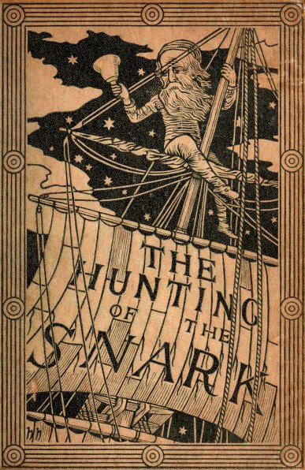

BY LEWIS CARROLL
AUTHOR OF “ALICE’S ADVENTURES IN WONDERLAND,”
AND “THROUGH THE LOOKING-GLASS.”

WITH NINE ILLUSTRATIONS
BY
HENRY HOLIDAY
LONDON
MACMILLAN AND CO.
1876.

[The Right of Translation and Reproduction is Reserved.]

LONDON:
R. CLAY, SONS, AND TAYLOR, PRINTERS,
BREAD STREET HILL.

Inscribed to a dear Child:
in memory of golden summer hours
and whispers of a summer sea.
Girt with a boyish garb for boyish task,
Eager she wields her spade: yet loves as well
Rest on a friendly knee, intent to ask
The tale he loves to tell.
Rude spirits of the seething outer strife,
Unmeet to read her pure and simple spright,
Deem, if you list, such hours a waste of life,
Empty of all delight!
Chat on, sweet Maid, and rescue from annoy
Hearts that by wiser talk are unbeguiled.
Ah, happy he who owns that tenderest joy,
The heart-love of a child!
Away, fond thoughts, and vex my soul no more!
Work claims my wakeful nights, my busy days—
Albeit bright memories of that sunlit shore
Yet haunt my dreaming gaze!

PREFACE.
If—and the thing is wildly possible—the charge of writing nonsense were ever brought against the author of this brief but instructive poem, it would be based, I feel convinced, on the line (in p. 18)
“Then the bowsprit got mixed with the rudder sometimes.”
In view of this painful possibility, I will not (as I might) appeal indignantly to my other writings as a proof that I am incapable of such a deed: I will not (as I might) point to the strong moral purpose of this poem itself, to the arithmetical principles so cautiously inculcated in it, or to its noble teachings in Natural History—I will take the more prosaic course of simply explaining how it happened.
The Bellman, who was almost morbidly sensitive about appearances, used to have the bowsprit unshipped once or twice a week to be revarnished, and it more than once happened, when the time came for replacing it, that no one on board could remember which end of the ship it belonged to. They knew it was not of the slightest use to appeal to the Bellman about it—he would only refer to his Naval Code, and read out in pathetic tones Admiralty Instructions which none of them had ever been able to understand—so it generally ended in its being fastened on, anyhow, across the rudder. The helmsman* used to stand by with tears in his eyes: he knew it was all wrong, but alas! Rule 42 of the Code, “No one shall speak to the Man at the Helm,” had been completed by the Bellman himself with the words “and the Man at the Helm shall speak to no one.” So remonstrance was impossible, and no steering could be done till the next varnishing day. During these bewildering intervals the ship usually sailed backwards.
As this poem is to some extent connected with the lay of the Jabberwock, let me take this opportunity of answering a question that has often been asked me, how to pronounce “slithy toves.” The “i” in “slithy” is long, as in “writhe”; and “toves” is pronounced so as to rhyme with “groves.” Again, the first “o” in “borogoves” is pronounced like the “o” in “borrow.” I have heard people try to give it the sound of the “o” in “worry.” Such is Human Perversity.
This also seems a fitting occasion to notice the other hard words in that poem. Humpty-Dumpty’s theory, of two meanings packed into one word like a portmanteau, seems to me the right explanation for all.
For instance, take the two words “fuming” and “furious.” Make up your mind that you will say both words, but leave it unsettled which you will say first. Now open your mouth and speak. If your thoughts incline ever so little towards “fuming,” you will say “fuming-furious;” if they turn, by even a hair’s breadth, towards “furious,” you will say “furious-fuming;” but if you have that rarest of gifts, a perfectly balanced mind, you will say “frumious.”
Supposing that, when Pistol uttered the well-known words—
“Under which king, Bezonian? Speak or die!”
Justice Shallow had felt certain that it was either William or Richard, but had not been able to settle which, so that he could not possibly say either name before the other, can it be doubted that, rather than die, he would have gasped out “Rilchiam!”
* This office was usually undertaken by the Boots, who found in it a refuge from the Baker’s constant complaints about the insufficient blacking of his three pair of boots.

FIT I.—THE LANDING.
fit the first
THE LANDING.
“Just the place for a Snark!” the Bellman cried,
As he landed his crew with care;
Supporting each man on the top of the tide
By a finger entwined in his hair.
“Just the place for a Snark! I have said it twice:
That alone should encourage the crew.
Just the place for a Snark! I have said it thrice:
What I tell you three times is true.”

The crew was complete: it included a Boots—
A maker of Bonnets and Hoods—
A Barrister, brought to arrange their disputes—
And a Broker, to value their goods.
A Billiard-marker, whose skill was immense,
Might perhaps have won more than his share—
But a Banker, engaged at enormous expense,
Had the whole of their cash in his care.
There was also a Beaver, that paced on the deck,
Or would sit making lace in the bow:
And had often (the Bellman said) saved them from wreck,
Though none of the sailors knew how.

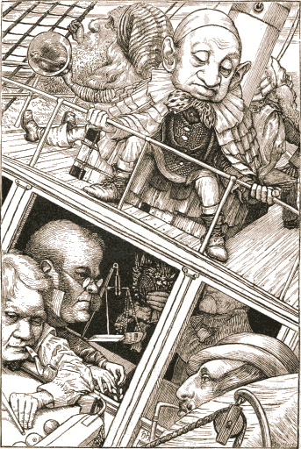

There was one who was famed for the number of things
He forgot when he entered the ship:
His umbrella, his watch, all his jewels and rings,
And the clothes he had bought for the trip.
He had forty-two boxes, all carefully packed,
With his name painted clearly on each:
But, since he omitted to mention the fact,
They were all left behind on the beach.
The loss of his clothes hardly mattered, because
He had seven coats on when he came,
With three pair of boots—but the worst of it was,
He had wholly forgotten his name.

He would answer to “Hi!” or to any loud cry,
Such as “Fry me!” or “Fritter my wig!”
To “What-you-may-call-um!” or “What-was-his-name!”
But especially “Thing-um-a-jig!”
While, for those who preferred a more forcible word,
He had different names from these:
His intimate friends called him “Candle-ends,”
And his enemies “Toasted-cheese.”
“His form is ungainly—his intellect small—”
(So the Bellman would often remark)
“But his courage is perfect! And that, after all,
Is the thing that one needs with a Snark.”

He would joke with hyænas, returning their stare
With an impudent wag of the head:
And he once went a walk, paw-in-paw, with a bear,
“Just to keep up its spirits,” he said.
He came as a Baker: but owned, when too late—
And it drove the poor Bellman half-mad—
He could only bake Bridecake—for which, I may state,
No materials were to be had.
The last of the crew needs especial remark,
Though he looked an incredible dunce:
He had just one idea—but, that one being “Snark,”
The good Bellman engaged him at once.

He came as a Butcher: but gravely declared,
When the ship had been sailing a week,
He could only kill Beavers. The Bellman looked scared,
And was almost too frightened to speak:
But at length he explained, in a tremulous tone,
There was only one Beaver on board;
And that was a tame one he had of his own,
Whose death would be deeply deplored.
The Beaver, who happened to hear the remark,
Protested, with tears in its eyes,
That not even the rapture of hunting the Snark
Could atone for that dismal surprise!

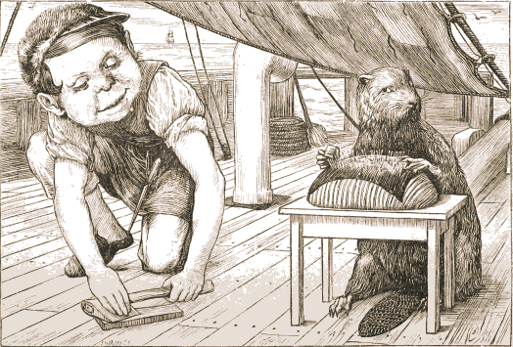

It strongly advised that the Butcher should be
Conveyed in a separate ship:
But the Bellman declared that would never agree
With the plans he had made for the trip:
Navigation was always a difficult art,
Though with only one ship and one bell:
And he feared he must really decline, for his part,
Undertaking another as well.
The Beaver’s best course was, no doubt, to procure
A second-hand dagger-proof coat—
So the Baker advised it—and next, to insure
Its life in some Office of note:

This the Banker suggested, and offered for hire
(On moderate terms), or for sale,
Two excellent Policies, one Against Fire,
And one Against Damage From Hail.
Yet still, ever after that sorrowful day,
Whenever the Butcher was by,
The Beaver kept looking the opposite way,
And appeared unaccountably shy.

FIT II.—THE BELLMAN’S SPEECH.

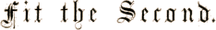
THE BELLMAN’S SPEECH.
The Bellman himself they all praised to the skies—
Such a carriage, such ease and such grace!
Such solemnity, too! One could see he was wise,
The moment one looked in his face!
He had bought a large map representing the sea,
Without the least vestige of land:
And the crew were much pleased when they found it to be
A map they could all understand.

“What’s the good of Mercator’s North Poles and Equators,
Tropics, Zones, and Meridian Lines?”
So the Bellman would cry: and the crew would reply
“They are merely conventional signs!
“Other maps are such shapes, with their islands and capes!
But we’ve got our brave Captain to thank”
(So the crew would protest) “that he’s bought us the best—
A perfect and absolute blank!”

This was charming, no doubt: but they shortly found out
That the Captain they trusted so well

Had only one notion for crossing the ocean,
And that was to tingle his bell.
He was thoughtful and grave—but the orders he gave
Were enough to bewilder a crew.
When he cried “Steer to starboard, but keep her head larboard!”
What on earth was the helmsman to do?
Then the bowsprit got mixed with the rudder sometimes:
A thing, as the Bellman remarked,
That frequently happens in tropical climes,
When a vessel is, so to speak, “snarked.”

But the principal failing occurred in the sailing,
And the Bellman, perplexed and distressed,
Said he had hoped, at least, when the wind blew due East,
That the ship would not travel due West!
But the danger was past—they had landed at last,
With their boxes, portmanteaus, and bags:
Yet at first sight the crew were not pleased with the view,
Which consisted of chasms and crags.
The Bellman perceived that their spirits were low,
And repeated in musical tone

Some jokes he had kept for a season of woe—
But the crew would do nothing but groan.
He served out some grog with a liberal hand,
And bade them sit down on the beach:
And they could not but own that their Captain looked grand,
As he stood and delivered his speech.
“Friends, Romans, and countrymen, lend me your ears!”
(They were all of them fond of quotations:
So they drank to his health, and they gave him three cheers,
While he served out additional rations).

“We have sailed many months, we have sailed many weeks,
(Four weeks to the month you may mark),
But never as yet (’tis your Captain who speaks)
Have we caught the least glimpse of a Snark!
“We have sailed many weeks, we have sailed many days,
(Seven days to the week I allow),
But a Snark, on the which we might lovingly gaze,
We have never beheld till now!
“Come, listen, my men, while I tell you again
The five unmistakable marks

By which you may know, wheresoever you go,
The warranted genuine Snarks.
“Let us take them in order. The first is the taste,
Which is meagre and hollow, but crisp:
Like a coat that is rather too tight in the waist,
With a flavour of Will-o-the-wisp.
“Its habit of getting up late you’ll agree
That it carries too far, when I say
That it frequently breakfasts at five-o’clock tea,
And dines on the following day.
“The third is its slowness in taking a jest.
Should you happen to venture on one,

It will sigh like a thing that is deeply distressed:
And it always looks grave at a pun.
“The fourth is its fondness for bathing-machines,
Which it constantly carries about,
And believes that they add to the beauty of scenes—
A sentiment open to doubt.
“The fifth is ambition. It next will be right
To describe each particular batch:
Distinguishing those that have feathers, and bite,
From those that have whiskers, and scratch.

“For, although common Snarks do no manner of harm,
Yet, I feel it my duty to say,
Some are Boojums—” The Bellman broke off in alarm,
For the Baker had fainted away.

FIT III.—THE BAKER’S TALE.

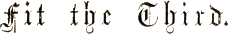
THE BAKER’S TALE.
They roused him with muffins—they roused him with ice—
They roused him with mustard and cress—
They roused him with jam and judicious advice—
They set him conundrums to guess.
When at length he sat up and was able to speak,
His sad story he offered to tell;
And the Bellman cried “Silence! Not even a shriek!”
And excitedly tingled his bell.

There was silence supreme! Not a shriek, not a scream,
Scarcely even a howl or a groan,
As the man they called “Ho!” told his story of woe
In an antediluvian tone.
“My father and mother were honest, though poor—”
“Skip all that!” cried the Bellman in haste.
“If it once becomes dark, there’s no chance of a Snark—
We have hardly a minute to waste!”
“I skip forty years,” said the Baker, in tears,
“And proceed without further remark

To the day when you took me aboard of your ship
To help you in hunting the Snark.
“A dear uncle of mine (after whom I was named)
Remarked, when I bade him farewell—”
“Oh, skip your dear uncle!” the Bellman exclaimed,
As he angrily tingled his bell.
“He remarked to me then,” said that mildest of men,
“‘If your Snark be a Snark, that is right:
Fetch it home by all means—you may serve it with greens,
And it’s handy for striking a light.

“‘You may seek it with thimbles—and seek it with care;
You may hunt it with forks and hope;
You may threaten its life with a railway-share;
You may charm it with smiles and soap—’”
(“That’s exactly the method,” the Bellman bold
In a hasty parenthesis cried,
“That’s exactly the way I have always been told
That the capture of Snarks should be tried!”)
“’But oh, beamish nephew, beware of the day,
If your Snark be a Boojum! For then
You will softly and suddenly vanish away,
And never be met with again!’

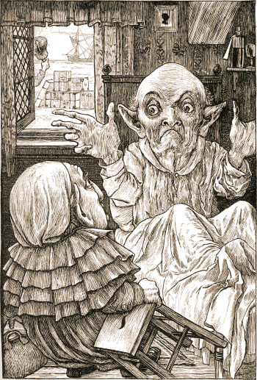

“It is this, it is this that oppresses my soul,
When I think of my uncle’s last words:
And my heart is like nothing so much as a bowl
Brimming over with quivering curds!
“It is this, it is this—” “We have had that before!”
The Bellman indignantly said.
And the Baker replied “Let me say it once more.
It is this, it is this that I dread!
“I engage with the Snark—every night after dark—
In a dreamy delirious fight:

I serve it with greens in those shadowy scenes,
And I use it for striking a light:
“But if ever I meet with a Boojum, that day,
In a moment (of this I am sure),
I shall softly and suddenly vanish away—
And the notion I cannot endure!”

FIT IV.—THE HUNTING.

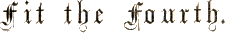
THE HUNTING.
The Bellman looked uffish, and wrinkled his brow.
“If only you’d spoken before!
It’s excessively awkward to mention it now,
With the Snark, so to speak, at the door!
“We should all of us grieve, as you well may believe,
If you never were met with again—
But surely, my man, when the voyage began,
You might have suggested it then?

“It’s excessively awkward to mention it now—
As I think I’ve already remarked.”
And the man they called “Hi!” replied, with a sigh,
“I informed you the day we embarked.
“You may charge me with murder—or want of sense—
(We are all of us weak at times):
But the slightest approach to a false pretence
Was never among my crimes!
“I said it in Hebrew—I said it in Dutch—
I said it in German and Greek:

But I wholly forgot (and it vexes me much)
That English is what you speak!”
“’Tis a pitiful tale,” said the Bellman, whose face
Had grown longer at every word:
“But, now that you’ve stated the whole of your case,
More debate would be simply absurd.
“The rest of my speech” (he explained to his men)
“You shall hear when I’ve leisure to speak it.
But the Snark is at hand, let me tell you again!
’Tis your glorious duty to seek it!

“To seek it with thimbles, to seek it with care;
To pursue it with forks and hope;
To threaten its life with a railway-share;
To charm it with smiles and soap!
“For the Snark’s a peculiar creature, that won’t
Be caught in a commonplace way.
Do all that you know, and try all that you don’t:
Not a chance must be wasted to-day!
“For England expects—I forbear to proceed:
’Tis a maxim tremendous, but trite:
And you’d best be unpacking the things that you need
To rig yourselves out for the fight.”

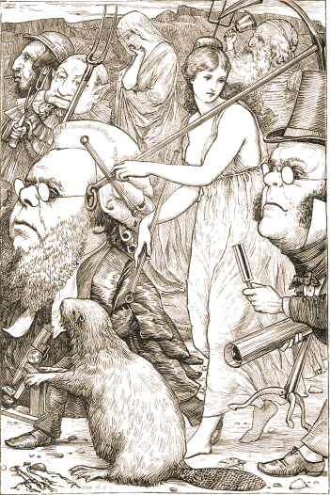

Then the Banker endorsed a blank cheque (which he crossed),
And changed his loose silver for notes.
The Baker with care combed his whiskers and hair,
And shook the dust out of his coats.
The Boots and the Broker were sharpening a spade—
Each working the grindstone in turn:
But the Beaver went on making lace, and displayed
No interest in the concern:
Though the Barrister tried to appeal to its pride,
And vainly proceeded to cite

A number of cases, in which making laces
Had been proved an infringement of right.
The maker of Bonnets ferociously planned
A novel arrangement of bows:
While the Billiard-marker with quivering hand
Was chalking the tip of his nose.
But the Butcher turned nervous, and dressed himself fine,
With yellow kid gloves and a ruff—
Said he felt it exactly like going to dine,
Which the Bellman declared was all “stuff.”
“Introduce me, now there’s a good fellow,” he said,
“If we happen to meet it together!”

And the Bellman, sagaciously nodding his head,
Said “That must depend on the weather.”
The Beaver went simply galumphing about,
At seeing the Butcher so shy:
And even the Baker, though stupid and stout,
Made an effort to wink with one eye.
“Be a man!” said the Bellman in wrath, as he heard
The Butcher beginning to sob.
“Should we meet with a Jubjub, that desperate bird,
We shall need all our strength for the job!”

FIT V.—THE BEAVER’S LESSON.

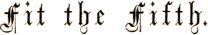
THE BEAVER’S LESSON.
They sought it with thimbles, they sought it with care;
They pursued it with forks and hope;
They threatened its life with a railway-share;
They charmed it with smiles and soap.
Then the Butcher contrived an ingenious plan
For making a separate sally;
And had fixed on a spot unfrequented by man,
A dismal and desolate valley.

But the very same plan to the Beaver occurred:
It had chosen the very same place:
Yet neither betrayed, by a sign or a word,
The disgust that appeared in his face.
Each thought he was thinking of nothing but “Snark”
And the glorious work of the day;
And each tried to pretend that he did not remark
That the other was going that way.
But the valley grew narrow and narrower still,
And the evening got darker and colder,
Till (merely from nervousness, not from goodwill)
They marched along shoulder to shoulder.

Then a scream, shrill and high, rent the shuddering sky,
And they knew that some danger was near:
The Beaver turned pale to the tip of its tail,
And even the Butcher felt queer.
He thought of his childhood, left far far behind—
That blissful and innocent state—
The sound so exactly recalled to his mind
A pencil that squeaks on a slate!
“’Tis the voice of the Jubjub!” he suddenly cried.
(This man, that they used to call “Dunce.”)
“As the Bellman would tell you,” he added with pride,
“I have uttered that sentiment once.

“’Tis the note of the Jubjub! Keep count, I entreat;
You will find I have told it you twice.
’Tis the song of the Jubjub! The proof is complete,
If only I’ve stated it thrice.”
The Beaver had counted with scrupulous care,
Attending to every word:
But it fairly lost heart, and outgrabe in despair,
When the third repetition occurred.
It felt that, in spite of all possible pains,
It had somehow contrived to lose count,

And the only thing now was to rack its poor brains
By reckoning up the amount.
“Two added to one—if that could but be done,”
It said, “with one’s fingers and thumbs!”
Recollecting with tears how, in earlier years,
It had taken no pains with its sums.
“The thing can be done,” said the Butcher, “I think.
The thing must be done, I am sure.
The thing shall be done! Bring me paper and ink,
The best there is time to procure.”

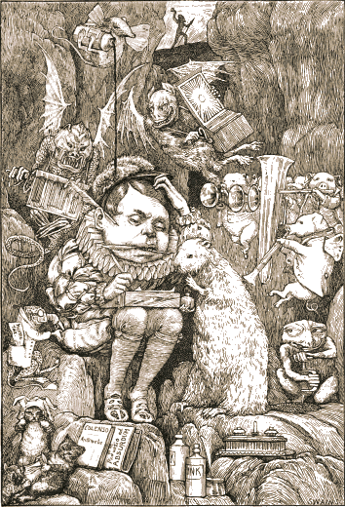

The Beaver brought paper, portfolio, pens,
And ink in unfailing supplies:
While strange creepy creatures came out of their dens,
And watched them with wondering eyes.
So engrossed was the Butcher, he heeded them not,
As he wrote with a pen in each hand,
And explained all the while in a popular style
Which the Beaver could well understand.
“Taking Three as the subject to reason about—
A convenient number to state—
We add Seven, and Ten, and then multiply out
By One Thousand diminished by Eight.

“The result we proceed to divide, as you see,
By Nine Hundred and Ninety and Two:
Then subtract Seventeen, and the answer must be
Exactly and perfectly true.
“The method employed I would gladly explain,
While I have it so clear in my head,
If I had but the time and you had but the brain—
But much yet remains to be said.
“In one moment I’ve seen what has hitherto been
Enveloped in absolute mystery,
And without extra charge I will give you at large
A Lesson in Natural History.”

In his genial way he proceeded to say
(Forgetting all laws of propriety,
And that giving instruction, without introduction,
Would have caused quite a thrill in Society),
“As to temper the Jubjub’s a desperate bird,
Since it lives in perpetual passion:
Its taste in costume is entirely absurd—
It is ages ahead of the fashion:
“But it knows any friend it has met once before:
It never will look at a bribe:
And in charity-meetings it stands at the door,
And collects—though it does not subscribe.

“Its flavour when cooked is more exquisite far
Than mutton, or oysters, or eggs:
(Some think it keeps best in an ivory jar,
And some, in mahogany kegs:)
“You boil it in sawdust: you salt it in glue:
You condense it with locusts and tape:
Still keeping one principal object in view—
To preserve its symmetrical shape.”
The Butcher would gladly have talked till next day,
But he felt that the Lesson must end,
And he wept with delight in attempting to say
He considered the Beaver his friend.

While the Beaver confessed, with affectionate looks
More eloquent even than tears,
It had learned in ten minutes far more than all books
Would have taught it in seventy years.
They returned hand-in-hand, and the Bellman, unmanned
(For a moment) with noble emotion,
Said “This amply repays all the wearisome days
We have spent on the billowy ocean!”
Such friends, as the Beaver and Butcher became,
Have seldom if ever been known;

In winter or summer, ’twas always the same—
You could never meet either alone.
And when quarrels arose—as one frequently finds
Quarrels will, spite of every endeavour—
The song of the Jubjub recurred to their minds,
And cemented their friendship for ever!

FIT VI.—THE BARRISTER’S DREAM.

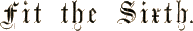
THE BARRISTER’S DREAM.
They sought it with thimbles, they sought it with care;
They pursued it with forks and hope;
They threatened its life with a railway-share;
They charmed it with smiles and soap.
But the Barrister, weary of proving in vain
That the Beaver’s lace-making was wrong,
Fell asleep, and in dreams saw the creature quite plain
That his fancy had dwelt on so long.

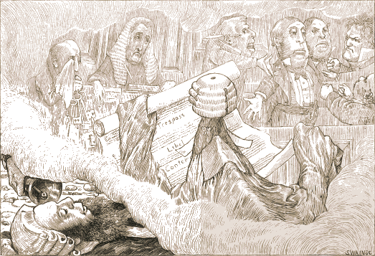

He dreamed that he stood in a shadowy Court,
Where the Snark, with a glass in its eye,
Dressed in gown, bands, and wig, was defending a pig
On the charge of deserting its sty.
The Witnesses proved, without error or flaw,
That the sty was deserted when found:
And the Judge kept explaining the state of the law
In a soft under-current of sound.
The indictment had never been clearly expressed,
And it seemed that the Snark had begun,
And had spoken three hours, before any one guessed
What the pig was supposed to have done.

The Jury had each formed a different view
(Long before the indictment was read),
And they all spoke at once, so that none of them knew
One word that the others had said.
“You must know—” said the Judge: but the Snark exclaimed “Fudge!
That statute is obsolete quite!
Let me tell you, my friends, the whole question depends
On an ancient manorial right.
“In the matter of Treason the pig would appear
To have aided, but scarcely abetted:

While the charge of Insolvency fails, it is clear,
If you grant the plea ‘never indebted.’
“The fact of Desertion I will not dispute:
But its guilt, as I trust, is removed
(So far as relates to the costs of this suit)
By the Alibi which has been proved.
“My poor client’s fate now depends on your votes.”
Here the speaker sat down in his place,
And directed the Judge to refer to his notes
And briefly to sum up the case.
But the Judge said he never had summed up before;
So the Snark undertook it instead,

And summed it so well that it came to far more
Than the Witnesses ever had said!
When the verdict was called for, the Jury declined,
As the word was so puzzling to spell;
But they ventured to hope that the Snark wouldn’t mind
Undertaking that duty as well.
So the Snark found the verdict, although, as it owned,
It was spent with the toils of the day:
When it said the word “GUILTY!” the Jury all groaned,
And some of them fainted away.

Then the Snark pronounced sentence, the Judge being quite
Too nervous to utter a word:
When it rose to its feet, there was silence like night,
And the fall of a pin might be heard.
“Transportation for life” was the sentence it gave,
“And then to be fined forty pound.”
The Jury all cheered, though the Judge said he feared
That the phrase was not legally sound.
But their wild exultation was suddenly checked
When the jailer informed them, with tears,
Such a sentence would have not the slightest effect,
As the pig had been dead for some years.

The Judge left the Court, looking deeply disgusted:
But the Snark, though a little aghast,
As the lawyer to whom the defence was intrusted,
Went bellowing on to the last.
Thus the Barrister dreamed, while the bellowing seemed
To grow every moment more clear:
Till he woke to the knell of a furious bell,
Which the Bellman rang close at his ear.

FIT VII.—THE BANKER’S FATE.

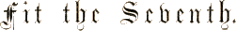
THE BANKER’S FATE.
They sought it with thimbles, they sought it with care;
They pursued it with forks and hope;
They threatened its life with a railway-share;
They charmed it with smiles and soap.
And the Banker, inspired with a courage so new
It was matter for general remark,
Rushed madly ahead and was lost to their view
In his zeal to discover the Snark.

But while he was seeking with thimbles and care,
A Bandersnatch swiftly drew nigh
And grabbed at the Banker, who shrieked in despair,
For he knew it was useless to fly.
He offered large discount—he offered a cheque
(Drawn “to bearer”) for seven-pounds-ten:
But the Bandersnatch merely extended its neck
And grabbed at the Banker again.
Without rest or pause—while those frumious jaws
Went savagely snapping around—
He skipped and he hopped, and he floundered and flopped,
Till fainting he fell to the ground.

The Bandersnatch fled as the others appeared
Led on by that fear-stricken yell:
And the Bellman remarked “It is just as I feared!”
And solemnly tolled on his bell.
He was black in the face, and they scarcely could trace
The least likeness to what he had been:
While so great was his fright that his waistcoat turned white—
A wonderful thing to be seen!
To the horror of all who were present that day.
He uprose in full evening dress,
And with senseless grimaces endeavoured to say
What his tongue could no longer express.

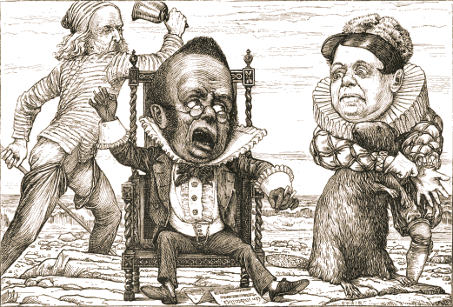

Down he sank in a chair—ran his hands through his hair—
And chanted in mimsiest tones
Words whose utter inanity proved his insanity,
While he rattled a couple of bones.
“Leave him here to his fate—it is getting so late!”
The Bellman exclaimed in a fright.
“We have lost half the day. Any further delay,
And we sha’n’t catch a Snark before night!”

FIT VIII.—THE VANISHING.

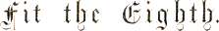
THE VANISHING.
They sought it with thimbles, they sought it with care;
They pursued it with forks and hope;
They threatened its life with a railway-share;
They charmed it with smiles and soap.
They shuddered to think that the chase might fail,
And the Beaver, excited at last,
Went bounding along on the tip of its tail,
For the daylight was nearly past.

“There is Thingumbob shouting!” the Bellman said.
“He is shouting like mad, only hark!
He is waving his hands, he is wagging his head,
He has certainly found a Snark!”
They gazed in delight, while the Butcher exclaimed
“He was always a desperate wag!”
They beheld him—their Baker—their hero unnamed—
On the top of a neighbouring crag,
Erect and sublime, for one moment of time.
In the next, that wild figure they saw

(As if stung by a spasm) plunge into a chasm,
While they waited and listened in awe.
“It’s a Snark!” was the sound that first came to their ears,
And seemed almost too good to be true.
Then followed a torrent of laughter and cheers:
Then the ominous words “It’s a Boo–”
Then, silence. Some fancied they heard in the air
A weary and wandering sigh
That sounded like “–jum!” but the others declare
It was only a breeze that went by.

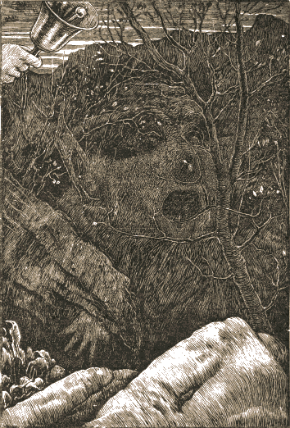

They hunted till darkness came on, but they found
Not a button, or feather, or mark,
By which they could tell that they stood on the ground
Where the Baker had met with the Snark.
In the midst of the word he was trying to say,
In the midst of his laughter and glee,
He had softly and suddenly vanished away—
For the Snark was a Boojum, you see.

THE END.

LONDON:
R. CLAY, SONS, AND TAYLOR, PRINTERS,
BREAD STREET HILL.

[TURN OVER.

WORKS BY LEWIS CARROLL.

Forty-ninth Thousand.
ALICE’S ADVENTURES IN WONDERLAND. With Forty-two Illustrations by Tenniel. Crown 8vo. cloth, gilt edges, price 6s.
“An excellent piece of nonsense.” —Times.
“That most delightful of children’s stories.” —Saturday Review.
“Elegant and delicious nonsense.” —Guardian.
GERMAN, FRENCH, AND ITALIAN TRANSLATIONS of the same, with Tenniel’s Illustrations. Crown 8vo. cloth, gilt edges, price 6s. each.
The Spectator in speaking of the German and French translations says: “On the whole, the turn of the original has been followed with surprising fidelity, and it is curious to see what slight verbal alterations have often sufficed to preserve the humour of the English.”
Thirty-eighth Thousand.
THROUGH THE LOOKING-GLASS, AND WHAT ALICE FOUND THERE. With Fifty Illustrations by Tenniel. Crown 8vo. cloth, gilt edges, 6s.
“Will fairly rank with the tale of her previous experiences.” —Daily Telegraph.
“Many of Mr. Tenniel’s designs are masterpieces of wise absurdity.” —Athenæum.
“Whether as regarding author or illustrator, this book is a jewel rarely to be found now a days.” —Echo.
“Not a whit inferior to its predecessor in grand extravagance of imagination, and delicious allegorical nonsense.” —British Quarterly Review.

MACMILLAN & CO., LONDON

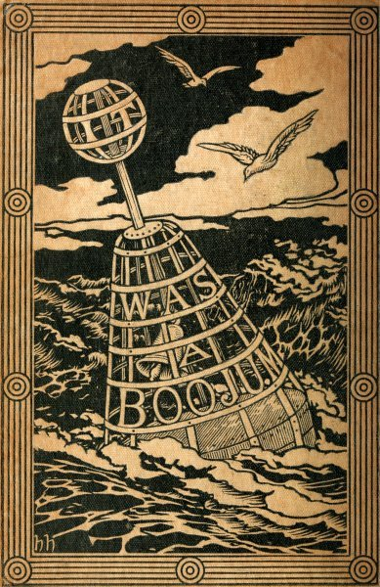

*** END OF THIS PROJECT GUTENBERG EBOOK ***
Updated editions will replace the previous one—the old editions will be renamed.
Creating the works from print editions not protected by U.S. copyright law means that no one owns a United States copyright in these works, so the Foundation (and you!) can copy and distribute it in the United States without permission and without paying copyright royalties. Special rules, set forth in the General Terms of Use part of this license, apply to copying and distributing Project Gutenberg™ electronic works to protect the PROJECT GUTENBERG™ concept and trademark. Project Gutenberg is a registered trademark, and may not be used if you charge for an eBook, except by following the terms of the trademark license, including paying royalties for use of the Project Gutenberg trademark. If you do not charge anything for copies of this eBook, complying with the trademark license is very easy. You may use this eBook for nearly any purpose such as creation of derivative works, reports, performances and research. Project Gutenberg eBooks may be modified and printed and given away—you may do practically ANYTHING in the United States with eBooks not protected by U.S. copyright law. Redistribution is subject to the trademark license, especially commercial redistribution.
START: FULL LICENSE

THE FULL PROJECT GUTENBERG LICENSE
PLEASE READ THIS BEFORE YOU DISTRIBUTE OR USE THIS WORK
To protect the Project Gutenberg™ mission of promoting the free distribution of electronic works, by using or distributing this work (or any other work associated in any way with the phrase “Project Gutenberg”), you agree to comply with all the terms of the Full Project Gutenberg™ License available with this file or online at www.gutenberg.org/license.
Section 1. General Terms of Use and Redistributing Project Gutenberg™ electronic works
1.A. By reading or using any part of this Project Gutenberg™ electronic work, you indicate that you have read, understand, agree to and accept all the terms of this license and intellectual property (trademark/copyright) agreement. If you do not agree to abide by all the terms of this agreement, you must cease using and return or destroy all copies of Project Gutenberg™ electronic works in your possession. If you paid a fee for obtaining a copy of or access to a Project Gutenberg™ electronic work and you do not agree to be bound by the terms of this agreement, you may obtain a refund from the person or entity to whom you paid the fee as set forth in paragraph 1.E.8.
1.B. “Project Gutenberg” is a registered trademark. It may only be used on or associated in any way with an electronic work by people who agree to be bound by the terms of this agreement. There are a few things that you can do with most Project Gutenberg™ electronic works even without complying with the full terms of this agreement. See paragraph 1.C below. There are a lot of things you can do with Project Gutenberg™ electronic works if you follow the terms of this agreement and help preserve free future access to Project Gutenberg™ electronic works. See paragraph 1.E below.
1.C. The Project Gutenberg Literary Archive Foundation (“the Foundation” or PGLAF), owns a compilation copyright in the collection of Project Gutenberg™ electronic works. Nearly all the individual works in the collection are in the public domain in the United States. If an individual work is unprotected by copyright law in the United States and you are located in the United States, we do not claim a right to prevent you from copying, distributing, performing, displaying or creating derivative works based on the work as long as all references to Project Gutenberg are removed. Of course, we hope that you will support the Project Gutenberg™ mission of promoting free access to electronic works by freely sharing Project Gutenberg™ works in compliance with the terms of this agreement for keeping the Project Gutenberg™ name associated with the work. You can easily comply with the terms of this agreement by keeping this work in the same format with its attached full Project Gutenberg™ License when you share it without charge with others.
1.D. The copyright laws of the place where you are located also govern what you can do with this work. Copyright laws in most countries are in a constant state of change. If you are outside the United States, check the laws of your country in addition to the terms of this agreement before downloading, copying, displaying, performing, distributing or creating derivative works based on this work or any other Project Gutenberg™ work. The Foundation makes no representations concerning the copyright status of any work in any country other than the United States.
1.E. Unless you have removed all references to Project Gutenberg:
1.E.1. The following sentence, with active links to, or other immediate access to, the full Project Gutenberg™ License must appear prominently whenever any copy of a Project Gutenberg™ work (any work on which the phrase “Project Gutenberg” appears, or with which the phrase “Project Gutenberg” is associated) is accessed, displayed, performed, viewed, copied or distributed:
This eBook is for the use of anyone anywhere in the United States and most other parts of the world at no cost and with almost no restrictions whatsoever. You may copy it, give it away or re-use it under the terms of the Project Gutenberg License included with this eBook or online at www.gutenberg.org. If you are not located in the United States, you will have to check the laws of the country where you are located before using this eBook.
1.E.2. If an individual Project Gutenberg™ electronic work is derived from texts not protected by U.S. copyright law (does not contain a notice indicating that it is posted with permission of the copyright holder), the work can be copied and distributed to anyone in the United States without paying any fees or charges. If you are redistributing or providing access to a work with the phrase “Project Gutenberg” associated with or appearing on the work, you must comply either with the requirements of paragraphs 1.E.1 through 1.E.7 or obtain permission for the use of the work and the Project Gutenberg™ trademark as set forth in paragraphs 1.E.8 or 1.E.9.
1.E.3. If an individual Project Gutenberg™ electronic work is posted with the permission of the copyright holder, your use and distribution must comply with both paragraphs 1.E.1 through 1.E.7 and any additional terms imposed by the copyright holder. Additional terms will be linked to the Project Gutenberg™ License for all works posted with the permission of the copyright holder found at the beginning of this work.
1.E.4. Do not unlink or detach or remove the full Project Gutenberg™ License terms from this work, or any files containing a part of this work or any other work associated with Project Gutenberg™.
1.E.5. Do not copy, display, perform, distribute or redistribute this electronic work, or any part of this electronic work, without prominently displaying the sentence set forth in paragraph 1.E.1 with active links or immediate access to the full terms of the Project Gutenberg™ License.
1.E.6. You may convert to and distribute this work in any binary, compressed, marked up, nonproprietary or proprietary form, including any word processing or hypertext form. However, if you provide access to or distribute copies of a Project Gutenberg™ work in a format other than “Plain Vanilla ASCII” or other format used in the official version posted on the official Project Gutenberg™ website (www.gutenberg.org), you must, at no additional cost, fee or expense to the user, provide a copy, a means of exporting a copy, or a means of obtaining a copy upon request, of the work in its original “Plain Vanilla ASCII” or other form. Any alternate format must include the full Project Gutenberg™ License as specified in paragraph 1.E.1.
1.E.7. Do not charge a fee for access to, viewing, displaying, performing, copying or distributing any Project Gutenberg™ works unless you comply with paragraph 1.E.8 or 1.E.9.
1.E.8. You may charge a reasonable fee for copies of or providing access to or distributing Project Gutenberg™ electronic works provided that:
• You pay a royalty fee of 20% of the gross profits you derive from the use of Project Gutenberg™ works calculated using the method you already use to calculate your applicable taxes. The fee is owed to the owner of the Project Gutenberg™ trademark, but he has agreed to donate royalties under this paragraph to the Project Gutenberg Literary Archive Foundation. Royalty payments must be paid within 60 days following each date on which you prepare (or are legally required to prepare) your periodic tax returns. Royalty payments should be clearly marked as such and sent to the Project Gutenberg Literary Archive Foundation at the address specified in Section 4, “Information about donations to the Project Gutenberg Literary Archive Foundation.”
• You provide a full refund of any money paid by a user who notifies you in writing (or by e-mail) within 30 days of receipt that s/he does not agree to the terms of the full Project Gutenberg™ License. You must require such a user to return or destroy all copies of the works possessed in a physical medium and discontinue all use of and all access to other copies of Project Gutenberg™ works.
• You provide, in accordance with paragraph 1.F.3, a full refund of any money paid for a work or a replacement copy, if a defect in the electronic work is discovered and reported to you within 90 days of receipt of the work.
• You comply with all other terms of this agreement for free distribution of Project Gutenberg™ works.
1.E.9. If you wish to charge a fee or distribute a Project Gutenberg™ electronic work or group of works on different terms than are set forth in this agreement, you must obtain permission in writing from the Project Gutenberg Literary Archive Foundation, the manager of the Project Gutenberg™ trademark. Contact the Foundation as set forth in Section 3 below.
1.F.
1.F.1. Project Gutenberg volunteers and employees expend considerable effort to identify, do copyright research on, transcribe and proofread works not protected by U.S. copyright law in creating the Project Gutenberg™ collection. Despite these efforts, Project Gutenberg™ electronic works, and the medium on which they may be stored, may contain “Defects,” such as, but not limited to, incomplete, inaccurate or corrupt data, transcription errors, a copyright or other intellectual property infringement, a defective or damaged disk or other medium, a computer virus, or computer codes that damage or cannot be read by your equipment.
1.F.2. LIMITED WARRANTY, DISCLAIMER OF DAMAGES - Except for the “Right of Replacement or Refund” described in paragraph 1.F.3, the Project Gutenberg Literary Archive Foundation, the owner of the Project Gutenberg™ trademark, and any other party distributing a Project Gutenberg™ electronic work under this agreement, disclaim all liability to you for damages, costs and expenses, including legal fees. YOU AGREE THAT YOU HAVE NO REMEDIES FOR NEGLIGENCE, STRICT LIABILITY, BREACH OF WARRANTY OR BREACH OF CONTRACT EXCEPT THOSE PROVIDED IN PARAGRAPH 1.F.3. YOU AGREE THAT THE FOUNDATION, THE TRADEMARK OWNER, AND ANY DISTRIBUTOR UNDER THIS AGREEMENT WILL NOT BE LIABLE TO YOU FOR ACTUAL, DIRECT, INDIRECT, CONSEQUENTIAL, PUNITIVE OR INCIDENTAL DAMAGES EVEN IF YOU GIVE NOTICE OF THE POSSIBILITY OF SUCH DAMAGE.
1.F.3. LIMITED RIGHT OF REPLACEMENT OR REFUND - If you discover a defect in this electronic work within 90 days of receiving it, you can receive a refund of the money (if any) you paid for it by sending a written explanation to the person you received the work from. If you received the work on a physical medium, you must return the medium with your written explanation. The person or entity that provided you with the defective work may elect to provide a replacement copy in lieu of a refund. If you received the work electronically, the person or entity providing it to you may choose to give you a second opportunity to receive the work electronically in lieu of a refund. If the second copy is also defective, you may demand a refund in writing without further opportunities to fix the problem.
1.F.4. Except for the limited right of replacement or refund set forth in paragraph 1.F.3, this work is provided to you ‘AS-IS’, WITH NO OTHER WARRANTIES OF ANY KIND, EXPRESS OR IMPLIED, INCLUDING BUT NOT LIMITED TO WARRANTIES OF MERCHANTABILITY OR FITNESS FOR ANY PURPOSE.
1.F.5. Some states do not allow disclaimers of certain implied warranties or the exclusion or limitation of certain types of damages. If any disclaimer or limitation set forth in this agreement violates the law of the state applicable to this agreement, the agreement shall be interpreted to make the maximum disclaimer or limitation permitted by the applicable state law. The invalidity or unenforceability of any provision of this agreement shall not void the remaining provisions.
1.F.6. INDEMNITY - You agree to indemnify and hold the Foundation, the trademark owner, any agent or employee of the Foundation, anyone providing copies of Project Gutenberg™ electronic works in accordance with this agreement, and any volunteers associated with the production, promotion and distribution of Project Gutenberg™ electronic works, harmless from all liability, costs and expenses, including legal fees, that arise directly or indirectly from any of the following which you do or cause to occur: (a) distribution of this or any Project Gutenberg™ work, (b) alteration, modification, or additions or deletions to any Project Gutenberg™ work, and (c) any Defect you cause.
Section 2. Information about the Mission of Project Gutenberg™
Project Gutenberg™ is synonymous with the free distribution of electronic works in formats readable by the widest variety of computers including obsolete, old, middle-aged and new computers. It exists because of the efforts of hundreds of volunteers and donations from people in all walks of life.
Volunteers and financial support to provide volunteers with the assistance they need are critical to reaching Project Gutenberg™’s goals and ensuring that the Project Gutenberg™ collection will remain freely available for generations to come. In 2001, the Project Gutenberg Literary Archive Foundation was created to provide a secure and permanent future for Project Gutenberg™ and future generations. To learn more about the Project Gutenberg Literary Archive Foundation and how your efforts and donations can help, see Sections 3 and 4 and the Foundation information page at www.gutenberg.org.
Section 3. Information about the Project Gutenberg Literary Archive Foundation
The Project Gutenberg Literary Archive Foundation is a non-profit 501(c)(3) educational corporation organized under the laws of the state of Mississippi and granted tax exempt status by the Internal Revenue Service. The Foundation’s EIN or federal tax identification number is 64-6221541. Contributions to the Project Gutenberg Literary Archive Foundation are tax deductible to the full extent permitted by U.S. federal laws and your state’s laws.
The Foundation’s business office is located at 809 North 1500 West, Salt Lake City, UT 84116, (801) 596-1887. Email contact links and up to date contact information can be found at the Foundation’s website and official page at www.gutenberg.org/contact
Section 4. Information about Donations to the Project Gutenberg Literary Archive Foundation
Project Gutenberg™ depends upon and cannot survive without widespread public support and donations to carry out its mission of increasing the number of public domain and licensed works that can be freely distributed in machine-readable form accessible by the widest array of equipment including outdated equipment. Many small donations ($1 to $5,000) are particularly important to maintaining tax exempt status with the IRS.
The Foundation is committed to complying with the laws regulating charities and charitable donations in all 50 states of the United States. Compliance requirements are not uniform and it takes a considerable effort, much paperwork and many fees to meet and keep up with these requirements. We do not solicit donations in locations where we have not received written confirmation of compliance. To SEND DONATIONS or determine the status of compliance for any particular state visit www.gutenberg.org/donate.
While we cannot and do not solicit contributions from states where we have not met the solicitation requirements, we know of no prohibition against accepting unsolicited donations from donors in such states who approach us with offers to donate.
International donations are gratefully accepted, but we cannot make any statements concerning tax treatment of donations received from outside the United States. U.S. laws alone swamp our small staff.
Please check the Project Gutenberg web pages for current donation methods and addresses. Donations are accepted in a number of other ways including checks, online payments and credit card donations. To donate, please visit: www.gutenberg.org/donate
Section 5. General Information About Project Gutenberg™ electronic works
Professor Michael S. Hart was the originator of the Project Gutenberg™ concept of a library of electronic works that could be freely shared with anyone. For forty years, he produced and distributed Project Gutenberg™ eBooks with only a loose network of volunteer support.
Project Gutenberg™ eBooks are often created from several printed editions, all of which are confirmed as not protected by copyright in the U.S. unless a copyright notice is included. Thus, we do not necessarily keep eBooks in compliance with any particular paper edition.
Most people start at our website which has the main PG search facility: www.gutenberg.org.
This website includes information about Project Gutenberg™, including how to make donations to the Project Gutenberg Literary Archive Foundation, how to help produce our new eBooks, and how to subscribe to our email newsletter to hear about new eBooks.

