Three Sunsets and Other Poems
Lewis Carroll
2011-03-06

The Project Gutenberg eBook of Three Sunsets and Other Poems, by Lewis Carroll
This ebook is for the use of anyone anywhere in the United States and most other parts of the world at no cost and with almost no restrictions whatsoever. You may copy it, give it away or re-use it under the terms of the Project Gutenberg License included with this ebook or online at https://www.gutenberg.org/license. If you are not located in the United States, you’ll have to check the laws of the country where you are located before using this eBook.
Title: Three Sunsets and Other Poems
Author: Lewis Carroll
Release Date: March 6, 2011 [EBook #35497]
Language: English
Credits: Produced by The Online Distributed Proofreading Team at http://www.pgdp.net (This file was produced from images generously made available by The Internet Archive.)

*** START OF THIS PROJECT GUTENBERG EBOOK ***

Three Sunsets And Other Poems

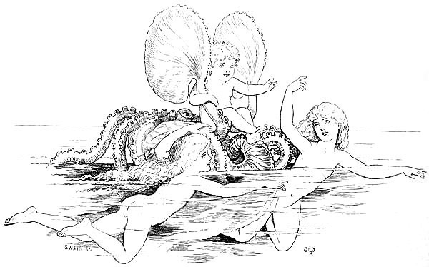

THREE SUNSETS
AND OTHER POEMS

BY
LEWIS CARROLL

WITH TWELVE FAIRY-FANCIES
BY
E. GERTRUDE THOMSON

PRICE FOUR SHILLINGS NET
LONDON
MACMILLAN AND CO., Limited
NEW YORK: THE MACMILLAN COMPANY
1898
All Rights Reserved

Richard Clay and Sons, Limited,
LONDON AND BUNGAY.

Preface
Nearly the whole of this volume is a reprint of the serious portion of Phantasmagoria and other Poems, which was first published in 1869 and has long been out of print. “The Path of Roses” was written soon after the Crimean War, when the name of Florence Nightingale had already become a household-word. “Only a Woman’s Hair” was suggested by a circumstance mentioned in The Life of Dean Swift, viz., that, after his death, a small packet was found among his papers, containing a single lock of hair and inscribed with those words. “After Three Days” was written after seeing Holman Hunt’s picture, The Finding of Christ in the Temple.
The two poems, “Far Away” and “A Song of Love”, are reprinted from Sylvie and Bruno and Sylvie and Bruno Concluded, books whose high price (made necessary by the great cost of production) has, I fear, put them out of the reach of most of my readers. “A Lesson in Latin” is reprinted from The Jabberwock, a Magazine got up among the Members of “The Girls’ Latin School, Boston, U.S.A.” The only poems, here printed for the first time, are put together under the title of “Puck Lost and Found,” having been inscribed in two books—Fairies, a poem by Allingham, illustrated by Miss E. Gertrude Thomson, and Merry Elves, a story-book, by whom written I do not know, illustrated by C. O. Murray—which were presented to a little girl and boy, as a sort of memento of a visit paid by them to the author one day, on which occasion he taught them the pastime—dear to the hearts of children—of folding paper-“pistols,” which can be made to imitate, fairly well, the noise of a real one.
Jan., 1898.

Three Sunsets.
He saw her once, and in the glance,
A moment’s glance of meeting eyes,
His heart stood still in sudden trance:
He trembled with a sweet surprise—
All in the waning light she stood,
The star of perfect womanhood.
That summer-eve his heart was light:
With lighter step he trod the ground:
And life was fairer in his sight,
And music was in every sound:
He blessed the world where there could be
So beautiful a thing as she.
There once again, as evening fell
And stars were peering overhead,
Two lovers met to bid farewell:
The western sun gleamed faint and red,
Lost in a drift of purple cloud
That wrapped him like a funeral-shroud.
Long time the memory of that night—
The hand that clasped, the lips that kissed,
The form that faded from his sight
Slow sinking through the tearful mist—
In dreamy music seemed to roll
Through the dark chambers of his soul.
So after many years he came
A wanderer from a distant shore:
The street, the house, were still the same,
But those he sought were there no more:
His burning words, his hopes and fears,
Unheeded fell on alien ears.
Only the children from their play
Would pause the mournful tale to hear,
Shrinking in half-alarm away,
Or, step by step, would venture near
To touch with timid curious hands
That strange wild man from other lands.
He sat beside the busy street,
There, where he last had seen her face:
And thronging memories, bitter-sweet,
Seemed yet to haunt the ancient place:
Her footfall ever floated near:
Her voice was ever in his ear.
He sometimes, as the daylight waned
And evening mists began to roll,
In half-soliloquy complained
Of that black shadow on his soul,
And blindly fanned, with cruel care,
The ashes of a vain despair.
The summer fled: the lonely man
Still lingered out the lessening days;
Still, as the night drew on, would scan
Each passing face with closer gaze—
Till, sick at heart, he turned away,
And sighed “she will not come to-day.”
So by degrees his spirit bent
To mock its own despairing cry,
In stern self-torture to invent
New luxuries of agony,
And people all the vacant space
With visions of her perfect face.
Then for a moment she was nigh,
He heard no step, but she was there;
As if an angel suddenly
Were bodied from the viewless air,
And all her fine ethereal frame
Should fade as swiftly as it came.
So, half in fancy’s sunny trance,
And half in misery’s aching void
With set and stony countenance
His bitter being he enjoyed,
And thrust for ever from his mind
The happiness he could not find.
As when the wretch, in lonely room,
To selfish death is madly hurled,
The glamour of that fatal fume
Shuts out the wholesome living world—
So all his manhood’s strength and pride
One sickly dream had swept aside.
Yea, brother, and we passed him there,
But yesterday, in merry mood,
And marveled at the lordly air
That shamed his beggar’s attitude,
Nor heeded that ourselves might be
Wretches as desperate as he;
Who let the thought of bliss denied
Make havoc of our life and powers,
And pine, in solitary pride,
For peace that never shall be ours,
Because we will not work and wait
In trustful patience for our fate.
And so it chanced once more that she
Came by the old familiar spot:
The face he would have died to see
Bent o’er him, and he knew it not;
Too rapt in selfish grief to hear,
Even when happiness was near.
And pity filled her gentle breast
For him that would not stir nor speak
The dying crimson of the west,
That faintly tinged his haggard cheek,
Fell on her as she stood, and shed
A glory round the patient head.
Ah, let him wake! The moments fly:
This awful tryst may be the last.
And see, the tear, that dimmed her eye,
Had fallen on him ere she passed—
She passed: the crimson paled to gray:
And hope departed with the day.
The heavy hours of night went by,
And silence quickened into sound,
And light slid up the eastern sky,
And life began its daily round—
But light and life for him were fled:
His name was numbered with the dead.
Nov., 1861.

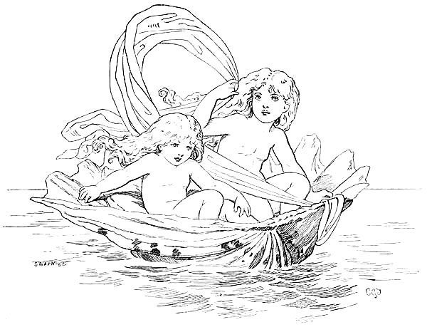

The Path Of Roses.
In the dark silence of an ancient room,
Whose one tall window fronted to the West,
Where, through laced tendrils of a hanging vine,
The sunset-glow was fading into night,
Sat a pale Lady, resting weary hands
Upon a great clasped volume, and her face
Within her hands. Not as in rest she bowed,
But large hot tears were coursing down her cheek,
And her low-panted sobs broke awefully
Upon the sleeping echoes of the night.
Soon she unclasp’d the volume once again,
And read the words in tone of agony,
As in self-torture, weeping as she read:—
“He crowns the glory of his race:
He prayeth but in some fit place
To meet his foeman face to face:
“And, battling for the True, the Right,
From ruddy dawn to purple night,
To perish in the midmost fight:
“Where hearts are fierce and hands are strong,
Where peals the bugle loud and long,
Where blood is dropping in the throng:
“Still, with a dim and glazing eye,
To watch the tide of victory,
To hear in death the battle-cry:
“Then, gathered grandly to his grave,
To rest among the true and brave,
In holy ground, where yew-trees wave:
“Where, from church-windows sculptured fair,
Float out upon the evening air
The note of praise, the voice of prayer:
“Where no vain marble mockery
Insults with loud and boastful lie
The simple soldier’s memory:
“Where sometimes little children go,
And read, in whisper’d accent slow,
The name of him who sleeps below.”
Her voice died out: like one in dreams she sat.
“Alas!” she sighed. “For what can Woman do?
Her life is aimless, and her death unknown:
Hemmed in by social forms she pines in vain.
Man has his work, but what can Woman do?”
And answer came there from the creeping gloom,
The creeping gloom that settled into night:
“Peace! For thy lot is other than a man’s:
His is a path of thorns: he beats them down:
He faces death: he wrestles with despair.
Thine is of roses, to adorn and cheer
His lonely life, and hide the thorns in flowers.”
She spake again: in bitter tone she spake:
“Aye, as a toy, the puppet of an hour,
Or a fair posy, newly plucked at morn,
But flung aside and withered ere the night.”
And answer came there from the creeping gloom,
The creeping gloom that blackened into night:
“So shalt thou be the lamp to light his path,
What time the shades of sorrow close around.”
And, so it seemed to her, an awful light
Pierced slowly through the darkness, orbed, and grew,
Until all passed away—the ancient room—
The sunlight dying through the trellised vine—
The one tall window—all had passed away,
And she was standing on the mighty hills.
Beneath, around, and far as eye could see,
Squadron on squadron, stretched opposing hosts,
Ranked as for battle, mute and motionless.
Anon a distant thunder shook the ground,
The tramp of horses, and a troop shot by—
Plunged headlong in that living sea of men—
Plunged to their death: back from that fatal field
A scattered handful, fighting hard for life,
Broke through the serried lines; but, as she gazed,
They shrank and melted, and their forms grew thin—
Grew pale as ghosts when the first morning ray
Dawns from the East—the trumpet’s brazen blare
Died into silence—and the vision passed—
Passed to a room where sick and dying lay
In long, sad line—there brooded Fear and Pain—
Darkness was there, the shade of Azrael’s wing.
But there was one that ever, to and fro,
Moved with light footfall: purely calm her face,
And those deep steadfast eyes that starred the gloom:
Still, as she went, she ministered to each
Comfort and counsel; cooled the fevered brow
With softest touch, and in the listening ear
Of the pale sufferer whispered words of peace.
The dying warrior, gazing as she passed,
Clasped his thin hands and blessed her. Bless her too,
Thou, who didst bless the merciful of old!
So prayed the Lady, watching tearfully
Her gentle moving onward, till the night
Had veiled her wholly, and the vision passed.
Then once again the solemn whisper came:
“So in the darkest path of man’s despair,
Where War and Terror shake the troubled earth,
Lies woman’s mission; with unblenching brow
To pass through scenes of horror and affright
Where men grow sick and tremble: unto her
All things are sanctified, for all are good.
Nothing so mean, but shall deserve her care:
Nothing so great, but she may bear her part.
No life is vain: each hath his place assigned:
Do thou thy task, and leave the rest to God.”
And there was silence, but the Lady made
No answer, save one deeply-breathed “Amen.”
And she arose, and in that darkening room
Stood lonely as a spirit of the night—
Stood calm and fearless in the gathered night—
And raised her eyes to heaven. There were tears
Upon her face, but in her heart was peace,
Peace that the world nor gives nor takes away!
April 10, 1856.

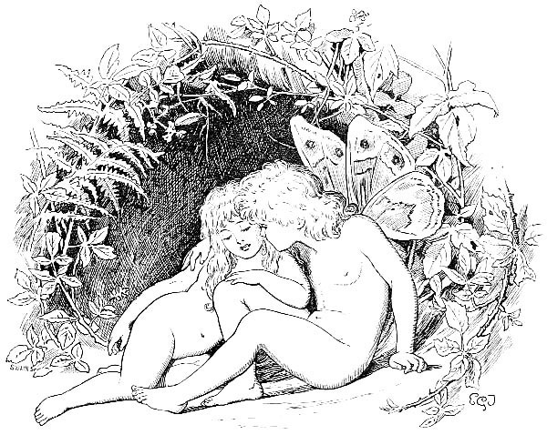

The Valley Of The Shadow Of Death
Hark, said the dying man, and sighed,
To that complaining tone—
Like sprite condemned, each eventide,
To walk the world alone.
At sunset, when the air is still,
I hear it creep from yonder hill:
It breathes upon me, dead and chill,
A moment, and is gone.
My son, it minds me of a day
Left half a life behind,
That I have prayed to put away
For ever from my mind.
But bitter memory will not die:
It haunts my soul when none is nigh:
I hear its whisper in the sigh
Of that complaining wind.
And now in death my soul is fain
To tell the tale of fear
That hidden in my breast hath lain
Through many a weary year:
Yet time would fail to utter all—
The evil spells that held me thrall,
And thrust my life from fall to fall,
Thou needest not to hear.
The spells that bound me with a chain,
Sin’s stern behests to do,
Till Pleasure’s self, invoked in vain,
A heavy burden grew—
Till from my spirit’s fevered eye,
A hunted thing, I seemed to fly
Through the dark woods that underlie
Yon mountain-range of blue.
Deep in those woods I found a vale
No sunlight visiteth,
Nor star, nor wandering moonbeam pale;
Where never comes the breath
Of summer-breeze—there in mine ear,
Even as I lingered half in fear,
I heard a whisper, cold and clear,
“This is the gate of Death.
“O bitter is it to abide
In weariness alway:
At dawn to sigh for eventide,
At eventide for day.
Thy noon hath fled: thy sun hath shone.
The brightness of thy day is gone:
What need to lag and linger on
Till life be cold and gray?
“O well,” it said, “beneath yon pool,
In some still cavern deep,
The fevered brain might slumber cool,
The eyes forget to weep:
Within that goblet’s mystic rim
Are draughts of healing, stored for him
Whose heart is sick, whose sight is dim,
Who prayeth but to sleep!”
The evening-breeze went moaning by,
Like mourner for the dead,
And stirred, with shrill complaining sigh,
The tree-tops overhead:
My guardian-angel seemed to stand
And mutely wave a warning hand—
With sudden terror all unmanned,
I turned myself and fled!
A cottage-gate stood open wide:
Soft fell the dying ray
On two fair children, side by side,
That rested from their play—
Together bent the earnest head,
As ever and anon they read
From one dear Book: the words they said
Come back to me to-day.
Like twin cascades on mountain-stair
Together wandered down
The ripples of the golden hair,
The ripples of the brown:
While, through the tangled silken haze,
Blue eyes looked forth in eager gaze,
More starlike than the gems that blaze
About a monarch’s crown.
My son, there comes to each an hour
When sinks the spirit’s pride—
When weary hands forget their power
The strokes of death to guide:
In such a moment, warriors say,
A word the panic-rout may stay,
A sudden charge redeem the day
And turn the living tide.
I could not see, for blinding tears,
The glories of the west:
A heavenly music filled mine ears,
A heavenly peace my breast.
“Come unto Me, come unto Me—
All ye that labour, unto Me—
Ye heavy-laden, come to Me—
And I will give you rest.”
The night drew onward: thin and blue
The evening mists arise
To bathe the thirsty land in dew,
As erst in Paradise—
While, over silent field and town,
The deep blue vault of heaven looked down;
Not, as of old, in angry frown,
But bright with angels’ eyes.
Blest day! Then first I heard the voice
That since hath oft beguiled
These eyes from tears, and bid rejoice
This heart with anguish wild—
Thy mother, boy, thou hast not known;
So soon she left me here to moan—
Left me to weep and watch, alone,
Our one beloved child.
Though, parted from my aching sight,
Like homeward-speeding dove,
She passed into the perfect light
That floods the world above;
Yet our twin spirits, well I know—
Though one abide in pain below—
Love, as in summers long ago,
And evermore shall love.
So with a glad and patient heart
I move toward mine end:
The streams, that flow awhile apart,
Shall both in ocean blend.
I dare not weep: I can but bless
The Love that pitied my distress,
And lent me, in Life’s wilderness,
So sweet and true a friend.
But if there be—O if there be
A truth in what they say,
That angel-forms we cannot see
Go with us on our way;
Then surely she is with me here,
I dimly feel her spirit near—
The morning-mists grow thin and clear,
And Death brings in the Day.
April, 1868.

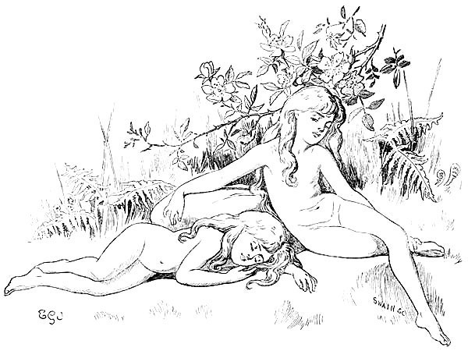

Solitude
I love the stillness of the wood:
I love the music of the rill:
I love to couch in pensive mood
Upon some silent hill.
Scarce heard, beneath yon arching trees,
The silver-crested ripples pass;
And, like a mimic brook, the breeze
Whispers among the grass.
Here from the world I win release,
Nor scorn of men, nor footstep rude,
Break in to mar the holy peace
Of this great solitude.
Here may the silent tears I weep
Lull the vexed spirit into rest,
As infants sob themselves to sleep
Upon a mother’s breast.
But when the bitter hour is gone,
And the keen throbbing pangs are still,
Oh sweetest then to couch alone
Upon some silent hill!
To live in joys that once have been,
To put the cold world out of sight,
And deck life’s drear and barren scene
With hues of rainbow-light.
For what to man the gift of breath,
If sorrow be his lot below;
If all the day that ends in death
Be dark with clouds of woe?
Shall the poor transport of an hour
Repay long years of sore distress—
The fragrance of a lonely flower
Make glad the wilderness?
Ye golden hours of Life’s young spring,
Of innocence, of love and truth!
Bright, beyond all imagining,
Thou fairy-dream of youth!
I’d give all wealth that years have piled,
The slow result of Life’s decay,
To be once more a little child
For one bright summer-day.
March 16, 1853.

Far Away.
He stept so lightly to the land,
All in his manly pride:
He kissed her cheek, he clasped her hand;
Yet still she glanced aside.
“Too gay he seems,” she darkly dreams,
“Too gallant and too gay,
To think of me—poor simple me—
When he is far away!”
“I bring my Love this goodly pearl
Across the seas,” he said:
“A gem to deck the dearest girl
That ever sailor wed!”
She holds it tight: her eyes are bright:
Her throbbing heart would say
“He thought of me—he thought of me—
When he was far away!”
The ship has sailed into the West:
Her ocean-bird is flown:
A dull dead pain is in her breast,
And she is weak and lone:
But there’s a smile upon her face,
A smile that seems to say
“He’ll think of me—he’ll think of me—
When he is far away!
“Though waters wide between us glide,
Our lives are warm and near:
No distance parts two faithful hearts—
Two hearts that love so dear:
And I will trust my sailor-lad,
For ever and a day,
To think of me—to think of me—
When he is far away!”

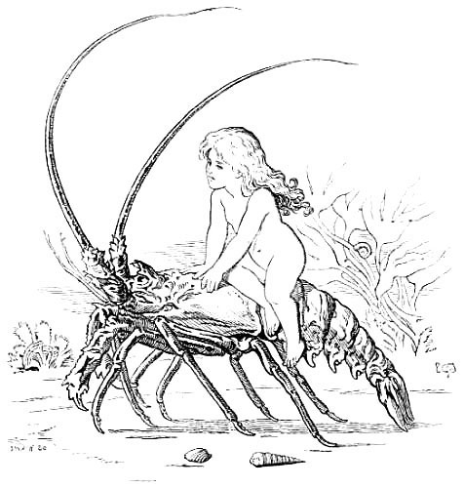

Beatrice.
In her eyes is the living light
Of a wanderer to earth
From a far celestial height:
Summers five are all the span—
Summers five since Time began
To veil in mists of human night
A shining angel-birth.
Does an angel look from her eyes?
Will she suddenly spring away,
And soar to her home in the skies?
Beatrice! Blessing and blessed to be!
Beatrice! Still, as I gaze on thee,
Visions of two sweet maids arise,
Whose life was of yesterday:
Of a Beatrice pale and stern,
With the lips of a dumb despair,
With the innocent eyes that yearn—
Yearn for the young sweet hours of life,
Far from sorrow and far from strife,
For the happy summers, that never return,
When the world seemed good and fair:
Of a Beatrice glorious, bright—
Of a sainted, ethereal maid,
Whose blue eyes are deep fountains of light,
Cheering the poet that broodeth apart,
Filling with gladness his desolate heart,
Like the moon when she shines thro’ a cloudless night
On a world of silence and shade.
And the visions waver and faint,
And the visions vanish away
That my fancy delighted to paint—
She is here at my side, a living child,
With the glowing cheek and the tresses wild,
Nor death-pale martyr, nor radiant saint,
Yet stainless and bright as they.
For I think, if a grim wild beast
Were to come from his charnel-cave,
From his jungle-home in the East—
Stealthily creeping with bated breath,
Stealthily creeping with eyes of death—
He would all forget his dream of the feast,
And crouch at her feet a slave.
She would twine her hand in his mane:
She would prattle in silvery tone,
Like the tinkle of summer-rain—
Questioning him with her laughing eyes,
Questioning him with a glad surprise,
Till she caught from those fierce eyes again
The love that lit her own.
And be sure, if a savage heart,
In a mask of human guise,
Were to come on her here apart—
Bound for a dark and a deadly deed,
Hurrying past with pitiless speed—
He would suddenly falter and guiltily start
At the glance of her pure blue eyes.
Nay, be sure, if an angel fair,
A bright seraph undefiled,
Were to stoop from the trackless air,
Fain would she linger in glad amaze—
Lovingly linger to ponder and gaze,
With a sister’s love and a sister’s care,
On the happy, innocent child.
Dec. 4, 1862.

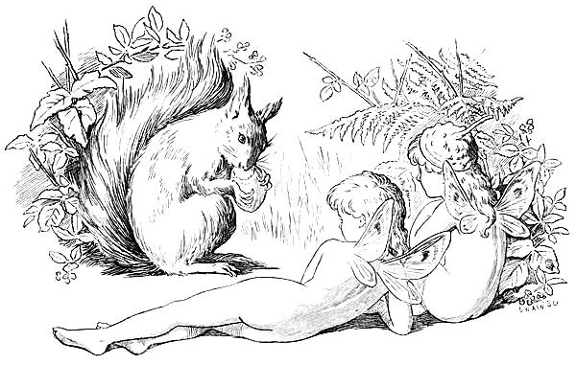

Stolen Waters.
The light was faint, and soft the air
That breathed around the place;
And she was lithe, and tall, and fair,
And with a wayward grace
Her queenly head she bare.
With glowing cheek, with gleaming eye,
She met me on the way:
My spirit owned the witchery
Within her smile that lay:
I followed her, I knew not why.
The trees were thick with many a fruit,
The grass with many a flower:
My soul was dead, my tongue was mute,
In that accursëd hour.
And, in my dream, with silvery voice,
She said, or seemed to say,
“Youth is the season to rejoice—”
I could not choose but stay:
I could not say her nay.
She plucked a branch above her head,
With rarest fruitage laden:
“Drink of the juice, Sir Knight,” she said:
“’Tis good for knight and maiden.”
Oh, blind mine eye that would not trace—
Oh, deaf mine ear that would not heed—
The mocking smile upon her face,
The mocking voice of greed!
I drank the juice; and straightway felt
A fire within my brain:
My soul within me seemed to melt
In sweet delirious pain.
“Sweet is the stolen draught,” she said:
“Hath sweetness stint or measure?
Pleasant the secret hoard of bread:
What bars us from our pleasure?”
“Yea, take we pleasure while we may,”
I heard myself replying.
In the red sunset, far away,
My happier life was dying:
My heart was sad, my voice was gay.
And unawares, I knew not how,
I kissed her dainty finger-tips,
I kissed her on the lily brow,
I kissed her on the false, false lips—
That burning kiss, I feel it now!
“True love gives true love of the best:
Then take,” I cried, “my heart to thee!”
The very heart from out my breast
I plucked, I gave it willingly:
Her very heart she gave to me—
Then died the glory from the west.
In the gray light I saw her face,
And it was withered, old, and gray;
The flowers were fading in their place,
Were fading with the fading day.
Forth from her, like a hunted deer,
Through all that ghastly night I fled,
And still behind me seemed to hear
Her fierce unflagging tread;
And scarce drew breath for fear.
Yet marked I well how strangely seemed
The heart within my breast to sleep:
Silent it lay, or so I dreamed,
With never a throb or leap.
For hers was now my heart, she said,
The heart that once had been mine own:
And in my breast I bore instead
A cold, cold heart of stone.
So grew the morning overhead.
The sun shot downward through the trees
His old familiar flame:
All ancient sounds upon the breeze
From copse and meadow came—
But I was not the same.
They call me mad: I smile, I weep,
Uncaring how or why:
Yea, when one’s heart is laid asleep,
What better than to die?
So that the grave be dark and deep.
To die! To die? And yet, methinks,
I drink of life, to-day,
Deep as the thirsty traveler drinks
Of fountain by the way:
My voice is sad, my heart is gay.
When yestereve was on the wane,
I heard a clear voice singing
So sweetly that, like summer-rain,
My happy tears came springing:
My human heart returned again.
“A rosy child,
Sitting and singing, in a garden fair,
The joy of hearing, seeing,
The simple joy of being—
Or twining rosebuds in the golden hair
That ripples free and wild.
“A sweet pale child—
Wearily looking to the purple West—
Waiting the great For-ever
That suddenly shall sever
The cruel chains that hold her from her rest—
By earth-joys unbeguiled.
“An angel-child—
Gazing with living eyes on a dead face:
The mortal form forsaken,
That none may now awaken,
That lieth painless, moveless in her place,
As though in death she smiled!
“Be as a child—
So shalt thou sing for very joy of breath—
So shalt thou wait thy dying,
In holy transport lying—
So pass rejoicing through the gate of death,
In garment undefiled.”
Then call me what they will, I know
That now my soul is glad:
If this be madness, better so,
Far better to be mad,
Weeping or smiling as I go.
For if I weep, it is that now
I see how deep a loss is mine,
And feel how brightly round my brow
The coronal might shine,
Had I but kept mine early vow:
And if I smile, it is that now
I see the promise of the years—
The garland waiting for my brow,
That must be won with tears,
With pain—with death—I care not how.
May 9, 1862.

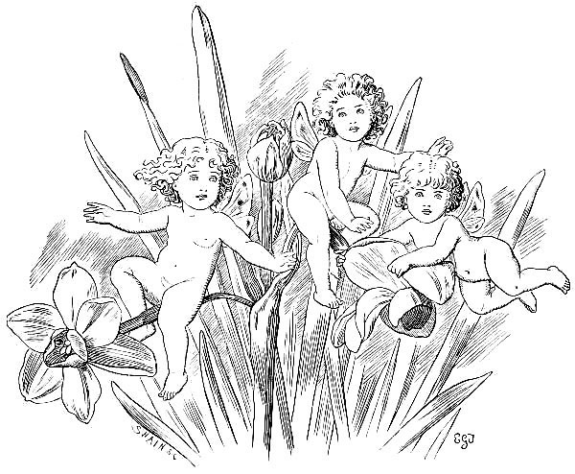

The Willow-Tree.
The morn was bright, the steeds were light,
The wedding guests were gay:
Young Ellen stood within the wood
And watched them pass away.
She scarcely saw the gallant train:
The tear-drop dimmed her ee:
Unheard the maiden did complain
Beneath the Willow-Tree.
“Oh Robin, thou didst love me well,
Till, on a bitter day,
She came, the Lady Isabel,
And stole thy heart away.
My tears are vain: I live again
In days that used to be,
When I could meet thy welcome feet
Beneath the Willow-Tree.
“Oh Willow gray, I may not stay
Till Spring renew thy leaf;
But I will hide myself away,
And nurse a lonely grief.
It shall not dim Life’s joy for him:
My tears he shall not see:
While he is by, I’ll come not nigh
My weeping Willow-Tree.
“But when I die, oh let me lie
Beneath thy loving shade,
That he may loiter careless by,
Where I am lowly laid.
And let the white white marble tell,
If he should stoop to see,
‘Here lies a maid that loved thee well,
Beneath the Willow-Tree.’”
1859.

Only A Woman’s Hair.
‘Only a woman’s hair’! Fling it aside!
A bubble on Life’s mighty stream:
Heed it not, man, but watch the broadening tide
Bright with the western beam.
Nay! In those words there rings from other years
The echo of a long low cry,
Where a proud spirit wrestles with its tears
In loneliest agony.
And, as I touch that lock, strange visions throng
Upon my soul with dreamy grace—
Of woman’s hair, the theme of poet’s song
In every time and place.
A child’s bright tresses, by the breezes kissed
To sweet disorder as she flies,
Veiling, beneath a cloud of golden mist,
Flushed cheek and laughing eyes—
Or fringing, like a shadow, raven-black,
The glory of a queen-like face—
Or from a gipsy’s sunny brow tossed back
In wild and wanton grace—
Or crown-like on the hoary head of Age,
Whose tale of life is well-nigh told—
Or, last, in dreams I make my pilgrimage
To Bethany of old.
I see the feast—the purple and the gold—
The gathering crowd of Pharisees,
Whose scornful eyes are centred to behold
Yon woman on her knees.
The stifled sob rings strangely on mine ears,
Wrung from the depth of sin’s despair:
And still she bathes the sacred feet with tears,
And wipes them with her hair.
He scorned not then the simple loving deed
Of her, the lowest and the last;
Then scorn not thou, but use with earnest heed
This relic of the past.
The eyes that loved it once no longer wake:
So lay it by with reverent care—
Touching it tenderly for sorrow’s sake—
It is a woman’s hair.
Feb. 17, 1862.

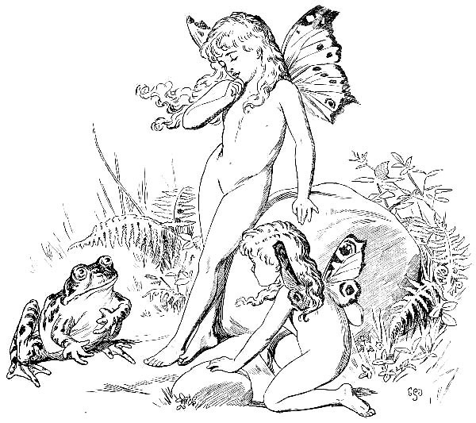

The Sailor’s Wife.
See! There are tears upon her face—
Tears newly shed, and scarcely dried:
Close, in an agonised embrace,
She clasps the infant at her side.
Peace dwells in those soft-lidded eyes,
Those parted lips that faintly smile—
Peace, the foretaste of Paradise,
In heart too young for care or guile.
No peace that mother’s features wear;
But quivering lip, and knotted brow,
And broken mutterings, all declare
The fearful dream that haunts her now.
The storm-wind, rushing through the sky,
Wails from the depths of cloudy space;
Shrill, piercing as the seaman’s cry
When death and he are face to face.
Familiar tones are in the gale:
They ring upon her startled ear:
And quick and low she pants the tale
That tells of agony and fear:
“Still that phantom-ship is nigh—
With a vexed and life-like motion,
All beneath an angry sky,
Rocking on an angry ocean.
“Round the straining mast and shrouds
Throng the spirits of the storm:
Darkly seen through driving clouds,
Bends each gaunt and ghastly form.
“See! The good ship yields at last!
Dumbly yields, and fights no more;
Driving, in the frantic blast,
Headlong on the fatal shore.
“Hark! I hear her battered side,
With a low and sullen shock,
Dashed, amid the foaming tide,
Full upon a sunken rock.
“His face shines out against the sky,
Like a ghost, so cold and white;
With a dead despairing eye
Gazing through the gathered night.
“Is he watching, through the dark
Where a mocking ghostly hand
Points a faint and feeble spark
Glimmering from the distant land?
“Sees he, in this hour of dread,
Hearth and home and wife and child?
Loved ones who, in summers fled,
Clung to him and wept and smiled?
“Reeling sinks the fated bark
To her tomb beneath the wave:
Must he perish in the dark—
Not a hand stretched out to save?
“See the spirits, how they crowd!
Watching death with eyes that burn!
Waves rush in——” she shrieks aloud,
Ere her waking sense return.
The storm is gone: the skies are clear:
Hush’d is that bitter cry of pain:
The only sound, that meets her ear,
The heaving of the sullen main.
Though heaviness endure the night,
Yet joy shall come with break of day:
She shudders with a strange delight—
The fearful dream is pass’d away.
She wakes: the grey dawn streaks the dark:
With early song the copses ring:
Far off she hears the watch-dog bark
A joyful bark of welcoming!
Feb. 23, 1857.

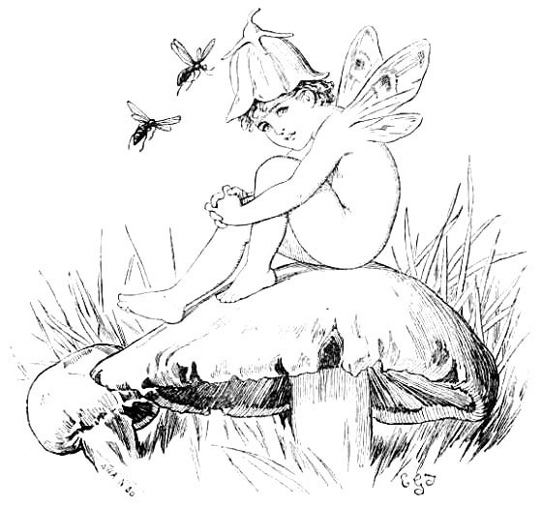

After Three Days.
I stood within the gate
Of a great temple, ’mid the living stream
Of worshipers that thronged its regal state
Fair-pictured in my dream.
Jewels and gold were there;
And floors of marble lent a crystal sheen
To body forth, as in a lower air,
The wonders of the scene.
Such wild and lavish grace
Had whispers in it of a coming doom;
As richest flowers lie strown about the face
Of her that waits the tomb.
The wisest of the land
Had gathered there, three solemn trysting-days,
For high debate: men stood on either hand
To listen and to gaze.
The aged brows were bent,
Bent to a frown, half thought, and half annoy,
That all their stores of subtlest argument
Were baffled by a boy.
In each averted face
I marked but scorn and loathing, till mine eyes
Fell upon one that stirred not in his place,
Tranced in a dumb surprise.
Surely within his mind
Strange thoughts are born, until he doubts the lore
Of those old men, blind leaders of the blind,
Whose kingdom is no more.
Surely he sees afar
A day of death the stormy future brings;
The crimson setting of the herald-star
That led the Eastern kings.
Thus, as a sunless deep
Mirrors the shining heights that crown the bay,
So did my soul create anew in sleep
The picture seen by day.
Gazers came and went—
A restless hum of voices marked the spot—
In varying shades of critic discontent
Prating they knew not what.
“Where is the comely limb,
The form attuned in every perfect part,
The beauty that we should desire in him?”
Ah! Fools and slow of heart!
Look into those deep eyes,
Deep as the grave, and strong with love divine;
Those tender, pure, and fathomless mysteries,
That seem to pierce through thine.
Look into those deep eyes,
Stirred to unrest by breath of coming strife,
Until a longing in thy soul arise
That this indeed were life:
That thou couldst find Him there,
Bend at His sacred feet thy willing knee,
And from thy heart pour out the passionate prayer
“Lord, let me follow Thee!”
But see the crowd divide:
Mother and sire have found their lost one now:
The gentle voice, that fain would seem to chide
Whispers “Son, why hast thou”—
In tone of sad amaze—
“Thus dealt with us, that art our dearest thing?
Behold, thy sire and I, three weary days,
Have sought thee sorrowing.”
And I had stayed to hear
The loving words “How is it that ye sought?”—
But that the sudden lark, with matins clear,
Severed the links of thought.
Then over all there fell
Shadow and silence; and my dream was fled,
As fade the phantoms of a wizard’s cell
When the dark charm is said.
Yet, in the gathering light,
I lay with half-shut eyes that would not wake,
Lovingly clinging to the skirts of night
For that sweet vision’s sake.
Feb. 16, 1861.

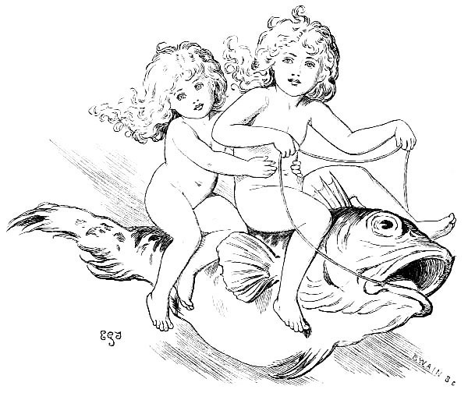

Faces In The Fire.
The night creeps onward, sad and slow:
In these red embers’ dying glow
The forms of Fancy come and go.
An island-farm—broad seas of corn
Stirred by the wandering breath of morn—
The happy spot where I was born.
The picture fadeth in its place:
Amid the glow I seem to trace
The shifting semblance of a face.
’Tis now a little childish form—
Red lips for kisses pouted warm—
And elf-locks tangled in the storm.
’Tis now a grave and gentle maid,
At her own beauty half afraid,
Shrinking, and willing to be stayed.
Oh, Time was young, and Life was warm,
When first I saw that fairy-form,
Her dark hair tossing in the storm.
And fast and free these pulses played,
When last I met that gentle maid—
When last her hand in mine was laid.
Those locks of jet are turned to gray,
And she is strange and far away
That might have been mine own to-day—
That might have been mine own, my dear,
Through many and many a happy year—
That might have sat beside me here.
Ay, changeless through the changing scene,
The ghostly whisper rings between,
The dark refrain of ‘might have been.’
The race is o’er I might have run:
The deeds are past I might have done;
And sere the wreath I might have won.
Sunk is the last faint flickering blaze:
The vision of departed days
Is vanished even as I gaze.
The pictures, with their ruddy light,
Are changed to dust and ashes white,
And I am left alone with night.
Jan., 1860.

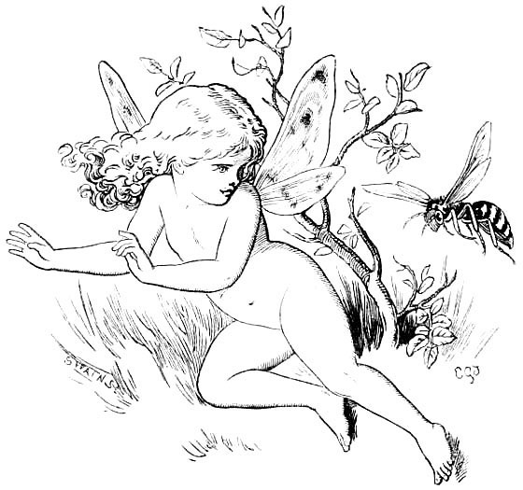

A Lesson in Latin
Our Latin books, in motley row,
Invite us to our task—
Gay Horace, stately Cicero:
Yet there’s one verb, when once we know,
No higher skill we ask:
This ranks all other lore above—
We’ve learned “‘Amare’ means ‘to love’!”
So, hour by hour, from flower to flower,
We sip the sweets of Life:
Till, all too soon, the clouds arise,
And flaming cheeks and flashing eyes
Proclaim the dawn of strife:
With half a smile and half a sigh,
“Amare! Bitter One!” we cry.
Last night we owned, with looks forlorn,
“Too well the scholar knows
There is no rose without a thorn”—
But peace is made! We sing, this morn,
“No thorn without a rose!”
Our Latin lesson is complete:
We’ve learned that Love is Bitter-Sweet!
May, 1888.

Puck Lost And Found
Puck has fled the haunts of men:
Ridicule has made him wary:
In the woods, and down the glen,
No one meets a Fairy!
“Cream!” the greedy Goblin cries—
Empties the deserted dairy—
Steals the spoons, and off he flies.
Still we seek our Fairy!
Ah! What form is entering?
Lovelit eyes and laughter airy!
Is not this a better thing,
Child, whose visit thus I sing,
Even than a Fairy?
Nov. 22, 1891.
Puck has ventured back agen:
Ridicule no more affrights him:
In the very haunts of men
Newer sport delights him.
Capering lightly to and fro,
Ever frolicking and funning—
“Crack!” the mimic pistols go!
Hark! The noise is stunning!
All too soon will Childhood gay
Realise Life’s sober sadness.
Let’s be merry while we may,
Innocent and happy Fay!
Elves were made for gladness!
Nov. 25, 1891.

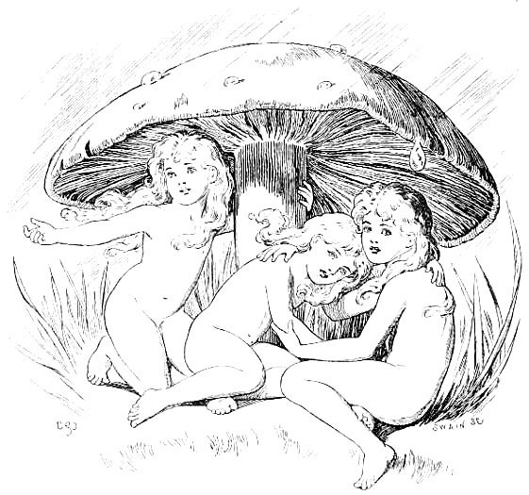

A Song Of Love
Say, what is the spell, when her fledgelings are cheeping,
That lures the bird home to her nest?
Or wakes the tired mother, whose infant is weeping,
To cuddle and croon it to rest?
What the magic that charms the glad babe in her arms,
Till it cooes with the voice of the dove?
’Tis a secret, and so let us whisper it low—
And the name of the secret is Love!
For I think it is Love,
For I feel it is Love,
For I’m sure it is nothing but Love!
Say, whence is the voice that, when anger is burning,
Bids the whirl of the tempest to cease?
That stirs the vexed soul with an aching—a yearning
For the brotherly hand-grip of peace?
Whence the music that fills all our being—that thrills
Around us, beneath, and above?
’Tis a secret: none knows how it comes, how it goes—
But the name of the secret is Love!
For I think it is Love,
For I feel it is Love,
For I’m sure it is nothing but Love!
Say, whose is the skill that paints valley and hill,
Like a picture so fair to the sight?
That flecks the green meadow with sunshine and shadow,
Till the little lambs leap with delight?
’Tis a secret untold to hearts cruel and cold,
Though ’tis sung, by the angels above,
In notes that ring clear for the ears that can hear—
And the name of the secret is Love!
For I think it is Love,
For I feel it is Love,
For I’m sure it is nothing but Love!
Oct., 1886.

THE END.

[TURN OVER.

Works By Lewis Carroll

ALICE’S ADVENTURES IN WONDERLAND. With Forty-Two Illustrations by Tenniel. (First published in 1865.) Crown 8vo, cloth, gilt edges, price 6s. net. Eighty-sixth Thousand.
THE SAME; PEOPLE’S EDITION. (First published in 1887.) Crown 8vo, cloth, price 2s. 6d. net. Seventieth Thousand.
AVENTURES D’ALICE AU PAYS DES MERVEILLES. Traduit de l’Anglais par Henri Bué. Ouvrage illustré de 42 Vignettes par John Tenniel. (First published in 1869.) Crown 8vo, cloth, gilt edges, price 6s. net. Second Thousand.
Alice’s Abenteuer im Wunderland. Aus dem Englischen von Antonie Zimmermann. Mit 42 Illustrationen von John Tenniel. (First published in 1869.) Crown 8vo, cloth, gilt edges, price 6s. net.
LE AVVENTURE D’ALICE NEL PAESE DELLE MERAVIGLIE. Tradotte dall’ Inglese da T. Pietrocola-Rossetti. Con 42 Vignette di Giovanni Tenniel. (First published in 1872.) Crown 8vo, cloth, gilt edges, price 6s. net.
ALICE’S ADVENTURES UNDER GROUND. Being a Facsimile of the original MS. Book, which was afterwards developed into “Alice’s Adventures in Wonderland.” With Thirty-seven Illustrations by the Author. (Begun, July, 1862; finished, Feb. 1863; first published, in facsimile, in 1886.) Crown 3vo, cloth, gilt edges, price 4s. net. Third Thousand.
THE NURSERY “ALICE.” Containing Twenty Coloured Enlargements from Tenniel’s Illustrations to “Alice’s Adventures in Wonderland.” With Text adapted to Nursery Readers. Cover designed by E. Gertrude Thomson. (First published in 1890.) 4to, boards, price 4s. net. Eleventh Thousand.
THROUGH THE LOOKING GLASS, AND WHAT ALICE FOUND THERE. With Fifty Illustrations by Tenniel. (First published in 1871.) Crown 8vo, cloth, gilt edges, price 6s. net. Sixty-first Thousand.
THROUGH THE LOOKING-GLASS, AND WHAT ALICE FOUND THERE; PEOPLE’S EDITION. (First published in 1887.) Crown 8vo, cloth, price 2s. 6d. net. Forty-sixth Thousand.
ALICE’S ADVENTURES IN WONDERLAND; AND THROUGH THE LOOKING-GLASS; PEOPLE’S EDITIONS. Both Books together in One Volume (First published in 1887.) Crown 3vo, cloth, price 4s. 6d. net.
THE HUNTING OF THE SNARK. An Agony in Eight Fits. With Nine Illustrations, and two large gilt designs on cover, by Henry Holiday. (First published in 1876.) Crown 8vo, cloth, gilt edges, price 4s. 6d. net. Twentieth Thousand.
RHYME? AND REASON? With Sixty-five Illustrations by Arthur B. Frost, and Nine by Henry Holiday. (First published in 1883, being a reprint, with a few additions, of the comic portion of “Phantasmagoria and other Poems,” published in 1869, and of “The Hunting of the Snark,” published in 1876.) Crown 8vo, cloth, gilt edges, price 6s. net. Sixth Thousand.
SYMBOLIC LOGIC. In three Parts, which will be issued separately:—
Part I. Elementary. (First published in 1896.) Crown 8vo, limp cloth, price 2s., net.
Second Thousand, Fourth Edition.
Part II. Advanced.
Part III. Transcendental.
} [In preparation.
N.B.—An envelope, containing two blank Diagrams (Biliteral and Triliteral) and 9 Counters (4 Red and 5 Grey) can be had for 3d., by post 4d.
A TANGLED TALE. Reprinted from The Monthly Packet. With Six Illustrations by Arthur B. Frost. (First published in 1885.) Crown 8vo, cloth, gilt edges, price 4s. 6d. net. Fourth Thousand.
SYLVIE AND BRUNO. With Forty-six Illustrations by Harry Furniss. (First published in 1889.) Crown 8vo, cloth, gilt edges, price 7s. 6d. net. Thirteenth Thousand.
N.B.—This book contains 395 pages—nearly as much as the two “Alice” books put together.
SYLVIE AND BRUNO CONCLUDED. With Forty-six Illustrations by Harry Furniss. (First published in 1893.) Crown 8vo, cloth, gilt edges, price 7s. 6d. net. Third Thousand.
N.B.—This book contains 411 pages.
ORIGINAL GAMES AND PUZZLES. Crown 8vo, cloth, gilt edges. [In preparation.
THREE SUNSETS, and Other Poems. With Twelve Fairy-Fancies by E. Gertrude Thomson. (First published in 1893.) Fcap. 4to, cloth, gilt edges, price 4s., net.
N.B.—This is a reprint, with a few additions, of the serious portion of “Phantasmagoria, and other Poems,” published in 1869.
MACMILLAN AND CO., Limited, LONDON.

ADVICE TO WRITERS.
Buy “THE WONDERLAND CASE FOR POSTAGE STAMPS,” invented by Lewis Carroll, Oct. 29, 1888, size 4 inches by 3, containing 12 separate pockets for stamps of different values, 2 Coloured Pictorial Surprises taken from Alice in Wonderland, and 8 or 9 Wise Words about Letter-Writing. It is published by Messrs. Emberlin & Son, 4 Magdalen Street, Oxford. Price 1s.
N.B.—If ordered by Post, an additional payment will be required, to cover cost of postage, as follows:—
One copy, 1½d. Two or three do., 2d. Four do., 2½d. Five to fourteen do., 3d. Each subsequent fourteen or fraction thereof, 1½d.

*** End Of This Project Gutenberg Ebook ***
Updated editions will replace the previous one—the old editions will be renamed.
Creating the works from print editions not protected by U.S. copyright law means that no one owns a United States copyright in these works, so the Foundation (and you!) can copy and distribute it in the United States without permission and without paying copyright royalties. Special rules, set forth in the General Terms of Use part of this license, apply to copying and distributing Project Gutenberg™ electronic works to protect the PROJECT GUTENBERG™ concept and trademark. Project Gutenberg is a registered trademark, and may not be used if you charge for an eBook, except by following the terms of the trademark license, including paying royalties for use of the Project Gutenberg trademark. If you do not charge anything for copies of this eBook, complying with the trademark license is very easy. You may use this eBook for nearly any purpose such as creation of derivative works, reports, performances and research. Project Gutenberg eBooks may be modified and printed and given away—you may do practically ANYTHING in the United States with eBooks not protected by U.S. copyright law. Redistribution is subject to the trademark license, especially commercial redistribution.
START: FULL LICENSE
THE FULL PROJECT GUTENBERG LICENSE
PLEASE READ THIS BEFORE YOU DISTRIBUTE OR USE THIS WORK
To protect the Project Gutenberg™ mission of promoting the free distribution of electronic works, by using or distributing this work (or any other work associated in any way with the phrase “Project Gutenberg”), you agree to comply with all the terms of the Full Project Gutenberg™ License available with this file or online at www.gutenberg.org/license.
Section 1. General Terms of Use and Redistributing Project Gutenberg™ electronic works
1.A. By reading or using any part of this Project Gutenberg™ electronic work, you indicate that you have read, understand, agree to and accept all the terms of this license and intellectual property (trademark/copyright) agreement. If you do not agree to abide by all the terms of this agreement, you must cease using and return or destroy all copies of Project Gutenberg™ electronic works in your possession. If you paid a fee for obtaining a copy of or access to a Project Gutenberg™ electronic work and you do not agree to be bound by the terms of this agreement, you may obtain a refund from the person or entity to whom you paid the fee as set forth in paragraph 1.E.8.
1.B. “Project Gutenberg” is a registered trademark. It may only be used on or associated in any way with an electronic work by people who agree to be bound by the terms of this agreement. There are a few things that you can do with most Project Gutenberg™ electronic works even without complying with the full terms of this agreement. See paragraph 1.C below. There are a lot of things you can do with Project Gutenberg™ electronic works if you follow the terms of this agreement and help preserve free future access to Project Gutenberg™ electronic works. See paragraph 1.E below.
1.C. The Project Gutenberg Literary Archive Foundation (“the Foundation” or PGLAF), owns a compilation copyright in the collection of Project Gutenberg™ electronic works. Nearly all the individual works in the collection are in the public domain in the United States. If an individual work is unprotected by copyright law in the United States and you are located in the United States, we do not claim a right to prevent you from copying, distributing, performing, displaying or creating derivative works based on the work as long as all references to Project Gutenberg are removed. Of course, we hope that you will support the Project Gutenberg™ mission of promoting free access to electronic works by freely sharing Project Gutenberg™ works in compliance with the terms of this agreement for keeping the Project Gutenberg™ name associated with the work. You can easily comply with the terms of this agreement by keeping this work in the same format with its attached full Project Gutenberg™ License when you share it without charge with others.
1.D. The copyright laws of the place where you are located also govern what you can do with this work. Copyright laws in most countries are in a constant state of change. If you are outside the United States, check the laws of your country in addition to the terms of this agreement before downloading, copying, displaying, performing, distributing or creating derivative works based on this work or any other Project Gutenberg™ work. The Foundation makes no representations concerning the copyright status of any work in any country other than the United States.
1.E. Unless you have removed all references to Project Gutenberg:
1.E.1. The following sentence, with active links to, or other immediate access to, the full Project Gutenberg™ License must appear prominently whenever any copy of a Project Gutenberg™ work (any work on which the phrase “Project Gutenberg” appears, or with which the phrase “Project Gutenberg” is associated) is accessed, displayed, performed, viewed, copied or distributed:
This eBook is for the use of anyone anywhere in the United States and most other parts of the world at no cost and with almost no restrictions whatsoever. You may copy it, give it away or re-use it under the terms of the Project Gutenberg License included with this eBook or online at www.gutenberg.org. If you are not located in the United States, you will have to check the laws of the country where you are located before using this eBook.
1.E.2. If an individual Project Gutenberg™ electronic work is derived from texts not protected by U.S. copyright law (does not contain a notice indicating that it is posted with permission of the copyright holder), the work can be copied and distributed to anyone in the United States without paying any fees or charges. If you are redistributing or providing access to a work with the phrase “Project Gutenberg” associated with or appearing on the work, you must comply either with the requirements of paragraphs 1.E.1 through 1.E.7 or obtain permission for the use of the work and the Project Gutenberg™ trademark as set forth in paragraphs 1.E.8 or 1.E.9.
1.E.3. If an individual Project Gutenberg™ electronic work is posted with the permission of the copyright holder, your use and distribution must comply with both paragraphs 1.E.1 through 1.E.7 and any additional terms imposed by the copyright holder. Additional terms will be linked to the Project Gutenberg™ License for all works posted with the permission of the copyright holder found at the beginning of this work.
1.E.4. Do not unlink or detach or remove the full Project Gutenberg™ License terms from this work, or any files containing a part of this work or any other work associated with Project Gutenberg™.
1.E.5. Do not copy, display, perform, distribute or redistribute this electronic work, or any part of this electronic work, without prominently displaying the sentence set forth in paragraph 1.E.1 with active links or immediate access to the full terms of the Project Gutenberg™ License.
1.E.6. You may convert to and distribute this work in any binary, compressed, marked up, nonproprietary or proprietary form, including any word processing or hypertext form. However, if you provide access to or distribute copies of a Project Gutenberg™ work in a format other than “Plain Vanilla ASCII” or other format used in the official version posted on the official Project Gutenberg™ website (www.gutenberg.org), you must, at no additional cost, fee or expense to the user, provide a copy, a means of exporting a copy, or a means of obtaining a copy upon request, of the work in its original “Plain Vanilla ASCII” or other form. Any alternate format must include the full Project Gutenberg™ License as specified in paragraph 1.E.1.
1.E.7. Do not charge a fee for access to, viewing, displaying, performing, copying or distributing any Project Gutenberg™ works unless you comply with paragraph 1.E.8 or 1.E.9.
1.E.8. You may charge a reasonable fee for copies of or providing access to or distributing Project Gutenberg™ electronic works provided that:
• You pay a royalty fee of 20% of the gross profits you derive from the use of Project Gutenberg™ works calculated using the method you already use to calculate your applicable taxes. The fee is owed to the owner of the Project Gutenberg™ trademark, but he has agreed to donate royalties under this paragraph to the Project Gutenberg Literary Archive Foundation. Royalty payments must be paid within 60 days following each date on which you prepare (or are legally required to prepare) your periodic tax returns. Royalty payments should be clearly marked as such and sent to the Project Gutenberg Literary Archive Foundation at the address specified in Section 4, “Information about donations to the Project Gutenberg Literary Archive Foundation.”
• You provide a full refund of any money paid by a user who notifies you in writing (or by e-mail) within 30 days of receipt that s/he does not agree to the terms of the full Project Gutenberg™ License. You must require such a user to return or destroy all copies of the works possessed in a physical medium and discontinue all use of and all access to other copies of Project Gutenberg™ works.
• You provide, in accordance with paragraph 1.F.3, a full refund of any money paid for a work or a replacement copy, if a defect in the electronic work is discovered and reported to you within 90 days of receipt of the work.
• You comply with all other terms of this agreement for free distribution of Project Gutenberg™ works.
1.E.9. If you wish to charge a fee or distribute a Project Gutenberg™ electronic work or group of works on different terms than are set forth in this agreement, you must obtain permission in writing from the Project Gutenberg Literary Archive Foundation, the manager of the Project Gutenberg™ trademark. Contact the Foundation as set forth in Section 3 below.
1.F.
1.F.1. Project Gutenberg volunteers and employees expend considerable effort to identify, do copyright research on, transcribe and proofread works not protected by U.S. copyright law in creating the Project Gutenberg™ collection. Despite these efforts, Project Gutenberg™ electronic works, and the medium on which they may be stored, may contain “Defects,” such as, but not limited to, incomplete, inaccurate or corrupt data, transcription errors, a copyright or other intellectual property infringement, a defective or damaged disk or other medium, a computer virus, or computer codes that damage or cannot be read by your equipment.
1.F.2. LIMITED WARRANTY, DISCLAIMER OF DAMAGES - Except for the “Right of Replacement or Refund” described in paragraph 1.F.3, the Project Gutenberg Literary Archive Foundation, the owner of the Project Gutenberg™ trademark, and any other party distributing a Project Gutenberg™ electronic work under this agreement, disclaim all liability to you for damages, costs and expenses, including legal fees. YOU AGREE THAT YOU HAVE NO REMEDIES FOR NEGLIGENCE, STRICT LIABILITY, BREACH OF WARRANTY OR BREACH OF CONTRACT EXCEPT THOSE PROVIDED IN PARAGRAPH 1.F.3. YOU AGREE THAT THE FOUNDATION, THE TRADEMARK OWNER, AND ANY DISTRIBUTOR UNDER THIS AGREEMENT WILL NOT BE LIABLE TO YOU FOR ACTUAL, DIRECT, INDIRECT, CONSEQUENTIAL, PUNITIVE OR INCIDENTAL DAMAGES EVEN IF YOU GIVE NOTICE OF THE POSSIBILITY OF SUCH DAMAGE.
1.F.3. LIMITED RIGHT OF REPLACEMENT OR REFUND - If you discover a defect in this electronic work within 90 days of receiving it, you can receive a refund of the money (if any) you paid for it by sending a written explanation to the person you received the work from. If you received the work on a physical medium, you must return the medium with your written explanation. The person or entity that provided you with the defective work may elect to provide a replacement copy in lieu of a refund. If you received the work electronically, the person or entity providing it to you may choose to give you a second opportunity to receive the work electronically in lieu of a refund. If the second copy is also defective, you may demand a refund in writing without further opportunities to fix the problem.
1.F.4. Except for the limited right of replacement or refund set forth in paragraph 1.F.3, this work is provided to you ‘AS-IS’, WITH NO OTHER WARRANTIES OF ANY KIND, EXPRESS OR IMPLIED, INCLUDING BUT NOT LIMITED TO WARRANTIES OF MERCHANTABILITY OR FITNESS FOR ANY PURPOSE.
1.F.5. Some states do not allow disclaimers of certain implied warranties or the exclusion or limitation of certain types of damages. If any disclaimer or limitation set forth in this agreement violates the law of the state applicable to this agreement, the agreement shall be interpreted to make the maximum disclaimer or limitation permitted by the applicable state law. The invalidity or unenforceability of any provision of this agreement shall not void the remaining provisions.
1.F.6. INDEMNITY - You agree to indemnify and hold the Foundation, the trademark owner, any agent or employee of the Foundation, anyone providing copies of Project Gutenberg™ electronic works in accordance with this agreement, and any volunteers associated with the production, promotion and distribution of Project Gutenberg™ electronic works, harmless from all liability, costs and expenses, including legal fees, that arise directly or indirectly from any of the following which you do or cause to occur: (a) distribution of this or any Project Gutenberg™ work, (b) alteration, modification, or additions or deletions to any Project Gutenberg™ work, and (c) any Defect you cause.
Section 2. Information about the Mission of Project Gutenberg™
Project Gutenberg™ is synonymous with the free distribution of electronic works in formats readable by the widest variety of computers including obsolete, old, middle-aged and new computers. It exists because of the efforts of hundreds of volunteers and donations from people in all walks of life.
Volunteers and financial support to provide volunteers with the assistance they need are critical to reaching Project Gutenberg™’s goals and ensuring that the Project Gutenberg™ collection will remain freely available for generations to come. In 2001, the Project Gutenberg Literary Archive Foundation was created to provide a secure and permanent future for Project Gutenberg™ and future generations. To learn more about the Project Gutenberg Literary Archive Foundation and how your efforts and donations can help, see Sections 3 and 4 and the Foundation information page at www.gutenberg.org.
Section 3. Information about the Project Gutenberg Literary Archive Foundation
The Project Gutenberg Literary Archive Foundation is a non-profit 501(c)(3) educational corporation organized under the laws of the state of Mississippi and granted tax exempt status by the Internal Revenue Service. The Foundation’s EIN or federal tax identification number is 64-6221541. Contributions to the Project Gutenberg Literary Archive Foundation are tax deductible to the full extent permitted by U.S. federal laws and your state’s laws.
The Foundation’s business office is located at 809 North 1500 West, Salt Lake City, UT 84116, (801) 596-1887. Email contact links and up to date contact information can be found at the Foundation’s website and official page at www.gutenberg.org/contact
Section 4. Information about Donations to the Project Gutenberg Literary Archive Foundation
Project Gutenberg™ depends upon and cannot survive without widespread public support and donations to carry out its mission of increasing the number of public domain and licensed works that can be freely distributed in machine-readable form accessible by the widest array of equipment including outdated equipment. Many small donations ($1 to $5,000) are particularly important to maintaining tax exempt status with the IRS.
The Foundation is committed to complying with the laws regulating charities and charitable donations in all 50 states of the United States. Compliance requirements are not uniform and it takes a considerable effort, much paperwork and many fees to meet and keep up with these requirements. We do not solicit donations in locations where we have not received written confirmation of compliance. To SEND DONATIONS or determine the status of compliance for any particular state visit www.gutenberg.org/donate.
While we cannot and do not solicit contributions from states where we have not met the solicitation requirements, we know of no prohibition against accepting unsolicited donations from donors in such states who approach us with offers to donate.
International donations are gratefully accepted, but we cannot make any statements concerning tax treatment of donations received from outside the United States. U.S. laws alone swamp our small staff.
Please check the Project Gutenberg web pages for current donation methods and addresses. Donations are accepted in a number of other ways including checks, online payments and credit card donations. To donate, please visit: www.gutenberg.org/donate
Section 5. General Information About Project Gutenberg™ electronic works
Professor Michael S. Hart was the originator of the Project Gutenberg™ concept of a library of electronic works that could be freely shared with anyone. For forty years, he produced and distributed Project Gutenberg™ eBooks with only a loose network of volunteer support.
Project Gutenberg™ eBooks are often created from several printed editions, all of which are confirmed as not protected by copyright in the U.S. unless a copyright notice is included. Thus, we do not necessarily keep eBooks in compliance with any particular paper edition.
Most people start at our website which has the main PG search facility: www.gutenberg.org.
This website includes information about Project Gutenberg™, including how to make donations to the Project Gutenberg Literary Archive Foundation, how to help produce our new eBooks, and how to subscribe to our email newsletter to hear about new eBooks.

