The Way to Wealth
or, "Poor Richard Improved"
Benjamin Franklin
2022-09-20T08:31:54.627186+00:002013-10-01
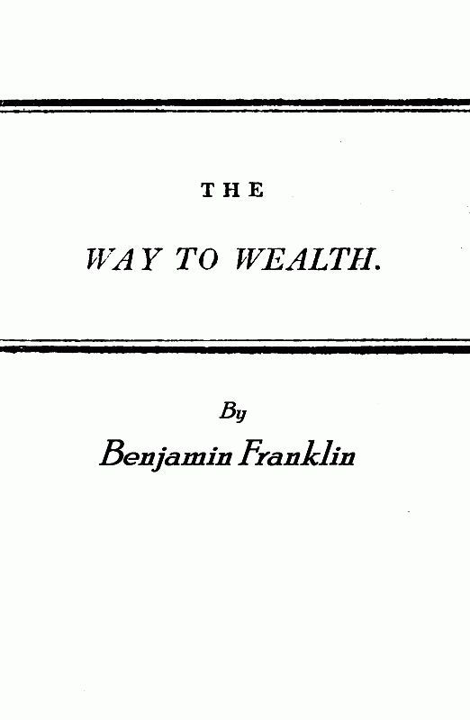

THE
WAY TO WEALTH.

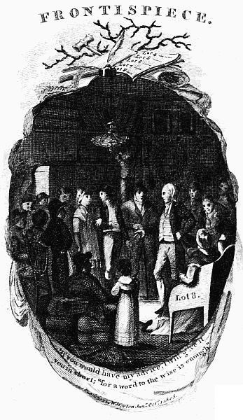

FRANKLIN'S
WAY TO WEALTH;
OR,
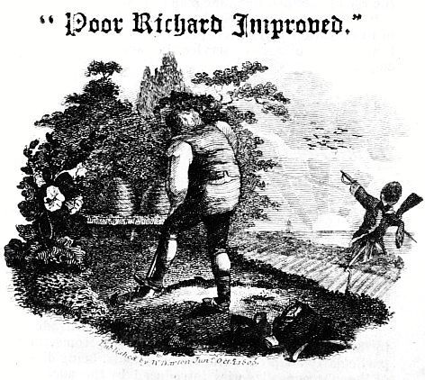
LONDON:
Printed by and for W. and T. Darton,
No. 58, Holborn-Hill.
1810.

To Parents, Governesses, And School Masters.
Just Published,
A GRAMMATICAL CATECHISM for the use of Schools, upon the plan of Lindley Murray.
"This manual is particularly adapted to the purposes of examination and catechetical instruction, and will be found of the utmost service in weekly grammatical enquiries."
This Day is Published, Price 5s. 12mo. bound,
THE PAGAN MYTHOLOGY of ancient Greece and Rome versified, accompanied with Philosophical Elucidations of the probable latent meaning of some of the Fables of the Ancients, on a theory entirely new. By R. ATKINS. Illustrated by twenty-two Cuts on Wood.
"This little work is intended as an easy Introduction to the Mythology of ancient Greece and Rome, and is particularly adapted to the use of Schools, being divested of the obscene allegories introduced by the ancients in their usual figurative style. It is certainly better calculated to convey a general idea of the subject, than any attempt of the kind which has yet fallen under our observation. The Poetical Illustrations are simple, and well calculated to the purpose of becoming a vehicle of instruction to juvenile minds, and the elucidations of the fables are plausible and ingenious."
Repository, June, 1809.
Sold by W. and T. Darton,
58, Holborn Hill.

Introduction.
Dr. Franklin, wishing to collect into one piece all the sayings upon the following subjects, which he had dropped in the course of publishing the Almanacks called "Poor Richard," introduces Father Abraham for this purpose. Hence it is, that Poor Richard is so often quoted, and that, in the present title, he is said to be improved. Notwithstanding the stroke of humour in the concluding paragraph of this address, Poor Richard (Saunders) and Father Abraham have proved, in America, that they are no common preachers. And shall we, brother Englishmen, refuse good sense and saving knowledge, because it comes from the other side of the water?

The following may be had of the Proprietors,
W. & T. DARTON,
And of most Booksellers in the United Kingdom.
Virtue and Innocence, a Poem | 1 | 0
The Economy of Human Life | 1 | 0
Old Friends in a New Dress, or Selections from Esop's Fables, in Verse, 2 parts, plates | 2 | 0
Little Jack Horner, in Verse, plain 1s. coloured | 1 | 6
Portraits of Curious Characters in London, &c. with Biographical and Interesting Anecdotes | 1 | 6
Watt's Catechism and Prayers, in 1 vol. half bound | 1 | 0
Wonders of the Horse, recorded in Anecdotes, Prose and Verse, by Joseph Taylor | 2 | 6
Tales of the Robin & other Small Birds, in Verse, by Joseph Taylor | 2 | 6
Instructive Conversation Cards, consisting of 32 Biographical Sketches of Eminent British Characters | 1 | 6
Ditto, containing a Description of the most distinguished Places in England | 1 | 6
⁂ Just published, The Mice & their Pic Nic; a good Moral Tale, price with neat coloured plates | 1 | 0

The Way To Wealth.
COURTEOUS READER,
I have heard that nothing gives an author so great pleasure, as to find his works respectfully quoted by others. Judge, then, how much I must have been gratified by an incident I am going to relate to you. I stopped my horse, lately, where a great number of people were collected at an auction of merchants' goods. The hour of the sale not being come, they were conversing on the badness of the times; and one of the company called to a plain, clean, old man, with white locks, 'Pray, Father Abraham, what think you of the times? Will not those heavy taxes quite ruin the country! How shall we be ever able to pay them? What would you advise us to?'——Father Abraham stood up, and replied, 'If you would have my advice, I will give it you in short; "for a word to the wise is enough," as Poor Richard says.' They joined in desiring him to speak his mind, and, gathering round him, he proceeded as follows:
'Friends,' says he, 'the taxes are indeed very heavy; and, if those laid on by the government were the only ones we had to pay, we might more easily discharge them; but we have many others, and much more grievous to some of us. We are taxed twice as much by our idleness, three times as much by our pride, and four times as much by our folly; and from these taxes the commissioners cannot ease or deliver us by allowing an abatement. However, let us hearken to good advice, and something may be done for us; "God helps them that help themselves," as Poor Richard says.
I. 'It would be thought a hard government that should tax its people one-tenth part of their time to be employed in its service: but idleness taxes many of us much more; sloth, by bringing on diseases, absolutely shortens life.

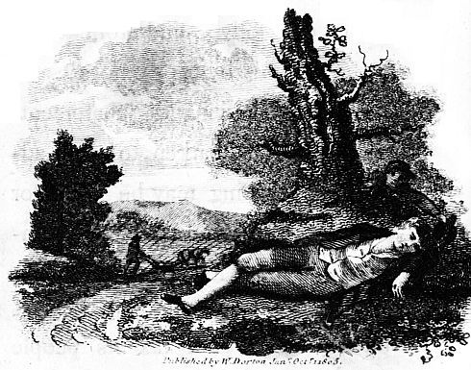
"Sloth, like rust, consumes faster than labour wears, while the used key is always bright," as Poor Richard says.—"But, dost thou love life? then do not squander time, for that is the stuff life is made of," as Poor Richard says.—How much more than is necessary do we spend in sleep! forgetting that, "the sleeping fox catches no poultry, and that there will be sleeping enough in the grave," as Poor Richard says.
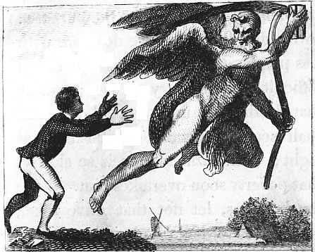
"If time be of all things the most precious, wasting time must be" as Poor Richard says, "the greatest prodigality;" since, as he elsewhere tells us, "Lost time is never found again; and what we call time enough, always proves little enough." Let us then up and be doing, and doing to the purpose: so by diligence shall we do more with less perplexity. "Sloth makes all things difficult, but industry all easy; and he that riseth late, must trot all day, and shall scarce overtake his business at night; while laziness travels so slowly, that poverty soon overtakes him. Drive thy business, let not that drive thee; and early to bed, and early to rise, makes a man healthy, wealthy, and wise," as Poor Richard says.
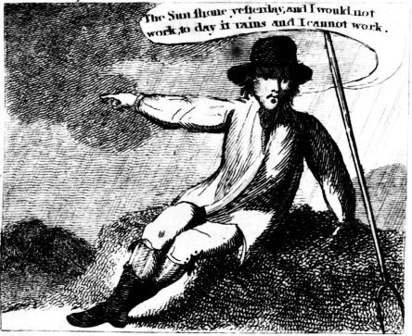
'So what signifies wishing and hoping for better times? We may make these times better, if we bestir ourselves. "Industry need not wish, and he that lives upon hope will die fasting. There are no gains without pains; then help hands, for I have no lands;" or if I have, they are smartly taxed. "He that hath a trade, hath an estate; and he that hath a calling, hath an office of profit and honour," as Poor Richard says; but then the trade must be worked at, and the calling well followed, or neither the estate nor the office will enable us to pay our taxes.—If we are industrious, we shall never starve; for "at the working man's house hunger looks in, but dares not enter." Nor will the bailiff or the constable enter, for "industry pays debts, while despair increaseth them." What, though you have found no treasure, nor has any rich relation left you a legacy. "Diligence is the mother of good luck, and God gives all things to industry. Then plow deep, while sluggards sleep, and you shall have corn to sell and to keep." Work while it is called to-day, for you know not how much you may be hindered to-morrow. "One to-day is worth two to-morrows," as Poor Richard says, and farther, "Never leave that till to-morrow, which you can do to-day."—If you were a servant, would you not be ashamed that a good master should catch you idle? Are you then your own master? be ashamed to catch yourself idle, when there is so much to be done for yourself, your family, your country, and your king. Handle your tools without mittens: remember, that "The cat in gloves catches no mice," as Poor Richard says. It is true, there is much to be done, and, perhaps, you are weak-handed: but stick to it steadily, and you will see great effects; for "Constant dropping wears away stones; and by diligence and patience the mouse ate in two the cable; and little strokes fell great oaks."
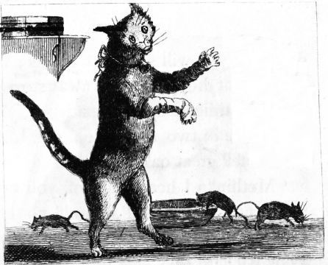
'Methinks I hear some of you say, "Must a man afford himself no leisure?" I will tell thee, my friend, what Poor Richard says, "Employ thy time well, if thou meanest to gain leisure; and, since thou art not sure of a minute, throw not away an hour." Leisure is time for doing something useful; this leisure the diligent man will obtain, but the lazy man never; for "A life of leisure and a life of laziness are two things. Many, without labour, would live by their wits only, but they break for want of stock;" whereas industry gives comfort, and plenty, and respect. "Fly pleasures and they will follow you. The diligent spinner has a large shift; and now I have a sheep and a cow, every body bids me good-morrow."
II. 'But with our industry we must likewise be steady, settled, and careful, and oversee our own affairs with our own eyes, and not trust too much to others: for, as Poor Richard says,
"I never saw an oft-removed tree,
Nor yet an oft-removed family,
That throve so well as those that settled be."
And again, "Three removes are as bad as a fire," and again, "Keep thy shop, and thy shop will keep thee:" and again, "If you would have your business done, go; if not, send." And again,

"He that by the plow would thrive,
Himself must either hold or drive."
'And again, "The eye of the master will do more work than both his hands:" and again, "Want of care does us more damage than want of knowledge;" and again, "Not to oversee workmen, is to leave them your purse open."

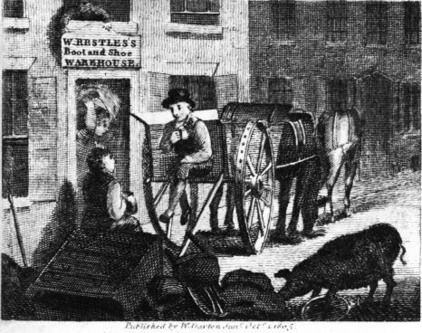
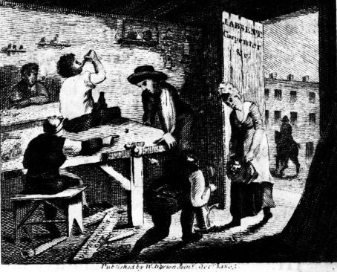
'Trusting too much to others' care is the ruin of many; for, "In the affairs of this world, men are saved, not by faith, but by the want of it:" but a man's own care is profitable; for, "If you would have a faithful servant, and one that you like,—serve yourself. A little neglect may breed great mischief; for want of a nail the shoe was lost; for want of a shoe the horse was lost; and for want of a horse the rider was lost;" being overtaken and slain by the enemy; all for want of a little care about a horse-shoe nail.
III. 'So much for industry, my friends, and attention to one's own business; but to these we must add frugality, if we would make our industry more certainly successful. A man may if he knows not how to save as he gets, "keep his nose all his life to the grindstone, and die not worth a groat at last. A fat kitchen makes a lean will;" and,

"Many estates are spent in the getting,
Since women for tea forsook spinning and knitting,
And men for punch forsook hewing and splitting."
"If you would be wealthy, think of saving, as well as of getting. The Indies have not made Spain rich, because her out-goes are greater than her incomes."
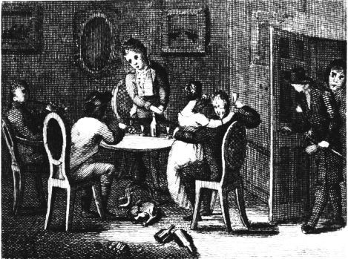
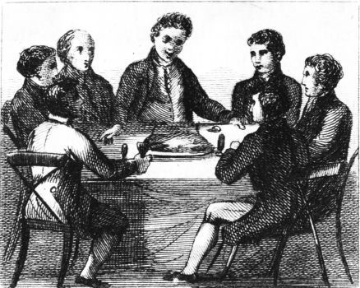

'Away, then, with your expensive follies, and you will not then have so much cause to complain of hard times, heavy taxes, and chargeable families; for,
"Women and wine, game and deceit,
Make the wealth small, and the want great."
And farther, "What maintains one vice, would bring up two children." You may think perhaps, that a little tea, or a little punch now and then, diet a little more costly, clothes a little finer, and a little entertainment now and then, can be no great matter; but remember, "Many a little makes a mickle." Beware of little expences; "A small leak will sink a great ship," as Poor Richard says; and again, "Who dainties love shall beggars prove;" and moreover, "Fools make feasts, and wise men eat them." Here you are all got together to this sale of fineries and nick-nacks. You call them goods; but, if you do not take care, they will prove evils to some of you. You expect they will be sold cheap, and, perhaps, they may for less than they cost; but, if you have no occasion for them, they must be dear to you. Remember what poor Richard says, "Buy what thou hast no need of, and ere long thou shalt sell thy necessaries." And again, "At a great pennyworth pause a while:" he means, that perhaps the cheapness is apparent only, and not real; or the bargain, by straitening thee in thy business, may do thee more harm than good. For, in another place, he says, "Many have been ruined by buying good pennyworths." Again, "It is foolish to lay out money in a purchase of repentance;" and yet this folly is practised every day at auctions, for want of minding the Almanack. Many a one, for the sake of finery on the back, have gone with a hungry belly, and half starved their families; "Silks and satins, scarlet and velvets, put out the kitchen fire," as Poor Richard says. These are not the necessaries of life; they can scarcely be called the conveniences: and yet only because they look pretty, how many want to have them?—By these, and other extravagancies, the genteel are reduced to poverty, and forced to borrow of those whom they formerly despised, but who, through industry and frugality, have maintained their standing; in which case it appears plainly, that "A ploughman on his legs is higher than a gentleman on his knees," as Poor Richard says. Perhaps they have had a small estate left them, which they knew not the getting of; they think "it is day, and will never be night:" that a little to be spent out of so much is not worth minding; but "Always taking out of the meal-tub, and never putting in, soon comes to the bottom," as Poor Richard says; and then, "When the well is dry, they know the worth of water." But this they might have known before, if they had taken his advice. "If you would know the value of money, go and try to borrow some; for he that goes a borrowing, goes a sorrowing," as Poor Richard says; and, indeed, so does he that lends to such people, when he goes to get it in again. Poor Dick farther advises, and says,
"Fond pride of dress is sure a very curse,
Ere fancy you consult, consult your purse."
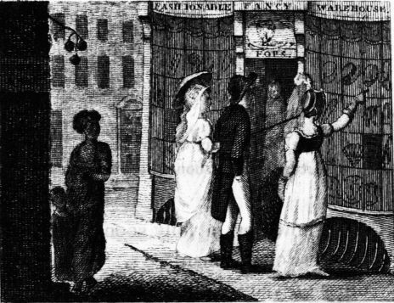
'And again, "Pride is as loud a beggar as Want, and a great deal more saucy." When you have bought one fine thing, you must buy ten more, that your appearance may be all of a piece; but Poor Dick says, "It is easier to suppress the first desire, than to satisfy all that follow it." And it is as truly folly for the poor to ape the rich, as for the frog to swell, in order to equal the ox.
"Vessels large may venture more,
But little boats should keep near shore."
It is, however, a folly soon punished: for, as Poor Richard says, "Pride that dines on vanity, sups on contempt;—Pride breakfasted with Plenty, dined with Poverty and supped with Infamy." And, after all, of what use is this pride of appearance, for which so much is risked, so much is suffered? It cannot promote health, nor ease pain; it makes no increase of merit in the person, it creates envy, it hastens misfortune.

'But what madness it must be to run in debt for these superfluities? We are offered, by the terms of this sale, six months credit; and that, perhaps, has induced some of us to attend it, because we cannot spare the ready money, and hope now to be fine without it. But, ah! think what you do when you run in debt; you give to another power over your liberty, If you cannot pay at the time, you will be ashamed to see your creditor; you will be in fear when you speak to him; you will make poor pitiful sneaking excuses, and, by degrees, come to lose your veracity, and sink into base, downright lying; for, "The second vice is lying, the first is running in debt," as Poor Richard says; and again, to the same purpose, "Lying rides upon Debt's back:" whereas a free-born Englishman ought not to be ashamed nor afraid to see or speak to any man living. But poverty often deprives a man of all spirit and virtue. "It is hard for an empty bag to stand upright."—What would you think of that prince, or of that government, who should issue an edict forbidding you to dress like a gentleman or gentlewoman, on pain of imprisonment or servitude? Would you not say that you were free, have a right to dress as you please, and that such an edict would be a breach of your privileges, and such a government tyrannical? And yet you are about to put yourself under that tyranny, when you run in debt for such dress! Your creditor has authority, at his pleasure, to deprive you of your liberty, by confining you in gaol for life, or by selling you for a servant, if you should not be able to pay him. When you have got your bargain, you may, perhaps, think little of payment; but, as Poor Richard says, "Creditors have better memories than debtors; creditors are a superstitious sect, great observers of set days and times." The day comes round before you are aware, and the demand is made before you are prepared to satisfy it; or, if you bear your debt in mind, the term, which at first seemed so long, will, as it lessens, appear extremely short: "Time will seem to have added wings to his heels as well as his shoulders. Those have a short Lent, who owe money to be paid at Easter." At present, perhaps, you may think yourselves in thriving circumstances, and that you can bear a little extravagance without injury; but
"For age and want save while you may,
No morning sun lasts a whole day."
'Gain may be temporary and uncertain; but ever, while you live, expense is constant and certain; and "It is easier to build two chimneys, than to keep one in fuel," as Poor Richard says: so, "Rather go to bed supper-less, than rise in debt,"
Get what you can, and what you get hold,
'Tis the stone that will turn all your lead into gold.
And when you have got the Philosopher's stone, sure you will no longer complain of bad times, or the difficulty of paying taxes.
IV. 'This doctrine, my friends, is reason and wisdom; but, after all, do not depend too much upon your own industry, and frugality, and prudence, though excellent things; for they may all be blasted without the blessing of Heaven; and therefore, ask that blessing humbly, and be not uncharitable to those that at present seem to want it, but comfort and help them. Remember, Job suffered, and was afterwards prosperous.
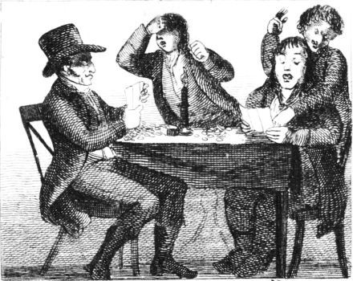
'And now to conclude, "Experience keeps a dear school, but fools will learn in no other," as Poor Richard says, and scarce in that; for it is true, "We may give advice, but we cannot give conduct." However, remember this, "They that will not be counselled cannot be helped;" and farther, that "If you will not hear Reason, she will surely rap your knuckles," as Poor Richard says.'

Thus the old gentleman ended his harangue. The people heard it, and approved the doctrine, and immediately practised the contrary, just as if it had been a common sermon; for the auction opened, and they began to buy extravagantly.—I found the good man had thoroughly studied my Almanacks, and digested all I had dropt on those topics during the course of twenty-five years. The frequent mention he made of me must have tired any one else; but my vanity was wonderfully delighted with it, though I was conscious that not a tenth part of the wisdom was my own, which he ascribed to me; but rather the gleanings that I had made of the sense of all ages and nations. However, I resolved to be the better for the echo of it; and, though I had at first determined to buy stuff for a new coat, I went away, resolved to wear my old one a little longer. Reader, if thou wilt do the same, thy profit will be as great as mine.—I am, as ever, thine to serve thee,
Richard Saunders.
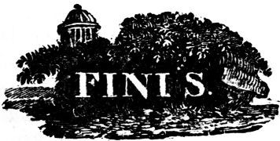
W. and T. Darton, Printers, Holborn-Hill, London.

Transcriber's Notes:
Only the most obvious and clear punctuation errors repaired. The opening single quotes end pages later.
Page 9, "grevious" changed to "grievous" (much more grievous)
Page 11, "waisting" changed to "wasting" (wasting time must be)
Page 12, "mak" changed to "make" (We may make)

*** End Of This Project Gutenberg Ebook ***
Updated editions will replace the previous one—the old editions will be renamed.
Creating the works from print editions not protected by U.S. copyright law means that no one owns a United States copyright in these works, so the Foundation (and you!) can copy and distribute it in the United States without permission and without paying copyright royalties. Special rules, set forth in the General Terms of Use part of this license, apply to copying and distributing Project Gutenberg™ electronic works to protect the PROJECT GUTENBERG™ concept and trademark. Project Gutenberg is a registered trademark, and may not be used if you charge for an eBook, except by following the terms of the trademark license, including paying royalties for use of the Project Gutenberg trademark. If you do not charge anything for copies of this eBook, complying with the trademark license is very easy. You may use this eBook for nearly any purpose such as creation of derivative works, reports, performances and research. Project Gutenberg eBooks may be modified and printed and given away—you may do practically ANYTHING in the United States with eBooks not protected by U.S. copyright law. Redistribution is subject to the trademark license, especially commercial redistribution.
START: FULL LICENSE
The Full Project Gutenberg License
PLEASE READ THIS BEFORE YOU DISTRIBUTE OR USE THIS WORK
To protect the Project Gutenberg™ mission of promoting the free distribution of electronic works, by using or distributing this work (or any other work associated in any way with the phrase “Project Gutenberg”), you agree to comply with all the terms of the Full Project Gutenberg™ License available with this file or online at www.gutenberg.org/license.
Section 1. General Terms of Use and Redistributing Project Gutenberg™ electronic works
1.A. By reading or using any part of this Project Gutenberg™ electronic work, you indicate that you have read, understand, agree to and accept all the terms of this license and intellectual property (trademark/copyright) agreement. If you do not agree to abide by all the terms of this agreement, you must cease using and return or destroy all copies of Project Gutenberg™ electronic works in your possession. If you paid a fee for obtaining a copy of or access to a Project Gutenberg™ electronic work and you do not agree to be bound by the terms of this agreement, you may obtain a refund from the person or entity to whom you paid the fee as set forth in paragraph 1.E.8.
1.B. “Project Gutenberg” is a registered trademark. It may only be used on or associated in any way with an electronic work by people who agree to be bound by the terms of this agreement. There are a few things that you can do with most Project Gutenberg™ electronic works even without complying with the full terms of this agreement. See paragraph 1.C below. There are a lot of things you can do with Project Gutenberg™ electronic works if you follow the terms of this agreement and help preserve free future access to Project Gutenberg™ electronic works. See paragraph 1.E below.
1.C. The Project Gutenberg Literary Archive Foundation (“the Foundation” or PGLAF), owns a compilation copyright in the collection of Project Gutenberg™ electronic works. Nearly all the individual works in the collection are in the public domain in the United States. If an individual work is unprotected by copyright law in the United States and you are located in the United States, we do not claim a right to prevent you from copying, distributing, performing, displaying or creating derivative works based on the work as long as all references to Project Gutenberg are removed. Of course, we hope that you will support the Project Gutenberg™ mission of promoting free access to electronic works by freely sharing Project Gutenberg™ works in compliance with the terms of this agreement for keeping the Project Gutenberg™ name associated with the work. You can easily comply with the terms of this agreement by keeping this work in the same format with its attached full Project Gutenberg™ License when you share it without charge with others.
1.D. The copyright laws of the place where you are located also govern what you can do with this work. Copyright laws in most countries are in a constant state of change. If you are outside the United States, check the laws of your country in addition to the terms of this agreement before downloading, copying, displaying, performing, distributing or creating derivative works based on this work or any other Project Gutenberg™ work. The Foundation makes no representations concerning the copyright status of any work in any country other than the United States.
1.E. Unless you have removed all references to Project Gutenberg:
1.E.1. The following sentence, with active links to, or other immediate access to, the full Project Gutenberg™ License must appear prominently whenever any copy of a Project Gutenberg™ work (any work on which the phrase “Project Gutenberg” appears, or with which the phrase “Project Gutenberg” is associated) is accessed, displayed, performed, viewed, copied or distributed:
This eBook is for the use of anyone anywhere in the United States and most other parts of the world at no cost and with almost no restrictions whatsoever. You may copy it, give it away or re-use it under the terms of the Project Gutenberg License included with this eBook or online at www.gutenberg.org. If you are not located in the United States, you will have to check the laws of the country where you are located before using this eBook.
1.E.2. If an individual Project Gutenberg™ electronic work is derived from texts not protected by U.S. copyright law (does not contain a notice indicating that it is posted with permission of the copyright holder), the work can be copied and distributed to anyone in the United States without paying any fees or charges. If you are redistributing or providing access to a work with the phrase “Project Gutenberg” associated with or appearing on the work, you must comply either with the requirements of paragraphs 1.E.1 through 1.E.7 or obtain permission for the use of the work and the Project Gutenberg™ trademark as set forth in paragraphs 1.E.8 or 1.E.9.
1.E.3. If an individual Project Gutenberg™ electronic work is posted with the permission of the copyright holder, your use and distribution must comply with both paragraphs 1.E.1 through 1.E.7 and any additional terms imposed by the copyright holder. Additional terms will be linked to the Project Gutenberg™ License for all works posted with the permission of the copyright holder found at the beginning of this work.
1.E.4. Do not unlink or detach or remove the full Project Gutenberg™ License terms from this work, or any files containing a part of this work or any other work associated with Project Gutenberg™.
1.E.5. Do not copy, display, perform, distribute or redistribute this electronic work, or any part of this electronic work, without prominently displaying the sentence set forth in paragraph 1.E.1 with active links or immediate access to the full terms of the Project Gutenberg™ License.
1.E.6. You may convert to and distribute this work in any binary, compressed, marked up, nonproprietary or proprietary form, including any word processing or hypertext form. However, if you provide access to or distribute copies of a Project Gutenberg™ work in a format other than “Plain Vanilla ASCII” or other format used in the official version posted on the official Project Gutenberg™ website (www.gutenberg.org), you must, at no additional cost, fee or expense to the user, provide a copy, a means of exporting a copy, or a means of obtaining a copy upon request, of the work in its original “Plain Vanilla ASCII” or other form. Any alternate format must include the full Project Gutenberg™ License as specified in paragraph 1.E.1.
1.E.7. Do not charge a fee for access to, viewing, displaying, performing, copying or distributing any Project Gutenberg™ works unless you comply with paragraph 1.E.8 or 1.E.9.
1.E.8. You may charge a reasonable fee for copies of or providing access to or distributing Project Gutenberg™ electronic works provided that:
• You pay a royalty fee of 20% of the gross profits you derive from the use of Project Gutenberg™ works calculated using the method you already use to calculate your applicable taxes. The fee is owed to the owner of the Project Gutenberg™ trademark, but he has agreed to donate royalties under this paragraph to the Project Gutenberg Literary Archive Foundation. Royalty payments must be paid within 60 days following each date on which you prepare (or are legally required to prepare) your periodic tax returns. Royalty payments should be clearly marked as such and sent to the Project Gutenberg Literary Archive Foundation at the address specified in Section 4, “Information about donations to the Project Gutenberg Literary Archive Foundation.”
• You provide a full refund of any money paid by a user who notifies you in writing (or by e-mail) within 30 days of receipt that s/he does not agree to the terms of the full Project Gutenberg™ License. You must require such a user to return or destroy all copies of the works possessed in a physical medium and discontinue all use of and all access to other copies of Project Gutenberg™ works.
• You provide, in accordance with paragraph 1.F.3, a full refund of any money paid for a work or a replacement copy, if a defect in the electronic work is discovered and reported to you within 90 days of receipt of the work.
• You comply with all other terms of this agreement for free distribution of Project Gutenberg™ works.
1.E.9. If you wish to charge a fee or distribute a Project Gutenberg™ electronic work or group of works on different terms than are set forth in this agreement, you must obtain permission in writing from the Project Gutenberg Literary Archive Foundation, the manager of the Project Gutenberg™ trademark. Contact the Foundation as set forth in Section 3 below.
1.F.
1.F.1. Project Gutenberg volunteers and employees expend considerable effort to identify, do copyright research on, transcribe and proofread works not protected by U.S. copyright law in creating the Project Gutenberg™ collection. Despite these efforts, Project Gutenberg™ electronic works, and the medium on which they may be stored, may contain “Defects,” such as, but not limited to, incomplete, inaccurate or corrupt data, transcription errors, a copyright or other intellectual property infringement, a defective or damaged disk or other medium, a computer virus, or computer codes that damage or cannot be read by your equipment.
1.F.2. LIMITED WARRANTY, DISCLAIMER OF DAMAGES - Except for the “Right of Replacement or Refund” described in paragraph 1.F.3, the Project Gutenberg Literary Archive Foundation, the owner of the Project Gutenberg™ trademark, and any other party distributing a Project Gutenberg™ electronic work under this agreement, disclaim all liability to you for damages, costs and expenses, including legal fees. YOU AGREE THAT YOU HAVE NO REMEDIES FOR NEGLIGENCE, STRICT LIABILITY, BREACH OF WARRANTY OR BREACH OF CONTRACT EXCEPT THOSE PROVIDED IN PARAGRAPH 1.F.3. YOU AGREE THAT THE FOUNDATION, THE TRADEMARK OWNER, AND ANY DISTRIBUTOR UNDER THIS AGREEMENT WILL NOT BE LIABLE TO YOU FOR ACTUAL, DIRECT, INDIRECT, CONSEQUENTIAL, PUNITIVE OR INCIDENTAL DAMAGES EVEN IF YOU GIVE NOTICE OF THE POSSIBILITY OF SUCH DAMAGE.
1.F.3. LIMITED RIGHT OF REPLACEMENT OR REFUND - If you discover a defect in this electronic work within 90 days of receiving it, you can receive a refund of the money (if any) you paid for it by sending a written explanation to the person you received the work from. If you received the work on a physical medium, you must return the medium with your written explanation. The person or entity that provided you with the defective work may elect to provide a replacement copy in lieu of a refund. If you received the work electronically, the person or entity providing it to you may choose to give you a second opportunity to receive the work electronically in lieu of a refund. If the second copy is also defective, you may demand a refund in writing without further opportunities to fix the problem.
1.F.4. Except for the limited right of replacement or refund set forth in paragraph 1.F.3, this work is provided to you ‘AS-IS’, WITH NO OTHER WARRANTIES OF ANY KIND, EXPRESS OR IMPLIED, INCLUDING BUT NOT LIMITED TO WARRANTIES OF MERCHANTABILITY OR FITNESS FOR ANY PURPOSE.
1.F.5. Some states do not allow disclaimers of certain implied warranties or the exclusion or limitation of certain types of damages. If any disclaimer or limitation set forth in this agreement violates the law of the state applicable to this agreement, the agreement shall be interpreted to make the maximum disclaimer or limitation permitted by the applicable state law. The invalidity or unenforceability of any provision of this agreement shall not void the remaining provisions.
1.F.6. INDEMNITY - You agree to indemnify and hold the Foundation, the trademark owner, any agent or employee of the Foundation, anyone providing copies of Project Gutenberg™ electronic works in accordance with this agreement, and any volunteers associated with the production, promotion and distribution of Project Gutenberg™ electronic works, harmless from all liability, costs and expenses, including legal fees, that arise directly or indirectly from any of the following which you do or cause to occur: (a) distribution of this or any Project Gutenberg™ work, (b) alteration, modification, or additions or deletions to any Project Gutenberg™ work, and (c) any Defect you cause.
Section 2. Information about the Mission of Project Gutenberg™
Project Gutenberg™ is synonymous with the free distribution of electronic works in formats readable by the widest variety of computers including obsolete, old, middle-aged and new computers. It exists because of the efforts of hundreds of volunteers and donations from people in all walks of life.
Volunteers and financial support to provide volunteers with the assistance they need are critical to reaching Project Gutenberg™’s goals and ensuring that the Project Gutenberg™ collection will remain freely available for generations to come. In 2001, the Project Gutenberg Literary Archive Foundation was created to provide a secure and permanent future for Project Gutenberg™ and future generations. To learn more about the Project Gutenberg Literary Archive Foundation and how your efforts and donations can help, see Sections 3 and 4 and the Foundation information page at www.gutenberg.org.
Section 3. Information about the Project Gutenberg Literary Archive Foundation
The Project Gutenberg Literary Archive Foundation is a non-profit 501(c)(3) educational corporation organized under the laws of the state of Mississippi and granted tax exempt status by the Internal Revenue Service. The Foundation’s EIN or federal tax identification number is 64-6221541. Contributions to the Project Gutenberg Literary Archive Foundation are tax deductible to the full extent permitted by U.S. federal laws and your state’s laws.
The Foundation’s business office is located at 809 North 1500 West, Salt Lake City, UT 84116, (801) 596-1887. Email contact links and up to date contact information can be found at the Foundation’s website and official page at www.gutenberg.org/contact
Section 4. Information about Donations to the Project Gutenberg Literary Archive Foundation
Project Gutenberg™ depends upon and cannot survive without widespread public support and donations to carry out its mission of increasing the number of public domain and licensed works that can be freely distributed in machine-readable form accessible by the widest array of equipment including outdated equipment. Many small donations ($1 to $5,000) are particularly important to maintaining tax exempt status with the IRS.
The Foundation is committed to complying with the laws regulating charities and charitable donations in all 50 states of the United States. Compliance requirements are not uniform and it takes a considerable effort, much paperwork and many fees to meet and keep up with these requirements. We do not solicit donations in locations where we have not received written confirmation of compliance. To SEND DONATIONS or determine the status of compliance for any particular state visit www.gutenberg.org/donate.
While we cannot and do not solicit contributions from states where we have not met the solicitation requirements, we know of no prohibition against accepting unsolicited donations from donors in such states who approach us with offers to donate.
International donations are gratefully accepted, but we cannot make any statements concerning tax treatment of donations received from outside the United States. U.S. laws alone swamp our small staff.
Please check the Project Gutenberg web pages for current donation methods and addresses. Donations are accepted in a number of other ways including checks, online payments and credit card donations. To donate, please visit: www.gutenberg.org/donate
Section 5. General Information About Project Gutenberg™ electronic works
Professor Michael S. Hart was the originator of the Project Gutenberg™ concept of a library of electronic works that could be freely shared with anyone. For forty years, he produced and distributed Project Gutenberg™ eBooks with only a loose network of volunteer support.
Project Gutenberg™ eBooks are often created from several printed editions, all of which are confirmed as not protected by copyright in the U.S. unless a copyright notice is included. Thus, we do not necessarily keep eBooks in compliance with any particular paper edition.
Most people start at our website which has the main PG search facility: www.gutenberg.org.
This website includes information about Project Gutenberg™, including how to make donations to the Project Gutenberg Literary Archive Foundation, how to help produce our new eBooks, and how to subscribe to our email newsletter to hear about new eBooks.
The Project Gutenberg eBook of Franklin's Way to Wealth; or, "Poor Richard Improved", by Benjamin Franklin
This ebook is for the use of anyone anywhere in the United States and most other parts of the world at no cost and with almost no restrictions whatsoever. You may copy it, give it away or re-use it under the terms of the Project Gutenberg License included with this ebook or online at https://www.gutenberg.org/license. If you are not located in the United States, you’ll have to check the laws of the country where you are located before using this eBook.
Title: Franklin's Way to Wealth; or, "Poor Richard Improved"
Author: Benjamin Franklin
Release Date: October 1, 2013 [EBook #43855]
Language: English
Credits: Produced by Chris Curnow, Emmy and the Online Distributed Proofreading Team at http://www.pgdp.net

*** START OF THIS PROJECT GUTENBERG EBOOK ***
The cover image was created by the transcriber and is placed in the public domain.

