The Scarlet Plague
Jack London
2007-06-29

THE SCARLET PLAGUE
By Jack London

Illustrated By Gordon Grant

1915

CONTENTS /x/

THE SCARLET PLAGUE
I
II
III
IV
V
VI

Illustrations

Slowly he Pulled the Bowstring Taut 020
Rabbit is Good, Very Good 026
This Attracted the Old Man's Nostrils 033
With a Sling Such As David Carried 036
I Was a Professor of English Literature 054
Sixty Years Since I Have Seen a Piece of Soap. 059
Granser, You Make Me Sick With Your Gabble 071
But This New Plague Was Quicker 078
The Telephone Bell Rang 088
Fled from the City by Millions 092
I Heard Sounds of Rioting and Of Pistol Shots 098
Look at Yourself in the Mirror 100
Now in the Time of Calamity They Turned on Us 108
He Told Me he Had Been Cruelly Beaten 112
We Thrust Her Forth from the Building 121
She Fell Like a Plummet to the Earth 132
With My Horse and Dogs And Pony, I Set out 144
Everybody Called Him Chauffeur 149
Vesta the One Woman 150
There She Was, Boiling Fish-chowder 153
And Her the Chauffeur Beat and Made his Slave 158
Found Evidences of a Recently Occupied Camp 169
I Have Stored Many Books in a Cave 179

The Scarlet Plague
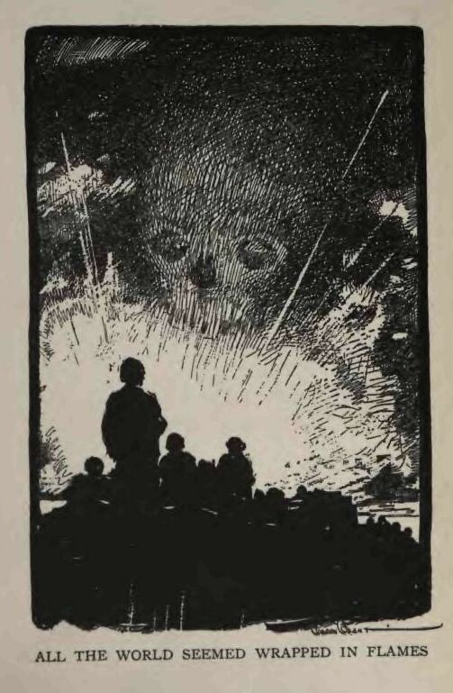

I
THE way led along upon what had once been the embankment of a railroad. But no train had run upon it for many years. The forest on either side swelled up the slopes of the embankment and crested across it in a green wave of trees and bushes. The trail was as narrow as a man's body, and was no more than a wild-animal runway. Occasionally, a piece of rusty iron, showing through the forest-mould, advertised that the rail and the ties still remained. In one place, a ten-inch tree, bursting through at a connection, had lifted the end of a rail clearly into view. The tie had evidently followed the rail, held to it by the spike long enough for its bed to be filled with gravel and rotten leaves, so that now the crumbling, rotten timber thrust itself up at a curious slant. Old as the road was, it was manifest that it had been of the mono-rail type.
An old man and a boy travelled along this runway. They moved slowly, for the old man was very old, a touch of palsy made his movements tremulous, and he leaned heavily upon his staff. A rude skull-cap of goat-skin protected his head from the sun. From beneath this fell a scant fringe of stained and dirty-white hair. A visor, ingeniously made from a large leaf, shielded his eyes, and from under this he peered at the way of his feet on the trail. His beard, which should have been snow-white but which showed the same weather-wear and camp-stain as his hair, fell nearly to his waist in a great tangled mass. About his chest and shoulders hung a single, mangy garment of goat-skin. His arms and legs, withered and skinny, betokened extreme age, as well as did their sunburn and scars and scratches betoken long years of exposure to the elements.
The boy, who led the way, checking the eagerness of his muscles to the slow progress of the elder, likewise wore a single garment—a ragged-edged piece of bear-skin, with a hole in the middle through which he had thrust his head. He could not have been more than twelve years old. Tucked coquettishly over one ear was the freshly severed tail of a pig. In one hand he carried a medium-sized bow and an arrow.
On his back was a quiverful of arrows. From a sheath hanging about his neck on a thong, projected the battered handle of a hunting knife. He was as brown as a berry, and walked softly, with almost a catlike tread. In marked contrast with his sunburned skin were his eyes—blue, deep blue, but keen and sharp as a pair of gimlets. They seemed to bore into aft about him in a way that was habitual. As he went along he smelled things, as well, his distended, quivering nostrils carrying to his brain an endless series of messages from the outside world. Also, his hearing was acute, and had been so trained that it operated automatically. Without conscious effort, he heard all the slight sounds in the apparent quiet—heard, and differentiated, and classified these sounds—whether they were of the wind rustling the leaves, of the humming of bees and gnats, of the distant rumble of the sea that drifted to him only in lulls, or of the gopher, just under his foot, shoving a pouchful of earth into the entrance of his hole.
Suddenly he became alertly tense. Sound, sight, and odor had given him a simultaneous warning. His hand went back to the old man, touching him, and the pair stood still. Ahead, at one side of the top of the embankment, arose a crackling sound, and the boy's gaze was fixed on the tops of the agitated bushes. Then a large bear, a grizzly, crashed into view, and likewise stopped abruptly, at sight of the humans. He did not like them, and growled querulously. Slowly the boy fitted the arrow to the bow, and slowly he pulled the bowstring taut. But he never removed his eyes from the bear.

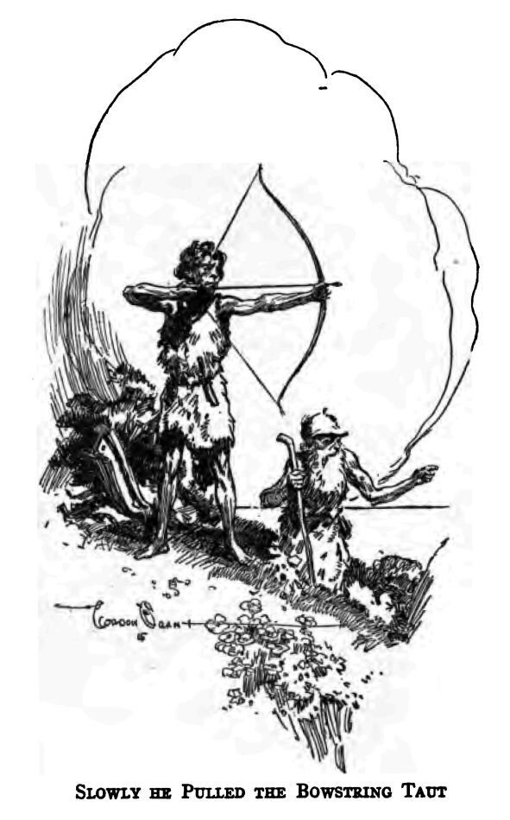
The old man peered from under his green leaf at the danger, and stood as quietly as the boy. For a few seconds this mutual scrutinizing went on; then, the bear betraying a growing irritability, the boy, with a movement of his head, indicated that the old man must step aside from the trail and go down the embankment. The boy followed, going backward, still holding the bow taut and ready. They waited till a crashing among the bushes from the opposite side of the embankment told them the bear had gone on. The boy grinned as he led back to the trail.
“A big un, Granser,” he chuckled.
The old man shook his head.
“They get thicker every day,” he complained in a thin, undependable falsetto. “Who'd have thought I'd live to see the time when a man would be afraid of his life on the way to the Cliff House. When I was a boy, Edwin, men and women and little babies used to come out here from San Francisco by tens of thousands on a nice day. And there weren't any bears then. No, sir. They used to pay money to look at them in cages, they were that rare.”
“What is money, Granser?”
Before the old man could answer, the boy recollected and triumphantly shoved his hand into a pouch under his bear-skin and pulled forth a battered and tarnished silver dollar. The old man's eyes glistened, as he held the coin close to them.
“I can't see,” he muttered. “You look and see if you can make out the date, Edwin.”
The boy laughed.
“You're a great Granser,” he cried delightedly, “always making believe them little marks mean something.”
The old man manifested an accustomed chagrin as he brought the coin back again close to his own eyes.
“2012,” he shrilled, and then fell to cackling grotesquely. “That was the year Morgan the Fifth was appointed President of the United States by the Board of Magnates. It must have been one of the last coins minted, for the Scarlet Death came in 2013. Lord! Lord!—think of it! Sixty years ago, and I am the only person alive to-day that lived in those times. Where did you find it, Edwin?”
The boy, who had been regarding him with the tolerant curiousness one accords to the prattlings of the feeble-minded, answered promptly.
“I got it off of Hoo-Hoo. He found it when we was herdin' goats down near San José last spring. Hoo-Hoo said it was money. Ain't you hungry, Granser?”
The ancient caught his staff in a tighter grip and urged along the trail, his old eyes shining greedily.
“I hope Hare-Lip 's found a crab... or two,” he mumbled. “They're good eating, crabs, mighty good eating when you've no more teeth and you've got grandsons that love their old grandsire and make a point of catching crabs for him. When I was a boy—”
But Edwin, suddenly stopped by what he saw, was drawing the bowstring on a fitted arrow. He had paused on the brink of a crevasse in the embankment. An ancient culvert had here washed out, and the stream, no longer confined, had cut a passage through the fill. On the opposite side, the end of a rail projected and overhung. It showed rustily through the creeping vines which overran it. Beyond, crouching by a bush, a rabbit looked across at him in trembling hesitancy. Fully fifty feet was the distance, but the arrow flashed true; and the transfixed rabbit, crying out in sudden fright and hurt, struggled painfully away into the brush. The boy himself was a flash of brown skin and flying fur as he bounded down the steep wall of the gap and up the other side. His lean muscles were springs of steel that released into graceful and efficient action. A hundred feet beyond, in a tangle of bushes, he overtook the wounded creature, knocked its head on a convenient tree-trunk, and turned it over to Granser to carry.

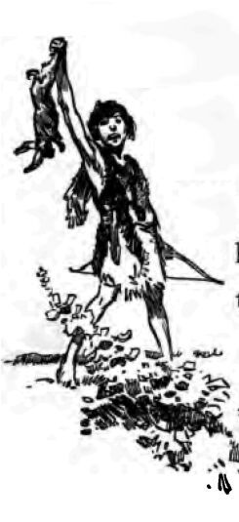
“Rabbit is good, very good,” the ancient quavered, “but when it comes to a toothsome delicacy I prefer crab. When I was a boy—”
“Why do you say so much that ain't got no sense?” Edwin impatiently interrupted the other's threatened garrulousness.
The boy did not exactly utter these words, but something that remotely resembled them and that was more guttural and explosive and economical of qualifying phrases. His speech showed distant kinship with that of the old man, and the latter's speech was approximately an English that had gone through a bath of corrupt usage.
“What I want to know,” Edwin continued, “is why you call crab 'toothsome delicacy'? Crab is crab, ain't it? No one I never heard calls it such funny things.”
The old man sighed but did not answer, and they moved on in silence. The surf grew suddenly louder, as they emerged from the forest upon a stretch of sand dunes bordering the sea. A few goats were browsing among the sandy hillocks, and a skin-clad boy, aided by a wolfish-looking dog that was only faintly reminiscent of a collie, was watching them. Mingled with the roar of the surf was a continuous, deep-throated barking or bellowing, which came from a cluster of jagged rocks a hundred yards out from shore. Here huge sea-lions hauled themselves up to lie in the sun or battle with one another. In the immediate foreground arose the smoke of a fire, tended by a third savage-looking boy. Crouched near him were several wolfish dogs similar to the one that guarded the goats.
The old man accelerated his pace, sniffing eagerly as he neared the fire.
“Mussels!” he muttered ecstatically. “Mussels! And ain't that a crab, Hoo-Hoo? Ain't that a crab? My, my, you boys are good to your old grandsire.”
Hoo-Hoo, who was apparently of the same age as Edwin, grinned.
“All you want, Granser. I got four.”
The old man's palsied eagerness was pitiful. Sitting down in the sand as quickly as his stiff limbs would let him, he poked a large rock-mussel from out of the coals. The heat had forced its shells apart, and the meat, salmon-colored, was thoroughly cooked. Between thumb and forefinger, in trembling haste, he caught the morsel and carried it to his mouth. But it was too hot, and the next moment was violently ejected. The old man spluttered with the pain, and tears ran out of his eyes and down his cheeks.
The boys were true savages, possessing only the cruel humor of the savage. To them the incident was excruciatingly funny, and they burst into loud laughter. Hoo-Hoo danced up and down, while Edwin rolled gleefully on the ground. The boy with the goats came running to join in the fun.
“Set 'em to cool, Edwin, set 'em to cool,” the old man besought, in the midst of his grief, making no attempt to wipe away the tears that still flowed from his eyes. “And cool a crab, Edwin, too. You know your grandsire likes crabs.”
From the coals arose a great sizzling, which proceeded from the many mussels bursting open their shells and exuding their moisture. They were large shellfish, running from three to six inches in length. The boys raked them out with sticks and placed them on a large piece of driftwood to cool.
“When I was a boy, we did not laugh at our elders; we respected them.”
The boys took no notice, and Granser continued to babble an incoherent flow of complaint and censure. But this time he was more careful, and did not burn his mouth. All began to eat, using nothing but their hands and making loud mouth-noises and lip-smackings. The third boy, who was called Hare-Lip, slyly deposited a pinch of sand on a mussel the ancient was carrying to his mouth; and when the grit of it bit into the old fellow's mucous membrane and gums, the laughter was again uproarious. He was unaware that a joke had been played on him, and spluttered and spat until Edwin, relenting, gave him a gourd of fresh water with which to wash out his mouth.
“Where's them crabs, Hoo-Hoo?” Edwin demanded. “Granser's set upon having a snack.”
Again Granser's eyes burned with greediness as a large crab was handed to him. It was a shell with legs and all complete, but the meat had long since departed. With shaky fingers and babblings of anticipation, the old man broke off a leg and found it filled with emptiness.
“The crabs, Hoo-Hoo?” he wailed. “The crabs?”
“I was fooling Granser. They ain't no crabs! I never found one.”
The boys were overwhelmed with delight at sight of the tears of senile disappointment that dribbled down the old man's cheeks. Then, unnoticed, Hoo-Hoo replaced the empty shell with a fresh-cooked crab. Already dismembered, from the cracked legs the white meat sent forth a small cloud of savory steam. This attracted the old man's nostrils, and he looked down in amazement.

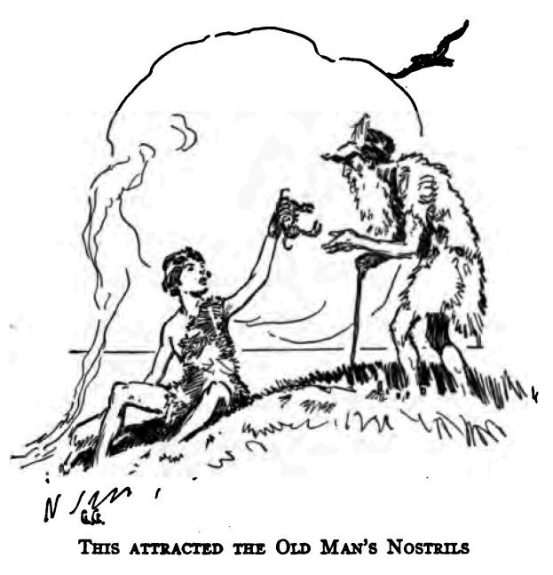
The change of his mood to one of joy was immediate. He snuffled and muttered and mumbled, making almost a croon of delight, as he began to eat. Of this the boys took little notice, for it was an accustomed spectacle. Nor did they notice his occasional exclamations and utterances of phrases which meant nothing to them, as, for instance, when he smacked his lips and champed his gums while muttering: “Mayonnaise! Just think—mayonnaise! And it's sixty years since the last was ever made! Two generations and never a smell of it! Why, in those days it was served in every restaurant with crab.”
When he could eat no more, the old man sighed, wiped his hands on his naked legs, and gazed out over the sea. With the content of a full stomach, he waxed reminiscent.
“To think of it! I've seen this beach alive with men, women, and children on a pleasant Sunday. And there weren't any bears to eat them up, either. And right up there on the cliff was a big restaurant where you could get anything you wanted to eat. Four million people lived in San Francisco then. And now, in the whole city and county there aren't forty all told. And out there on the sea were ships and ships always to be seen, going in for the Golden Gate or coming out. And airships in the air—dirigibles and flying machines. They could travel two hundred miles an hour. The mail contracts with the New York and San Francisco Limited demanded that for the minimum. There was a chap, a Frenchman, I forget his name, who succeeded in making three hundred; but the thing was risky, too risky for conservative persons. But he was on the right clew, and he would have managed it if it hadn't been for the Great Plague. When I was a boy, there were men alive who remembered the coming of the first aeroplanes, and now I have lived to see the last of them, and that sixty years ago.”
The old man babbled on, unheeded by the boys, who were long accustomed to his garrulousness, and whose vocabularies, besides, lacked the greater portion of the words he used. It was noticeable that in these rambling soliloquies his English seemed to recrudesce into better construction and phraseology. But when he talked directly with the boys it lapsed, largely, into their own uncouth and simpler forms.
“But there weren't many crabs in those days,” the old man wandered on. “They were fished out, and they were great delicacies. The open season was only a month long, too. And now crabs are accessible the whole year around. Think of it—catching all the crabs you want, any time you want, in the surf of the Cliff House beach!”
A sudden commotion among the goats brought the boys to their feet. The dogs about the fire rushed to join their snarling fellow who guarded the goats, while the goats themselves stampeded in the direction of their human protectors. A half dozen forms, lean and gray, glided about on the sand hillocks and faced the bristling dogs. Edwin arched an arrow that fell short. But Hare-Lip, with a sling such as David carried into battle against Goliath, hurled a stone through the air that whistled from the speed of its flight. It fell squarely among the wolves and caused them to slink away toward the dark depths of the eucalyptus forest.

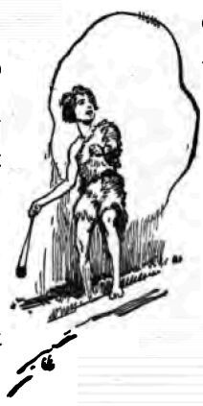
The boys laughed and lay down again in the sand, while Granser sighed ponderously. He had eaten too much, and, with hands clasped on his paunch, the fingers interlaced, he resumed his maunderings.
“'The fleeting systems lapse like foam,'” he mumbled what was evidently a quotation. “That's it—foam, and fleeting. All man's toil upon the planet was just so much foam. He domesticated the serviceable animals, destroyed the hostile ones, and cleared the land of its wild vegetation. And then he passed, and the flood of primordial life rolled back again, sweeping his handiwork away—the weeds and the forest inundated his fields, the beasts of prey swept over his flocks, and now there are wolves on the Cliff House beach.” He was appalled by the thought. “Where four million people disported themselves, the wild wolves roam to-day, and the savage progeny of our loins, with prehistoric weapons, defend themselves against the fanged despoilers. Think of it! And all because of the Scarlet Death—”
The adjective had caught Hare-Lip's ear.
“He's always saying that,” he said to Edwin. “What is scarlet?”
“'The scarlet of the maples can shake me like the cry of bugles going by,'” the old man quoted.
“It's red,” Edwin answered the question. “And you don't know it because you come from the Chauffeur Tribe. They never did know nothing, none of them. Scarlet is red—I know that.”
“Red is red, ain't it?” Hare-Lip grumbled. “Then what's the good of gettin' cocky and calling it scarlet?”
“Granser, what for do you always say so much what nobody knows?” he asked. “Scarlet ain't anything, but red is red. Why don't you say red, then?”
“Red is not the right word,” was the reply. “The plague was scarlet. The whole face and body turned scarlet in an hour's time. Don't I know? Didn't I see enough of it? And I am telling you it was scarlet because—well, because it was scarlet. There is no other word for it.”
“Red is good enough for me,” Hare-Lip muttered obstinately. “My dad calls red red, and he ought to know. He says everybody died of the Red Death.”
“Your dad is a common fellow, descended from a common fellow,” Granser retorted heatedly. “Don't I know the beginnings of the Chauffeurs? Your grandsire was a chauffeur, a servant, and without education. He worked for other persons. But your grandmother was of good stock, only the children did not take after her. Don't I remember when I first met them, catching fish at Lake Temescal?”
“What is education?” Edwin asked.
“Calling red scarlet,” Hare-Lip sneered, then returned to the attack on Granser. “My dad told me, an' he got it from his dad afore he croaked, that your wife was a Santa Rosan, an' that she was sure no account. He said she was a hash-slinger before the Red Death, though I don't know what a hash-slinger is. You can tell me, Edwin.”
But Edwin shook his head in token of ignorance.
“It is true, she was a waitress,” Granser acknowledged. “But she was a good woman, and your mother was her daughter. Women were very scarce in the days after the Plague. She was the only wife I could find, even if she was a hash-slinger, as your father calls it. But it is not nice to talk about our progenitors that way.”
“Dad says that the wife of the first Chauffeur was a lady—”
“What's a lady?” Hoo-Hoo demanded.
“A lady 's a Chauffeur squaw,” was the quick reply of Hare-Lip.
“The first Chauffeur was Bill, a common fellow, as I said before,” the old man expounded; “but his wife was a lady, a great lady. Before the Scarlet Death she was the wife of Van Worden. He was President of the Board of Industrial Magnates, and was one of the dozen men who ruled America. He was worth one billion, eight hundred millions of dollars—coins like you have there in your pouch, Edwin. And then came the Scarlet Death, and his wife became the wife of Bill, the first Chauffeur. He used to beat her, too. I have seen it myself.”
Hoo-Hoo, lying on his stomach and idly digging his toes in the sand, cried out and investigated, first, his toe-nail, and next, the small hole he had dug. The other two boys joined him, excavating the sand rapidly with their hands till there lay three skeletons exposed. Two were of adults, the third being that of a part-grown child. The old man trudged along on the ground and peered at the find.
“Plague victims,” he announced. “That's the way they died everywhere in the last days. This must have been a family, running away from the contagion and perishing here on the Cliff House beach. They—what are you doing, Edwin?”
This question was asked in sudden dismay, as Edwin, using the back of his hunting knife, began to knock out the teeth from the jaws of one of the skulls.
“Going to string 'em,” was the response.
The three boys were now hard at it; and quite a knocking and hammering arose, in which Granser babbled on unnoticed.
“You are true savages. Already has begun the custom of wearing human teeth. In another generation you will be perforating your noses and ears and wearing ornaments of bone and shell. I know. The human race is doomed to sink back farther and farther into the primitive night ere again it begins its bloody climb upward to civilization. When we increase and feel the lack of room, we will proceed to kill one another. And then I suppose you will wear human scalp-locks at your waist, as well—as you, Edwin, who are the gentlest of my grandsons, have already begun with that vile pigtail. Throw it away, Edwin, boy; throw it away.”
“What a gabble the old geezer makes,” Hare-Lip remarked, when, the teeth all extracted, they began an attempt at equal division.
They were very quick and abrupt in their actions, and their speech, in moments of hot discussion over the allotment of the choicer teeth, was truly a gabble. They spoke in monosyllables and short jerky sentences that was more a gibberish than a language. And yet, through it ran hints of grammatical construction, and appeared vestiges of the conjugation of some superior culture. Even the speech of Granser was so corrupt that were it put down literally it would be almost so much nonsense to the reader. This, however, was when he talked with the boys.
When he got into the full swing of babbling to himself, it slowly purged itself into pure English. The sentences grew longer and were enunciated with a rhythm and ease that was reminiscent of the lecture platform.
“Tell us about the Red Death, Granser,” Hare-Lip demanded, when the teeth affair had been satisfactorily concluded.
“The Scarlet Death,” Edwin corrected.
“An' don't work all that funny lingo on us,” Hare-Lip went on. “Talk sensible, Granser, like a Santa Rosan ought to talk. Other Santa Rosans don't talk like you.”

II
THE old man showed pleasure in being thus called upon. He cleared his throat and began.
“Twenty or thirty years ago my story was in great demand. But in these days nobody seems interested—”
“There you go!” Hare-Lip cried hotly. “Cut out the funny stuff and talk sensible. What's interested? You talk like a baby that don't know how.”
“Let him alone,” Edwin urged, “or he'll get mad and won't talk at all. Skip the funny places. We'll catch on to some of what he tells us.”
“Let her go, Granser,” Hoo-Hoo encouraged; for the old man was already maundering about the disrespect for elders and the reversion to cruelty of all humans that fell from high culture to primitive conditions.
The tale began.
“There were very many people in the world in those days. San Francisco alone held four millions—”
“What is millions?” Edwin interrupted.
Granser looked at him kindly.
“I know you cannot count beyond ten, so I will tell you. Hold up your two hands. On both of them you have altogether ten fingers and thumbs. Very well. I now take this grain of sand—you hold it, Hoo-Hoo.” He dropped the grain of sand into the lad's palm and went on. “Now that grain of sand stands for the ten fingers of Edwin. I add another grain. That's ten more fingers. And I add another, and another, and another, until I have added as many grains as Edwin has fingers and thumbs. That makes what I call one hundred. Remember that word—one hundred. Now I put this pebble in Hare-Lip's hand. It stands for ten grains of sand, or ten tens of fingers, or one hundred fingers. I put in ten pebbles. They stand for a thousand fingers. I take a mussel-shell, and it stands for ten pebbles, or one hundred grains of sand, or one thousand fingers....” And so on, laboriously, and with much reiteration, he strove to build up in their minds a crude conception of numbers. As the quantities increased, he had the boys holding different magnitudes in each of their hands. For still higher sums, he laid the symbols on the log of driftwood; and for symbols he was hard put, being compelled to use the teeth from the skulls for millions, and the crab-shells for billions. It was here that he stopped, for the boys were showing signs of becoming tired.
“There were four million people in San Francisco—four teeth.”
The boys' eyes ranged along from the teeth and from hand to hand, down through the pebbles and sand-grains to Edwin's fingers. And back again they ranged along the ascending series in the effort to grasp such inconceivable numbers.
“That was a lot of folks, Granser,” Edwin at last hazarded.
“Like sand on the beach here, like sand on the beach, each grain of sand a man, or woman, or child. Yes, my boy, all those people lived right here in San Francisco. And at one time or another all those people came out on this very beach—more people than there are grains of sand. More—more—more. And San Francisco was a noble city. And across the bay—where we camped last year, even more people lived, clear from Point Richmond, on the level ground and on the hills, all the way around to San Leandro—one great city of seven million people.—Seven teeth... there, that's it, seven millions.”
Again the boys' eyes ranged up and down from Edwin's fingers to the teeth on the log.
“The world was full of people. The census of 2010 gave eight billions for the whole world—eight crab-shells, yes, eight billions. It was not like to-day. Mankind knew a great deal more about getting food. And the more food there was, the more people there were. In the year 1800, there were one hundred and seventy millions in Europe alone. One hundred years later—a grain of sand, Hoo-Hoo—one hundred years later, at 1900, there were five hundred millions in Europe—five grains of sand, Hoo-Hoo, and this one tooth. This shows how easy was the getting of food, and how men increased. And in the year 2000 there were fifteen hundred millions in Europe. And it was the same all over the rest of the world. Eight crab-shells there, yes, eight billion people were alive on the earth when the Scarlet Death began.
“I was a young man when the Plague came—twenty-seven years old; and I lived on the other side of San Francisco Bay, in Berkeley. You remember those great stone houses, Edwin, when we came down the hills from Contra Costa? That was where I lived, in those stone houses. I was a professor of English literature.”

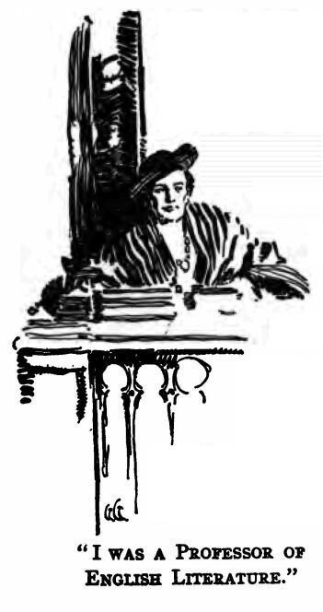
Much of this was over the heads of the boys, but they strove to comprehend dimly this tale of the past.
“What was them stone houses for?” Hare-Lip queried.
“You remember when your dad taught you to swim?” The boy nodded. “Well, in the University of California—that is the name we had for the houses—we taught young men and women how to think, just as I have taught you now, by sand and pebbles and shells, to know how many people lived in those days. There was very much to teach. The young men and women we taught were called students. We had large rooms in which we taught. I talked to them, forty or fifty at a time, just as I am talking to you now. I told them about the books other men had written before their time, and even, sometimes, in their time—”
“Was that all you did?—just talk, talk, talk?” Hoo-Hoo demanded. “Who hunted your meat for you? and milked the goats? and caught the fish?”
“A sensible question, Hoo-Hoo, a sensible question. As I have told you, in those days food-getting was easy. We were very wise. A few men got the food for many men. The other men did other things. As you say, I talked. I talked all the time, and for this food was given me—much food, fine food, beautiful food, food that I have not tasted in sixty years and shall never taste again. I sometimes think the most wonderful achievement of our tremendous civilization was food—its inconceivable abundance, its infinite variety, its marvellous delicacy. O my grandsons, life was life in those days, when we had such wonderful things to eat.”
This was beyond the boys, and they let it slip by, words and thoughts, as a mere senile wandering in the narrative.
“Our food-getters were called freemen. This was a joke. We of the ruling classes owned all the land, all the machines, everything. These food-getters were our slaves. We took almost all the food they got, and left them a little so that they might eat, and work, and get us more food—”
“I'd have gone into the forest and got food for myself,” Hare-Lip announced; “and if any man tried to take it away from me, I'd have killed him.”
The old man laughed.
“Did I not tell you that we of the ruling class owned all the land, all the forest, everything? Any food-getter who would not get food for us, him we punished or compelled to starve to death. And very few did that. They preferred to get food for us, and make clothes for us, and prepare and administer to us a thousand—a mussel-shell, Hoo-Hoo—a thousand satisfactions and delights. And I was Professor Smith in those days—Professor James Howard Smith. And my lecture courses were very popular—that is, very many of the young men and women liked to hear me talk about the books other men had written.
“And I was very happy, and I had beautiful things to eat. And my hands were soft, because I did no work with them, and my body was clean all over and dressed in the softest garments—
“He surveyed his mangy goat-skin with disgust.
“We did not wear such things in those days. Even the slaves had better garments. And we were most clean. We washed our faces and hands often every day. You boys never wash unless you fall into the water or go swimming.”
“Neither do you Granzer,” Hoo-Hoo retorted.
“I know, I know, I am a filthy old man, but times have changed. Nobody washes these days, there are no conveniences. It is sixty years since I have seen a piece of soap.

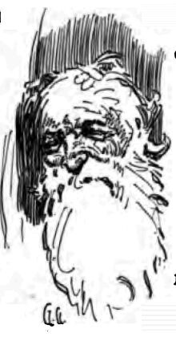
“You do not know what soap is, and I shall not tell you, for I am telling the story of the Scarlet Death. You know what sickness is. We called it a disease. Very many of the diseases came from what we called germs. Remember that word—germs. A germ is a very small thing. It is like a woodtick, such as you find on the dogs in the spring of the year when they run in the forest. Only the germ is very small. It is so small that you cannot see it—”
Hoo-Hoo began to laugh.
“You're a queer un, Granser, talking about things you can't see. If you can't see 'em, how do you know they are? That's what I want to know. How do you know anything you can't see?”
“A good question, a very good question, Hoo-Hoo. But we did see—some of them. We had what we called microscopes and ultramicroscopes, and we put them to our eyes and looked through them, so that we saw things larger than they really were, and many things we could not see without the microscopes at all. Our best ultramicroscopes could make a germ look forty thousand times larger. A mussel-shell is a thousand fingers like Edwin's. Take forty mussel-shells, and by as many times larger was the germ when we looked at it through a microscope. And after that, we had other ways, by using what we called moving pictures, of making the forty-thousand-times germ many, many thousand times larger still. And thus we saw all these things which our eyes of themselves could not see. Take a grain of sand. Break it into ten pieces. Take one piece and break it into ten. Break one of those pieces into ten, and one of those into ten, and one of those into ten, and one of those into ten, and do it all day, and maybe, by sunset, you will have a piece as small as one of the germs.” The boys were openly incredulous. Hare-Lip sniffed and sneered and Hoo-Hoo snickered, until Edwin nudged them to be silent.
“The woodtick sucks the blood of the dog, but the germ, being so very small, goes right into the blood of the body, and there it has many children. In those days there would be as many as a billion—a crab-shell, please—as many as that crab-shell in one man's body. We called germs micro-organisms. When a few million, or a billion, of them were in a man, in all the blood of a man, he was sick. These germs were a disease. There were many different kinds of them—more different kinds than there are grains of sand on this beach. We knew only a few of the kinds. The micro-organic world was an invisible world, a world we could not see, and we knew very little about it. Yet we did know something. There was the bacillus anthracis; there was the micrococcus; there was the Bacterium termo, and the Bacterium lactis—that's what turns the goat milk sour even to this day, Hare-Lip; and there were Schizomycetes without end. And there were many others....”
Here the old man launched into a disquisition on germs and their natures, using words and phrases of such extraordinary length and meaninglessness, that the boys grinned at one another and looked out over the deserted ocean till they forgot the old man was babbling on.
“But the Scarlet Death, Granser,” Edwin at last suggested.
Granser recollected himself, and with a start tore himself away from the rostrum of the lecture-hall, where, to another world audience, he had been expounding the latest theory, sixty years gone, of germs and germ-diseases.
“Yes, yes, Edwin; I had forgotten. Sometimes the memory of the past is very strong upon me, and I forget that I am a dirty old man, clad in goat-skin, wandering with my savage grandsons who are goatherds in the primeval wilderness. 'The fleeting systems lapse like foam,' and so lapsed our glorious, colossal civilization. I am Granser, a tired old man. I belong to the tribe of Santa Rosans. I married into that tribe. My sons and daughters married into the Chauffeurs, the Sacramen-tos, and the Palo-Altos. You, Hare-Lip, are of the Chauffeurs. You, Edwin, are of the Sacramentos. And you, Hoo-Hoo, are of the Palo-Altos. Your tribe takes its name from a town that was near the seat of another great institution of learning. It was called Stanford University. Yes, I remember now. It is perfectly clear. I was telling you of the Scarlet Death. Where was I in my story?”
“You was telling about germs, the things you can't see but which make men sick,” Edwin prompted.
“Yes, that's where I was. A man did not notice at first when only a few of these germs got into his body. But each germ broke in half and became two germs, and they kept doing this very rapidly so that in a short time there were many millions of them in the body. Then the man was sick. He had a disease, and the disease was named after the kind of a germ that was in him. It might be measles, it might be influenza, it might be yellow fever; it might be any of thousands and thousands of kinds of diseases.
“Now this is the strange thing about these germs. There were always new ones coming to live in men's bodies. Long and long and long ago, when there were only a few men in the world, there were few diseases. But as men increased and lived closely together in great cities and civilizations, new diseases arose, new kinds of germs entered their bodies. Thus were countless millions and billions of human beings killed. And the more thickly men packed together, the more terrible were the new diseases that came to be. Long before my time, in the middle ages, there was the Black Plague that swept across Europe. It swept across Europe many times. There was tuberculosis, that entered into men wherever they were thickly packed. A hundred years before my time there was the bubonic plague. And in Africa was the sleeping sickness. The bacteriologists fought all these sicknesses and destroyed them, just as you boys fight the wolves away from your goats, or squash the mosquitoes that light on you. The bacteriologists—”
“But, Granser, what is a what-you-call-it?” Edwin interrupted.
“You, Edwin, are a goatherd. Your task is to watch the goats. You know a great deal about goats. A bacteriologist watches germs. That's his task, and he knows a great deal about them. So, as I was saying, the bacteriologists fought with the germs and destroyed them—sometimes. There was leprosy, a horrible disease. A hundred years before I was born, the bacteriologists discovered the germ of leprosy. They knew all about it. They made pictures of it. I have seen those pictures. But they never found a way to kill it. But in 1984, there was the Pantoblast Plague, a disease that broke out in a country called Brazil and that killed millions of people. But the bacteriologists found it out, and found the way to kill it, so that the Pantoblast Plague went no farther. They made what they called a serum, which they put into a man's body and which killed the pantoblast germs without killing the man. And in 1910, there was Pellagra, and also the hookworm. These were easily killed by the bacteriologists. But in 1947 there arose a new disease that had never been seen before. It got into the bodies of babies of only ten months old or less, and it made them unable to move their hands and feet, or to eat, or anything; and the bacteriologists were eleven years in discovering how to kill that particular germ and save the babies.
“In spite of all these diseases, and of all the new ones that continued to arise, there were more and more men in the world. This was because it was easy to get food. The easier it was to get food, the more men there were; the more men there were, the more thickly were they packed together on the earth; and the more thickly they were packed, the more new kinds of germs became diseases. There were warnings. Soldervetzsky, as early as 1929, told the bacteriologists that they had no guaranty against some new disease, a thousand times more deadly than any they knew, arising and killing by the hundreds of millions and even by the billion. You see, the micro-organic world remained a mystery to the end. They knew there was such a world, and that from time to time armies of new germs emerged from it to kill men.
“And that was all they knew about it. For all they knew, in that invisible micro-organic world there might be as many different kinds of germs as there are grains of sand on this beach. And also, in that same invisible world it might well be that new kinds of germs came to be. It might be there that life originated—the 'abysmal fecundity,' Soldervetzsky called it, applying the words of other men who had written before him....”
It was at this point that Hare-Lip rose to his feet, an expression of huge contempt on his face.

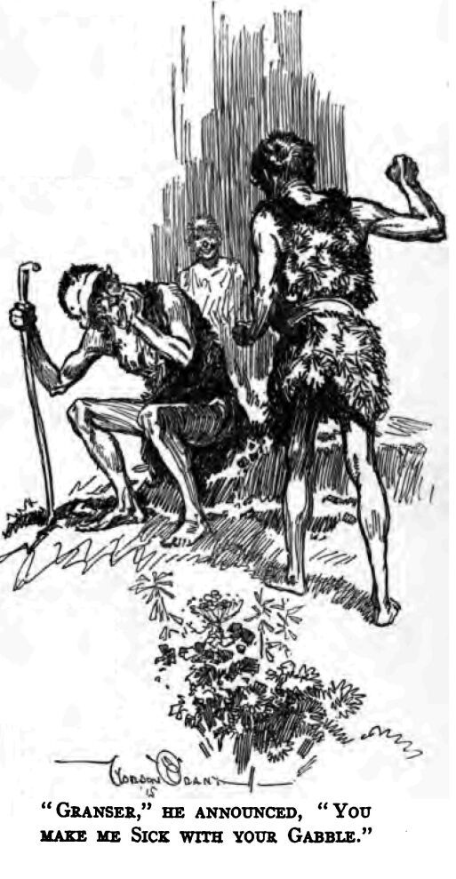
“Granser,” he announced, “you make me sick with your gabble. Why don't you tell about the Red Death? If you ain't going to, say so, an' we'll start back for camp.”
The old man looked at him and silently began to cry. The weak tears of age rolled down his cheeks and all the feebleness of his eighty-seven years showed in his grief-stricken countenance.
“Sit down,” Edwin counselled soothingly. “Granser's all right. He's just gettin' to the Scarlet Death, ain't you, Granser? He's just goin' to tell us about it right now. Sit down, Hare-Lip. Go ahead, Granser.”

III
THE old man wiped the tears away on his grimy knuckles and took up the tale in a tremulous, piping voice that soon strengthened as he got the swing of the narrative.
“It was in the summer of 2013 that the Plague came. I was twenty-seven years old, and well do I remember it. Wireless despatches—”
Hare-Lip spat loudly his disgust, and Granser hastened to make amends.
“We talked through the air in those days, thousands and thousands of miles. And the word came of a strange disease that had broken out in New York. There were seventeen millions of people living then in that noblest city of America. Nobody thought anything about the news. It was only a small thing. There had been only a few deaths. It seemed, though, that they had died very quickly, and that one of the first signs of the disease was the turning red of the face and all the body. Within twenty-four hours came the report of the first case in Chicago. And on the same day, it was made public that London, the greatest city in the world, next to Chicago, had been secretly fighting the plague for two weeks and censoring the news despatches—that is, not permitting the word to go forth to the rest of the world that London had the plague.
“It looked serious, but we in California, like everywhere else, were not alarmed. We were sure that the bacteriologists would find a way to overcome this new germ, just as they had overcome other germs in the past. But the trouble was the astonishing quickness with which this germ destroyed human beings, and the fact that it inevitably killed any human body it entered. No one ever recovered. There was the old Asiatic cholera, when you might eat dinner with a well man in the evening, and the next morning, if you got up early enough, you would see him being hauled by your window in the death-cart. But this new plague was quicker than that—much quicker.

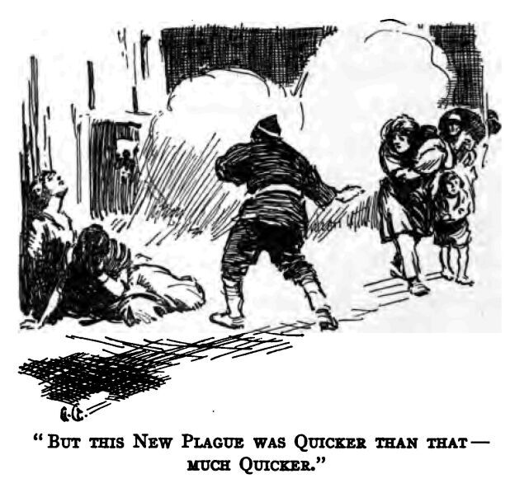
“From the moment of the first signs of it, a man would be dead in an hour. Some lasted for several hours. Many died within ten or fifteen minutes of the appearance of the first signs.
“The heart began to beat faster and the heat of the body to increase. Then came the scarlet rash, spreading like wildfire over the face and body. Most persons never noticed the increase in heat and heart-beat, and the first they knew was when the scarlet rash came out. Usually, they had convulsions at the time of the appearance of the rash. But these convulsions did not last long and were not very severe. If one lived through them, he became perfectly quiet, and only did he feel a numbness swiftly creeping up his body from the feet. The heels became numb first, then the legs, and hips, and when the numbness reached as high as his heart he died. They did not rave or sleep. Their minds always remained cool and calm up to the moment their heart numbed and stopped. And another strange thing was the rapidity of decomposition. No sooner was a person dead than the body seemed to fall to pieces, to fly apart, to melt away even as you looked at it. That was one of the reasons the plague spread so rapidly. All the billions of germs in a corpse were so immediately released.
“And it was because of all this that the bacteriologists had so little chance in fighting the germs. They were killed in their laboratories even as they studied the germ of the Scarlet Death. They were heroes. As fast as they perished, others stepped forth and took their places. It was in London that they first isolated it. The news was telegraphed everywhere. Trask was the name of the man who succeeded in this, but within thirty hours he was dead. Then came the struggle in all the laboratories to find something that would kill the plague germs. All drugs failed. You see, the problem was to get a drug, or serum, that would kill the germs in the body and not kill the body. They tried to fight it with other germs, to put into the body of a sick man germs that were the enemies of the plague germs—”
“And you can't see these germ-things, Granser,” Hare-Lip objected, “and here you gabble, gabble, gabble about them as if they was anything, when they're nothing at all. Anything you can't see, ain't, that's what. Fighting things that ain't with things that ain't! They must have been all fools in them days. That's why they croaked. I ain't goin' to believe in such rot, I tell you that.”
Granser promptly began to weep, while Edwin hotly took up his defence.
“Look here, Hare-Lip, you believe in lots of things you can't see.”
Hare-Lip shook his head.
“You believe in dead men walking about. You never seen one dead man walk about.”
“I tell you I seen 'em, last winter, when I was wolf-hunting with dad.”
“Well, you always spit when you cross running water,” Edwin challenged.
“That's to keep off bad luck,” was Hare-Lip's defence.
“You believe in bad luck?”
“Sure.”
“An' you ain't never seen bad luck,” Edwin concluded triumphantly. “You're just as bad as Granser and his germs. You believe in what you don't see. Go on, Granser.”
Hare-Lip, crushed by this metaphysical defeat, remained silent, and the old man went on. Often and often, though this narrative must not be clogged by the details, was Granser's tale interrupted while the boys squabbled among themselves. Also, among themselves they kept up a constant, low-voiced exchange of explanation and conjecture, as they strove to follow the old man into his unknown and vanished world.
“The Scarlet Death broke out in San Francisco. The first death came on a Monday morning. By Thursday they were dying like flies in Oakland and San Francisco. They died everywhere—in their beds, at their work, walking along the street. It was on Tuesday that I saw my first death—Miss Collbran, one of my students, sitting right there before my eyes, in my lecture-room. I noticed her face while I was talking. It had suddenly turned scarlet. I ceased speaking and could only look at her, for the first fear of the plague was already on all of us and we knew that it had come. The young women screamed and ran out of the room. So did the young men run out, all but two. Miss Collbran's convulsions were very mild and lasted less than a minute. One of the young men fetched her a glass of water. She drank only a little of it, and cried out:
“'My feet! All sensation has left them.'
“After a minute she said, 'I have no feet. I am unaware that I have any feet. And my knees are cold. I can scarcely feel that I have knees.'
“She lay on the floor, a bundle of notebooks under her head. And we could do nothing. The coldness and the numbness crept up past her hips to her heart, and when it reached her heart she was dead. In fifteen minutes, by the clock—I timed it—she was dead, there, in my own classroom, dead. And she was a very beautiful, strong, healthy young woman. And from the first sign of the plague to her death only fifteen minutes elapsed. That will show you how swift was the Scarlet Death.
“Yet in those few minutes I remained with the dying woman in my classroom, the alarm had spread over the university; and the students, by thousands, all of them, had deserted the lecture-room and laboratories. When I emerged, on my way to make report to the President of the Faculty, I found the university deserted. Across the campus were several stragglers hurrying for their homes. Two of them were running.
“President Hoag, I found in his office, all alone, looking very old and very gray, with a multitude of wrinkles in his face that I had never seen before. At the sight of me, he pulled himself to his feet and tottered away to the inner office, banging the door after him and locking it. You see, he knew I had been exposed, and he was afraid. He shouted to me through the door to go away. I shall never forget my feelings as I walked down the silent corridors and out across that deserted campus. I was not afraid. I had been exposed, and I looked upon myself as already dead. It was not that, but a feeling of awful depression that impressed me. Everything had stopped. It was like the end of the world to me—my world. I had been born within sight and sound of the university. It had been my predestined career. My father had been a professor there before me, and his father before him. For a century and a half had this university, like a splendid machine, been running steadily on. And now, in an instant, it had stopped. It was like seeing the sacred flame die down on some thrice-sacred altar. I was shocked, unutterably shocked.
“When I arrived home, my housekeeper screamed as I entered, and fled away. And when I rang, I found the housemaid had likewise fled. I investigated. In the kitchen I found the cook on the point of departure. But she screamed, too, and in her haste dropped a suitcase of her personal belongings and ran out of the house and across the grounds, still screaming. I can hear her scream to this day. You see, we did not act in this way when ordinary diseases smote us. We were always calm over such things, and sent for the doctors and nurses who knew just what to do. But this was different. It struck so suddenly, and killed so swiftly, and never missed a stroke. When the scarlet rash appeared on a person's face, that person was marked by death. There was never a known case of a recovery.
“I was alone in my big house. As I have told you often before, in those days we could talk with one another over wires or through the air. The telephone bell rang, and I found my brother talking to me. He told me that he was not coming home for fear of catching the plague from me, and that he had taken our two sisters to stop at Professor Bacon's home. He advised me to remain where I was, and wait to find out whether or not I had caught the plague.

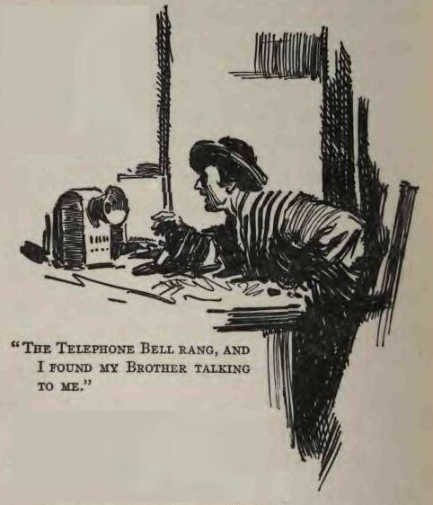
“To all of this I agreed, staying in my house and for the first time in my life attempting to cook. And the plague did not come out on me. By means of the telephone I could talk with whomsoever I pleased and get the news. Also, there were the newspapers, and I ordered all of them to be thrown up to my door so that I could know what was happening with the rest of the world.
“New York City and Chicago were in chaos. And what happened with them was happening in all the large cities. A third of the New York police were dead. Their chief was also dead, likewise the mayor. All law and order had ceased. The bodies were lying in the streets un-buried. All railroads and vessels carrying food and such things into the great city had ceased runnings and mobs of the hungry poor were pillaging the stores and warehouses. Murder and robbery and drunkenness were everywhere. Already the people had fled from the city by millions—at first the rich, in their private motor-cars and dirigibles, and then the great mass of the population, on foot, carrying the plague with them, themselves starving and pillaging the farmers and all the towns and villages on the way.

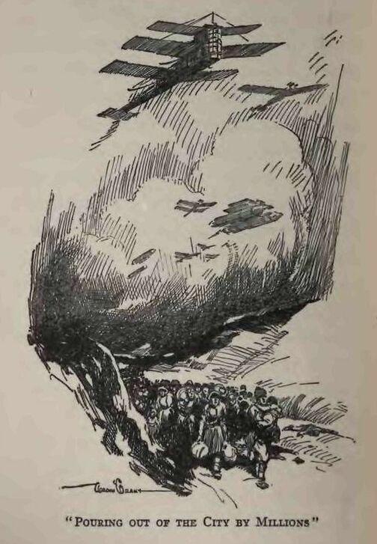
“The man who sent this news, the wireless operator, was alone with his instrument on the top of a lofty building. The people remaining in the city—he estimated them at several hundred thousand—had gone mad from fear and drink, and on all sides of him great fires were raging. He was a hero, that man who staid by his post—an obscure newspaperman, most likely.
“For twenty-four hours, he said, no transatlantic airships had arrived, and no more messages were coming from England. He did state, though, that a message from Berlin—that's in Germany—announced that Hoffmeyer, a bacteriologist of the Metchnikoff School, had discovered the serum for the plague. That was the last word, to this day, that we of America ever received from Europe. If Hoffmeyer discovered the serum, it was too late, or otherwise, long ere this, explorers from Europe would have come looking for us. We can only conclude that what happened in America happened in Europe, and that, at the best, some several score may have survived the Scarlet Death on that whole continent.
“For one day longer the despatches continued to come from New York. Then they, too, ceased. The man who had sent them, perched in his lofty building, had either died of the plague or been consumed in the great conflagrations he had described as raging around him. And what had occurred in New York had been duplicated in all the other cities. It was the same in San Francisco, and Oakland, and Berkeley. By Thursday the people were dying so rapidly that their corpses could not be handled, and dead bodies lay everywhere. Thursday night the panic outrush for the country began. Imagine, my grandsons, people, thicker than the salmon-run you have seen on the Sacramento river, pouring out of the cities by millions, madly over the country, in vain attempt to escape the ubiquitous death. You see, they carried the germs with them. Even the airships of the rich, fleeing for mountain and desert fastnesses, carried the germs.
“Hundreds of these airships escaped to Hawaii, and not only did they bring the plague with them, but they found the plague already there before them. This we learned, by the despatches, until all order in San Francisco vanished, and there were no operators left at their posts to receive or send. It was amazing, astounding, this loss of communication with the world. It was exactly as if the world had ceased, been blotted out. For sixty years that world has no longer existed for me. I know there must be such places as New York, Europe, Asia, and Africa; but not one word has been heard of them—not in sixty years. With the coming of the Scarlet Death the world fell apart, absolutely, irretrievably. Ten thousand years of culture and civilization passed in the twinkling of an eye, 'lapsed like foam.'
“I was telling about the airships of the rich. They carried the plague with them and no matter where they fled, they died. I never encountered but one survivor of any of them—Mungerson. He was afterwards a Santa Rosan, and he married my eldest daughter. He came into the tribe eight years after the plague. He was then nineteen years old, and he was compelled to wait twelve years more before he could marry. You see, there were no unmarried women, and some of the older daughters of the Santa Rosans were already bespoken. So he was forced to wait until my Mary had grown to sixteen years. It was his son, Gimp-Leg, who was killed last year by the mountain lion.
“Mungerson was eleven years old at the time of the plague. His father was one of the Industrial Magnates, a very wealthy, powerful man. It was on his airship, the Condor, that they were fleeing, with all the family, for the wilds of British Columbia, which is far to the north of here. But there was some accident, and they were wrecked near Mount Shasta. You have heard of that mountain. It is far to the north. The plague broke out amongst them, and this boy of eleven was the only survivor. For eight years he was alone, wandering over a deserted land and looking vainly for his own kind. And at last, travelling south, he picked up with us, the Santa Rosans.
“But I am ahead of my story. When the great exodus from the cities around San Francisco Bay began, and while the telephones were still working, I talked with my brother. I told him this flight from the cities was insanity, that there were no symptoms of the plague in me, and that the thing for us to do was to isolate ourselves and our relatives in some safe place. We decided on the Chemistry Building, at the university, and we planned to lay in a supply of provisions, and by force of arms to prevent any other persons from forcing their presence upon us after we had retired to our refuge.
“All this being arranged, my brother begged me to stay in my own house for at least twenty-four hours more, on the chance of the plague developing in me. To this I agreed, and he promised to come for me next day. We talked on over the details of the provisioning and the defending of the Chemistry Building until the telephone died. It died in the midst of our conversation. That evening there were no electric lights, and I was alone in my house in the darkness. No more newspapers were being printed, so I had no knowledge of what was taking place outside.

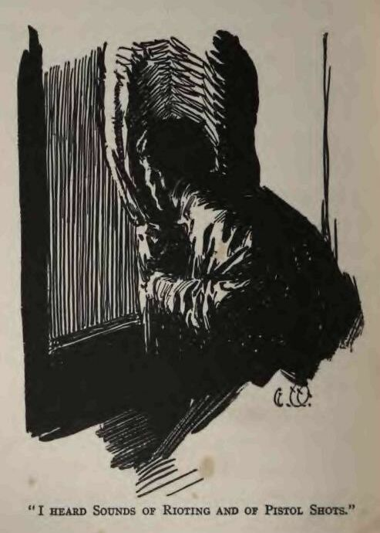
“I heard sounds of rioting and of pistol shots, and from my windows I could see the glare of the sky of some conflagration in the direction of Oakland. It was a night of terror. I did not sleep a wink. A man—why and how I do not know—was killed on the sidewalk in front of the house. I heard the rapid reports of an automatic pistol, and a few minutes later the wounded wretch crawled up to my door, moaning and crying out for help. Arming myself with two automatics, I went to him. By the light of a match I ascertained that while he was dying of the bullet wounds, at the same time the plague was on him. I fled indoors, whence I heard him moan and cry out for half an hour longer.
“In the morning, my brother came to me. I had gathered into a handbag what things of value I purposed taking, but when I saw his face I knew that he would never accompany me to the Chemistry Building. The plague was on him. He intended shaking my hand, but I went back hurriedly before him.
“'Look at yourself in the mirror,' I commanded.

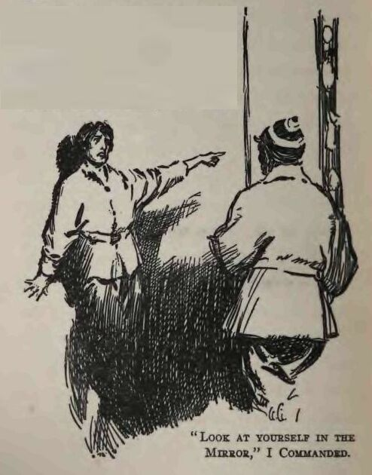
“He did so, and at sight of his scarlet face, the color deepening as he looked at it, he sank down nervelessly in a chair.
“'My God!' he said. 'I've got it. Don't come near me. I am a dead man.'
“Then the convulsions seized him. He was two hours in dying, and he was conscious to the last, complaining about the coldness and loss of sensation in his feet, his calves, his thighs, until at last it was his heart and he was dead.
“That was the way the Scarlet Death slew. I caught up my handbag and fled. The sights in the streets were terrible. One stumbled on bodies everywhere. Some were not yet dead. And even as you looked, you saw men sink down with the death fastened upon them. There were numerous fires burning in Berkeley, while Oakland and San Francisco were apparently being swept by vast conflagrations. The smoke of the burning filled the heavens, so that the midday was as a gloomy twilight, and, in the shifts of wind, sometimes the sun shone through dimly, a dull red orb. Truly, my grandsons, it was like the last days of the end of the world.
“There were numerous stalled motor cars, showing that the gasoline and the engine supplies of the garages had given out. I remember one such car. A man and a woman lay back dead in the seats, and on the pavement near it were two more women and a child. Strange and terrible sights there were on every hand. People slipped by silently, furtively, like ghosts—white-faced women carrying infants in their arms; fathers leading children by the hand; singly, and in couples, and in families—all fleeing out of the city of death. Some carried supplies of food, others blankets and valuables, and there were many who carried nothing.
“There was a grocery store—a place where food was sold. The man to whom it belonged—I knew him well—a quiet, sober, but stupid and obstinate fellow, was defending it. The windows and doors had been broken in, but he, inside, hiding behind a counter, was discharging his pistol at a number of men on the sidewalk who were breaking in. In the entrance were several bodies—of men, I decided, whom he had killed earlier in the day. Even as I looked on from a distance, I saw one of the robbers break the windows of the adjoining store, a place where shoes were sold, and deliberately set fire to it. I did not go to the groceryman's assistance. The time for such acts had already passed. Civilization was crumbling, and it was each for himself.”

IV
I WENT away hastily, down a cross-street, and at the first corner I saw another tragedy. Two men of the working class had caught a man and a woman with two children, and were robbing them. I knew the man by sight, though I had never been introduced to him. He was a poet whose verses I had long admired. Yet I did not go to his help, for at the moment I came upon the scene there was a pistol shot, and I saw him sinking to the ground. The woman screamed, and she was felled with a fist-blow by one of the brutes. I cried out threateningly, whereupon they discharged their pistols at me and I ran away around the corner. Here I was blocked by an advancing conflagration. The buildings on both sides were burning, and the street was filled with smoke and flame. From somewhere in that murk came a woman's voice calling shrilly for help. But I did not go to her. A man's heart turned to iron amid such scenes, and one heard all too many appeals for help.
“Returning to the corner, I found the two robbers were gone. The poet and his wife lay dead on the pavement. It was a shocking sight. The two children had vanished—whither I could not tell. And I knew, now, why it was that the fleeing persons I encountered slipped along so furtively and with such white faces. In the midst of our civilization, down in our slums and labor-ghettos, we had bred a race of barbarians, of savages; and now, in the time of our calamity, they turned upon us like the wild beasts they were and destroyed us. And they destroyed themselves as well.

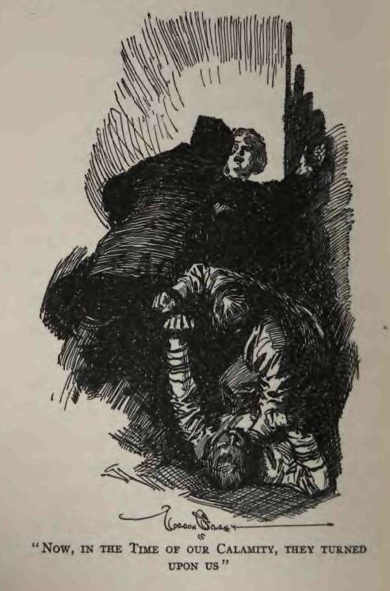
“They inflamed themselves with strong drink and committed a thousand atrocities, quarreling and killing one another in the general madness. One group of workingmen I saw, of the better sort, who had banded together, and, with their women and children in their midst, the sick and aged in litters and being carried, and with a number of horses pulling a truck-load of provisions, they were fighting their way out of the city. They made a fine spectacle as they came down the street through the drifting smoke, though they nearly shot me when I first appeared in their path. As they went by, one of their leaders shouted out to me in apologetic explanation. He said they were killing the robbers and looters on sight, and that they had thus banded together as the only-means by which to escape the prowlers.
“It was here that I saw for the first time what I was soon to see so often. One of the marching men had suddenly shown the unmistakable mark of the plague. Immediately those about him drew away, and he, without a remonstrance, stepped out of his place to let them pass on. A woman, most probably his wife, attempted to follow him. She was leading a little boy by the hand. But the husband commanded her sternly to go on, while others laid hands on her and restrained her from following him. This I saw, and I saw the man also, with his scarlet blaze of face, step into a doorway on the opposite side of the street. I heard the report of his pistol, and saw him sink lifeless to the ground.
“After being turned aside twice again by advancing fires, I succeeded in getting through to the university. On the edge of the campus I came upon a party of university folk who were going in the direction of the Chemistry Building. They were all family men, and their families were with them, including the nurses and the servants. Professor Badminton greeted me, I had difficulty in recognizing him. Somewhere he had gone through flames, and his beard was singed off. About his head was a bloody bandage, and his clothes were filthy.

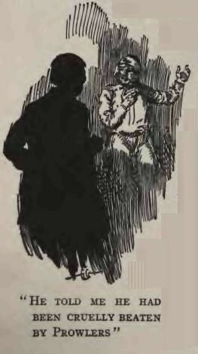
“He told me he had prowlers, and that his brother had been killed the previous night, in the defence of their dwelling.
“Midway across the campus, he pointed suddenly to Mrs. Swinton's face. The unmistakable scarlet was there. Immediately all the other women set up a screaming and began to run away from her. Her two children were with a nurse, and these also ran with the women. But her husband, Doctor Swinton, remained with her.
“'Go on, Smith,' he told me. 'Keep an eye on the children. As for me, I shall stay with my wife. I know she is as already dead, but I can't leave her. Afterwards, if I escape, I shall come to the Chemistry Building, and do you watch for me and let me in.'
“I left him bending over his wife and soothing her last moments, while I ran to overtake the party. We were the last to be admitted to the Chemistry Building. After that, with our automatic rifles we maintained our isolation. By our plans, we had arranged for a company of sixty to be in this refuge. Instead, every one of the number originally planned had added relatives and friends and whole families until there were over four hundred souls. But the Chemistry Building was large, and, standing by itself, was in no danger of being burned by the great fires that raged everywhere in the city.
“A large quantity of provisions had been gathered, and a food committee took charge of it, issuing rations daily to the various families and groups that arranged themselves into messes. A number of committees were appointed, and we developed a very efficient organization. I was on the committee of defence, though for the first day no prowlers came near. We could see them in the distance, however, and by the smoke of their fires knew that several camps of them were occupying the far edge of the campus. Drunkenness was rife, and often we heard them singing ribald songs or insanely shouting. While the world crashed to ruin about them and all the air was filled with the smoke of its burning, these low creatures gave rein to their bestiality and fought and drank and died. And after all, what did it matter? Everybody died anyway, the good and the bad, the efficients and the weaklings, those that loved to live and those that scorned to live. They passed. Everything passed.
“When twenty-four hours had gone by and no signs of the plague were apparent, we congratulated ourselves and set about digging a well. You have seen the great iron pipes which in those days carried water to all the city-dwellers. We feared that the fires in the city would burst the pipes and empty the reservoirs. So we tore up the cement floor of the central court of the Chemistry Building and dug a well. There were many young men, undergraduates, with us, and we worked night and day on the well. And our fears were confirmed. Three hours before we reached water, the pipes went dry.
“A second twenty-four hours passed, and still the plague did not appear among us. We thought we were saved. But we did not know what I afterwards decided to be true, namely, that the period of the incubation of the plague germs in a human's body was a matter of a number of days. It slew so swiftly when once it manifested itself, that we were led to believe that the period of incubation was equally swift. So, when two days had left us unscathed, we were elated with the idea that we were free of the contagion.
“But the third day disillusioned us. I can never forget the night preceding it. I had charge of the night guards from eight to twelve, and from the roof of the building I watched the passing of all man's glorious works. So terrible were the local conflagrations that all the sky was lighted up. One could read the finest print in the red glare. All the world seemed wrapped in flames. San Francisco spouted smoke and fire from a score of vast conflagrations that were like so many active volcanoes. Oakland, San Leandro, Haywards—all were burning; and to the northward, clear to Point Richmond, other fires were at work. It was an awe-inspiring spectacle. Civilization, my grandsons, civilization was passing in a sheet of flame and a breath of death. At ten o'clock that night, the great powder magazines at Point Pinole exploded in rapid succession. So terrific were the concussions that the strong building rocked as in an earthquake, while every pane of glass was broken. It was then that I left the roof and went down the long corridors, from room to room, quieting the alarmed women and telling them what had happened.
“An hour later, at a window on the ground floor, I heard pandemonium break out in the camps of the prowlers. There were cries and screams, and shots from many pistols. As we afterward conjectured, this fight had been precipitated by an attempt on the part of those that were well to drive out those that were sick. At any rate, a number of the plague-stricken prowlers escaped across the campus and drifted against our doors. We warned them back, but they cursed us and discharged a fusillade from their pistols. Professor Merryweather, at one of the windows, was instantly killed, the bullet striking him squarely between the eyes. We opened fire in turn, and all the prowlers fled away with the exception of three. One was a woman. The plague was on them and they were reckless. Like foul fiends, there in the red glare from the skies, with faces blazing, they continued to curse us and fire at us. One of the men I shot with my own hand. After that the other man and the woman, still cursing us, lay down under our windows, where we were compelled to watch them die of the plague.
“The situation was critical. The explosions of the powder magazines had broken all the windows of the Chemistry Building, so that we were exposed to the germs from the corpses. The sanitary committee was called upon to act, and it responded nobly. Two men were required to go out and remove the corpses, and this meant the probable sacrifice of their own lives, for, having performed the task, they were not to be permitted to reenter the building. One of the professors, who was a bachelor, and one of the undergraduates volunteered. They bade good-bye to us and went forth. They were heroes. They gave up their lives that four hundred others might live. After they had performed their work, they stood for a moment, at a distance, looking at us wistfully. Then they waved their hands in farewell and went away slowly across the campus toward the burning city.
“And yet it was all useless. The next morning the first one of us was smitten with the plague—a little nurse-girl in the family of Professor Stout. It was no time for weak-kneed, sentimental policies. On the chance that she might be the only one, we thrust her forth from the building and commanded her to be gone.

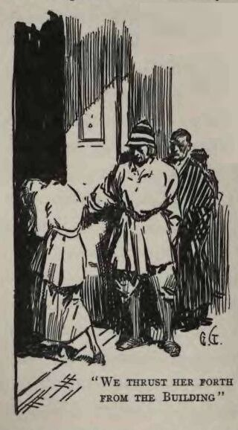
“She went away slowly across the campus, wringing her hands and crying pitifully. We felt like brutes, but what were we to do? There were four hundred of us, and individuals had to be sacrificed.
“In one of the laboratories three families had domiciled themselves, and that afternoon we found among them no less than four corpses and seven cases of the plague in all its different stages.
“Then it was that the horror began. Leaving the dead lie, we forced the living ones to segregate themselves in another room. The plague began to break out among the rest of us, and as fast as the symptoms appeared, we sent the stricken ones to these segregated rooms. We compelled them to walk there by themselves, so as to avoid laying hands on them. It was heartrending. But still the plague raged among us, and room after room was filled with the dead and dying. And so we who were yet clean retreated to the next floor and to the next, before this sea of the dead, that, room by room and floor by floor, inundated the building.
“The place became a charnel house, and in the middle of the night the survivors fled forth, taking nothing with them except arms and ammunition and a heavy store of tinned foods. We camped on the opposite side of the campus from the prowlers, and, while some stood guard, others of us volunteered to scout into the city in quest of horses, motor cars, carts, and wagons, or anything that would carry our provisions and enable us to emulate the banded workingmen I had seen fighting their way out to the open country.
“I was one of these scouts; and Doctor Hoyle, remembering that his motor car had been left behind in his home garage, told me to look for it. We scouted in pairs, and Dombey, a young undergraduate, accompanied me. We had to cross half a mile of the residence portion of the city to get to Doctor Hoyle's home. Here the buildings stood apart, in the midst of trees and grassy lawns, and here the fires had played freaks, burning whole blocks, skipping blocks and often skipping a single house in a block. And here, too, the prowlers were still at their work. We carried our automatic pistols openly in our hands, and looked desperate enough, forsooth, to keep them from attacking us. But at Doctor Hoyle's house the thing happened. Untouched by fire, even as we came to it the smoke of flames burst forth.
“The miscreant who had set fire to it staggered down the steps and out along the driveway. Sticking out of his coat pockets were bottles of whiskey, and he was very drunk. My first impulse was to shoot him, and I have never ceased regretting that I did not. Staggering and maundering to himself, with bloodshot eyes, and a raw and bleeding slash down one side of his bewhiskered face, he was altogether the most nauseating specimen of degradation and filth I had ever encountered. I did not shoot him, and he leaned against a tree on the lawn to let us go by. It was the most absolute, wanton act. Just as we were opposite him, he suddenly drew a pistol and shot Dombey through the head. The next instant I shot him. But it was too late. Dombey expired without a groan, immediately. I doubt if he even knew what had happened to him.
“Leaving the two corpses, I hurried on past the burning house to the garage, and there found Doctor Hoyle's motor car. The tanks were filled with gasoline, and it was ready for use. And it was in this car that I threaded the streets of the ruined city and came back to the survivors on the campus. The other scouts returned, but none had been so fortunate. Professor Fairmead had found a Shetland pony, but the poor creature, tied in a stable and abandoned for days, was so weak from want of food and water that it could carry no burden at all. Some of the men were for turning it loose, but I insisted that we should lead it along with us, so that, if we got out of food, we would have it to eat.
“There were forty-seven of us when we started, many being women and children. The President of the Faculty, an old man to begin with, and now hopelessly broken by the awful happenings of the past week, rode in the motor car with several young children and the aged mother of Professor Fairmead. Wathope, a young professor of English, who had a grievous bullet-wound in his leg, drove the car. The rest of us walked, Professor Fairmead leading the pony.
“It was what should have been a bright summer day, but the smoke from the burning world filled the sky, through which the sun shone murkily, a dull and lifeless orb, blood-red and ominous. But we had grown accustomed to that blood-red sun. With the smoke it was different. It bit into our nostrils and eyes, and there was not one of us whose eyes were not bloodshot. We directed our course to the southeast through the endless miles of suburban residences, travelling along where the first swells of low hills rose from the flat of the central city. It was by this way, only, that we could expect to gain the country.
“Our progress was painfully slow. The women and children could not walk fast. They did not dream of walking, my grandsons, in the way all people walk to-day. In truth, none of us knew how to walk. It was not until after the plague that I learned really to walk. So it was that the pace of the slowest was the pace of all, for we dared not separate on account of the prowlers. There were not so many now of these human beasts of prey. The plague had already well diminished their numbers, but enough still lived to be a constant menace to us. Many of the beautiful residences were untouched by fire, yet smoking ruins were everywhere. The prowlers, too, seemed to have got over their insensate desire to burn, and it was more rarely that we saw houses freshly on fire.
“Several of us scouted among the private garages in search of motor cars and gasoline. But in this we were unsuccessful. The first great flights from the cities had swept all such utilities away. Calgan, a fine young man, was lost in this work. He was shot by prowlers while crossing a lawn. Yet this was our only casualty, though, once, a drunken brute deliberately opened fire on all of us. Luckily, he fired wildly, and we shot him before he had done any hurt.
“At Fruitvale, still in the heart of the magnificent residence section of the city, the plague again smote us. Professor Fairmead was the victim. Making signs to us that his mother was not to know, he turned aside into the grounds of a beautiful mansion. He sat down forlornly on the steps of the front veranda, and I, having lingered, waved him a last farewell. That night, several miles beyond Fruitvale and still in the city, we made camp. And that night we shifted camp twice to get away from our dead. In the morning there were thirty of us. I shall never forget the President of the Faculty. During the morning's march his wife, who was walking, betrayed the fatal symptoms, and when she drew aside to let us go on, he insisted on leaving the motor car and remaining with her. There was quite a discussion about this, but in the end we gave in. It was just as well, for we knew not which ones of us, if any, might ultimately escape.

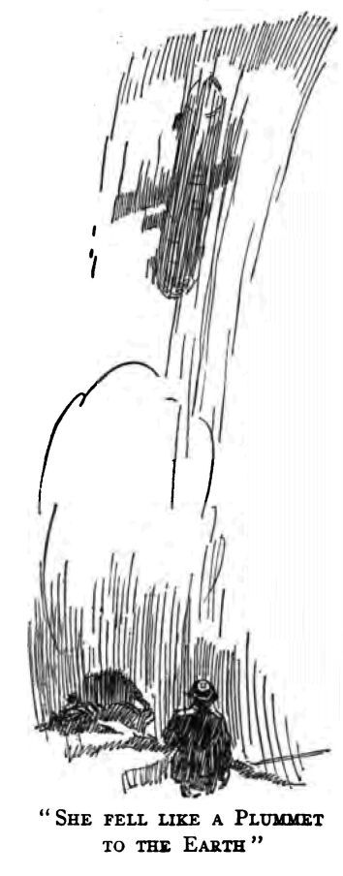
“That night, the second of our march, we camped beyond Haywards in the first stretches of country. And in the morning there were eleven of us that lived. Also, during the night, Wathope, the professor with the wounded leg, deserted us in the motor car. He took with him his sister and his mother and most of our tinned provisions. It was that day, in the afternoon, while resting by the wayside, that I saw the last airship I shall ever see. The smoke was much thinner here in the country, and I first sighted the ship drifting and veering helplessly at an elevation of two thousand feet. What had happened I could not conjecture, but even as we looked we saw her bow dip down lower and lower. Then the bulkheads of the various gas-chambers must have burst, for, quite perpendicular, she fell like a plummet to the earth.
“And from that day to this I have not seen another airship. Often and often, during the next few years, I scanned the sky for them, hoping against hope that somewhere in the world civilization had survived. But it was not to be. What happened with us in California must have happened with everybody everywhere.
“Another day, and at Niles there were three of us. Beyond Niles, in the middle of the highway, we found Wathope. The motor car had broken down, and there, on the rugs which they had spread on the ground, lay the bodies of his sister, his mother, and himself.
“Wearied by the unusual exercise of continual walking, that night I slept heavily. In the morning I was alone in the world. Canfield and Parsons, my last companions, were dead of the plague. Of the four hundred that sought shelter in the Chemistry Building, and of the forty-seven that began the march, I alone remained—I and the Shetland pony. Why this should be so there is no explaining. I did not catch the plague, that is all. I was immune. I was merely the one lucky man in a million—just as every survivor was one in a million, or, rather, in several millions, for the proportion was at least that.”

V
“FOR two days I sheltered in a pleasant grove where there had been no deaths. In those two days, while badly depressed and believing that my turn would come at any moment, nevertheless I rested and recuperated. So did the pony. And on the third day, putting what small store of tinned provisions I possessed on the pony's back, I started on across a very lonely land. Not a live man, woman, or child, did I encounter, though the dead were everywhere. Food, however, was abundant. The land then was not as it is now. It was all cleared of trees and brush, and it was cultivated. The food for millions of mouths was growing, ripening, and going to waste. From the fields and orchards I gathered vegetables, fruits, and berries. Around the deserted farmhouses I got eggs and caught chickens. And frequently I found supplies of tinned provisions in the store-rooms.
“A strange thing was what was taking place with all the domestic animals. Everywhere they were going wild and preying on one another. The chickens and ducks were the first to be destroyed, while the pigs were the first to go wild, followed by the cats. Nor were the dogs long in adapting themselves to the changed conditions. There was a veritable plague of dogs. They devoured the corpses, barked and howled during the nights, and in the daytime slunk about in the distance. As the time went by, I noticed a change in their behavior. At first they were apart from one another, very suspicious and very prone to fight. But after a not very long while they began to come together and run in packs. The dog, you see, always was a social animal, and this was true before ever he came to be domesticated by man. In the last days of the world before the plague, there were many many very different kinds of dogs—dogs without hair and dogs with warm fur, dogs so small that they would make scarcely a mouthful for other dogs that were as large as mountain lions. Well, all the small dogs, and the weak types, were killed by their fellows. Also, the very large ones were not adapted for the wild life and bred out. As a result, the many different kinds of dogs disappeared, and there remained, running in packs, the medium-sized wolfish dogs that you know to-day.”
“But the cats don't run in packs, Granser,” Hoo-Hoo objected.
“The cat was never a social animal. As one writer in the nineteenth century said, the cat walks by himself. He always walked by himself, from before the time he was tamed by man, down through the long ages of domestication, to to-day when once more he is wild.
“The horses also went wild, and all the fine breeds we had degenerated into the small mustang horse you know to-day. The cows likewise went wild, as did the pigeons and the sheep. And that a few of the chickens survived you know yourself. But the wild chicken of to-day is quite a different thing from the chickens we had in those days.
“But I must go on with my story. I travelled through a deserted land. As the time went by I began to yearn more and more for human beings. But I never found one, and I grew lonelier and lonelier. I crossed Livermore Valley and the mountains between it and the great valley of the San Joaquin. You have never seen that valley, but it is very large and it is the home of the wild horse. There are great droves there, thousands and tens of thousands. I revisited it thirty years after, so I know. You think there are lots of wild horses down here in the coast valleys, but they are as nothing compared with those of the San Joaquin. Strange to say, the cows, when they went wild, went back into the lower mountains. Evidently they were better able to protect themselves there.
“In the country districts the ghouls and prowlers had been less in evidence, for I found many villages and towns untouched by fire. But they were filled by the pestilential dead, and I passed by without exploring them. It was near Lathrop that, out of my loneliness, I picked up a pair of collie dogs that were so newly free that they were urgently willing to return to their allegiance to man. These collies accompanied me for many years, and the strains of them are in those very dogs there that you boys have to-day. But in sixty years the collie strain has worked out. These brutes are more like domesticated wolves than anything else.”
Hare-Lip rose to his feet, glanced to see that the goats were safe, and looked at the sun's position in the afternoon sky, advertising impatience at the prolixity of the old man's tale. Urged to hurry by Edwin, Granser went on.
“There is little more to tell. With my two dogs and my pony, and riding a horse I had managed to capture, I crossed the San Joaquin and went on to a wonderful valley in the Sierras called Yosemite. In the great hotel there I found a prodigious supply of tinned provisions. The pasture was abundant, as was the game, and the river that ran through the valley was full of trout. I remained there three years in an utter loneliness that none but a man who has once been highly civilized can understand. Then I could stand it no more. I felt that I was going crazy. Like the dog, I was a social animal and I needed my kind. I reasoned that since I had survived the plague, there was a possibility that others had survived. Also, I reasoned that after three years the plague germs must all be gone and the land be clean again.

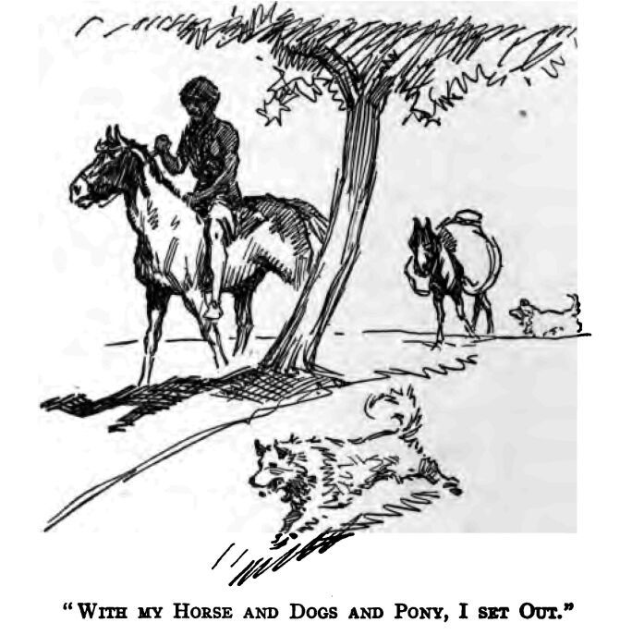
“With my horse and dogs and pony, I set out. Again I crossed the San Joaquin Valley, the mountains beyond, and came down into Livermore Valley. The change in those three years was amazing. All the land had been splendidly tilled, and now I could scarcely recognize it, 'such was the sea of rank vegetation that had overrun the agricultural handiwork of man. You see, the wheat, the vegetables, and orchard trees had always been cared for and nursed by man, so that they were soft and tender. The weeds and wild bushes and such things, on the contrary, had always been fought by man, so that they were tough and resistant. As a result, when the hand of man was removed, the wild vegetation smothered and destroyed practically all the domesticated vegetation. The coyotes were greatly increased, and it was at this time that I first encountered wolves, straying in twos and threes and small packs down from the regions where they had always persisted.
“It was at Lake Temescal, not far from the one-time city of Oakland, that I came upon the first live human beings. Oh, my grandsons, how can I describe to you my emotion, when, astride my horse and dropping down the hillside to the lake, I saw the smoke of a campfire rising through the trees. Almost did my heart stop beating. I felt that I was going crazy. Then I heard the cry of a babe—a human babe. And dogs barked, and my dogs answered. I did not know but what I was the one human alive in the whole world. It could not be true that here were others—smoke, and the cry of a babe.
“Emerging on the lake, there, before my eyes, not a hundred yards away, I saw a man, a large man. He was standing on an outjutting rock and fishing. I was overcome. I stopped my horse. I tried to call out but could not. I waved my hand. It seemed to me that the man looked at me, but he did not appear to wave. Then I laid my head on my arms there in the saddle. I was afraid to look again, for I knew it was an hallucination, and I knew that if I looked the man would be gone. And so precious was the hallucination, that I wanted it to persist yet a little while. I knew, too, that as long as I did not look it would persist.
“Thus I remained, until I heard my dogs snarling, and a man's voice. What do you think the voice said? I will tell you. It said: 'Where in hell did you come from??'

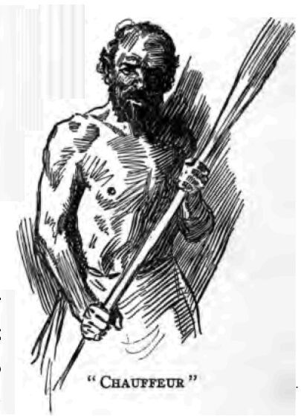
“Those were the words, the exact words. That was what your other grandfather said to me, Hare-Lip, when he greeted me there on the shore of Lake Temescal fifty-seven years ago. And they were the most ineffable words I have ever heard. I opened my eyes, and there he stood before me, a large, dark, hairy man, heavy-jawed, slant-browed, fierce-eyed. How I got off my horse I do not know. But it seemed that the next I knew I was clasping his hand with both of mine and crying. I would have embraced him, but he was ever a narrow-minded, suspicious man, and he drew away from me. Yet did I cling to his hand and cry.”
Granser's voice faltered and broke at the recollection, and the weak tears streamed down his cheeks while the boys looked on and giggled.
“Yet did I cry,” he continued, “and desire to embrace him, though the Chauffeur was a brute, a perfect brute—the most abhorrent man I have ever known. His name was... strange, how I have forgotten his name. Everybody called him Chauffeur—it was the name of his occupation, and it stuck. That is how, to this day, the tribe he founded is called the Chauffeur Tribe.
“He was a violent, unjust man. Why the plague germs spared him I can never understand. It would seem, in spite of our old metaphysical notions about absolute justice, that there is no justice in the universe. Why did he live?—an iniquitous, moral monster, a blot on the face of nature, a cruel, relentless, bestial cheat as well. All he could talk about was motor cars, machinery, gasoline, and garages—and especially, and with huge delight, of his mean pilferings and sordid swindlings of the persons who had employed him in the days before the coming of the plague. And yet he was spared, while hundreds of millions, yea, billions, of better men were destroyed.

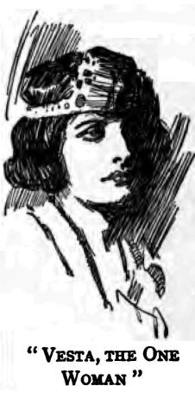
“I went on with him to his camp, and there I saw her, Vesta, the one woman. It was glorious and... pitiful. There she was, Vesta Van Warden, the young wife of John Van Warden, clad in rags, with marred and scarred and toil-calloused hands, bending over the campfire and doing scullion work—she, Vesta, who had been born to the purple of the greatest baronage of wealth the world had ever known. John Van Warden, her husband, worth one billion, eight hundred millions and President of the Board of Industrial Magnates, had been the ruler of America. Also, sitting on the International Board of Control, he had been one of the seven men who ruled the world. And she herself had come of equally noble stock. Her father, Philip Saxon, had been President of the Board of Industrial Magnates up to the time of his death. This office was in process of becoming hereditary, and had Philip Saxon had a son that son would have succeeded him. But his only child was Vesta, the perfect flower of generations of the highest culture this planet has ever produced. It was not until the engagement between Vesta and Van Warden took place, that Saxon indicated the latter as his successor. It was, I am sure, a political marriage. I have reason to believe that Vesta never really loved her husband in the mad passionate way of which the poets used to sing. It was more like the marriages that obtained among crowned heads in the days before they were displaced by the Magnates.
“And there she was, boiling fish-chowder in a soot-covered pot, her glorious eyes inflamed by the acrid smoke of the open fire. Hers was a sad story. She was the one survivor in a million, as I had been, as the Chauffeur had been. On a crowning eminence of the Alameda Hills, overlooking San Francisco Bay, Van Warden had built a vast summer palace. It was surrounded by a park of a thousand acres. When the plague broke out, Van Warden sent her there. Armed guards patrolled the boundaries of the park, and nothing entered in the way of provisions or even mail matter that was not first fumigated. And yet did the plague enter, killing the guards at their posts, the servants at their tasks, sweeping away the whole army of retainers—or, at least, all of them who did not flee to die elsewhere. So it was that Vesta found herself the sole living person in the palace that had become a charnel house.

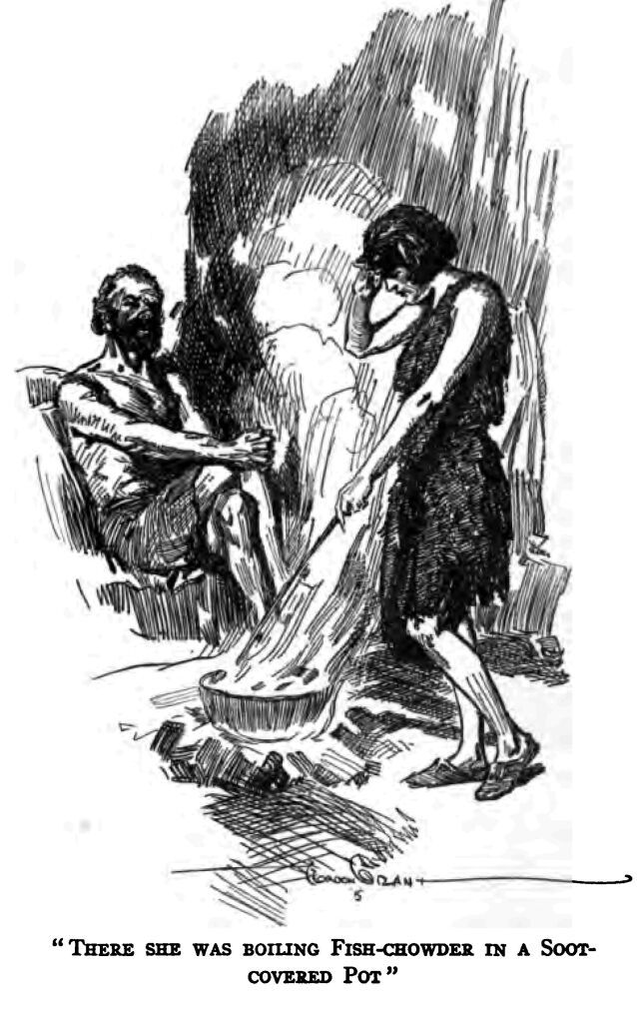
“Now the Chauffeur had been one of the servants that ran away. Returning, two months afterward, he discovered Vesta in a little summer pavilion where there had been no deaths and where she had established herself. He was a brute. She was afraid, and she ran away and hid among the trees. That night, on foot, she fled into the mountains—she, whose tender feet and delicate body had never known the bruise of stones nor the scratch of briars. He followed, and that night he caught her. He struck her. Do you understand? He beat her with those terrible fists of his and made her his slave. It was she who had to gather the firewood, build the fires, cook, and do all the degrading camp-labor—she, who had never performed a menial act in her life. These things he compelled her to do, while he, a proper savage, elected to lie around camp and look on. He did nothing, absolutely nothing, except on occasion to hunt meat or catch fish.”
“Good for Chauffeur,” Hare-Lip commented in an undertone to the other boys. “I remember him before he died. He was a corker. But he did things, and he made things go. You know, Dad married his daughter, an' you ought to see the way he knocked the spots outa Dad. The Chauffeur was a son-of-a-gun. He made us kids stand around. Even when he was croaking he reached out for me, once, an' laid my head open with that long stick he kept always beside him.”
Hare-Lip rubbed his bullet head reminiscently, and the boys returned to the old man, who was maundering ecstatically about Vesta, the squaw of the founder of the Chauffeur Tribe.
“And so I say to you that you cannot understand the awfulness of the situation. The Chauffeur was a servant, understand, a servant. And he cringed, with bowed head, to such as she. She was a lord of life, both by birth and by marriage. The destinies of millions, such as he, she carried in the hollow of her pink-white hand. And, in the days before the plague, the slightest contact with such as he would have been pollution. Oh, I have seen it. Once, I remember, there was Mrs. Goldwin, wife of one of the great magnates. It was on a landing stage, just as she was embarking in her private dirigible, that she dropped her parasol. A servant picked it up and made the mistake of handing it to her—to her, one of the greatest royal ladies of the land! She shrank back, as though he were a leper, and indicated her secretary to receive it. Also, she ordered her secretary to ascertain the creature's name and to see that he was immediately discharged from service. And such a woman was Vesta Van Warden. And her the Chauffeur beat and made his slave.

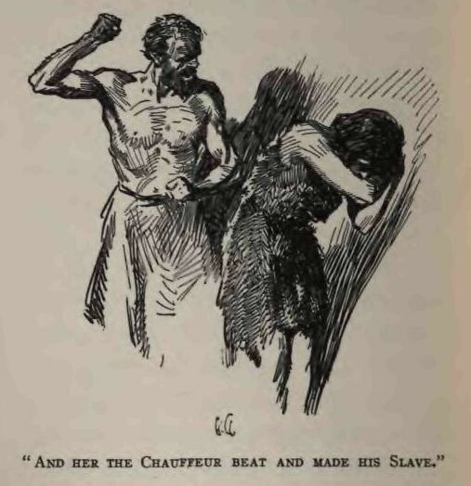
“—Bill—that was it; Bill, the Chauffeur. That was his name. He was a wretched, primitive man, wholly devoid of the finer instincts and chivalrous promptings of a cultured soul. No, there is no absolute justice, for to him fell that wonder of womanhood, Vesta Van Warden. The grievous-ness of this you will never understand, my grandsons; for you are yourselves primitive little savages, unaware of aught else but savagery. Why should Vesta not have been mine? I was a man of culture and refinement, a professor in a great university. Even so, in the time before the plague, such was her exalted position, she would not have deigned to know that I existed. Mark, then, the abysmal degradation to which she fell at the hands of the Chauffeur. Nothing less than the destruction of all mankind had made it possible that I should know her, look in her eyes, converse with her, touch her hand—ay, and love her and know that her feelings toward me were very kindly. I have reason to believe that she, even she, would have loved me, there being no other man in the world except the Chauffeur. Why, when it destroyed eight billions of souls, did not the plague destroy just one more man, and that man the Chauffeur?
“Once, when the Chauffeur was away fishing, she begged me to kill him. With tears in her eyes she begged me to kill him. But he was a strong and violent man, and I was afraid. Afterwards, I talked with him. I offered him my horse, my pony, my dogs, all that I possessed, if he would give Vesta to me. And he grinned in my face and shook his head. He was very insulting. He said that in the old days he had been a servant, had been dirt under the feet of men like me and of women like Vesta, and that now he had the greatest lady in the land to be servant to him and cook his food and nurse his brats. 'You had your day before the plague,' he said; 'but this is my day, and a damned good day it is. I wouldn't trade back to the old times for anything.' Such words he spoke, but they are not his words. He was a vulgar, low-minded man, and vile oaths fell continually from his lips.
“Also, he told me that if he caught me making eyes at his woman he'd wring my neck and give her a beating as well. What was I to do? I was afraid. He was a brute. That first night, when I discovered the camp, Vesta and I had great talk about the things of our vanished world. We talked of art, and books, and poetry; and the Chauffeur listened and grinned and sneered. He was bored and angered by our way of speech which he did not comprehend, and finally he spoke up and said: 'And this is Vesta Van Warden, one-time wife of Van Warden the Magnate—a high and stuck-up beauty, who is now my squaw. Eh, Professor Smith, times is changed, times is changed. Here, you, woman, take off my moccasins, and lively about it. I want Professor Smith to see how well I have you trained.'
“I saw her clench her teeth, and the flame of revolt rise in her face. He drew back his gnarled fist to strike, and I was afraid, and sick at heart. I could do nothing to prevail against him. So I got up to go, and not be witness to such indignity. But the Chauffeur laughed and threatened me with a beating if I did not stay and behold. And I sat there, perforce, by the campfire on the shore of Lake Temescal, and saw Vesta, Vesta Van Warden, kneel and remove the moccasins of that grinning, hairy, apelike human brute.
“—Oh, you do not understand, my grandsons. You have never known anything else, and you do not understand.
“'Halter-broke and bridle-wise,' the Chauffeur gloated, while she performed that dreadful, menial task. 'A trifle balky at times, Professor, a trifle balky; but a clout alongside the jaw makes her as meek and gentle as a lamb.'
“And another time he said: 'We've got to start all over and replenish the earth and multiply. You're handicapped, Professor. You ain't got no wife, and we're up against a regular Garden-of-Eden proposition. But I ain't proud. I'll tell you what, Professor.' He pointed at their little infant, barely a year old. 'There's your wife, though you'll have to wait till she grows up. It's rich, ain't it? We're all equals here, and I'm the biggest toad in the splash. But I ain't stuck up—not I. I do you the honor, Professor Smith, the very great honor of betrothing to you my and Vesta Van Warden's daughter. Ain't it cussed bad that Van Warden ain't here to see?'”

VI
“I LIVED three weeks of infinite torment there in the Chauffeur's camp. And then, one day, tiring of me, or of what to him was my bad effect on Vesta, he told me that the year before, wandering through the Contra Costa Hills to the Straits of Carquinez, across the Straits he had seen a smoke. This meant that there were still other human beings, and that for three weeks he had kept this inestimably precious information from me. I departed at once, with my dogs and horses, and journeyed across the Contra Costa Hills to the Straits. I saw no smoke on the other side, but at Port Costa discovered a small steel barge on which I was able to embark my animals. Old canvas which I found served me for a sail, and a southerly breeze fanned me across the Straits and up to the ruins of Vallejo. Here, on the outskirts of the city, I found evidences of a recently occupied camp.

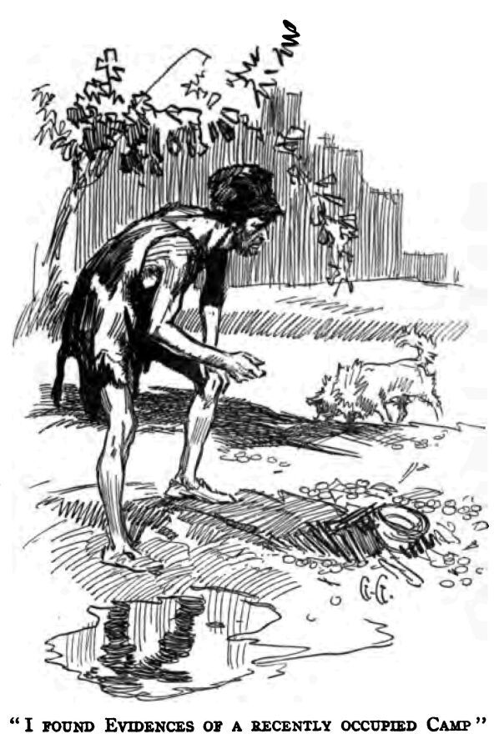
“Many clam-shells showed me why these humans had come to the shores of the Bay. This was the Santa Rosa Tribe, and I followed its track along the old railroad right of way across the salt marshes to Sonoma Valley. Here, at the old brickyard at Glen Ellen, I came upon the camp. There were eighteen souls all told. Two were old men, one of whom was Jones, a banker. The other was Harrison, a retired pawnbroker, who had taken for wife the matron of the State Hospital for the Insane at Napa. Of all the persons of the city of Napa, and of all the other towns and villages in that rich and populous valley, she had been the only survivor. Next, there were the three young men—Cardiff and Hale, who had been farmers, and Wainwright, a common day-laborer. All three had found wives. To Hale, a crude, illiterate farmer, had fallen Isadore, the greatest prize, next to Vesta, of the women who came through the plague. She was one of the world's most noted singers, and the plague had caught her at San Francisco. She has talked with me for hours at a time, telling me of her adventures, until, at last, rescued by Hale in the Mendocino Forest Reserve, there had remained nothing for her to do but become his wife. But Hale was a good fellow, in spite of his illiteracy. He had a keen sense of justice and right-dealing, and she was far happier with him than was Vesta with the Chauffeur.
“The wives of Cardiff and Wainwright were ordinary women, accustomed to toil with strong constitutions—just the type for the wild new life which they were compelled to live. In addition were two adult idiots from the feeble-minded home at Eldredge, and five or six young children and infants born after the formation of the Santa Rosa Tribe. Also, there was Bertha. She was a good woman, Hare-Lip, in spite of the sneers of your father. Her I took for wife. She was the mother of your father, Edwin, and of yours, Hoo-Hoo. And it was our daughter, Vera, who married your father, Hare-Lip—your father, Sandow, who was the oldest son of Vesta Van Warden and the Chauffeur.
“And so it was that I became the nineteenth member of the Santa Rosa Tribe. There were only two outsiders added after me. One was Mungerson, descended from the Magnates, who wandered alone in the wilds of Northern California for eight years before he came south and joined us. He it was who waited twelve years more before he married my daughter, Mary. The other was Johnson, the man who founded the Utah Tribe. That was where he came from, Utah, a country that lies very far away from here, across the great deserts, to the east. It was not until twenty-seven years after the plague that Johnson reached California. In all that Utah region he reported but three survivors, himself one, and all men. For many years these three men lived and hunted together, until, at last, desperate, fearing that with them the human race would perish utterly from the planet, they headed westward on the possibility of finding women survivors in California. Johnson alone came through the great desert, where his two companions died. He was forty-six years old when he joined us, and he married the fourth daughter of Isadore and Hale, and his eldest son married your aunt, Hare-Lip, who was the third daughter of Vesta and the Chauffeur. Johnson was a strong man, with a will of his own. And it was because of this that he seceded from the Santa Rosans and formed the Utah Tribe at San José. It is a small tribe—there are only nine in it; but, though he is dead, such was his influence and the strength of his breed, that it will grow into a strong tribe and play a leading part in the recivilization of the planet.
“There are only two other tribes that we know of—the Los Angelitos and the Carmelitos. The latter started from one man and woman. He was called Lopez, and he was descended from the ancient Mexicans and was very black. He was a cowherd in the ranges beyond Carmel, and his wife was a maidservant in the great Del Monte Hotel. It was seven years before we first got in touch with the Los Angelitos. They have a good country down there, but it is too warm. I estimate the present population of the world at between three hundred and fifty and four hundred—provided, of course, that there are no scattered little tribes elsewhere in the world. If there be such, we have not heard from them. Since Johnson crossed the desert from Utah, no word nor sign has come from the East or anywhere else. The great world which I knew in my boyhood and early manhood is gone. It has ceased to be. I am the last man who was alive in the days of the plague and who knows the wonders of that far-off time. We, who mastered the planet—its earth, and sea, and sky—and who were as very gods, now live in primitive savagery along the water courses of this California country.
“But we are increasing rapidly—your sister, Hare-Lip, already has four children. We are increasing rapidly and making ready for a new climb toward civilization. In time, pressure of population will compel us to spread out, and a hundred generations from now we may expect our descendants to start across the Sierras, oozing slowly along, generation by generation, over the great continent to the colonization of the East—a new Aryan drift around the world.
“But it will be slow, very slow; we have so far to climb. We fell so hopelessly far. If only one physicist or one chemist had survived! But it was not to be, and we have forgotten everything. The Chauffeur started working in iron. He made the forge which we use to this day. But he was a lazy man, and when he died he took with him all he knew of metals and machinery. What was I to know of such things? I was a classical scholar, not a chemist.. The other men who survived were not educated. Only two things did the Chauffeur accomplish—the brewing of strong drink and the growing of tobacco. It was while he was drunk, once, that he killed Vesta. I firmly believe that he killed Vesta in a fit of drunken cruelty though he always maintained that she fell into the lake and was drowned.
“And, my grandsons, let me warn you against the medicine-men. They call themselves doctors, travestying what was once a noble profession, but in reality they are medicine-men, devil-devil men, and they make for superstition and darkness. They are cheats and liars. But so debased and degraded are we, that we believe their lies. They, too, will increase in numbers as we increase, and they will strive to rule us. Yet are they liars and charlatans. Look at young Cross-Eyes, posing as a doctor, selling charms against sickness, giving good hunting, exchanging promises of fair weather for good meat and skins, sending the death-stick, performing a thousand abominations. Yet I say to you, that when he says he can do these things, he lies. I, Professor Smith, Professor James Howard Smith, say that he lies. I have told him so to his teeth. Why has he not sent me the death-stick? Because he knows that with me it is without avail. But you, Hare-Lip, so deeply are you sunk in black superstition that did you awake this night and find the death-stick beside you, you would surely die. And you would die, not because of any virtues in the stick, but because you are a savage with the dark and clouded mind of a savage.
“The doctors must be destroyed, and all that was lost must be discovered over again. Wherefore, earnestly, I repeat unto you certain things which you must remember and tell to your children after you. You must tell them that when water is made hot by fire, there resides in it a wonderful thing called steam, which is stronger than ten thousand men and which can do all man's work for him. There are other very useful things. In the lightning flash resides a similarly strong servant of man, which was of old his slave and which some day will be his slave again.

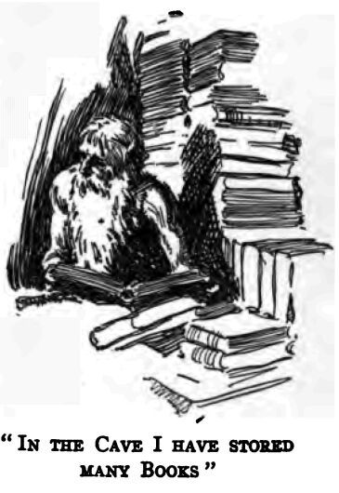
“Quite a different thing is the alphabet. It is what enables me to know the meaning of fine markings, whereas you boys know only rude picture-writing. In that dry cave on Telegraph Hill, where you see me often go when the tribe is down by the sea, I have stored many books. In them is great wisdom. Also, with them, I have placed a key to the alphabet, so that one who knows picture-writing may also know print. Some day men will read again; and then, if no accident has befallen my cave, they will know that Professor James Howard Smith once lived and saved for them the knowledge of the ancients.
“There is another little device that men inevitably will rediscover. It is called gunpowder. It was what enabled us to kill surely and at long distances. Certain things which are found in the ground, when combined in the right proportions, will make this gunpowder. What these things are, I have forgotten, or else I never knew. But I wish I did know. Then would I make powder, and then would I certainly kill Cross-Eyes and rid the land of superstition—”
“After I am man-grown I am going to give Cross-Eyes all the goats, and meat, and skins I can get, so that he'll teach me to be a doctor,” Hoo-Hoo asserted. “And when I know, I'll make everybody else sit up and take notice. They'll get down in the dirt to me, you bet.”
The old man nodded his head solemnly, and murmured:
“Strange it is to hear the vestiges and remnants of the complicated Aryan speech falling from the lips of a filthy little skin-clad savage. All the world is topsy-turvy. And it has been topsy-turvy ever since the plague.”
“You won't make me sit up,” Hare-Lip boasted to the would-be medicine-man. “If I paid you for a sending of the death-stick and it didn't work, I'd bust in your head—understand, you Hoo-Hoo, you?”
“I'm going to get Granser to remember this here gunpowder stuff,” Edwin said softly, “and then I'll have you all on the run. You, Hare-Lip, will do my fighting for me and get my meat for me, and you, Hoo-Hoo, will send the death-stick for me and make everybody afraid. And if I catch Hare-Lip trying to bust your head, Hoo-Hoo, I'll fix him with that same gunpowder. Granser ain't such a fool as you think, and I'm going to listen to him and some day I'll be boss over the whole bunch of you.”
The old man shook his head sadly, and said:
“The gunpowder will come. Nothing can stop it—the same old story over and over. Man will increase, and men will fight. The gunpowder will enable men to kill millions of men, and in this way only, by fire and blood, will a new civilization, in some remote day, be evolved. And of what profit will it be? Just as the old civilization passed, so will the new. It may take fifty thousand years to build, but it will pass. All things pass. Only remain cosmic force and matter, ever in flux, ever acting and reacting and realizing the eternal types—the priest, the soldier, and the king. Out of the mouths of babes comes the wisdom of all the ages. Some will fight, some will rule, some will pray; and all the rest will toil and suffer sore while on their bleeding carcasses is reared again, and yet again, without end, the amazing beauty and surpassing wonder of the civilized state. It were just as well that I destroyed those cave-stored books—whether they remain or perish, all their old truths will be discovered, their old lies lived and handed down. What is the profit—”
Hare-Lip leaped to his feet, giving a quick glance at the pasturing goats and the afternoon sun.
“Gee!” he muttered to Edwin, “The old geezer gets more long-winded every day. Let's pull for camp.”
While the other two, aided by the dogs, assembled the goats and started them for the trail through the forest, Edwin stayed by the old man and guided him in the same direction. When they reached the old right of way, Edwin stopped suddenly and looked back. Hare-Lip and Hoo-Hoo and the dogs and the goats passed on. Edwin was looking at a small herd of wild horses which had come down on the hard sand. There were at least twenty of them, young colts and yearlings and mares, led by a beautiful stallion which stood in the foam at the edge of the surf, with arched neck and bright wild eyes, sniffing the salt air from off the sea.
“What is it?” Granser queried.
“Horses,” was the answer. “First time I ever seen 'em on the beach. It's the mountain lions getting thicker and thicker and driving 'em down.”
The low sun shot red shafts of light, fan-shaped, up from a cloud-tumbled horizon. And close at hand, in the white waste of shore-lashed waters, the sea-lions, bellowing their old primeval chant, hauled up out of the sea on the black rocks and fought and loved.
“Come on, Granser,” Edwin prompted. And old man and boy, skin-clad and barbaric, turned and went along the right of way into the forest in the wake of the goats.
THE END
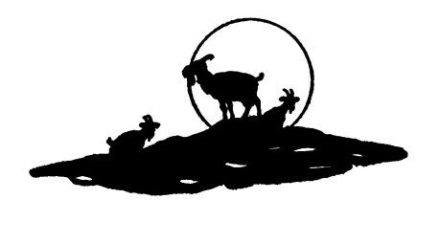

*** END OF THIS PROJECT GUTENBERG EBOOK ***
Updated editions will replace the previous one—the old editions will be renamed.
Creating the works from print editions not protected by U.S. copyright law means that no one owns a United States copyright in these works, so the Foundation (and you!) can copy and distribute it in the United States without permission and without paying copyright royalties. Special rules, set forth in the General Terms of Use part of this license, apply to copying and distributing Project Gutenberg™ electronic works to protect the PROJECT GUTENBERG™ concept and trademark. Project Gutenberg is a registered trademark, and may not be used if you charge for an eBook, except by following the terms of the trademark license, including paying royalties for use of the Project Gutenberg trademark. If you do not charge anything for copies of this eBook, complying with the trademark license is very easy. You may use this eBook for nearly any purpose such as creation of derivative works, reports, performances and research. Project Gutenberg eBooks may be modified and printed and given away—you may do practically ANYTHING in the United States with eBooks not protected by U.S. copyright law. Redistribution is subject to the trademark license, especially commercial redistribution.
START: FULL LICENSE

The Full Project Gutenberg License
PLEASE READ THIS BEFORE YOU DISTRIBUTE OR USE THIS WORK
To protect the Project Gutenberg™ mission of promoting the free distribution of electronic works, by using or distributing this work (or any other work associated in any way with the phrase “Project Gutenberg”), you agree to comply with all the terms of the Full Project Gutenberg™ License available with this file or online at www.gutenberg.org/license.
Section 1. General Terms of Use and Redistributing Project Gutenberg™ electronic works
1.A. By reading or using any part of this Project Gutenberg™ electronic work, you indicate that you have read, understand, agree to and accept all the terms of this license and intellectual property (trademark/copyright) agreement. If you do not agree to abide by all the terms of this agreement, you must cease using and return or destroy all copies of Project Gutenberg™ electronic works in your possession. If you paid a fee for obtaining a copy of or access to a Project Gutenberg™ electronic work and you do not agree to be bound by the terms of this agreement, you may obtain a refund from the person or entity to whom you paid the fee as set forth in paragraph 1.E.8.
1.B. “Project Gutenberg” is a registered trademark. It may only be used on or associated in any way with an electronic work by people who agree to be bound by the terms of this agreement. There are a few things that you can do with most Project Gutenberg™ electronic works even without complying with the full terms of this agreement. See paragraph 1.C below. There are a lot of things you can do with Project Gutenberg™ electronic works if you follow the terms of this agreement and help preserve free future access to Project Gutenberg™ electronic works. See paragraph 1.E below.
1.C. The Project Gutenberg Literary Archive Foundation (“the Foundation” or PGLAF), owns a compilation copyright in the collection of Project Gutenberg™ electronic works. Nearly all the individual works in the collection are in the public domain in the United States. If an individual work is unprotected by copyright law in the United States and you are located in the United States, we do not claim a right to prevent you from copying, distributing, performing, displaying or creating derivative works based on the work as long as all references to Project Gutenberg are removed. Of course, we hope that you will support the Project Gutenberg™ mission of promoting free access to electronic works by freely sharing Project Gutenberg™ works in compliance with the terms of this agreement for keeping the Project Gutenberg™ name associated with the work. You can easily comply with the terms of this agreement by keeping this work in the same format with its attached full Project Gutenberg™ License when you share it without charge with others.
1.D. The copyright laws of the place where you are located also govern what you can do with this work. Copyright laws in most countries are in a constant state of change. If you are outside the United States, check the laws of your country in addition to the terms of this agreement before downloading, copying, displaying, performing, distributing or creating derivative works based on this work or any other Project Gutenberg™ work. The Foundation makes no representations concerning the copyright status of any work in any country other than the United States.
1.E. Unless you have removed all references to Project Gutenberg:
1.E.1. The following sentence, with active links to, or other immediate access to, the full Project Gutenberg™ License must appear prominently whenever any copy of a Project Gutenberg™ work (any work on which the phrase “Project Gutenberg” appears, or with which the phrase “Project Gutenberg” is associated) is accessed, displayed, performed, viewed, copied or distributed:
This eBook is for the use of anyone anywhere in the United States and most other parts of the world at no cost and with almost no restrictions whatsoever. You may copy it, give it away or re-use it under the terms of the Project Gutenberg License included with this eBook or online at www.gutenberg.org. If you are not located in the United States, you will have to check the laws of the country where you are located before using this eBook.
1.E.2. If an individual Project Gutenberg™ electronic work is derived from texts not protected by U.S. copyright law (does not contain a notice indicating that it is posted with permission of the copyright holder), the work can be copied and distributed to anyone in the United States without paying any fees or charges. If you are redistributing or providing access to a work with the phrase “Project Gutenberg” associated with or appearing on the work, you must comply either with the requirements of paragraphs 1.E.1 through 1.E.7 or obtain permission for the use of the work and the Project Gutenberg™ trademark as set forth in paragraphs 1.E.8 or 1.E.9.
1.E.3. If an individual Project Gutenberg™ electronic work is posted with the permission of the copyright holder, your use and distribution must comply with both paragraphs 1.E.1 through 1.E.7 and any additional terms imposed by the copyright holder. Additional terms will be linked to the Project Gutenberg™ License for all works posted with the permission of the copyright holder found at the beginning of this work.
1.E.4. Do not unlink or detach or remove the full Project Gutenberg™ License terms from this work, or any files containing a part of this work or any other work associated with Project Gutenberg™.
1.E.5. Do not copy, display, perform, distribute or redistribute this electronic work, or any part of this electronic work, without prominently displaying the sentence set forth in paragraph 1.E.1 with active links or immediate access to the full terms of the Project Gutenberg™ License.
1.E.6. You may convert to and distribute this work in any binary, compressed, marked up, nonproprietary or proprietary form, including any word processing or hypertext form. However, if you provide access to or distribute copies of a Project Gutenberg™ work in a format other than “Plain Vanilla ASCII” or other format used in the official version posted on the official Project Gutenberg™ website (www.gutenberg.org), you must, at no additional cost, fee or expense to the user, provide a copy, a means of exporting a copy, or a means of obtaining a copy upon request, of the work in its original “Plain Vanilla ASCII” or other form. Any alternate format must include the full Project Gutenberg™ License as specified in paragraph 1.E.1.
1.E.7. Do not charge a fee for access to, viewing, displaying, performing, copying or distributing any Project Gutenberg™ works unless you comply with paragraph 1.E.8 or 1.E.9.
1.E.8. You may charge a reasonable fee for copies of or providing access to or distributing Project Gutenberg™ electronic works provided that:
• You pay a royalty fee of 20% of the gross profits you derive from the use of Project Gutenberg™ works calculated using the method you already use to calculate your applicable taxes. The fee is owed to the owner of the Project Gutenberg™ trademark, but he has agreed to donate royalties under this paragraph to the Project Gutenberg Literary Archive Foundation. Royalty payments must be paid within 60 days following each date on which you prepare (or are legally required to prepare) your periodic tax returns. Royalty payments should be clearly marked as such and sent to the Project Gutenberg Literary Archive Foundation at the address specified in Section 4, “Information about donations to the Project Gutenberg Literary Archive Foundation.”
• You provide a full refund of any money paid by a user who notifies you in writing (or by e-mail) within 30 days of receipt that s/he does not agree to the terms of the full Project Gutenberg™ License. You must require such a user to return or destroy all copies of the works possessed in a physical medium and discontinue all use of and all access to other copies of Project Gutenberg™ works.
• You provide, in accordance with paragraph 1.F.3, a full refund of any money paid for a work or a replacement copy, if a defect in the electronic work is discovered and reported to you within 90 days of receipt of the work.
• You comply with all other terms of this agreement for free distribution of Project Gutenberg™ works.
1.E.9. If you wish to charge a fee or distribute a Project Gutenberg™ electronic work or group of works on different terms than are set forth in this agreement, you must obtain permission in writing from the Project Gutenberg Literary Archive Foundation, the manager of the Project Gutenberg™ trademark. Contact the Foundation as set forth in Section 3 below.
1.F.
1.F.1. Project Gutenberg volunteers and employees expend considerable effort to identify, do copyright research on, transcribe and proofread works not protected by U.S. copyright law in creating the Project Gutenberg™ collection. Despite these efforts, Project Gutenberg™ electronic works, and the medium on which they may be stored, may contain “Defects,” such as, but not limited to, incomplete, inaccurate or corrupt data, transcription errors, a copyright or other intellectual property infringement, a defective or damaged disk or other medium, a computer virus, or computer codes that damage or cannot be read by your equipment.
1.F.2. LIMITED WARRANTY, DISCLAIMER OF DAMAGES - Except for the “Right of Replacement or Refund” described in paragraph 1.F.3, the Project Gutenberg Literary Archive Foundation, the owner of the Project Gutenberg™ trademark, and any other party distributing a Project Gutenberg™ electronic work under this agreement, disclaim all liability to you for damages, costs and expenses, including legal fees. YOU AGREE THAT YOU HAVE NO REMEDIES FOR NEGLIGENCE, STRICT LIABILITY, BREACH OF WARRANTY OR BREACH OF CONTRACT EXCEPT THOSE PROVIDED IN PARAGRAPH 1.F.3. YOU AGREE THAT THE FOUNDATION, THE TRADEMARK OWNER, AND ANY DISTRIBUTOR UNDER THIS AGREEMENT WILL NOT BE LIABLE TO YOU FOR ACTUAL, DIRECT, INDIRECT, CONSEQUENTIAL, PUNITIVE OR INCIDENTAL DAMAGES EVEN IF YOU GIVE NOTICE OF THE POSSIBILITY OF SUCH DAMAGE.
1.F.3. LIMITED RIGHT OF REPLACEMENT OR REFUND - If you discover a defect in this electronic work within 90 days of receiving it, you can receive a refund of the money (if any) you paid for it by sending a written explanation to the person you received the work from. If you received the work on a physical medium, you must return the medium with your written explanation. The person or entity that provided you with the defective work may elect to provide a replacement copy in lieu of a refund. If you received the work electronically, the person or entity providing it to you may choose to give you a second opportunity to receive the work electronically in lieu of a refund. If the second copy is also defective, you may demand a refund in writing without further opportunities to fix the problem.
1.F.4. Except for the limited right of replacement or refund set forth in paragraph 1.F.3, this work is provided to you ‘AS-IS’, WITH NO OTHER WARRANTIES OF ANY KIND, EXPRESS OR IMPLIED, INCLUDING BUT NOT LIMITED TO WARRANTIES OF MERCHANTABILITY OR FITNESS FOR ANY PURPOSE.
1.F.5. Some states do not allow disclaimers of certain implied warranties or the exclusion or limitation of certain types of damages. If any disclaimer or limitation set forth in this agreement violates the law of the state applicable to this agreement, the agreement shall be interpreted to make the maximum disclaimer or limitation permitted by the applicable state law. The invalidity or unenforceability of any provision of this agreement shall not void the remaining provisions.
1.F.6. INDEMNITY - You agree to indemnify and hold the Foundation, the trademark owner, any agent or employee of the Foundation, anyone providing copies of Project Gutenberg™ electronic works in accordance with this agreement, and any volunteers associated with the production, promotion and distribution of Project Gutenberg™ electronic works, harmless from all liability, costs and expenses, including legal fees, that arise directly or indirectly from any of the following which you do or cause to occur: (a) distribution of this or any Project Gutenberg™ work, (b) alteration, modification, or additions or deletions to any Project Gutenberg™ work, and (c) any Defect you cause.
Section 2. Information about the Mission of Project Gutenberg™
Project Gutenberg™ is synonymous with the free distribution of electronic works in formats readable by the widest variety of computers including obsolete, old, middle-aged and new computers. It exists because of the efforts of hundreds of volunteers and donations from people in all walks of life.
Volunteers and financial support to provide volunteers with the assistance they need are critical to reaching Project Gutenberg™’s goals and ensuring that the Project Gutenberg™ collection will remain freely available for generations to come. In 2001, the Project Gutenberg Literary Archive Foundation was created to provide a secure and permanent future for Project Gutenberg™ and future generations. To learn more about the Project Gutenberg Literary Archive Foundation and how your efforts and donations can help, see Sections 3 and 4 and the Foundation information page at www.gutenberg.org.
Section 3. Information about the Project Gutenberg Literary Archive Foundation
The Project Gutenberg Literary Archive Foundation is a non-profit 501(c)(3) educational corporation organized under the laws of the state of Mississippi and granted tax exempt status by the Internal Revenue Service. The Foundation’s EIN or federal tax identification number is 64-6221541. Contributions to the Project Gutenberg Literary Archive Foundation are tax deductible to the full extent permitted by U.S. federal laws and your state’s laws.
The Foundation’s business office is located at 809 North 1500 West, Salt Lake City, UT 84116, (801) 596-1887. Email contact links and up to date contact information can be found at the Foundation’s website and official page at www.gutenberg.org/contact
Section 4. Information about Donations to the Project Gutenberg Literary Archive Foundation
Project Gutenberg™ depends upon and cannot survive without widespread public support and donations to carry out its mission of increasing the number of public domain and licensed works that can be freely distributed in machine-readable form accessible by the widest array of equipment including outdated equipment. Many small donations ($1 to $5,000) are particularly important to maintaining tax exempt status with the IRS.
The Foundation is committed to complying with the laws regulating charities and charitable donations in all 50 states of the United States. Compliance requirements are not uniform and it takes a considerable effort, much paperwork and many fees to meet and keep up with these requirements. We do not solicit donations in locations where we have not received written confirmation of compliance. To SEND DONATIONS or determine the status of compliance for any particular state visit www.gutenberg.org/donate.
While we cannot and do not solicit contributions from states where we have not met the solicitation requirements, we know of no prohibition against accepting unsolicited donations from donors in such states who approach us with offers to donate.
International donations are gratefully accepted, but we cannot make any statements concerning tax treatment of donations received from outside the United States. U.S. laws alone swamp our small staff.
Please check the Project Gutenberg web pages for current donation methods and addresses. Donations are accepted in a number of other ways including checks, online payments and credit card donations. To donate, please visit: www.gutenberg.org/donate
Section 5. General Information About Project Gutenberg™ electronic works
Professor Michael S. Hart was the originator of the Project Gutenberg™ concept of a library of electronic works that could be freely shared with anyone. For forty years, he produced and distributed Project Gutenberg™ eBooks with only a loose network of volunteer support.
Project Gutenberg™ eBooks are often created from several printed editions, all of which are confirmed as not protected by copyright in the U.S. unless a copyright notice is included. Thus, we do not necessarily keep eBooks in compliance with any particular paper edition.
Most people start at our website which has the main PG search facility: www.gutenberg.org.
This website includes information about Project Gutenberg™, including how to make donations to the Project Gutenberg Literary Archive Foundation, how to help produce our new eBooks, and how to subscribe to our email newsletter to hear about new eBooks.
The Project Gutenberg eBook of The Scarlet Plague, by Jack London
This ebook is for the use of anyone anywhere in the United States and most other parts of the world at no cost and with almost no restrictions whatsoever. You may copy it, give it away or re-use it under the terms of the Project Gutenberg License included with this ebook or online at https://www.gutenberg.org/license. If you are not located in the United States, you’ll have to check the laws of the country where you are located before using this eBook.
Title: The Scarlet Plague
Author: Jack London
Release Date: June 29, 2007 [EBook #21970]
Language: English
Credits: Produced by David Widger

*** START OF THIS PROJECT GUTENBERG EBOOK ***

