Instructions

This experiment will last about 1 hour (30min + 30min), in which we ask you to give feedback on the shapes of the impulse response functions of a New Keynesian DSGE model. We consider impulse response functions of four variables to a shock to total-factor productivity (TFP). The four variables are: the differenced level of output dy, the differenced consumption dc, the labour supply labobs, and the differenced real wage dw.

We ask you to do the following steps until the experiment ends:

1. Set the slider on the position that corresponds to the impulse response functions that you think are the most realistic.
2. Confirm your feedback by clicking the “Confirm” button.
3. Wait the next query.

We provide you a figure (Figure 1) of the posterior impulse response functions of the same model that has been estimated on USA sample from 1984 to 2015. This may give you some guidance in providing realistic impulse response functions as a feedback.

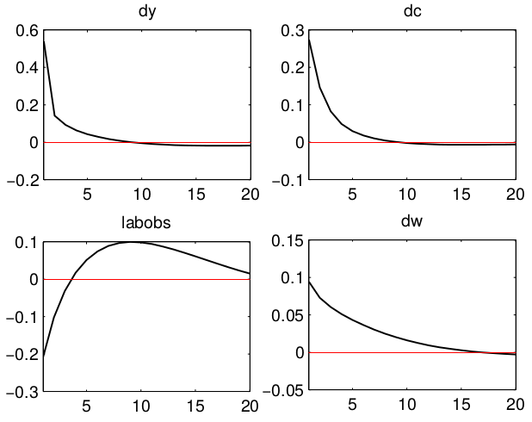

Figure 1: The posterior impulse response functions to a shock to TFP (USA sample from 1984 to 2015).

